علم اللغة النفسي
Psycholinguistics
رمز المقرر 7403455
جامعة الملك فيصل
كلية الآداب – لغة انجليزية – انتساب مطور طلاب
الدكتور ابراهيم عبد الرحمن ابراهيم المحبوب
البريد الالكتروني ialmahboob@gmail.com

جوال المقرر : 0537512249
Office Hours: Sunday 20 - 21

Introduction Psycholinguistics
Question:
- What do psycholinguists study ?
Answer:
- A lot of things related to language. However, with a special concentration on HOW language is dealt with in the human brain or in other words how language is processed.
Examples Questions
- How are words and word meanings represented in someone’s mind?
- How are sentences composed in someone’s mind at the time of speech?
- How are words and sentences and their meanings analyzed at the time of listening or reading?
Textbook
Fundamentals of Psycholinguistics
Author: Eva M. Fernandez and Helen Smith Cairns
Publisher: WILEY-BLACKWELL (2011)
Picture references
- https://sites.google.com/site/wuhpnet/psycholinguistics

Lecture 1 Psycholinguistic Research Methods WORDS 1
An Important Fact
“Research in this field therefore requires that metal language-processing events be inferred from observable behavior” O’Grady et al (2010).

One example of “observable behavior” is what some people call slips of the tongue or speech errors.

Examples of slips of the tongue
Intended: rules of word formation
Produced: words of rule formation
Intended: I’d forgotten about that
Produced: I’d forgot aboutten that
Intended: easily enough
Produced: easy enoughly

- So what does this tell us about the brain and word processing?

It tells us that morphemes function independently from words during sentence planning.

Lecture 2 Psycholinguistic Research Methods WORDS 2
A Basic Question
How are “words” organized in the mind?
Comparison
A desktop dictionary is usually consulted when we:
What a word means
How a word is spelled
How a word is pronounced
And the words are usually organized alphabetically !

Our Mental Lexicon is organized a little bit different it:
It can accommodate new words
It can be accessed very quickly
One example of how quick we can access our mental lexicon is what is commonly referred as the:
“Tip-of-the-tongue phenomena”

Tip-of-the-tongue phenomena
This is the situation where you are unable to access a word (or remember a word)in your mental lexicon and all you needed was the:
meaning of the word
the sound of the word
the first letter
or what the word rhymes with

A technical term
At this pint we should stop calling them words. The technical term for the items in the lexicon is entries. So we should re-phrase the question we posed at the beginning of this lecture and ask:
How are entries organized in the mind?

What the mental lexicon could look like. (picture 1)
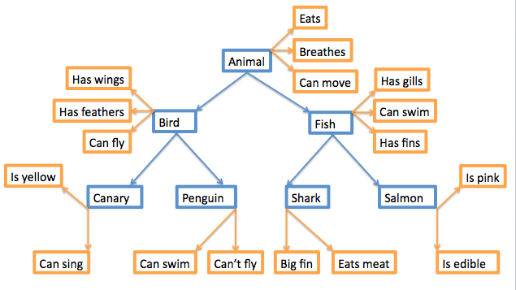

More questions
How are entries linked together?
How are entries accessed?
What information is contained in an entry?

Big problem
The mental lexicon cannot be observed !
(Picture 2)

So how can we know?
Through creative experiments such as:
Lexical decision and priming

Lecture 3 Lexical Decision and Priming

Lexical Decision
A lexical decision experiment is conducted by asking a native speaker to sit in front of a computer screen where he/she is asked to judge as quickly as possible if the word that appears on the screen is a real word. If the word is real the participant clicks “yes”; if not, the participant clicks “no”.

What are we looking for?
Usually what we are looking for in this task is:
Response latency: and that is the time it takes for the a participant to respond “yes/no”.
Response accuracy: and that is whether or not the participant responded accurately.

Details
When designing this task the participants are usually tested on one set of stimuli against another set of stimuli. For example:
“Nouns” compared to “Verbs”. “concrete words” compared to “abstract words”
This test measures the speed and accuracy in which the mental lexicon is accessed.

Interesting findings
It has been found that it usually takes participants about a half a second to press “yes” for word they know or frequently used words. However, it takes three-quarters of a second to press “yes” for less common words. This is commonly known as the frequency effect.

What we can infer from this is that our mental lexicons are probably organized in a way that words we use often are more easy to access.

Priming
Priming can be considered as an extension of lexical decision task. However, in this task before the participant is asked to choose “yes” or “no” the target word is preceded by another stimulus (called the prime). What is measured is the extent the prime influences the participant’s lexical decision on the target stimuli.

When the target is preceded by a related word the response is usually quicker.

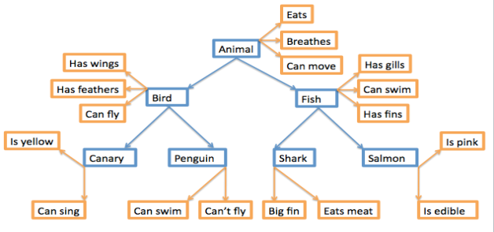

Lecture 4 Sentence Processing
There is a difference between investigating the mental lexicon and investigating sentence processing.
A sentence is understood(either in the case of reading or listening) through the meaning of its words and analysis of its syntactic structures.
This unconscious ability as parsing.
Parsing
Much of the work in psycholinguistics regarding sentence processing is focused on:
How parsing happens
What are the steps that take place in parsing
Parsing speed
The conditions when parsing doesn’t work
Timed-Reading Experiments
Among the most common timed-reading experiments is the bar-pressing test.
In this test the participant is asked to sits in front of a computer screen and read a sentence one word at a time. The participant presses a bar on the keyboard to read the next word till he/she reaches the end of the sentence.
What we can learn from this experiment
We can learn about the amount of time required to process certain words (content words/function words)
How long participants pause at the end of clause boundaries
Results usually show interesting time patterns.
Eye Movement
Tracking eye movement on words during reading revealed that eye fixation time is usually longer for less frequent words and that the points of fixation are usually content words rather than function words.
Research has shown that the more difficult the sentence is in structure the more regressive saccades there are in addition to longer fixation times.
What happens in the Lab
Lecture 5 Sentence Processing
Event-Related Potentials (ERPs)
ERP experiments measure electrical activity in the brain. That is voltage fluctuations resulting from the brain’s electrical activity.
(Those things they puton a person’s head are called “electrods”)

What happens in the lab?
The participant sits in front a computer screen.
The participants reads words or sentences.
The computer records the instant at which a stimulus is presented.
Then the computer compares the voltage fluctuation to on going activity in the brain.

Lecture 6 Processing Phonetics Phonology
What happens when we hear a sentence?
If you hear someone say
“The dog bit the cat”
- You will probably hear the segment /ð/
- Then the segment /ə/
- Then at enormous speed you’re able to access the representation of the word the in your mental lexicon.
- By that time you have realized that the next word is going to be a noun.
- Then the segment d-o-g are analyzed
- After that you hear the segments /bi/ and you biased to the possibility that this word is going to be bit because of the association with dog.

This is what is called:
“bottom-up processing”
Where a phonetic analysis is used to isolate phonemes and word boundaries and relate these items in the mental lexicon.

You do not rely on phonetic analysis alone in trying to understand the sentence:
“the dog bit the cat”

You also used the information you know about cats and dogs and what to expect from one another. This process is called:
“top-down processing”

Features
Consider the phonetic feature [ + voice] in the following speech error or slip of the tongue.
big and fat
pig and vat
Notice that the sounds /b-p/ and /f-v/ only differ from each other in the feature [ + voice] whereas the place of articulation is the same.

Psycholinguists consider such speech errors as evidence that language production makes use of the individual feature components of phonemes and that the phonemes that we produce in speech may actually be put together out of bundles of such features O’Grady et al (2010).

Phonemes
Marslen-Wilson in the 1980s proposed the “cohort model” of lexical access. This model states that a word’s cohort consists of all the lexical items that share an initial sequence of phonemes.

For example:
When someone hears the word glass he/she initially considers all the words that begin with the sound [g]. When the sound [l] is recognized, the number of possible words (the cohort) is reduced to those words that begin with [gl]. This process continues until the cohort of possible words is reduced to one, which is the intended word.
This suggests that the phoneme is the fundamental unit of auditory word recognition.

Lecture 7 The Biological Basis of Language 1
Language is Species Specific
What that means is:
language is likely to be part of the genetic makeup of members of the species
So far scientist haven’t found similar tendencies in other species.
Universal Grammar
What we mean by that is:
languages of the world are similar because all humans have the same language capacities.
However please note that the term Universal Grammar also has other implications.
The critical period
Is there an age restriction on acquiring a first language?
There is a very strong view that there is an age restriction.

Neurolinguistics
Neurolinguistics is the study of the representation of the language in the brain.
Aphasia
Aphasia is a language impairment linked to brain injury.

Broca's aphasia is also known as non-fluent aphasia.
Is characterized by halting, effortful speech; it is associated with damage involving Broca’s area in the frontal lobe of the left hemisphere.
Wernicke's aphasia is also known as fluent aphasia.
Is characterized by fluent meaningless strings; it is caused by damage involving Wernicke’s area in the temporal lobe of the left hemisphere.

Lecture 8 The Biological Basis of Language 2
Left and Right Hemispheres

language is lateralized
That is: language function is located in one of the two hemispheres.
Not all people are the same. Some have it on the in right, some in the left and some in both hemispheres.
But most people have it in the left.

Control of the body is contralateral
That is: the left hemisphere controls the right side of the body and the right hemisphere controls the left side of the body.

The dichotic listening experiment
In this experiment the participant is given two different inputs to each ear at the same time.
Usually the participant reports what he/she heard in the right ear.
This is called the right-ear advantage for language

Lecture 9 The Speaker
Before We Speak
The production of a sentence begins with the speaker’s intention to communicate an idea or some item of information. This has been referred to by Levelt (1989) as a preverbal message, because at this point the idea has not yet been cast into a linguistic form. Turning an idea into a linguistic representation involves mental operations that require consulting both the lexicon and the grammar shared by the speaker and hearer.

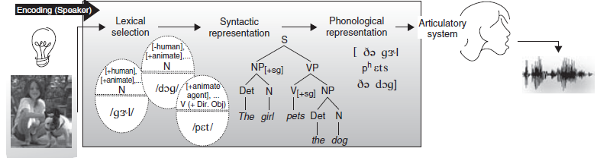
The diagram above discribes some processing operations, ordered left to right, performed by the speaker when producing the sentence The girl pets the dog. Production begins with an idea for a message (the light bulb on the far left) triggering a process of lexical selection. The capsule-like figures represent lexical items for the words girl, dog, and pet, activated based on the intended meaning for the message; these include basic lexical semantic and morphosyntactic information (top half) and phonological form information (bottom half). The tree diagram in the center represents the sentence’s syntactic form. The phonetic transcription to the right represents the sentence’s eventual phonological form, sent on to the articulatory system, which produces the corresponding speech signal. The different representations are accessed and built very rapidly and with some degree of overlap
What if the speaker speaks two languages?
Few adjustments need to be made to the working model in diagram above to account for production by people who speak two or more languages. We need to assume that a bilingual has two language-specific grammars, and a lexicon with language-specific entries, and we need to specify how these language-specific knowledge repositories are activated (or deactivated) – but that is all. When a bilingual is speaking in a unilingual mode (only one language), only one of the grammars is consulted to build structural representations, and the active language’s lexical entries are activated. When in a bilingual mode (when the bilingual’s two languages are being used in the same conversation), access to both grammars and lexical items from both languages must be possible (Grosjean 2001).

Code-switching
One type of alternation between languages in bilingual speech is code-switching. Code-switching is switching between two codes (two languages, or two distinct dialects of the same language) within the same discourse. A switch can take place between sentences (intersentential code-switching). A switch can also occur within the same sentence (intrasentential code-switching), at clause boundaries, or at smaller phrasal boundaries. A third category, tag-switching, involves the insertion of frequently used discourse markers, like so, you know, I mean, etc.

Barrowing
Code-switching is not to be confused with barrowing. When a word from one language is incorporated into the lexicon of another language, The phenomenon is called borrowing.

