Lecture 12
Eng 250
مقدمه في اللغويات التطبيقية
Chapter 3 - The Sounds of Language

I. Sounds [ A. Voiced & B. Voiceless]

II. Place of Articulation
A. Bilabials B. Labiodentals C. Dentals D. Alveolars
E. Palatals F. Velars G. Glottals

III. Manner of Articulation
A. Stops B. Fricatives C. Affricates D. Nasals E. Liquids F. Glides

IV. Charting Consonant Sounds
V. Vowels.
A. Front B. Central C. Back D. High
E. Mid F. Low G. Diphthongs

V. Sample Questions

I- Sounds ( Voiced Sounds )
- [b] book rebuild club
- [m] male smile team
- [w] wall unwilling how
- [v] voice adventure leave
- [ð] there mother
- [d] danger understand load
- [z] zero razor thesis
- [n] north author south
- [l] land selfishness role
- [r] round surround fou(r)
- [g] gap geography mug
- [ʒ] pleasure measure treasure
- [ʤ] gist adjust language
- [ŋ] ceiling English understanding
- [j] you royal toy

I- Sounds ( Voiceless Sounds )

B. Voiceless sounds
- [p] pen open help
- [f] feel refill self
- [θ] thought author health
- [t] table stop seat
- [s] Sunday resize house
- [∫] sure discussion brush
- [ʧ] chair recharge speech
- [k] cure recognize leak
- [h] hand behind Allah

II. Place of Articulation
Place of Articulation:
The location inside the mouth at which the constriction takes place.
Describing consonant sounds in terms of WHERE they are articulated. [the tongue and other parts of the mouth are used only for producing consonant sounds ]

A. Bilabials:
The upper lip [ bi ] and the lower lip [labia ]
- The sounds that are produced by bilabials are [ p , b , m ]

B. Labiodentals:
The lower lip [ labia ] and the upper teeth [ dentals ]
- The sounds that are produced by labiodentals are [ f , v ]

C. Dentals:
The sounds that are produced by the tongue tip and the upper front teeth
- The sounds that are produced by dentals are [ think , that ]

D. Alveolars:
The sounds that are produced with the front part of the tongue on the alveolar ridge which is the rough , bony ridge immediately behind and above the upper teeth. [ t, d , s, z , n ]

E. Palatals/ Alveolar- palatals :-
The sounds that are produced with the tongue and the palate[ the hard part in the roof of the mouth ].
[ shut , church, treasure, joke ]
-v -v +v +v

F. Velars:
The sounds that are produced with the back of the tongue against the velum
[ soft palate ]
[ k , g , ng ,
-v +v +v

G. Glottals :
Glottis is the place between the vocal cords /folds in the larynx.
The only sound that is produced without the active use of the tongue and other parts of the mouth.
[ h ]
-v
See the table on page 30

III. Manner of Articulation
Manner of Articulation:- Describing consonant sounds in terms of HOW they are articulated or in the way they are made or produced.
A – Stops/ plosive :
The consonant sounds that are produced as a result of blocking effect on the air stream, then letting it go abruptly .
[p], [b], [t] , [d], [k], [g]

B - Fricatives:-
The sounds produced when blocking the air stream and having the air pushed through the very narrow opening causing a type of friction .
[ f] , [v] , [ think’] , [that] , [s] , [z] , [sh] , treasure]

C. Affricates:-
The sounds produced while combining a brief stopping of the air stream with an obstructed release causing some friction.
[ cheap] , [germ]
-v +v

D – Nasals:
The consonant sounds that are produced when the velum is lowered and the air stream is allowed to flow through the nose.
[m], [n], [ng]
+v +v +v

E - Liquids:-
There are 2 sounds. The Lateral liquid [L] is produced by letting the air stream flow around the sides of the tongue and the tip of the tongue contacts the middle of the alveolar ridge.
The [ r] sound is formed with the tongue tip raised and curled back; near the alveolar ridge.

F. Glides:-
The sounds produced while combining a brief stopping of the air stream with an obstructed release causing some friction.
[ w] , [j] win-you
-v +v

IV. Charting Consonant Sounds
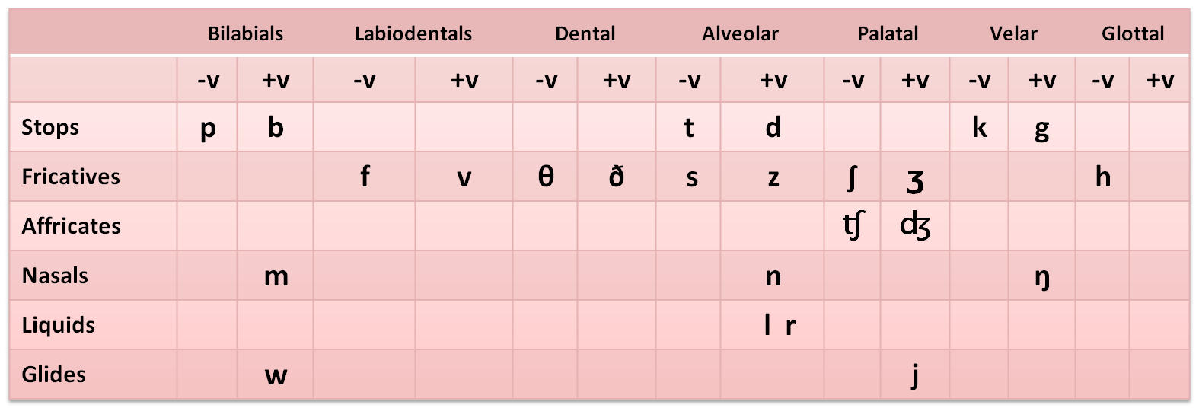

Examples
- Stops:
[p] people republic sleep
[b] basic symbols rub
[t] table reciting seat
[d] dangerous reading covered
[k] keep recognize steak
[g] goal regard bag

2. Fricatives
[f] food define enough
[v] very revise love
[θ] think diphthong mouth
[ð] that mother ?
[s] self understand house
[z] zero desert quiz
[ ∫ ] shore pushes crash
[ʒ] measure treasure]
[h] house behind

3. Affricate
[ ʧ ] church recharge research
[ ʤ] jordan enjoy Jeddah jar

4. Nasals
[m] money remind come
[n] national conference station
[ŋ] // English boring

5. Liquids
[l] learning rely steal
[r] reading cardinal where ?

6. Glides
[w] want reward how
[ j ] you royal enjoy

Approximants: The combination of the liquids [l] and [r] and the glides [w] and [j] in one category

V. Single Vowels & Diphthongs
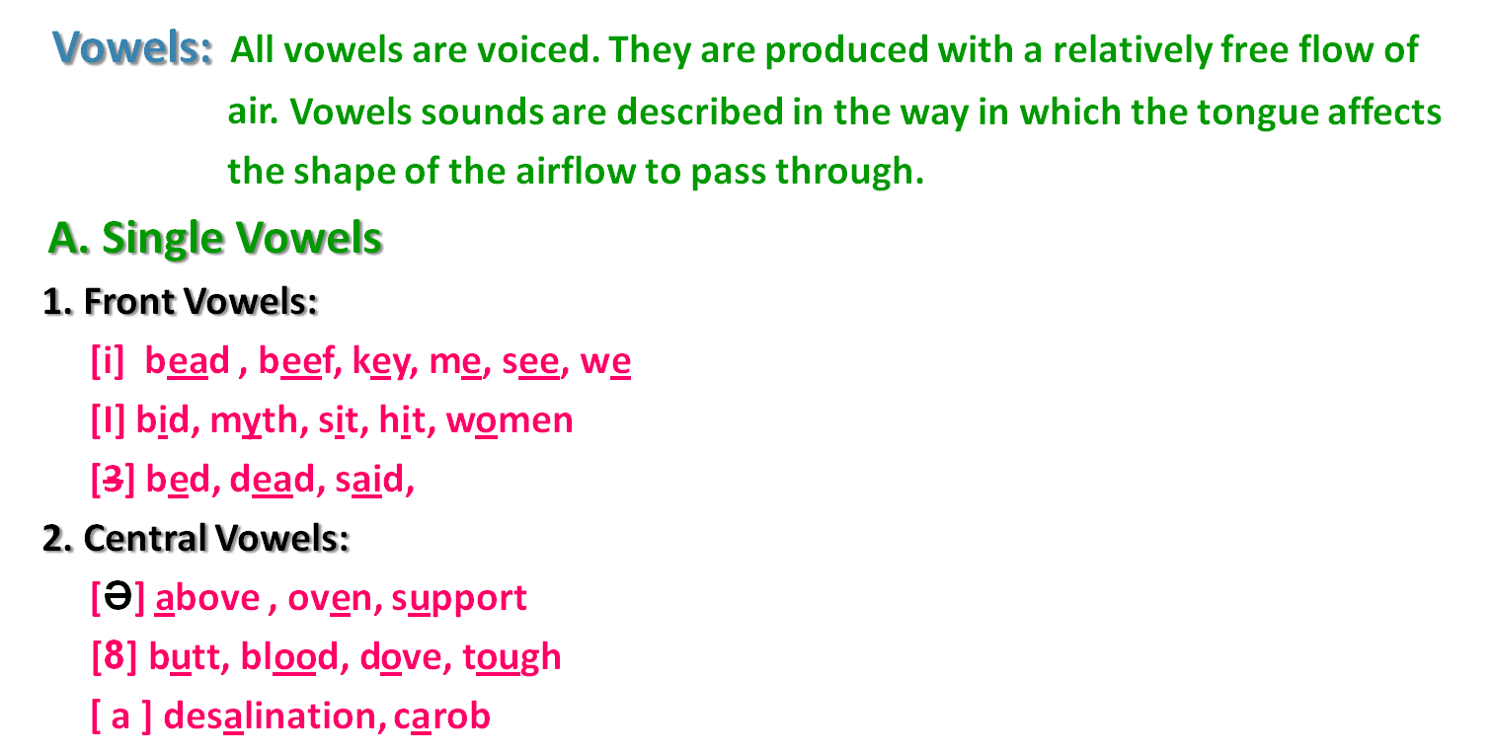

3. Back vowels:
[u] boo, move, two, you
[ʊ ] book, could, put,
[o] hot, pot ,
[Ɔ] born, caught, fall, raw
[ɑ] bod, cot, swan

B. Diphthongs:
Sounds that consist of a combination of two vowel sounds.
[ai] buy, eye, I, my, pie, by, sigh
[au] cow, how, now, doubt, bough
[ ei ] eight, great, late, hate, say
[ ou] boat, throw, home, toe
[ oi ] boy, noise
[Ə ] about , understand it is called schwa

VI. Charting Vowels
Back | Central | Front
you u  Ʊ |  | me i  bid I | High
pot o  fall Ɔ | Above Ə  8 blood | support e  said Ɛ | Mid
swan ɑ | sat a | laugh æ | Low

VIII. - Sample Questions

1. The study of how speech sounds are made or articulated is called “ _____”
A. Phonetics B. Acoustic Phonetics
C. Articulatory Phonetics D. Auditory Phonetics

- “ ____” is the only voiceless sound from the following.
A. B B. K
C. M D. G

3. The sounds that are produced by the tongue tip and the upper front teeth are called __________.
A. Dentals B. Labiodentals
C. Bilabials D. Alveolars

4. For producing only consonant sounds, the __________ and other parts of the mouth are used.
A. nose B. tongue
C. fingers D. ears

5. It is the sound ____ that is only produced by Glottals .
A. [f] B. [p]
C. [d] D. [ h]

6. All of the following sounds are produced by velars except the sound “ ____”
A. [r] B. [K]
C. [ng] D. [G]

7. The sounds that are produced when blocking the air stream and having air pushed through the very narrow opening causing a type of friction are alled ____.
A. Dentals B. Fricatives
C. Bilabials D. Alveolars

8. The underlined vowel sound in the word “ key” is one of the _________ .
A. long B. front vowels
C. Back vowels D. central vowels

9. Sounds that consist of a combination of two vowel sounds are called ________
A. Diphthongs B. front vowels
C. Back vowels D. central vowels

10. All of the following sounds are diphthongs except the sound “ _________” .A. [au] B. [ei]
C. [oi] D. [u:]

11. The underlined vowel sound in the word “ _________” is called a schwa.
A. shore B. hat
C. about D. tin

12. “ ______________” is the study which deals with the physical properties of speech as sound waves in a language.
A. Phonetics B. Acoustic Phonetics
C. Articulatory Phonetics D. Auditory Phonetics

With best Regards
Dr, Ghassan. M. Nayfi

ـألسآحر – ملتقى الانتساب المطور بجامعة الملك فيصل

