In The Name Of Allah Most Gracious Most Mercifvl

King Faisal University
Deanship of E-Learning and Distance Education



The Modern Novel
Instructor : Dr. Abdulgawad Elnady
All content from 1 to 14
By
Heart story



First Lecture
Warm-up
- Before we talk about the nature and characteristics of the novel in the 20th century, let us have a brief history of English literature in the 19th century.
- This will help us to understand a lot about the nature of the novel in the modern age.
A Brief History of England in the 19th Century
The 19th Century: Life and Literature
- First of all, what is meant by Modern?
- According to scholars, the modern era began approximately in the 16th century.
- It means the start of the modern ages in Europe. We have to distinguish between literature written in the dark ages and literature written from the Renaissance onwards.
- It means also novels written with the start of the modern ages. In this way, we can consider Robinson Crusoe to be a modern novel.
The 19th Century: Life and Literature

The novel in the 18th century
- We already studied this period in our course The Rise of the Novel.
- It is a period of beginnings. Lots of demerits and some merits.
- The novel suffered from repetition, complex language, coincidence, contradiction, weak plots, digression, and weak character portrayal.
- But the novel also broke fresh grounds in form and content.
- It at least opened up people’s eyes to the problems of society that were long unspoken of in poetry and drama.
- Questions:
- Robinson Crusoe is (a modern- a medieval- an Anglo-Saxon) novel.
- The novel in the 18th century had (lots of merits- lots of demerits- no merits)
- The Modern novel means (only novels written in the 20th century- novels written only in the 19th century- all novels written with the start of the modern age.)
- According to scholars, the modern era began approximately in the (16th- 17th- 20th ) century.
- Another famous name for the novel in this period is the Victorian novel (1837 – 1901)
- Why is that? The age has been given its name from Queen Victoria (1819-1901) whose reign of England continued from 1837 to 1901.
- She became queen at the age of 18; she was graceful and self-assured. She also had a gift for drawing and painting.
- Her interest in the arts coincided with the emergence of the greatest age of the English novel.
Questions
- The Victorian novel takes its name from: (Queen Elizabeth- Queen Victoria- King George).
- Queen Victoria ruled England for (over 60 years- 25 years- ten years)
- The greatest age of the English novel is the (Elizabethan- Victorian- Georgian) age.
- Queen Victoria ruled England when she was (60- 18- 40) years of age.
- Queen Victoria had an interest in (cooking- arts and painting- writing)
- Four factors can help us understand The novel in the 19th century:
- Enormous changes occurred in political and social life in England and the rest of the world.
- The scientific and technical innovations of the Industrial Revolution, the emergence of modern nationalism, and the European colonization of much of Africa, the Middle East, and the Far East changed most of Europe.
- Far-reaching new ideas created the greatest outpouring of literary production the world has ever seen.
To understand those factors:
Let us read what Charles Dickens said in his A Tale of Two Cities about the age not just in England but also all over Europe.
It was the best of times, it was the worst of times, it was the age of wisdom, it was the age of foolishness, it was the epoch of belief, it was the epoch of incredulity, it was the season of Light, it was the season of Darkness, it was the spring of hope, it was the winter of despair, we had everything before us, we had nothing before us, we were all going direct to Heaven, we were all going direct the other way—in short, the period was so far like the present period, that some of its noisiest authorities insisted on its being received, for good or for evil, in the superlative degree of comparison only.
Which means
the Victorian age was an age of contradiction:
- Some people were very rich, some very poor
- Some people felt quite happy, some quite miserable
- Some people enjoyed freedom and luxury, some lived in prisons and suffered from instability
- Some people travelled and explored the world, some were stuck at factories and small institutions
- Some people had strong faith in the future, some were lost and pessimistic
- Some people were full of confidence in themselves and in their powers as individuals, some lost confidence in everything Faith and doubt

Which means : Lord Alfred Tennyson
- There lives more faith in honest doubt, believe me, than in half the creeds.
Self-reverence, self-knowledge, self-control; these three alone lead one to sovereign power.
Behold, we know not anything;
I can but trust that good shall fall
At last — far off — at last, to all,
And every winter change to spring.
- So runs my dream: but what am I?
An infant crying in the night:
An infant crying for the light:
And with no language but a cry.
Also of interest to most Victorian Novelists:
- Education
- Poverty
- Hunger
- Diseases
- Death
- Pollution
- Social injustice and class distinction
- Clash between science and religion
- The place of England as a super colonial power
As for form:
- The novel had a firmer structure
- The form was suitable to the content
- Plots and characters became less in number
- Plots and characters were more tightly and strongly built
- Language got easier and sentences shorter
- Coincidences were less and less used in novels
- More verisimilitude
- More irony and symbolism

The Situation of the Novel
- The novel became the most popular form of literature and also the main form of entertainment since thery were read aloud within the family.
- Novelists felt they had a moral and social responsibility to fulfil: they depicted society as they saw it (realism) and denounced its evils (criticism). They aimed at making readers realise social injustices.
- A great example here is Charles Dickens who devoted all his novels to the criticism of society especiaally to the problems of poverty and education.

The Victorian Novel
- Victorian novels seek to represent a large and comprehensive social world, with a variety of classes.
- Victorian novels are realistic, their major theme is the place of the individual in society, the aspiration of the hero or heroine for love or social position.
- The protagonist’s search for fulfillment is emblematic of the human condition.
- For the first time, women were major writers: the Brontës, Elizabeth Gaskell, George Eliot.
The Victorian novel was a principal form of entertainment
The Victorian Novel
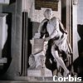
- On Dickens’s grave, we read these very important phrases:
- Dickens’ epitaph:
- “He was a sympathizer to the poor, the suffering, and the oppressed; and by his death, one of England’s greatest writers is lost to the world.”
Many Victorian novelists joined him in this mission of criticizing society to improve it
To sum up
- The Victorian novel was quite interested in dealing with the problems of society.
- It was full of realism.
- Lots of novels were written in this age in celebration of the greatness of the British empire: the greatest nation and the greatest novel.
- The form of the Victorian novel was stronger and much more improved than that of the 18th century.
Questions
- One famous Victorian novelist who worked for the improvement of society through criticizing it is
(Forster- Woolf- Dickens).
- The greatest age of the English novel was
(romantic- classic- realistic).
- The form of the Victorian novel is
(the same as- stronger than- worse than) that of the novel in the 18th century.
- Many women novelists appeared in English literature in the
(17th- 18th- 19th) century.

Second Lecture

Quick Revision
- The Victorian novel was quite interested in dealing with the problems of society.
- It was full of realism.
- Lots of novels were written in this age in celebration of the greatness of the British empire: the greatest nation and the greatest novel.
- The form of the Victorian novel was stronger and much more improved than that of the 18th century.
- One famous Victorian novelist who worked for the improvement of society through criticizing it is (Forster- Woolf- Dickens).
- The greatest age of the English novel was (romantic- classic- realistic).
- The form of the Victorian novel is (the same as- stronger than- worse than) that of the novel in the 18th century.
- Many women novelists appeared in English literature in the (17th- 18th- 19th) century.

History Repeats Itself
How does history repeat itself?
- The novel in the 18th century dealt with the problems of society and the suffering of people.
- At the start of the 19th century writers left realism and preferred to talk about nature, love, and beauty. This new shift away from society was called Romanticism.
- Then the greater part of the 19th century was a return back to realism. It was the greatest age of realism in the English novel.
By the end of the 19th century and the start of the 20th, writers got sick of the traditional realism of the 19th century. They came up with something totally different, this time it was called Modernism.
History has really repeated itself in the following way:
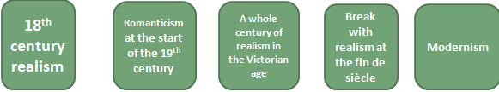
Modernism
What is modernism in brief?
It is a rebellion against old traditions of form and content. Classical, conventional ways of expression and even subject matter were rejected and newer, forms and themes were looked for.

The ordered, stable and inherently meaningful world view of the nineteenth century could not, wrote T.S. Eliot, accord with "the immense panorama of futility and anarchy which is contemporary history." Modernism thus marks a distinctive break with Victorian bourgeois morality; rejecting nineteenth-century optimism, they presented a profoundly pessimistic picture of a culture in disarray.
“Modernism” is an international artistic movement, flourishing from the 1880s to the end of WW II (1945), known for radical experimentation and rejection of the old order of civilization and 19th century optimism; a reaction against Realism and Naturalism

when did it start?
According to Virginia Woolf, on or about 1910, the world changed. So she believes it began at about this time.
Other scholars see that it began at the fin de siècle of the 19th century until the end of the 2nd world war in 1945.
The words fin de siècle mean: the end of the century.

Questions
- The words fin de siècle mean:
(the end of the century- the start of the century- the middle of the century).
- Modernism means writers used
(different- the same- opposite) ways of expression.
- Modernist writers are
(optimistic- pessimistic- neutral).
- History repeats itself in English literature, which means every age (relies on romanticism-reacts to realism- is realistic)
- Modernist writers (liked- objected to- supported) the order and stability of the 19th century.
- Modernism started in (the 19th century- the 21st century- the end of the 19th and the beginning of the 20th century)
- According to Virginia Woolf, modernism began in (1910-1945-1888).
Modernism Major tenets:
- Break with all traditional approaches to form and content.
- Experimentation
- Free verse
- Fragmentation: nothing connects with anything else.
- Dissatisfaction with the world of politics and the attempt to escape from it through invention of some forms like fables and journeys.
- Again history repeats itself. Robinson Crusoe is an 18th century novel that used the trope of the journey. It is used again William Golding (Lord of the Flies) and George Orwell (Animal Farm).
In literature, the movement is associated with the works of (among others) Eliot, James Joyce, Virginia Woolf, W.B. Yeats, Ezra Pound, Gertrude Stein, H.D., Franz Kafka and Knut Hamsun. In their attempt to throw off the aesthetic burden of the realist novel, these writers introduced a variety of literary tactics and devices.

Questions
Some writers associated with modernism are (James Joyce- Charles Dickens- Daniel Defoe).
Modernism: some more tenets
- Marked by a strong and intentional break with tradition. This break includes a strong reaction against established religious, political, and social views.
- Belief that the world is created in the act of perceiving it; that is, the world is what we say it is, not what others tell us about it.
- There is no such thing as absolute truth. All things are relative.
- No connection with history or institutions. Their experience is that of alienation, loss, and despair.
- Championship of the individual and celebration of inner strength.
- Life is unordered.

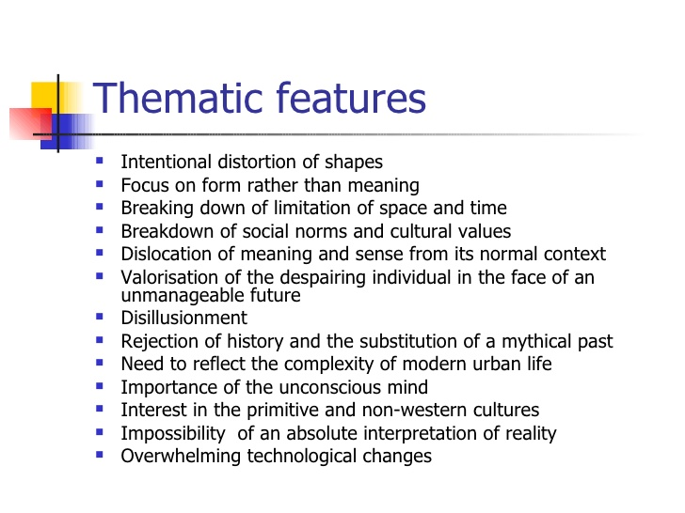
Questions
Modernism is marked by a strong and intentional break with tradition:
- It respects and imitates tradition
- It is a rebellion against tradition
- It uses the same techniques and methods of the past
- It values traditional concepts
How far can Animal Farm be considered a modernist novel?
Breaks away with the form of the 19th c novel
Breaks away with traditional language of fiction
Grapples with the predicament of the modern man who sees himself dissociated from the world of politics around him.
Uses new experimental form summoned from history.
It is pessimistic.

1945
Predicts a dark future for humanity
Uses parody
Calls for the same mottos of the French Revolution
Animal Farm by George Orwell 1945
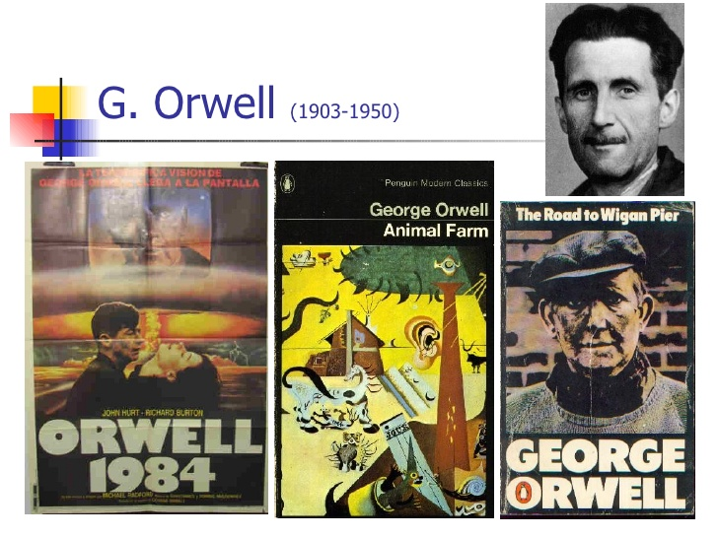
Third Lecture
Modernism : Quick Revision
- Break with all traditional approaches to form and content.
- Experimentation
- Fragmentation: nothing connects with anything else.
- Dissatisfaction with the world of politics and the attempt to escape from it through invention of some forms like fables and journeys.
- Again history repeats itself. Robinson Crusoe is an 18th century novel that used the trope of the journey. It is used again William Golding (Lord of the Flies) and George Orwell (Animal Farm). 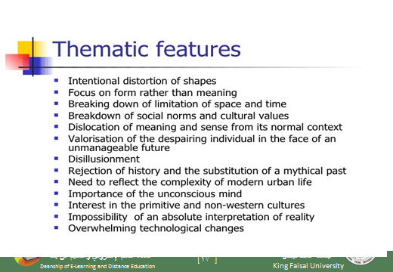
How far is Animal Farm a Modernist Novel?
In what way does it depart from old ways of expression?
In what way does it talk about things that were traditionally talked about in the fiction of the 19th century?
In what way too, like history, does it repeat certain forms of literature?
Let us see
Animal farm is a Fable:
What is a fable?
a short tale to teach a moral lesson, often with animals or inanimate objects as characters.
A story, in prose or verse, that features animals, mythical creatures, plants, inanimate objects or forces of nature which are given human qualities such as verbal communication and that illustrates or leads to an interpretation of a moral lesson (a "moral).
Example: the Wolf and the Lamb.
Another definition
a fable has animals or birds as characters
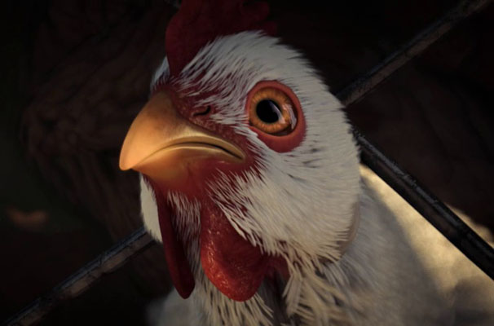
The Wolf and the Lamb
- To understand our novel as a fable, let us read “The Wolf and the Lamb” which is a nice short fable.
- Notice: this fable (The Wolf and the Lamb) is part of our course.
- It is not just a tale that we read for entertainment only.
- It will help us a lot in understanding how Animal Farm operates on many levels.
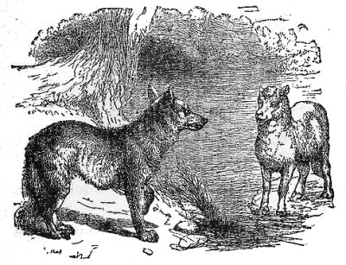
A wolf stopped to drink at a stream and spied a young lamb resting in the shade nearby. "You there!" the wolf said.
"Me, sir?" said the lamb, getting to his feet and bowing.
"Yes, you. You've been drinking in the stream, and you stirred up the mud so the water was foul when I came to drink. It would be a matter of justice if I ate you."
The lamb trembled. "Please, sir. I wasn't drinking at all. And in any case, I am downstream from you. Any mud would have gone the other way."
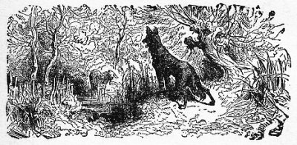

True, true," said the wolf, approaching. "But I remember you now. We met here on this very spot a year ago, and you insulted me. For such a gross insult, you owe me your life."
"Sir," said the lamb, "I am sorry that anyone gave you offense. However, I could not have been the one who insulted you last year, for I was born only four months ago."
Hm," said the wolf, who now towered over the lamb. "I see." The wolf narrowed his eyes. "But look at the destruction of this meadow. Grass once grew up to my shoulders here. But you, you greedy criminal, have cropped it down to the earth!"
"I do not wish to seem disrespectful," said the lamb, "but I could not have eaten the grass as you say. To this day, I have tasted only my mother's milk. I am innocent of every charge."
"Indeed, indeed," said the wolf. "I cannot eat you for fouling the stream, for insulting me last year, or for eating all the grass. I must say that your wit and your politeness impress me. You have met every accusation with a fine argument."
"Thank you," said the lamb.
"Nevertheless," said the wolf, "arguments, no matter how polite, tend to disturb the general peace. Therefore, it is my duty to eat you."
And he did.
So where is the connection?
- Does the story talk directly about governments?
- Does the writer seem to be in harmony with the world around him?
- Is he optimistic?
- Are there normal human beings as characters?
- Is the form of the story traditional like the novels of the 19th century?
- Has the writer been able to fully express himself through this form or has he just chosen a new form only?
What Animal Farm Talks About
Animal Farm by Geroge Orwell was first published in 1945 as a political allegory of the Russian Revolution, particularly directed at Stalin's Russia. Animal fables are an art form which have remained popular in Western literature. This novel is also an obvious allegory presenting a very nice balance between levels of meaning. One could characterize this novel as a perfect portrayal of a world where absolute power corrupts absolutely.
What is an allegory?
The rhetorical strategy of extending a metaphor through an entire narrative so that objects, persons, and actions in the text are equated with meanings that lie outside the text. One of the most famous allegories in English is John Bunyan's Pilgrim's Progress (1678), a tale of Christian salvation. Modern allegories include the films The Seventh Seal (1957) and Avatar(2009) as well as the novels Animal Farm (1945) and The Lord of the Flies (1954).
What is the difference between an allegory and a fable?
Slight difference:
A fable has to use animals for characters
An allegory may or may not use animal characters.
Question
An allegory is (exactly the same as- totally different from- somehow similar to) a fable.

Much of what happens symbolically parallels specific developments in the history of Russian communism, and several of the animal characters are based on real participants in the Russian Revolution. Due to the universal relevance of the novel's themes, the reader does not need to possess an encyclopedic knowledge of Marxist Leninism or Russian history in order to appreciate Orwell's satire of them. An acquaintance with certain facts from Russia's past, however, serves as useful in a deeper, more profound understanding of his criticism. Animal Farm most definitely resembles the Russian Revolution and the rise of Stalin, it is more meaningfully an anatomy of all political revolutions, where the revolutionary ideals of justice, equality, and fraternity shatter in the event.
what is the connection between the novel and the French Revolution?
Both deal with the mottos of the French Revolution and how far they can be applied to reality.
liberty, equality, and fraternity
Orwell paints a grim picture of the political 20th century, a time he believed marked the end of the very concept of human freedom. Every line of serious work that I have written since 1936 has been written, directly or indirectly, against totalitarianism and for democratic socialism as I understand it." -- George Orwell, "Why I Write”

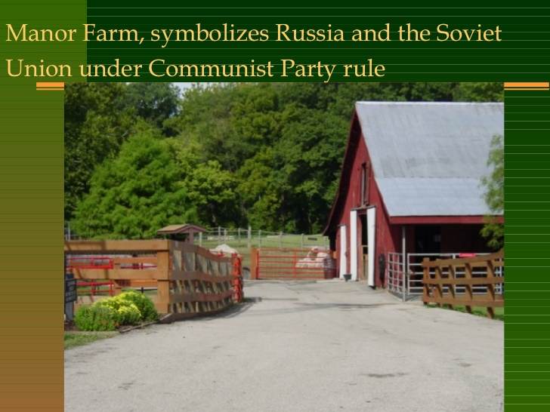

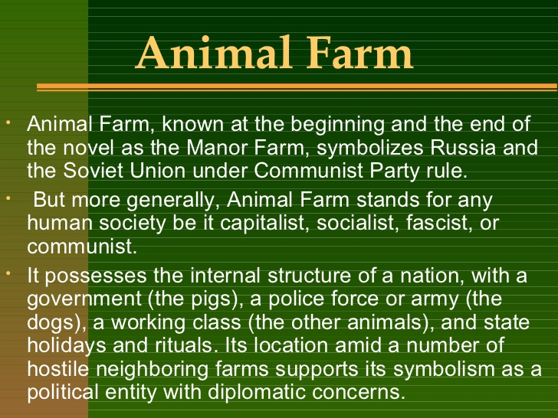

Fourth Lecture
Quick Revision
- One major feature of modernism is the dissatisfaction with the world of politics and the attempt to escape from it through invention of some forms like fables and journeys.
- This process is a revival of some older forms. So we can say: history repeats itself. Robinson Crusoe is an 18th century novel that used the trope of the journey. It is used again William Golding (Lord of the Flies) and George Orwell (Animal Farm).

Quick Revision Animal Farm is a Fable:
We talked about the fact that Animal Farm is a fable which is a short tale to teach a moral lesson, often with animals or inanimate objects as characters.
We also talked about the fable and the allegory, saying that the fable entirely uses animal characters while allegory uses both as in our novel.
To repeat, Animal Farm is an allegory that uses some of the features of the fable.

The Wolf and the Lamb
- We also studied together a story (written in the form of a fable) called The Wolf and the Lamb so we can understand our novel.
- Notice: this fable (The Wolf and the Lamb) is part of our course.
- It is not just a tale that we read for entertainment only.
- It will help us a lot in understanding how Animal Farm operates on many levels.

Some Thoughts on The Wolf and the Lamb
- How many accusations are there in The Wolf and the Lamb?
- How many replies are there in The Wolf and the Lamb?
- The wolf represents (tyrants- animals- people-policemen) in real life.
- The lamb represents (tyrants- animals- people-policemen) in real life.

- The author of “The Wolf and the Lamb” is anonymous which means:
- He is from Russia
- His name is hard to pronounce
- He is unknown
- His name is known to the police

- The story of the Wolf and the Lamb helps us to know how tyrants deal with
- Lambs
- Sheep
- Wolves
- Real people

- The story of the Wolf and the Lamb is …………..as it does not have human beingS as characters:
- a fable
- An allegory
- A novella
- A metaphor

- The story of the Wolf and the Lamb has strong connections with Animal Farm because:
- both of them use animal characters for the criticism of governments
- Both of them have sheep as characters
- Both of them are written in English
- Both of them belong to the genre of poetry

- Does the story of the Wolf and the Lamb and Animal Farm talk directly about governments?
- Yes
- No
- This is not clear from the texts
- They talk about different matters not about governments

Connections between “The Wolf and the Lamb” and Animal Farm
- Do writers of both works seem to be in harmony with the world around them? Of course not. They express their utter dissatisfaction with the world around them, and this is a feature of modernism.
- Are writers of both works optimistic? They are quite pessimistic as they regard dictatorship as the main reason behind injustice and inequality in the modern world.
Further Thoughts on the Connections between both works
- Is the form of Animal Farm traditional like the novels of the 19th century? It is innovative. It makes use once again of forms that were used at the start of the novel in a new way.
- Has the writer been able to fully express himself through this form or has he just chosen a new form only? The form has enabled him to fully express himself without colliding with political systems or regimes.

What Animal Farm Talks About
Animal Farm by George Orwell was first published in 1945 as a political allegory of the Russian Revolution, particularly directed at Stalin's Russia.
There was a dictatorial regime in Russia before the 1917 revolution. Everybody hated the Czar of Russia (represented in the novel as Mr Jones) for his oppression of Russians and for the injustice, inequality, and prejudice with which he treated his countrymen. The revolution of 1917 overthrew him. But the revolution will fail to apply the same principles that it was originally meant to uphold. In other words, the people (in the novel: the animals) who took part in the revolution against injustice and inequality will not be able to maintain all these values.
Stalin’s Russia which was in control of the country after the revolution could not achieve those noble values for a long time. This is what Orwell has been disappointed with.
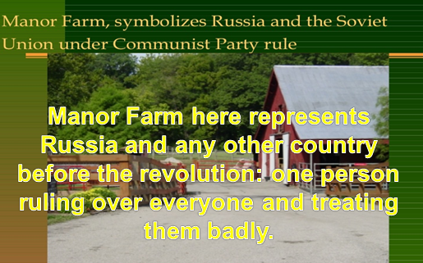
Mr. Jones, of the Manor Farm, had locked the hen-houses for the night, but was too drunk to remember to shut the pop-holes. With the ring of light from his lantern dancing from side to side, he lurched across the yard, kicked off his boots at the back door, drew himself a last glass of beer from the barrel in the scullery, and made his way up to bed, where Mrs. Jones was already snoring.
Sum up the character of Mr Jones. What does he remind you of?
As soon as the light in the bedroom went out there was a stirring and a fluttering all through the farm buildings. Word had gone round during the day that old Major, the prize Middle White boar, had had a strange dream on the previous night and wished to communicate it to the other animals. It had been agreed that they should all meet in the big barn as soon as Mr. Jones was safely out of the way. Old Major (so he was always called, though the name under which he had been exhibited was Willingdon Beauty) was so highly regarded on the farm that everyone was quite ready to lose an hour's sleep in order to hear what he had to say.

At one end of the big barn, on a sort of raised platform, Major was already ensconced on his bed of straw, under a lantern which hung from a beam. He was twelve years old and had lately grown rather stout, but he was still a majestic-looking pig, with a wise and benevolent appearance in spite of the fact that his tushes had never been cut. Before long the other animals began to arrive and make themselves comfortable after their different fashions.
Question: Old Major represents….. In real life

Fifth Lecture
Quick Revision
- We studied the relationship between the Wolf and the Lamb and Animal Farm, saying that both works are attacks against dictatorship, whether before or after the revolution. As the last line of “The Wolf and the Lamb” says,
- A Tyrant will always find an excuse
- An excuse for treating people badly
- An excuse for justifying all his or her maltreatment of people.
- Both forms have been quite effective in expressing the points of view of writers.

What is the setting of the novel?
Time (the 20th century, the modern age)
place: a farm somewhere in England. This means that we expect the writer to talk about the conditions of people in England. But of course the events of the novel talk originally about Russia.
So there is a change of setting to escape from any accusation that the writer is directly with or against a certain government.

Question
Does the novel have animal characters only? Don't we have human beings as characters?
Mr Jones is the owner of the farm.
He is described as a tyrant who takes control of the animals and does not feed them well.
What is the attitude of the animals? Do they just sit silent without resisting?
They start to notice all these forms of injustice and inequality they suffer from, but they cannot do anything to it simply because they have been used to not thinking, not protesting.
What they need is a leader to push them forward, to lead them into action.

The Novel
Remember the leaders of the French Revolution? In exactly the same circumstances, people suffered a lot until Voltaire, Rousseau, and Montesquieu came over and led them into the French Revolution against the dictatorial monarch that ruled France at that time and which brought about lots of changes in France.
Almost every piece of information that you read in the novel has a basis in reality. In the second paragraph, we read about Old Major. In reality, Old Major represents Karl Marx, the communist thinker who called for equality and fraternity and liberty.
Karl Marx offered a solution to the problems of people. According to him, the main problem was inequality X equality. Some people were richer, better, and more distinguished. The others were poorer, worse, and less distinguished. Solution: equality. There shouldn’t be any differences between classes of people in terms of power, fame, money, even appearance. Communism

What is Communism?
A school of thought, a movement that meant:
All property and wealth is owned by all members of the society.
Famous thinker: Karl Marx

Romanovs
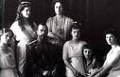
Old Russia had been ruled for 300 years by a family called the Romanovs. They were called czars (or tsars) and ruled as kings and queens.
They lived a fantastic life in their palace, surrounded by all kinds of luxuries.
The Romanovs ruled without challenge for a long time. In 1914, Russia was involved in World War I and fought Germany. Czar Nicholas, the king, went with his troops to the battles in the frozen north.

Five months into the war, Russia had lost 400,000 men. They would eventually lose 2 million.
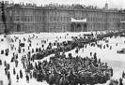

Things at home weren’t good either. It was bitter cold, and there wasn’t enough food to go around. People who were already tired of the Czar’s life of privilege began to talk of Revolution.

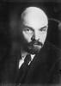
Vladmir Lenin was the man who was, in large part, responsible for leading the revolution against the Romanovs.
Vladmir Lenin and Karl Marx were the two men who sparked the Russian Revolution and originated the idea of “Communism”.
Communism is a political system where all members are supposedly equal, and all work for the good of the system. Lenin and Marx encouraged the overthrow of the Czar and his family in order to clear the way for equality for all, at least in theory.

George Orwell, a writer who was born in 1903, was intrigued by the Russian Revolution and decided to write an allegory about it. An allegory is a story where symbols or symbolic characters are used to portray real people or things.
Orwell wanted to expose what he called the “myth” of the Soviet system. He felt that because of human behavior and greed, such a system could never function.
His book, ANIMAL FARM, could not be published until 1945, after war had ceased.
“Man is the only real enemy we have. Remove Man from the scene, and the root cause of hunger and overwork is abolished for ever. Man is the only creature that consumes without producing. He does not give milk, he does not lay eggs, he is too weak to pull the plough, he cannot run fast enough to catch rabbits. Yet he is lord of all the animals. He sets them to work, he gives back to them the bare minimum that will prevent them from starving, and the rest he keeps for himself.”- George Orwell, ANIMAL FARM
Characters in ANIMAL FARM and who they represent
Mr. Jones
The owner of Manor Farm. He forces the animals to work and doesn’t take good care of them. He has a good life but doesn’t share his good fortune with the animals, and they feel mistreated.

Czar Nicholas
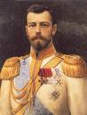
The king of Russia, from a dynasty 300 years in the making. He lived well while Russian peasants starved. Married to Alexandra, several children.

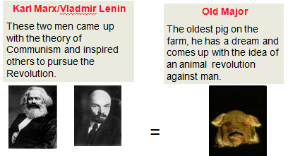

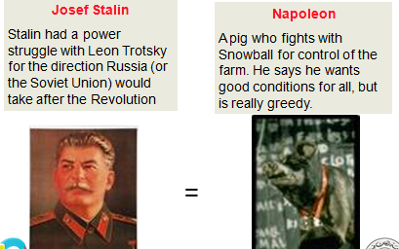

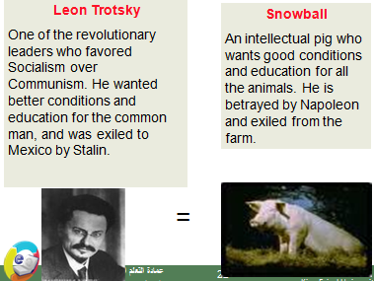
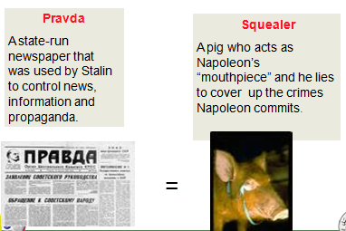

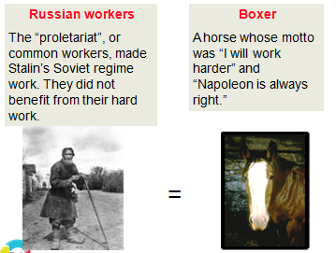
Pigs: they represent the Communist party
Dogs (puppies): they represent the KGB secret police
Moses the Raven: represents Orwell’s idea that religion is used to keep people confused
Sheep: they represent people who are blind followers and who don’t think for themselves.
Other humans: represent different countries that had dealings with the Soviet Union (Hitler’s Germany, Churchill’s England, etc.)
Czarist supporters
Some Russians remained loyal to the Czar. They are called ‘czarists’ and they had usually benefited from the Czar’s lavish lifestyle.

Mollie
A white horse who loves the ribbons and sugar the humans gave her. She misses the old days.

6th Lecture
- We studied the relationship between the novel and the real history of Russia before and after the 1917 in Russia.
- Almost all characters in the novel match real figures of the history of Russia in the first half of the century.
- We agreed that the novel attacks the failure of the revolution due to the return back to injustice and inequality and to lack of freedom.
Questions
What does Old Major represent in real life?
- Karl Marx
- Vladimir Lenin
- Napoleon
- Squealer

What does the character of Mr Jones reflect in reality?
- Karl Marx
- Vladimir Lenin
- Napoleon
- The dictatorial Czar of Russia before 1917
- When did the Russian Revolution take place?
1917- 1945- 1967- 1952
- When was Animal Farm published?
1917- 1945- 1967- 1952
What do animals need in order to start a revolution?
- A leader to lead them into action.
- More food
- More leisure time
- More drinks
The moral leader of the revolution in the novel is Old Major.
The real practical leaders are ….

- We read parts of the first chapter of the novel which sets the theme, plot and setting of the whole work.
- What is the setting of the novel?
- What are some of the major themes?
- What can you say about the plot?

Plan of our Lecture Today
- To focus on Old Major’s speech as it is a pivotal stage in the development of the novel
- To see in detail how he wins the hearts of animals and pushes them forward towards the revolution.
- To grasp the gradual development of the plot along the parallel lines drawn by the writer from the start of the novel.

- Now Old Major is about to deliver a speech.
- He represents Karl Marx who played a great (theoretical) role in the build-up to the revolution.
- Old major reflects the ability and skills of orators who do their best to touch the hearts of the audience, especially before the revolution.
- What are the techniques that he uses to affect animals?

How Old Major Touches the Hearts of Animals
- Endearing himself to them by calling them comrades every other time.
- Repetition of certain emotional phrases as when he refers to man as he, he, he alone.
- Being direct and specific as in the above example.
- Asking questions.
Give examples
- Changing the tone of his voice.
- Appealing to all classes of animals in front of him and mentioning them in name one by one.
- Using negation

How Old Major Touches the Hearts of Animals
"Now, comrades, what is the nature of this life of ours? Let us face it: our lives are miserable, laborious, and short. We are born, we are given just so much food as will keep the breath in our bodies, and those of us who are capable of it are forced to work to the last atom of our strength; and the very instant that our usefulness has come to an end we are slaughtered with hideous cruelty. No animal in England knows the meaning of happiness or leisure after he is a year old. No animal in England is free. The life of an animal is misery and slavery: that is the plain truth”.
Questions, negation, emotionality
"Man is the only creature that consumes without producing. He does not give milk, he does not lay eggs, he is too weak to pull the plough, he cannot run fast enough to catch rabbits. Yet he is lord of all the animals. He sets them to work, he gives back to them the bare minimum that will prevent them from starving, and the rest he keeps for himself. Our labour tills the soil, our dung fertilises it, and yet there is not one of us that owns more than his bare skin.
Being specific, stating his goal clearly and directly

You cows that I see before me, how many thousands of gallons of milk have you given during this last year? And what has happened to that milk which should have been breeding up sturdy calves? Every drop of it has gone down the throats of our enemies. And you hens, how many eggs have you laid in this last year, and how many of those eggs ever hatched into chickens? The rest have all gone to market to bring in money for Jones and his men.
Addressing each animal in person to show interest and affection and to raise anger against man
Being so specific: Knowing Exactly What to Say to Them
"Is it not crystal clear, then, comrades, that all the evils of this life of ours spring from the tyranny of human beings? Only get rid of Man, and the produce of our labour would be our own. Almost overnight we could become rich and free. What then must we do? Why, work night and day, body and soul, for the overthrow of the human race! That is my message to you, comrades: Rebellion! I do not know when that Rebellion will come, it might be in a week or in a hundred years, but I know, as surely as I see this straw beneath my feet, that sooner or later justice will be done.

7th Lecture

- We studied the relationship between the novel and the real history of Russia before and after the 1917 in Russia.
- Almost all characters in the novel match real figures of the history of Russia in the first half of the century.
- We agreed that the novel attacks the failure of the revolution due to the return back to injustice and inequality and to lack of freedom.
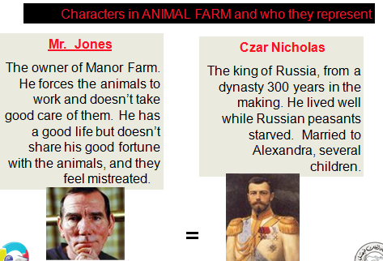

Pigs: they represent the Communist party
Dogs (puppies): they represent the KGB secret police
Moses the Raven: represents Orwell’s idea that religion is used to keep people confused
Sheep: they represent people who are blind followers and who don’t think for themselves.
Other humans: represent different countries that had dealings with the Soviet Union (Hitler’s Germany, Churchill’s England, etc.)
Czarist supporters
Some Russians remained loyal to the Czar. They are called ‘czarists’ and they had usually benefited from the Czar’s lavish lifestyle.
Mollie
A white horse who loves the ribbons and sugar the humans gave her. She misses the old days.

Old Major Again
"I have little more to say. I merely repeat, remember always your duty of enmity towards Man and all his ways. Whatever goes upon two legs is an enemy. Whatever goes upon four legs, or has wings, is a friend. And remember also that in fighting against Man, we must not come to resemble him. Even when you have conquered him, do not adopt his vices.
Repetition, clarity of thought, generalization, negation, issuing orders
No animal must ever live in a house, or sleep in a bed, or wear clothes, or drink alcohol, or smoke tobacco, or touch money, or engage in trade. All the habits of Man are evil. And, above all, no animal must ever tyrannise over his own kind. Weak or strong, clever or simple, we are all brothers. No animal must ever kill any other animal. All animals are equal.
Generalization
The Song
Beasts of England, beasts of Ireland,

Using songs
Beasts of every land and clime,
Hearken to my joyful tidings
Of the golden future time.
Soon or late the day is coming,
Tyrant Man shall be o'erthrown,
And the fruitful fields of England
Shall be trod by beasts alone.
- It is full of enthusiasm.
- It is full of melody so it can be memorized well by all animals/people even those who know nothing about culture or education
- It has a direct clear relationship with what Old Major plans for in future.
- It is stirring.
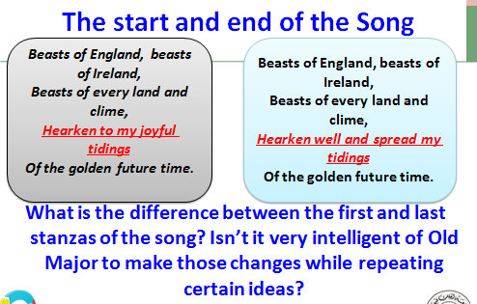

Direct Effect of the Song
The singing of this song threw the animals into the wildest excitement. Almost before Major had reached the end, they had begun singing it for themselves. Even the stupidest of them had already picked up the tune and a few of the words, and as for the clever ones, such as the pigs and dogs, they had the entire song by heart within a few minutes. And then, after a few preliminary tries, the whole farm burst out into 'Beasts of England' in tremendous unison. The cows lowed it, the dogs whined it, the sheep bleated it, the horses whinnied it, the ducks quacked it.
Direct Effect of the Speech
- To address people and touch their hearts, Old Major has been so eloquent.

Very powerful effect
- He has changed his tone
- He has repeated certain phrases for further effects
- He has addressed some animals by name
- He has used songs that are relevant to his topic
- He has asked questions
- He has used negations
- He has used endearing terms like comrades and brothers
After the song has had all this effect upon all animals, Mr Jones wakes up at the sound. What happens?
Will animals rise to action directly?
Unfortunately, the uproar awoke Mr. Jones, who sprang out of bed, making
sure that there was a fox in the yard. He seized the gun which always stood in a corner of his bedroom, and let fly a charge of number 6 shot into the darkness. The pellets buried themselves in the wall of the barn and the meeting broke up hurriedly. Everyone fled to his own sleeping-place. The birds jumped on to their perches, the animals settled down in the straw, and the whole farm was asleep in a moment.
What do you understand by this unexpected reaction?
What do you understand by this unexpected reaction?
- we understand that the writer is so realistic. This passive reaction has only been expected as animals are not used yet to expressing themselves.
- They need training and some more time and courage in order to put Old Major’s words into effect.
- In any case, there is a strong sense of verisimilitude in the novel.
Question
When Mr Jones awakes after the song,
- animals rebel directly against him
- Animals remain in their places without saying anything
- All animals are afraid and go back to their places

Remember
- verisimilitude means:
- Reality as it can be
- Not reality as it is

Eighth Lecture
Chapter Two

- This is the real beginning of the plot.
- The real complications.
- Animals are plotting against Mr Jones.
- We gather that from now on a real challenge is confronting animals.
- We have no idea about what is going to happen on the farm. A lot of suspense.
Orwell as an Artist
Orwell is a real artist:
- He has already established the form and the content of the novel in our minds in the very early chapters. He has left us with the idea of parallelism, of the existence of an ulterior meaning behind the events taking place to animals.
- We should not be fooled into believing that the story just talks about animals: another deeper meaning is there all the time.

Old Major Dies three Nights After his Famous Speech
This was early in March. During the next three months there was much secret activity. Major's speech had given to the more intelligent animals on the farm a completely new outlook on life.
They did not know when the Rebellion predicted by Major would take place, they had no reason for thinking that it would be within their own lifetime, but they saw clearly that it was their duty to prepare for it.
The work of teaching and organising the others fell naturally upon the pigs, who were generally recognised as being the cleverest of the animals.
Pre-eminent among the pigs were two young boars named Snowball and Napoleon.

Question
Old Major dies ……………….after his famous speech:
- three Nights
- Three weeks
- Three months
- Three years

What happens to animals after the death of Old Major?
- They sit silent for ever
- All of them plan a revolution
- Only the pigs plan a revolution against Mr Jones
- They die out of sadness

Why are pigs responsible for leading animals into action?
- They are the cleverest of animals
- Old Major said so before his death
- Animals told them that they are happy with their leadership
- They did so without permission of animals, using force

Verisimilitude again
Snowball and Napoleon have something in common and also something different:
They both want to be leaders of animals. They share the struggle for power which we can find in many leaders.
But while one of them is so violent and tends towards action and bloodshed, the other likes education and learning and does not support violence.
This is of course quite realistic.
- This is of course quite realistic as any two leaders of any country must be different altogether. Different and perhaps conflicting.
- Also we begin to feel that Napoleon, who will soon be the only leader of the farm, is characterized by violence and by the hatred of culture and education.
- He is the symbol of tyrants everywhere round the world.
Some of the animals talked of the duty of loyalty to Mr. Jones, whom they referred to as "Master," or made elementary remarks such as "Mr. Jones feeds us. If he were gone, we should starve to death." Others asked such questions as "Why should we care what happens after we are dead?" or "If this Rebellion is to happen anyway, what difference does it make whether we work for it or not?", and the pigs had great difficulty in making them see that this was contrary to the spirit of Animalism.
- what is realistic about that?
- In any revolution, some people are expected to have a different point of view, different loyalty. Those who benefitted by the ex-regime like Mollie and those very poor classes lacking education and suffering from poverty insist usually on being loyal to the “Master” and thus they stand in the way of the revolution.
- Quite realisitc.

The Plot (Cause and Effect)
Old Major, a prize-winning boar, gathers the animals of the Manor Farm for a meeting in the big barn.
He tells them of a dream he has had in which all animals live together with no human beings to oppress or control them.
He tells the animals that they must work toward such a paradise and teaches them a song called “Beasts of England,” in which his dream vision is lyrically described.
The animals greet Major's vision with great enthusiasm. When he dies only three nights after the meeting, three younger pigs—Snowball, Napoleon, and Squealer—formulate his main principles into a philosophy called Animalism.
Late one night, the animals manage to defeat the farmer Mr. Jones in a battle, running him off the land.
They rename the property Animal Farm and dedicate themselves to achieving Major's dream.
The cart-horse Boxer devotes himself to the cause with particular zeal, committing his great strength to the prosperity of the farm and adopting as a personal maxim the affirmation “I will work harder.”

At first, Animal Farm prospers. Snowball works at teaching the animals to read, and Napoleon takes a group of young puppies to educate them in the principles of Animalism.
When Mr. Jones reappears to take back his farm, the animals defeat him again, in what comes to be known as the Battle of the Cowshed, and take the farmer's abandoned gun as a token of their victory.
As time passes, however, Napoleon and Snowball increasingly quibble over the future of the farm, and they begin to struggle with each other for power and influence among the other animals.

Where we Stand
The story takes place on a farm somewhere in England. It is told by an all-knowing narrator in third person.
The action begins when the oldest pig on the farm, Old Major, calls all the animals to a secret meeting.
He tells them of his dream of revolution against the cruel Mr. Jones. His speech gives the animals a new outlook on life. The pigs, being considered the most intelligent, begin to instruct the other animals.
They work out the theory of Animalism, run Mr. Jones off the farm, and post seven commandments above the door of the barn. So begins the story.
The Seven Commandments
- Whatever goes upon two legs is an enemy.
- Whatever goes upon four legs, or has wings is a friend.
- No animal shall wear clothes.
- No animal shall sleep in a bed.
- No animal shall drink alcohol.
- No animal shall kill another animal.
- All animals are equal.
Stop and Think
- will animals be able to abide by those rules?
- What can help them to abide by them?
- What can lead them to divert from these golden rules?
- What is the message Orwell intends us to grasp behind all this?
The Seven Commandments
The story ends with a new version of the original slogan and one simple commandment.
New Version: Four legs good, two legs better.
THE NEW AND FINAL COMMANDMENT
“ALL ANIMALS ARE EQUAL BUT SOME ANIMALS ARE MORE EQUAL THAN OTHERS.”

NinethLecture
Where We Stand

- We have seen how animals plotted against Mr Jones and started the revolution that Old Major prophesied. 0537512461
- We have also seen how the cleverest of animals, the pigs, have easily taken control of animals thanks to their knowledge, cleverness, and eagerness for leadership. Those are necessary qualities for taking a leading role.

Where We Stand
- We also agreed that the novel is full of realism though the writer has chosen a form that looks far from realism which is the allegory whereby the story is built mainly around animals.
- Question: how has Orwell made of the novel a realistic one though it talks mainly about animals?
how has Orwell made of the novel a realistic one though it talks mainly about animals?
- By insisting on the parallel relationship between history and fiction
- By being objective
- By being ironic and challenging

The Place of Religion in Communism
The pigs' most troublesome opponent proves to be Moses, the raven, who flies about spreading tales of a place called Sugarcandy Mountain, where animals go when they die—a place of great pleasure and plenty, where sugar grows on the hedges.
Even though many of the animals despise the talkative and idle Moses, they nevertheless find great appeal in the idea of Sugarcandy Mountain.
The pigs work very hard to convince the other animals of the falsehood of Moses's teachings.
It was situated somewhere up in the sky, a little distance beyond the clouds, Moses said.
In Sugarcandy Mountain it was Sunday seven days a week, clover was in season all the year round, and lump sugar and linseed cake grew on the hedges.
The animals hated Moses because he told tales and did no work, but some of them believed in Sugarcandy Mountain, and the pigs had to argue very hard to persuade them that there was no such place.

Question
In Sugarcandy Mountain it was Sunday seven days a week:
- Animals will not have to work.
- Animals will go to the Church on Sunday.
- Animals will go to the Church everyday.
- Sugar can be found in mountains

The pigs had to argue very hard to persuade them that there was no such place.
- Pigs here means Communist leaders in Russia who hated religion
- The word pigs only refers to animals on the farm
- Pigs do not argue
- Pigs and animals liked sugar

Communism regards religion as the opium of the people. This means that it tells people sweet things about the future and asks them not to trouble themselves in this life, on the understanding that in heaven, they will be rewarded with everything they were deprived of in real life.
Moses (the raven) is the symbol of religion.
He is despised, hated by all. (Another meaning here is that Communist thinking asks people to hate religion)

What is the opium of the people according to Communists?
- Politics
- Economy
- Religion
- Money

Question
* The character of Moses in the novel is regarded as:
(hateful- lovely- neutral- happy).

Moses is seen by animals as asking them to:
- become lazy and wait for reward in the afterlife
- To become active and to forget about religion
- To support Mollie
- To attack Snowball

The Rebellion
- The Rebellion occurs much earlier than anyone expected and comes off with shocking ease.
Mr. Jones has been driven to drink after losing money in a lawsuit, and he has let his men become lazy, dishonest, and neglectful.
One day, Mr. Jones goes on a drinking binge and forgets to feed the animals.
Unable to bear their hunger, the cows break into the store shed and the animals begin to eat.
Mr. Jones and his men discover the transgression and begin to whip the cows.

- What is the direct reason for the rebellion of animals against Mr Jones?
      - Hunger and maltreatment
      - Poverty
      - Diseases
      - Old Major’s speech only

- Spurred to anger, the animals turn on the men, attack them, and easily chase them from the farm.
Astonished by their success, the animals hurry to destroy the last remaining evidence of their subservience:
chains, bits, halters, whips, and other implements stored in the farm buildings.
After obliterating all signs of Mr. Jones, the animals enjoy a double ration of corn and sing “Beasts of England” seven times through, until it is time to sleep.
The pigs reveal to the other animals that they have taught themselves how to read, and Snowball replaces the inscription “Manor Farm” on the front gate with the words “Animal Farm.”
Snowball and Napoleon, having reduced the principles of Animalism to seven key commandments, paint these commandments on the side of the big barn.
The animals go to gather the harvest, but the cows, who haven't been milked in some time, begin lowing loudly.
The pigs milk them, and the animals eye the five pails of milk desirously.
Napoleon tells them not to worry about the milk; he says that it will be “attended to.”
Snowball leads the animals to the fields to begin harvesting.
Napoleon lags behind, and when the animals return that evening, the milk has disappeared.
- We have seen how pigs educated themselves immediately after the speech of Old major.
- Now there is a huge difference between them and the other animals: they have knowledge. Knowledge means power.
- They have also promised to deal with milk in a different way, but it turns out that they use it for their own benefit, as in the past when Mr Jones used it for his own benefit.
The pigs steal all the fresh milk from the cows. The less intelligent animals don’t seem to notice.
- These are the seeds of failure for the revolution.

Mollie
They were coming down the stairs when Mollie was discovered to be missing.
Going back, the others found that she had remained behind in the best bedroom. She had taken a piece of blue ribbon from Mrs. Jones's dressing-table, and was holding it against her shoulder and admiring herself in the glass in a very foolish manner.
The others reproached her sharply, and they went outside.
What does Mollie represent?
- People who still favour the old regime after the rebellion
- Women
- Animals
- Leaders

"What is going to happen to all that milk?" said someone. "Jones used sometimes to mix some of it in our mash," said one of the hens. "Never mind the milk, comrades!" cried Napoleon, placing himself in front of the buckets. "That will be attended to.
The harvest is more important. Comrade Snowball will lead the way.
I shall follow in a few minutes. Forward, comrades! The hay is waiting.“ So the animals trooped down to the hayfield to begin the harvest, and when they came back in the evening it was noticed that the milk had disappeared.

TenthLecture
Chapter Three

All through that summer the work of the farm went like clockwork. The animals were happy as they had never conceived it possible to be. Every mouthful of food was an acute positive pleasure, now that it was truly their own food, produced by themselves and for themselves, not doled out to them by a grudging master. With the worthless parasitical human beings gone, there was more for everyone to eat.
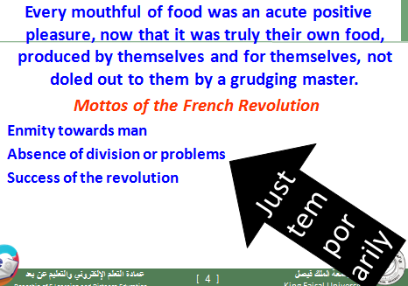

Chapter Three
- The harvest is a great success. It is finished two days earlier than Jones and his men used to manage. The animals are so enthusiastic and excited about the fact that the food is truly their own, that no food is stolen during the harvesting.
- They enjoy a certain kind of freedom and equality.
- But this does not last for a long time. Problems among them start to emerge.
- As we said before, some animals (pigs) begin to take advantage of the resources of the farm just like Mr Jones/ the Czar used to do earlier. Also there are some animals who do not fully support the revolution or those who still prefer the old regime.

Question
Why is the revolution among animals doomed to failure?
- Because it has been crushed by the government
- Because animals hate it
- Because animals get hungry
- Because some animals betray the spirit of the revolution
Almost all the animals have worked as hard as they possibly could, but there are some exceptions.
Mollie, the vain mare, often leaves the fields early complaining about a stone in her hoof, and the cat seems to appear only for meals.
Boxer, it turns out, is a huge asset. He’s big, and not particularly smart, but he works harder than everyone else. In fact, to emphasize this point, he walks around all day repeating, "I will work harder" over and over.
He represents the majority of people everywhere in all ages.

Mollie (the mare, remember?) is extraordinarily lazy. She also has this odd tendency for ribbons. She is easily attracted to anyone who will give her comfort and luxury, sugar and ribbons.
Benjamin is this really cool vague donkey. He has this one interesting line. When asked his opinion on the Rebellion, Benjamin says, "Donkeys live a long time. None of you has ever seen a dead donkey.“
He is desperate.

There are people like that in real life
He is indifferent.

Snowball establishes a number of committees with various goals, such as cleaning the cows' tails and re-educating the rats and rabbits. Most of these committees fail to accomplish their aims, but the classes designed to teach all of the farm animals how to read and write meet with some success. By the end of the summer, all of the animals achieve some degree of literacy. The pigs become fluent in reading and writing, while some of the dogs are able to learn to read the Seven Commandments. Muriel the goat can read scraps of newspaper, while Clover knows the alphabet but cannot string the letters together.

Poor Boxer never gets beyond the letter D. When it becomes apparent that many of the animals are unable to memorize the Seven Commandments, Snowball reduces the principles to one essential maxim, which he says contains the heart of Animalism: “Four legs good, two legs bad.” The birds take offense until Snowball hastily explains that wings count as legs. The other animals accept the maxim without argument, and the sheep begin to chant it at random times, mindlessly, as if it were a song.
Napoleon takes no interest in Snowball's committees. When the dogs Jessie and Bluebell each give birth to puppies, he takes the puppies into his own care, saying that the training of the young should take priority over adult education. He raises the puppies in a loft above the harness room, out of sight of the rest of Animal Farm. Around this time, the animals discover, to their outrage, that the pigs have been taking all of the milk and apples for themselves.
Squealer explains to them that pigs need milk and apples in order to think well, and since the pigs' work is brain work, it is in everyone's best interest for the pigs to eat the apples and drink the milk. Should the pigs' brains fail because of a lack of apples and milk, Squealer hints, Mr. Jones might come back to take over the farm. This prospect frightens the other animals, and they agree to forgo milk and apples in the interest of the collective good.

The pigs did not actually work, but directed and supervised the others. With their superior knowledge it was natural that they should assume the leadership.

Squealer explains to them that pigs need milk and apples in order to think well, and since the pigs' work is brain work, it is in everyone's best interest for the pigs to eat the apples and drink the milk. Pigs do not like milk or apples. They lie.
Squealer functions as the mouthpiece of the ruling party.
Should the pigs' brains fail because of a lack of apples and milk, Squealer hints, Mr. Jones might come back to take over the farm. Using the technique of horror and threats.

Animals discover, to their outrage, that the pigs have been taking all of the milk and apples for themselves. But they cannot do anything because they cannot imagine that pigs have betrayed them. They are too kind to suspect their fellow brothers.
Napoleon takes the puppies into his own care. He starts arming himself and preparing for the future when he will take all the power to himself.
Napoleon takes no interest in Snowball's committees. These committees are meant to educate the masses, the ordinary animals. As a tyrant, Napoleon is not pleased by this. He prefers animals to be ignorant so he can easily lead them.
Boxer was the admiration of everybody. He had been a hard worker even in Jones's time, but now he seemed more like three horses than one; there were days when the entire work of the farm seemed to rest on his mighty shoulders. From morning to night he was pushing and pulling, always at the spot where the work was hardest. began. His answer to every problem, every setback, was "I will work harder!"--which he had adopted as his personal motto.

Question
Who said: "I will work harder!"--?
- Boxer
- Benjamin
- Mollie
- Old Major
- Napoleon

Old Benjamin, the donkey, seemed quite unchanged since the Rebellion. He did his work in the same slow obstinate way as he had done it in Jones's time, never shirking and never volunteering for extra work either. About the Rebellion and its results he would express no opinion. When asked whether he was not happier now that Jones was gone, he would say only "Donkeys live a long time. None of you has ever seen a dead donkey," and the others had to be content with this cryptic answer.

who seemed quite unchanged since the Rebellion?
- Benjamin
- Mollie
- Old Major
- Napoleon

Eleventh Lecture
Chapter Four

Every day Snowball and Napoleon sent out flights of pigeons whose instructions were to mingle with the animals on neighbouring farms, tell them the story of the Rebellion, and teach them the tune of 'Beasts of England'.
who was interested in exporting the revolution to other nations?
A- all animals
B- Boxer and Clover
C- Snowball and Napoleon

Chapter Four
Snowball and Napoleon are sending pigeons (symobl of peace) to neighbouring farms and beyond, to tell the animals about the rebellion. News of the rebellion has spread to the surrounding countries.
The farmers at first pretend not to be troubled about the rebellion, believing that the animals cannot possibly make a success of the farm. But as time passes the farmers become more and more troubled, and their animals become more and more emboldened.
The tune of Beasts of England is now known by nearly every animal in the county.
Nevertheless, they were both thoroughly frightened by the rebellion on Animal Farm, and very anxious to prevent their own animals from learning too much about it.
At first they pretended to laugh to scorn the idea of animals managing a farm for themselves. The whole thing would be over in a fortnight, they said.
They put it about that the animals on the Manor Farm (they insisted on calling it the Manor Farm; they would not tolerate the name "Animal Farm") were perpetually fighting among themselves and were also rapidly starving to death.
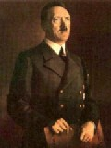
Mr. Pilkington - Owner of Foxwood (Leader of England). He doesn't represent one person in particular, but rather is a composite of all of the leaders of England.
Mr. Frederick - Owner of Pinchfield (Leader of Germany). Frederick is a composite of the leaders of Germany. However, throughout most of the book, Frederick is a representation of Hitler.

Question
Foxwood and Pinchfield are the two farms affected by the revolution on Animal Farm.
Foxwood stands for
(England- Germany- Russia)
Pinchfield stands for
(England- Germany- Russia)

How do leaders of neighbouring farms first deal with the Revolution on Animal Farm?
- They pretend to laugh to scorn the idea of animals managing a farm for themselves
- They begin fighting those animals at once
- They do nothing
- We have no idea from the novel.

- The same thing happened in Russia. Leaders of the Revolution sent messengers to some European countries to motivate people there towards revolutions.
- This of course troubled the governments of those countries a lot.
- Communism spread all over the world in this way. It reached George Orwell’s England in this manner.
- It was not a welcome movement at first, and that is why Orwell could not publish Animal Farm until 1945.

- Have all animals agreed to exporting the revolution to other countries?
- No
- Only pigs decided that. They have never consulted with animals on this issue.
- They wanted to achieve glory for themselves only.
- Again this is a sign that the revolution will not last long.

The farmers try to spread lies about torture and slavery on Animal Farm, but the animals of the county do not believe them.
They whistle the tune and sing the words of Beasts of England, though they risk terrible beatings by doing so.
More and more stories are heard of individual animals disobeying and in some cases attacking their human masters.

The word farmers here means:
- Neighboring governments
- Real farmers everywhere
- Farmers who worked on Animal Farm
- Farmers in Africa

One day in October, Jones, all his men, and half a dozen others from the neighbouring farms, attack Animal Farm.
They walk up the laneway through the main gate. They are all armed with sticks except for Jones, who carries a gun.
The animals, however, are well prepared. After an initial skirmish where the pigeons and geese attack the humans, Snowball attacks them, supported by Benjamin, Muriel and all the sheep.
The men repulse this attack with their sticks, and Snowball sounds the retreat.
They fall back to the farmyard, pursued by the men, who think that they have triumphed. However, they have walked into a trap.
As soon as the men are in the farmyard, a number of the larger animals emerge from the shed behind them, and cut off their retreat.
Snowball’s group now attacks again. Snowball charges at Jones.
Jones fires a shot at Snowball and wounds him, but this is not enough to prevent Snowball from crashing into him and sending him tumbling to the ground, the gun flying out of his hand in the process, Now Boxer joins the attack, rearing up on his hind legs and striking viciously with his hoofed forelegs.
Boxer strikes one of the men on the skull, apparently killing him.
At the sight of this, the other men run for their lives, back down the laneway and out the gate. The invasion is over.

There was not an animal on the farm that did not take vengeance on them after his own fashion. (but where is Napoleon?)

In the post-battle excitement, Boxer is extremely remorseful for killing the man, while the animals suddenly realise that Mollie is missing.
They search the farm, and find her hiding in a corner. She fled the battle as soon as the gun went off.
They return to the farmyard to find that the man was only stunned, and has since recovered and escaped.
The animals celebrate their victory. The flag is raised, Beasts of England is sung. A medal for “Animal Hero, First Class” is created and awarded to Snowball.
A medal for “Animal Hero, Second Class” is created, and awarded to a sheep that died when Jones fired his gun.
They decide to keep the gun and place it at the bottom of the flagstaff, to be fired each year on the anniversaries of the rebellion, and of the battle.
"He is dead," said Boxer sorrowfully. "I had no intention of doing that.
I forgot that I was wearing iron shoes. Who will believe that I did not do this on purpose?"
"No sentimentality, comrade!" cried Snowball from whose wounds the blood was still dripping. "War is war. The only good human being is a dead one.“
See the differences between pigs and other animals?

- Pigs like to boast about their own achievement as in Snowball rewarding himself with a medal “Animal Hero, First Class” and giving the sheep a lesser one: “Animal Hero, Second Class”.
- Most pigs have not participated in the battle. They only lead towards it and it is only normal animals who fight.
- Boxer is so kind. He does not bear the sight of blood or the idea that he might have killed somebody.
- Pigs on the other hand have no problem at all in shedding blood.
- Mollie as expected escapes such important scenes. Like real aristocratic people in Russia, she cares only for her comfort and pleasures.

There was much discussion as to what the battle should be called. In the end, it was named the Battle of the Cowshed, since that was where the ambush had been sprung.
Mr. Jones's gun had been found lying in the mud, and it was known that there was a supply of cartridges in the farmhouse.
It was decided to set the gun up at the foot of the Flagstaff, like a piece of artillery, and to fire it twice a year--once on October the twelfth, the anniversary of the Battle of the Cowshed, and once on Midsummer Day, the anniversary of the Rebellion.

Question
What is the name of the battle between animals and neighbouring farms?
- Manor farm battle
- Animal farm battle
- The Battle of the Cowshed
- The Battle of Germany

TwelfthLecture
Chapter Five

The divisions between Snowball and Napoleon are becoming more pronounced, and it seems that they now oppose each other on every proposal. Snowball’s eloquence allows him to control the meetings. However, Napoleon works quietly behind the scenes building support, and succeeding in getting all of the sheep onto his side.
Napoleon uses the machinations of dictators: investigating, plotting, and organizing.
Snowball is forever proposing new plans and schemes for the improvement of the farm, all of which are opposed by Napoleon. Snowball’s most ambitious plan is for the construction of a windmill, which he says can provide heat and electricity to the farm.
It can also help animals to work less and to have some days off. He accepts that it will be a huge undertaking, and is vague about some of the details.
Most animals are interested in his plans except of course Napoleon.
Napoleon is completely against the idea, and makes his opposition clear. Snowball continues to work on his plans, and spends hours every day in a shed working on them, drawing them out on the wooden floor.
All of the animals visit Snowball regularly in the shed to watch the plans grow into something that looks very complex and impressive. Only Napoleon holds back, and when he does come to inspect the plans, he urinates on them. It is clear he hates any achievement that makes Snowball popular among animals.
How does Napoleon express his objection to Snowball especially the windmill?
- Always being absent from the meetings about the windmill held by Snowball
- Saying clearly that feeding animals is better than any other project
- Saying directly that the windmill is a failure
- Using the sheep to make a rough sound as Snowball speaks
- Urinating on the project
- Finally chasing Snowball out of the farm
- Using the small dogs he has been raising to fight Snowball
- Finally he decides to build the windmill himself saying that he is the one who planned it at first.
"Mollie," she said, "I have something very serious to say to you. This morning I saw you looking over the hedge that divides Animal Farm from Foxwood.
One of Mr. Pilkington's men was standing on the other side of the hedge. And--I was a long way away, but I am almost certain I saw this—he was talking to you and you were allowing him to stroke your nose.
What does that mean, Mollie?“ "He didn't! I wasn't! It isn't true!" cried Mollie, beginning to prance about and paw the ground.
Orwell says that supporters of the old regime do not mind working against the revolution like Mollie who never cares about the farm, only about her own interests.
All of them came to look at Snowball's drawings at least once a day. Even the hens and ducks came, and were at pains not to tread on the chalk marks. Only Napoleon held aloof.
He had declared himself against the windmill from the start. One day, however, he arrived unexpectedly to examine the plans.
He walked heavily round the shed, looked closely at every detail of the plans and snuffed at them once or twice, then stood for a little while contemplating them out of the corner of his eye; then suddenly he lifted his leg, urinated over the plans, and walked out without uttering a word.
The narrative voice should be detached and neutral-objective like the narrative voice in Animal Farm. The writer should not side with one party against the other.
He should not be:
Overseeing, directing, controlling, mastering, guiding, motivating, encouraging, changing, revolutionizing, pushing, Using, exploiting. Leading
Among the following animals some will be flat and some will be round characters. Which is which?
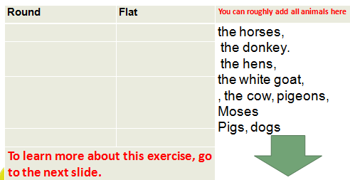
Among the following animals some will be flat and some will be round characters.
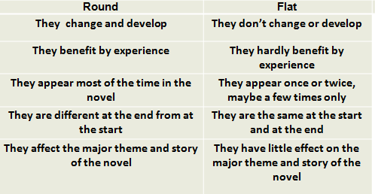
Napoleon addresses them. He tells them that Sunday Meetings are henceforth abolished, and that all decisions in future will be taken solely by the pigs. Any dissent is silenced by growls from the dogs, and the meeting finishes to a fifteen-minute chorus of “Four legs good, two legs bad” from the sheep.
Squealer follows up in the aftermath, explaining to the shocked animals of the farm that Napoleon has taken on the leadership with great reluctance and with great sacrifice to himself. The animals are soon won over when they are reminded of what life was like under Jones.
Three weeks after this fateful meeting, Napoleon announces that the Windmill will now be built. The animals are warned that this will mean lots of extra hard work, and a reduction in their rations.
Squealer explains the apparent change of heart by convincing the animals that Napoleon had been in favour of the windmill all along, but had to appear to be against it in order to get rid of Snowball. The animals are easily persuaded. Something is rotten in the state of the Animal Farm.

Chapter Six
Another year passes. The animals work themselves to the bone on the harvest and on the windmill, all under the supervision of the pigs. The animals are asked to work on Sunday afternoons as well, on a voluntary basis, though any animal that did not work on Sunday had their rations halved. By autumn time, it is clear that the harvest is a poorer one than the previous year. This will make the coming winter all the more difficult.
As you can notice now, things are getting worse and worse on Animal Farm.
However, animals are so kind-hearted and forgetful. They do not have the ability, either, to grasp the wickedness of the pigs.

Progress on the windmill is laborious and slow. The stones with which it is to be built have to be hauled to the top of the quarry and thrown from there to the bottom, so that the stones can be broken into the appropriate sizes. It takes until the end of the summer to accumulate enough stone to begin building the windmill, work which depends almost entirely on the tremendous efforts of Boxer, who works himself harder than ever before.

As the work on the harvest and the windmill proceeds, the animals find themselves running out of supplies. Items such as paraffin, seeds, manure and machinery could not be produced on the farm.
This problem is resolved when Napoleon announces one day that Animal Farm will henceforth enter into trading arrangements with some of the surrounding farms. Hay and wheat from the farm will be sold, and the hens are told that they will have to give up some of their eggs, a sacrifice that they should be proud to make.

Some of the animals are doubtful about this move, seeming to remember an agreement in the early days after the rebellion never to have anything to do with humans.
Again, Squealer puts any doubts to rest in the following days, informing them that such a resolution was never written down.
From then on, Napoleon engages a local solicitor to act as the middleman between Animal Farm and the outside world. The solicitor comes every Monday, and his presence makes the other animals very uneasy, but their doubts are eased by their pride in seeing Napoleon give orders to a human.
Squealer questions the memory of animals, another strategy.

Shortly afterwards, the pigs move into the farmhouse. They eat in the kitchen, relax in the drawing room, and even sleep in the beds. Some of the animals are very doubtful about this. Clover consults the seven commandments on the gable wall, and asks Muriel to read out the fourth commandment, which states, “No animal shall sleep in a bed with sheets.
” Muriel cannot remember sheets being mentioned before.
However, helped by the smooth words of Squealer, she assumes that she must have been wrong, She and the other animals accept his argument that the pigs, as the leaders, must have as much comfort as possible to facilitate their brainwork.

The work on the windmill continues. The animals are all extremely proud of their progress so far, except for Benjamin, who expresses no opinion for or against the windmill. By November, the windmill is half finished. However, disaster strikes when a nighttime storm destroys it.
The animals all gather around the ruin. Napoleon is silent for a long time, before making the sudden and dramatic announcement that the windmill was destroyed by Snowball. Some pig footprints leading away from the farm are discovered, and Napoleon confirms them to belong to Snowball. The other animals are shocked that their former leader could do such a thing.
Napoleon announces that work on rebuilding the windmill will commence immediately.

Chapter 6 in Brief
The animals work "like slaves." Heavy irony ensues.
Napoleon starts engaging in trade with the neighboring farms. "Wait a minute," you might say, "I thought there was a rule against trade!" Yeah. That’s what the animals thought, too. Talk to Squealer. They also move into the farmhouse. Talk to Squealer again.
Snowball becomes the scapegoat, which is particularly convenient when the windmill blows down in a gale.
Little by little, pigs become absolute leaders of the farm.
- They act as dictators.
- They order, ask, and silence the other animals.
- Animals start to notice that pigs have distinguished themselves but can do nothing as they do not have knowledge or power.
- The revolution will soon come to an end.
- Please always refer to the Seven Commandments.

1. Whatever goes on two legs is an enemy.
2. Whatever goes on four legs, or has wings, is a friend.
3. No animal shall wear clothes.
4. No animal shall sleep in a bed.
5. No animal shall drink alcohol.
6. No animal shall kill any other animal.
7. All animals are equal.

Thirteenth Lecture
The Seven Commandments

- Whatever goes on two legs is an enemy.
2. Whatever goes on four legs, or has wings, is a friend.
3. No animal shall wear clothes.
4. No animal shall sleep in a bed.
5. No animal shall drink alcohol.
6. No animal shall kill any other animal.
7. All animals are equal.

How the Seven Commandments are Broken
Almost immediately after the Commandments are written the cows have to be milked.
The milk they produce is taken by the pigs exclusively so the seventh Commandment seems to be undermined from the very beginning.
When the pigs also start claiming the windfall apples, Squealer explains that they are not taking them as privilege but because science has shown that milk and apples are necessary for the pigs' "brain work".
This at least satisfies the animals that they are equal to the pigs but it does not fool the reader.

The first two Commandments are subtly broken in the first years of Animal Farm but there is no attempt to rewrite them.
Snowball, the hero of the Battle of the Cowshed, becomes an enemy of the farm after his expulsion by Napoleon, while the resumption of trade via Mr Whymper causes some discussion but, as Squealer points out, trade was not banned in writing and Mr Whymper is not treated as a friend.
The first alteration to the Commandments comes after the pigs move back into the farmhouse.
The ban on sleeping in beds is changed in Napoleon's favour by the addition of the words "with sheets".
At this point in the history of the farm the pigs do not quite have enough power to do what they like and Squealer is forced to change the Commandments to fit new circumstances. But sleeping in beds is a minor matter compared to murder, and the next alteration to the Commandments is far more shocking.
After the failures of the winter and the collapse of the first windmill, the pigs use Snowball as scapegoat. This leads to the 'show trials' in which animals 'confess' to crimes inspired by Snowball.
The horrific executions that follow are in direct contradiction of the original sixth Commandment but when this is checked the words "without cause" have been added.
Napoleon's selfish behaviour is the cause of the alteration to the fifth Commandment. When he and the other pigs get drunk, Napoleon's hangover is a cause for alarm but all that eventually happens is that the words "to excess" are added to the Commandment.
It is at this point that Squealer's part in the changes to the Commandments is revealed to the reader as he falls off the ladder he was using to reach the barn wall.
After this incident, more and more of the farm's resources are diverted to the provision of alcohol for the pigs. The sale of Boxer's body to the knackers results in the delivery of a crate of fine food and alcohol.
No minor alteration is ever made to the third Commandment about wearing clothes.
This is because by the time the pigs adopt clothes they are so powerful, and the other animals are so fearful, that it is unnecessary.
Instead, all pretence of "unalterable laws" is abandoned and the Commandments are replaced by the meaningless slogan:
"All animals are equal, but some animals are more equal than others."

Orwell's use of the Seven Commandments provides a kind of checklist of betrayal.
The original Commandments express the ideals of animalism and the hopes for a new life by the animals on the farm.
It is significant that the betrayal of these ideals begins almost immediately, as this is an important part of Orwell's message about revolutions - that all power corrupts.
The Commandments make it easy for the reader to trace the progress of Napoleon and the other pigs' corruption and, as each one is broken, the original ideals are brought to mind.
Relationship between them and the plot
The Seven Commandments are a successful way of tracing the decline of the rebellion because they show how the pigs alter the rules on the farm to suit themselves.
The other animals trust in writing and it is the pigs' control of writing that gives them a great deal of their power.
The alterations to the Commandments are sometimes funny, like the one about alcohol, and sometimes shocking, like the one about killing. In the end, the slogan "All animals are equal" sums up the sad decline of the fortunes of the idealistic animals of the farm.

Chapter Seven
Since the collapse of the windmill, the animals are starving. But they try to convince the outside world otherwise. Again, public relations and image control.
The hens are told their eggs will be taken. They rebel, but are starved as a consequence (via control of the teeth-baring dogs) and nine die. Again, heavy irony ensues.
More scapegoating at Snowball’s expense. Boxer seems, amazingly, to remember history the way that it occurred, but Squealer quickly convinces him otherwise.
At a meeting, several animals confess (while in the presence of the teeth-baring dogs) to having been in league with Snowball, or with Jones, or both. They are subsequently killed upon Napoleon’s orders.
Due to Boxer’s doubt regarding the new and rewritten history, Napoleon tries to have him killed by the dogs. However, when Boxer’s brute strength becomes apparent, Napoleon seems to change his mind.
There’s a lot of subtlety here – none of the animals, and especially not Boxer, think for a moment that there was an attempt on Boxer’s life.
On the surface, it simply appears as though the dogs went rogue and attacked him.
There’s this great, contemplative moment when Clover looks over the farm and thinks to herself that these scenes of bloody terror are certainly not what the animals have worked so hard for. Such emotion, such poignancy – read your book.
The song which we have all come to know and love ("Beasts of England") is abolished.

Chapter Eight
After the executions, Clover is again uneasy that one of the seven commandments has been broken. She asks Muriel to read her the sixth commandment again from the gable wall.
The commandment reads, “No animal shall kill another animal without cause.” Clover did not seem to remember having read the last two words before, but she thought no more of it.
The animals spend the following year working harder than ever. Squealer exhorts them to greater efforts, telling them that productivity on the farm has improved enormously since the rebellion, though many of the animals secretly feel hungry.
Napoleon, who is now known as “Our Leader, Comrade Napoleon,” and several other flattering titles, is seen in public rarely, and now employs a cockerel as a herald, as well as being accompanied at all times by his dogs.
Relations between the neighbouring farms, Frederick of Pinchfield and Pilkington of Foxwood, remain complex. Napoleon, through the middleman, has been trying to sell off a pile of timber to one of the other neighbours.
At this time, rumours abound that Frederick is about to attack the farm. A plot to murder Napoleon is uncovered.
Three hens confess that Snowball, said to be living on Pinchfield, put them up to it. The hens are executed.
Napoleon announces shortly afterwards that the wood is to be sold to Pilkington of Foxwood.
When, later in the year, the wheat crop is found to be full of weeds, Snowball, and by implication Frederick, are blamed.
The whole farm seethes with anger and resentment against Frederick, who is now the sworn enemy of Animal farm.
The windmill is completed by autumn. The animals forget their worries temporarily to celebrate this magnificent achievement.
The animals are all congratulated by Napoleon. Two days later, he calls them to a meeting and announces that the wood is to be sold to Frederick.
The animals are astonished, but Squealer easily explains this away as part of Napoleon’s strategy, to appear friendly with one neighbour while secretly courting the other.
The sale goes ahead, and the solicitor organises the transport of the wood off the farm, and the delivery of the banknotes to Napoleon.
Three days later, the notes are discovered to be forgeries. Napoleon assembles the animals again and pronounces the death sentence on Frederick.
At the same time, he warns them that Frederick and his men may be about to attack the farm.
The attack comes the next morning. Fifteen men, six with guns, approach the farm, and the battle is joined.

Messengers are sent to Foxwood requesting assistance, but Pilkington sends back a curt rejection.
The animals are driven back to the farm buildings. While they are trapped there, the men plant dynamite around the windmill.
In the ensuing explosion, the windmill is obliterated. The animals react to this by forgetting all about the guns and charging headlong at the men, who after a brief struggle, run for their lives.

The animals are dejected at the loss of the windmill, but the pigs quickly set about the task of rebuilding morale by reminding them of the magnificent victory they have won.

The day will be forever commemorated as the Battle of the Windmill. In the ensuing celebrations, the forged banknotes are forgotten.
The pigs then discover a cask of whisky in the farmhouse. That night, loud celebrations are heard in the farmhouse, to the amazement of the other animals.
Soon afterwards, it is announced that a small field near the orchard, originally set aside for retired animals who could work no more, was to be ploughed up and sown with barley.
Muriel is troubled by this development, and she consults the fifth commandment.
Again, she realises she has remembered it incorrectly, for it says, “No animal shall drink alcohol to excess.”
Napoleon gets a new name, as "Napoleon" is not majestic enough.
Now it is "Our Leader, Comrade Napoleon." He’s also becoming a total snob about the amount and consistency of the foam on his cappuccinos.

Fourteenth Lecture
Ninth Chapter

Ninth Chapter
Rebuilding of the windmill begins immediately after the celebrations. Boxer works harder than ever, despite carrying an injury from the battle. His thoughts are now turning to retirement, for which, under the laws of Animal farm, he is due the next year.
In the meantime, another cold winter with little food must be endured. Squealer bamboozles the animals with productivity figures which prove how much better off they are than when they were under Jones, although many have by now forgotten life under Jones.
The strain of the resources of the farms grows, not least due to the birth of thirty-one piglets the previous autumn.

Napoleon declares that a new schoolroom must be built for the piglets, who are instructed to remain aloof from the other animals.
The schoolroom is in addition to the requirement to rebuild the windmill and the need to keep the farm supplied with various other requirements. Potatoes are sold, and practically every egg laid by the hens is sold to earn the money required for these supplies.
All the while, the animals’ rations are being reduced, while the pigs make beer from the barley they sowed earlier in the year.
Napoleon declares that a new schoolroom must be built for the piglets, who are instructed to remain aloof from the other animals.
The schoolroom is in addition to the requirement to rebuild the windmill and the need to keep the farm supplied with various other requirements.
Potatoes are sold, and practically every egg laid by the hens is sold to earn the money required for these supplies.
All the while, the animals’ rations are being reduced, while the pigs make beer from the barley they sowed earlier in the year.
Napoleon now introduces a weekly event called the Spontaneous Demonstration, where every animal would leave their work to march in military procession around the farm, so as to instil pride in the animals in the achievements of the farm since the rebellion.
It comforts the animals to know that, no matter how hard their lives, at least they have the benefit of being their own masters.
Another consolation around this time is the reappearance of Moses and his tales of SugarCandy Mountain.
Many of the animals like to believe that they will go to a better place after their deaths, and the pigs now seem to tolerate Moses, giving him an allowance of beer every day.
The building work around the farm continues through the summer, heavily dependent on the extraordinary efforts of Boxer.
He is showing some signs at this stage that his strength is failing.
He himself is hoping to get as much done as he possibly can before he retires. Then, one summer evening, he collapses.
All the animals rush to his side, unable to bear the thought that anything might happen to him. He barely has the strength to get back to his feet and to struggle back to his stall.
Squealer promises to send him to the town so that the veterinary surgeon can treat him. Clover and Benjamin spend as much time as they can over the next few days nursing him.
Then, while the animals are all at work, the van comes to take Boxer away. They would not have noticed, except that Benjamin gallops across the farm to tell them that Boxer is being taken away. No one has ever seen Benjamin gallop before.
The animals rush to the yard in time to see the van begin to pull away. They start to wave goodbye to Boxer, but Benjamin is very agitated, and tells them to read the letters on the van.
Muriel reads out the sign on the van, which describes the van as belonging to the local horse-slaughterer.
The animals try to warn Boxer, who tries to kick his way out of the van, but he has no strength, and the kicking from the van soon dies away.
Three days later, Squealer announces that Boxer died in the hospital. He makes a moving speech in praise of Boxer.
He explains the sign on the van by saying that the veterinary surgeon bought the van from the horse-slaughterer, and had not yet replaced the sign.
The animals are very relieved to hear this, and are greatly consoled by Squealer’s further descriptions of the wonderful care and treatment that Boxer received in his final hours.
Napoleon pays his respects to Boxer at the meeting on the following Sunday. He tells them that it was not possible to return Boxer’s remains for burial on the farm, but that he will be commemorated with a wreath instead.
Napoleon announces a memorial banquet for Boxer, which takes place in the farmhouse shortly afterwards, attended only by the pigs.

Tenth Chapter
Years have passed, and many of the animals are dead. Only Clover, Benjamin, Moses and some of the pigs remember the days before the rebellion. Clover is by now very old, well past retirement age, except that no animal has actually managed to retire yet.
The windmill has finally been completed. It is used for milling corn, rather than for generating electricity, and brings a good profit to the farm.
Another windmill is now being built to generate electricity. There is no more talk of the three-day week, or any of the other luxuries that Snowball originally promised would accrue from the windmill.
The farm is growing richer, but the animals themselves do not seem to benefit much from it. There are many pigs and dogs on the farm now.
The pigs are all involved in the bureaucracy of running the farm, and are not available to do any actual work, though Squealer makes it clear to the others that what the pigs do is of vital importance to the farm.
Squealer continues to impress everyone with detailed figures of how everything has improved on the farm, but deep down the animals are unable to reconcile this with the lack of improvement in their own conditions.
Nonetheless, Animal Farm remains the only farm in England to be owned by the animals, and the animals remain enormously proud of this.
Summer arrives. Squealer is seen to take all the sheep of the farm aside, and no-one sees them for a week. The sheep eventually return.
That evening, as the animals are returning to the yard from work, Clover is heard neighing excitedly from the yard.
The animals rush forward to see what is happening. They stop dead when they all see what has startled Clover. It is the sight of Squealer walking upright, on his hind legs.
At this moment, all of the pigs leave the farmhouse in single file, all upright on two legs.
Finally, Napoleon emerges from the farmhouse, upright and carrying a whip.
It is the most shocking thing the animals have ever seen. It goes against everything that they have been taught up. Just as it seems that someone might object, the sheep break into a deafening chorus of “Four legs good, two legs better.”
They went on for five minutes, during which the pigs walked briefly around and then returned to the farmhouse.
The chance to protest is gone. Clover goes to the gable wall and brings Benjamin with her.
She asks Benjamin to read for her what is on the gable wall.
All the commandments are gone, and all that is written there now is “All animals are equal, But some animals are more equal than others.”
After this, the pigs and their sows start wearing clothes and carrying whips.
They begin to have more direct dealings with the neighbouring farmers. One day, the pigs invite a number of the local farmers to inspect the farm.
After the inspection, the pigs and the farmers return to the farmhouse for a celebration.
After a time, loud noises of laughter and singing are heard through the windows.
The other animals are overcome with curiosity, and they approach the farmhouse to see what is going on.
They look through the windows to see the pigs and farmers seated around the living room table, playing cards, making speeches and congratulating one another.
Mr Pilkington makes a speech telling the pigs how impressed he is with Animal Farm, especially with the hard work and poor rations of the farm animals.

Napoleon makes a speech in return, expressing his happiness that the mistrust between Animal Farm and the others is now at an end.
He furthermore announces that the animals will cease to address each other as “Comrade,” and that “Animal Farm” will now revert to being called “Manor Farm.”
As Napoleon finishes his speech to great applause, the animals outside seem to notice something changing in the features of the pigs, but what?
As the applause dies down and the card game is resumed, the animals creep away from the window. However, they hurry back when they hear a furious argument break out.
The argument is because Mr. Pilkington and Napoleon have both played an Ace of Spades at the same time. But as the animals look from Napoleon to Pilkington, from man to pig and from pig back to man, they find that they are unable to tell the difference.

Some Final Remarks
- Aren’t we back to point zero?
- This is what we call circular structure.
- Has the writer said one word about communism or Russia or England?
- What do you think of Orwell as an artist?
- What do you think of the novel as satire?
- Do you like the novel?

Best of luck everyone

