التمهيدية..

Introductory Lecture

The Elements of the lecture
- Course description and objectives
- Course content
- References and teaching resources
- Grading
- Office hours

Course Description
This course introduces students to the three significant literary movements: Romantic, Victorian and Modern. Emphasis will be on
- The main characteristics of each literary movement.
- Discussion of the philosophical, social and intellectual changes to provide the students with basic background of the periods.
- Analysis of some selected poems representing the three literary movements.

Course Objectives
1- The objective of this course is to give an overview of the important writers and literary ideas of the English Romantic, Victorian and Modern Periods.
2- This will include a review of the historical, literary and sociological reasons for the development of literature.
3- The course will develop a deeper understanding of the movements’ themes and techniques. Students will be able to analyze, interpret and critically evaluate literary texts.

Course Content
This course will involve 14 one-hour lectures in which we are going to deal with:
- Introduction and the main characteristics of the Romantic poetry.
- Selected poems to William Blake, William Wordsworth, Byron and Shelly.
- Introduction and the main characteristics of the Victorian poetry.
- Selected poems to Browning and Tennyson
- Introduction and the main characteristics of Modern poetry.
- Selected poems to Philip Larken

References and Teaching Resources
Required Text(s)
1- The Norton Anthology of English Literature Vol. II. M.H. Abrams
Available at:
  - Jarir Bookstore
  - Obeikan Bookstore

References and Teaching Resources
Essential References
- 1- English Romantic Poets: Modern Essays in Criticism. Ed. M.H. Abrams
- 2- The Victorian frame of Mind. W.H. Houghton
- 3- Poetry Today: A critical Guide to British Poetry 1960- 1995. Anthony Thwaite
- 4- The Alien Vision of Victorian Poetry: sources of the poetic imagination in Tennyson, Browning and Arnold. E.D.H. Johnson
- Web Sites
- Sparknotes.com
- Gradesaver.com
- Victorianweb.org
- Questia.com
- English. Illinois. Edu/maps
- Rpo.org

Grading
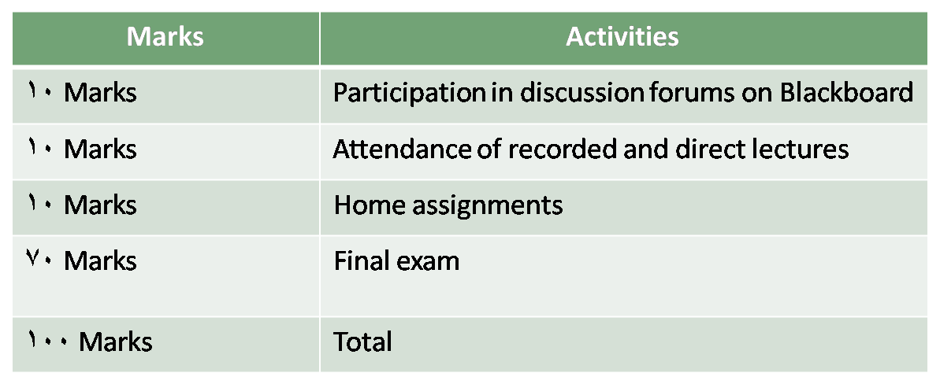

Mobile Office Hours...
Office Hours:
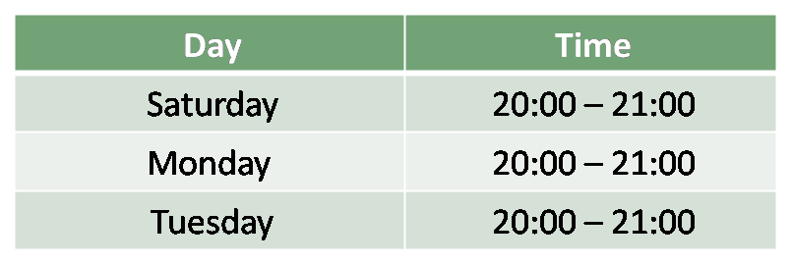

Mobile Number: ………………………..
Mobile will be turned on only during office hours mentioned above, so everyone should abide by these hours.
Email: …………………………………….

