-11-
Determiners

Determiners

After witnessing our grammar’s NP rule grew ever more complicated, you may wonder if at last we have got it the way we want it ----- at the point where it can generate all possible noun phrases in English. It cannot, at least not yet, but having come this far, you are well prepared to take any additional modification in stride. Look at the positive side: With each change we have made, our grammar has become more and more powerful, able to produce ever more varied types of English sentences.

Our noun-phrase to date is as follows:
(Art) (Adj)+ N (PP) ( CompP)
NP ------> { Prop }
CompP

- We will take another look at the top line of the previous rule, which generates noun phrases such as this one:
(Art) (Adj)+ N (PP) ( CompP)
The large box of groceries

- In particular, let us consider the slot occupied by the category Art in that phrase. In addition to the articles (a, an, and the), other words could also fill that slot in a grammatical phrase:

- This large box of groceries
- Each large box of groceries
- My large box of groceries
- John’s large box of groceries

- Each of these above words can occur in place of the in the sample noun phrase. A few more tests can help us decide if these words can be true replacements for the Art category. First, none of them can occur along with the:

* The this large box of groceries
* This the large box of groceries
* The each large box of groceries
* John’s the large box of groceries
* The my large box of groceries

- Second, just as two articles cannot occur in a phrase (* the a box), the four words also cannot with each other:
* This each large box of the groceries
* John’s this large box of groceries
* Each my large box of groceries
- Finally, like the article, each of the four substitutes must precede the adjectives; none can follow it:
* Large this box of groceries
* Large each box groceries
* Large John’s box of groceries
* Large my box of groceries

- The apparent exception, Large John’s, has a different meaning. It is ungrammatical if it is to retain the meaning that the box is large.

- From these tests, we conclude that the four words this, each, John’s, and my do fill the same slot as the article in the noun phrase. A larger category is needed, one that will include articles as well as these four as-yet-unlabeled words. We will call all such words DETERMINERS (Det). If we substitute “Det” for “Art”, the rule now becomes:
NP -------> (Det) (Adj)+ N (PP) (CompP)

- Determiners can be a variety of things, including articles as well as the four substitute words. Once we find categories for them, we can insert their names in place of the dotted lines in this rule:
- Art
- Det -------> { ……. }
…….
Demonstratives and Quantifiers

The words this, that, these and those are called DEMONESTRATIVE MODIFIERS (DEM) because they demonstrate (point out definitely) which particular box of groceries is being discussed. The word each is called a QUANTIFIER or QUANT (also called an INDEFINITE MODIFIERS). Other quantifiers include all, any, enough, every, few, many more, most, much, no, several, and some. They are called quantifiers because they quantify ( provide quantity information about) the nouns that follow them.
So far we have named three options to fill the missing categories in the previous rule:
Art
Det -------> { Dem }
Quant
Those greedy quests ate several large helpings of the lasagna
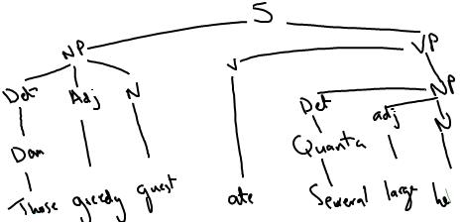
Possessive Pronouns

The third new determiner that we saw in our first example:
My large box of groceries
my, is a POSSESSIVE PRONOUN (more accurately, A POSSESSIVE PERSONAL PRONOUN), which we will abbreviate as (Prop-s ), with the subscript P standing for ‘personal’ and S for ‘possessive’.
Whereas personal pronouns act as noun phrases, possessive pronouns act as determiners. With possessive pronouns, we now have four options for determiners:
Art
Det -------> { Dem }
Quant
Prop-s
My sister and I send our warm regards to you
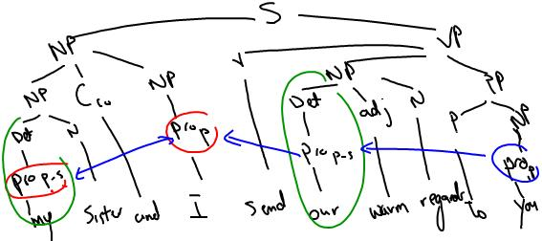

Possessive Noun Phrase

The final example of determiners, John’s, is a POSSESSIVE NOUN PHRASE (‘s and ‘ ) possessive markers as Poss….
- John’s large box of groceries
Like a possessive pronoun, its purpose is to indicate ownership. Although John’s is the possessive form of a single noun (John), multiword noun phrases can also have possessive forms, as the following indicates:
John’s large box of groceries
The boy’s large box of groceries
A small family’s large box of groceries
My boss’s large box of groceries

Now consider this final option for determiners:
Art
Det -------> { Dem }
Quant
Prop-s
NP Poss

