Introduction to Linguistics
Animals and human language:
- Communication:
- Properties of human language:
- Displacement
- Arbitrariness
- Productivity
- Cultural transmission

We should first distinguish between communicative signals and informative signals.
Informative Signals
If someone is listening to you, he /she may be informed about you through a number of signals that you have not intentionally sent. For example, he /she may note that you have a cold (you sneezed), that you are not at ease (you shifted around in your seat), that your are disorganized (non-matching socks).
Communicative Signals
When you use language to tell this person, I’m one of the applicants for the vacant position of senior brain surgeon at the hospital, you are normally considered to be intentionally communicating something.
Informative Signals
The blackbird is not normally taken to be communicating anything by having black feathers, sitting on a branch and looking down at the ground.
Communicative Signals
But is considered to be sending a communicative signal with the loud squawking produced when a cat appears on the scene.

Properties of human language:
Displacement:
When your pet cat comes home and stands at your feet calling meow, you are likely to understand this message as relating to that time and place. If you ask your cat where it has been and what it was up to, you’ll probably get the same meow response. Animal communication seems to be designed exclusively for this moment, here and now. It cannot be used to relate events that are far removed in time and place.
Humans can refer to past and future time. This property of human language is called displacement. It allows language users to talk about things and events not present in the immediate environment. Displacement allows us to talk about things and places (ogre, Superman) whose existence we cannot even be sure of.

Arbitrariness:
There is no natural connection between a linguistic form and its meaning. The connection is quite arbitrary. We can’t just look at the Arabic word كلب and, from its shape, for example, determine that it has a natural and obvious meaning any more than we can with its English translation form dog. The linguistic form has no natural or ‘iconic’ relationship with that hairy four-legged barking object out in the world. This aspect of the relationship between linguistic signs and objects in the world is described as arbitrariness.

Productivity:
Humans are continually creating new expressions by manipulating their linguistic resources to describe new objects and situations. This property is described as productivity (or ‘creativity’ or ‘open-endedness’) and essentially means that the potential number of vocal expressions in any human language is infinite.
The communication systems of other creatures are not like that. Cicadas have four signals to choose from and vervet monkeys have thirty-six vocal calls. It is not possible for creatures to produce new signals to communicate. The honeybee, normally able to communicate the location of a nectar source to other bees, will fail to do so if the location is really ‘new.’ the bees cannot manipulate its communication system to create a ‘new’ message including vertical distance.

Cultural transmission:
The process whereby a language is passed on from one generation to the next is described as cultural transmission. We inherit physical features such as brown eyes and dark hair from our parents, we do not inherit their language. We acquire a language in a culture with other speakers and not from parental genes. An infant born to Korean parents in Korea, but adopted and brought up from birth by English speakers in the United States, will have physical characteristics inherited from his or her natural parents, but will speak English.

Study questions
- What is the difference between formative and communicative signals?

Informative Signals
Someone may be informed about you through a number of signals that you have not intentionally sent.
Communicative Signals
You are normally considered to be intentionally communicating something.

2. Is it true that animals can refer to past and future time when they communicate? No, it is not true.

3. Is it true that there is no natural connection between a linguistic form and its meaning? Yes, it is true.

4. Is it true that humans cannot create new expressions to describe new objects and situations? No, it is not true.

The sounds of language:
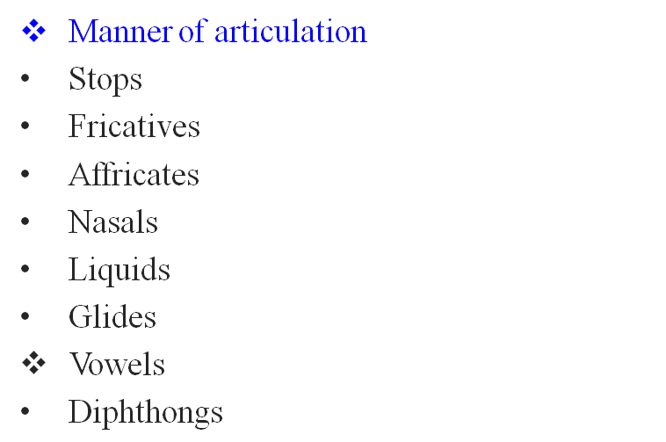
- Phonetics
- Voiced and voiceless sounds
- Place of articulation
- Bilabials
- Labiodentals
- Dentals
- Alveolars
- Velars and Glottals
- Charting consonant sounds


‘The sounds of spoken English do not match up, a lot of the time, with letters of written English’
- Phonetics
Greek ‘phone’ = sound or voice
The general study of the characteristics of speech sounds.
Articulatory phonetics The study of how speech sounds are made

- Voiced and voiceless sounds:

- When the vocal cords (vocal folds) are spread apart, the air from the lungs passes between them unimpeded. ZZZZZ or VVVVV (vibration)
- When the vocal cords (vocal folds) are drawn together, the air from the lungs repeatedly pushes them apart as it passes through. SSSSS or FFFFF ( no vibration)
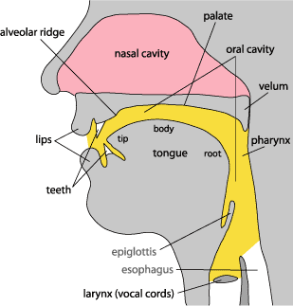

- Place of articulation:
- Bilabials
- Labiodentals
- Dentals
- Alveolars
- Palatals
- Velars
- Glottals

- Place of articulation:
- Bilabials:
These are sounds formed using both upper and lower lips. The first sounds in the words pat, bat, and mat are all bilabials. They are represented by the symbols [p], which is voiceless, and [b] and [m], which are voiced.
- Labiodentals:
These are sounds formed with the upper teeth and the lower lip. The first sounds in of the words fat and vat and the final sounds in the words safe and save are labiodentals. They are represented by the symbols [f], which is voiceless, and [v], which is voiced. Cough and photo, are both pronounced as [f].
- Dentals:
These are sounds formed with the tongue tip behind the upper front teeth. The initial sound of thin and the final sound of bath are both voiceless dentals. The symbol used for this sound is [θ]. The voiced dental is represented by the symbol [ð] like the, there, then and thus.
- Alveolars:
These are sounds formed with the front part of the tongue on the alveolar ridge. The initial sounds in top, dip, sit, zoo and nut are all alveolars. The symbols for these sounds are easy to remember [t], [d], [s], [z], [n]. Of these, [t] and [s] are voiceless whereas [d], [z] and [n] are voiced. Other alveolars are the [l] sound as in lap and [r] as in right.
- Palatals:
These are sounds formed with the tongue and the hard palate. The initial sounds in the words shout and child, which are both voiceless. The “sh” sound is represented as [ʃ] and the “ch” sound is represented as [tʃ]. The word shoe-brush begins and ends with the voiceless palatal sound [ʃ] and the word church begins and ends with the other voiceless palatal sound [tʃ]. The sound [ʒ] such as treasure and pleasure which is voiced palatal. The other voiced palatal is [dʒ] as in joke and gem. The sound [j] is also voiced palatal as in yet .
- Velars:
Sounds produced with the back of the tongue against the velum are called velars. . The sound [k] as in cook is voiceless. The sound [g] as in go. The voiced sound [ŋ] as in bang.

- Glottals:
There is one sound that is produced without the active use of the tongue and other parts of the mouth. It is the voiceless sound [h] as in horse .

- Charting consonant sounds:
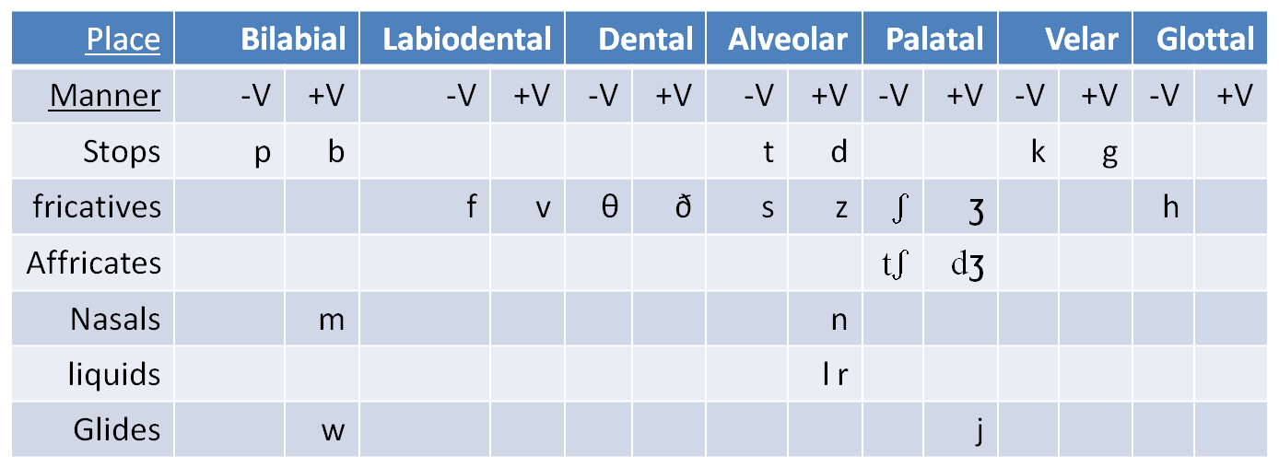

- Manner of articulation:
- Stops
- Fricatives
- Affricates
- Nasals
- Liquids
- Glides
ــــــــــــــــــــــــــــــــــــــــــــــــــــــــــــــــــــــــــــــــــــــــــــــــــــ

- Stops:
The set [p], [b], [t], [d], [k], [g] are all produced by some form of “stopping” of the air stream (very briefly) then letting it go abruptly. This type of consonant sound , resulting from a blocking or stopping effect on the air stream, is called a stop (or a “plosive”). Example: bed.
- Fricatives:
The set of sounds [f], [v], [θ], [ð], [s], [z], [ʃ], [ʒ] involved almost blocking the air stream and having the air push through the very narrow opening. As the air is pushed through, a type of friction is produced and the resulting sounds are called fricatives. Example: fish, those.

- Affricates:
If you combine a brief stopping of the air stream with an obstructed release which causes some friction, you will be able to produce the sounds [tʃ] and [dʒ] these are called affricates . Example: cheap and jeep.
.

- Nasals:
When the velum is lowered and the air stream is allowed to flow out through the nose to produce [m], [n] and [n], the sounds are described as nasals Example: morning and name.

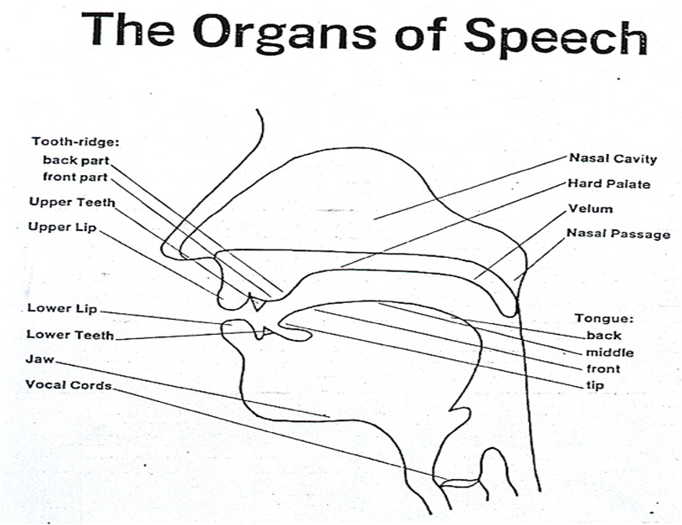
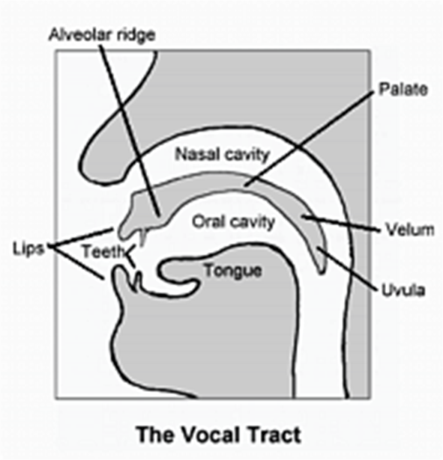
[2]

- Liquids:
The initial sounds in led and red are described as liquids. They are both voiced. The [l] sound is called a lateral liquid and formed by letting the air stream flow around the sides of the tongue as the tip of the tongue makes contact with the middle of the alveolar ridge. The [r] sound at the beginning of red is formed with the tongue tip raised and curled back near the alveolar ridge.
- Glides:
The sounds [w] and [j] are described as glides. They are both voiced and occur at the beginning of we, you and yes. These sounds are typically produced with the tongue in motion (or “gliding”) to or from the position of a vowel and are sometimes called semi-vowels.

Study questions
- Which of the following words normally end with voiceless (- V) sounds and which end with voiced sounds (+ V) sounds?
a. bang ____ d. fizz ____ g. splat ____
b. crash ____ e. rap ____ h. thud ____
c. ding ____ f. smack ____ i. wham ____
2. Try to pronounce the initial sounds of the following words and indentify the place of articulation of each one (e.g. bilabial, alveolar, etc.).
a. calf __________ e. hand __________ i. shoulder __________
b. chin __________ f. knee __________ j. stomach __________
c. foot __________ g. mouth __________ k. thigh __________
d. groin __________ h. pelvis __________ l. toe __________

Identify the manner of articulation of the initial sounds in the following words (stop, fricative, etc.).
a. cheery _________ d. funny _________ g. merry _________
b. crazy _________ e. jolly _________ h. silly _________
c. dizzy _________ f. loony _________ i. wimpy _________

The sounds of language:
- Vowels:
Vowel sounds are produced with a relatively free flow of air. They are typically voiced. To describe vowel sounds, we consider the way in which the tongue influences the shape through which the air must pass. To talk about a place of articulation, we think of the space inside the mouth as having a front versus a back and a high versus a low area. Thus, in the pronunciation of heat and hit, we talk about ‘high, front’ vowel sounds because the sound is made with the front part of the mouth in a raised position.
In contrast, the vowel sound in hat is produced with the tongue in a lower position and the sound in hot can be described as a ‘low, back’ vowel.
heat, hit your mouth will stay fairly closed
hat, hot sound your tongue will move lower and cause your mouth to open wider.

- Vowels:
Vowel sounds are produced with a relatively free flow of air. They are having a
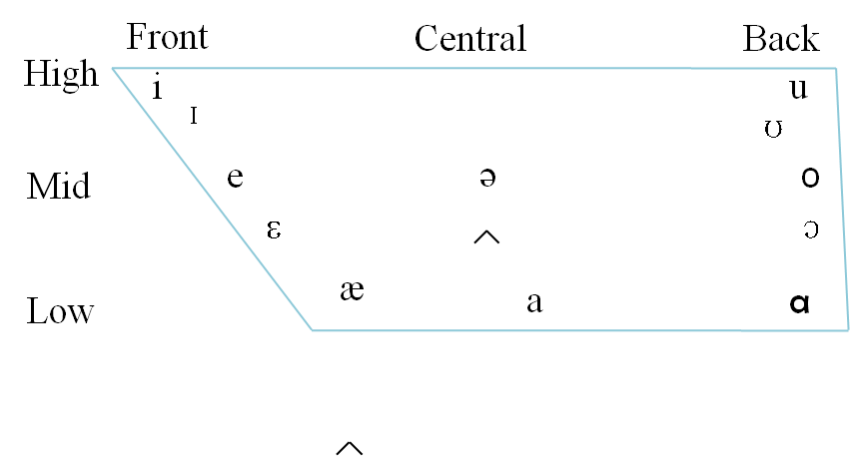

Front vowels Central vowels Back vowels
[ i ] key, me, beef, heat [ ә ] above, oven, support [ u ] boo, move, two, you
[ I ] bid, myth [ ] blood, tough [ʊ ] book, could, put
[ɛ ] bed, dead, said [ɔ ] born, caught, fall
[æ] bad ,laugh, wrap [ a] book, could, put

Diphthongs:
The combination of two sounds is known as diphthongs.
[ ] buy, eye, I, pie, sigh [ ] boat, home, throw, toe
[ ] doubt, cow, bough [ ] boy, noise
[ ] bait, eight, great, late, say

Homework
1. Using symbols introduced in this chapter, write a basic phonetic transcription of the most common pronunciation of the following words..
a. catch __________ e. noise __________ i. thought __________
b. doubt __________ f. phone __________ j. tough __________
c. gem __________ g. shy __________ k. would __________
d. measure __________ h. these __________ l. wring __________

[3]
The sound patterns of language:
- Phonology
- Phonemes
- Phones and allophones
- Minimal pairs and sets
- Syllables
- Consonant clusters
- Assimilation
- Elision

- Phonology: is the description of the systems and patterns of speech sounds in a language.
- Phonemes: are meaningful sounds, if one sound is used instead of the other in a word its meaning will change. /f/ and /v/ fat and vat
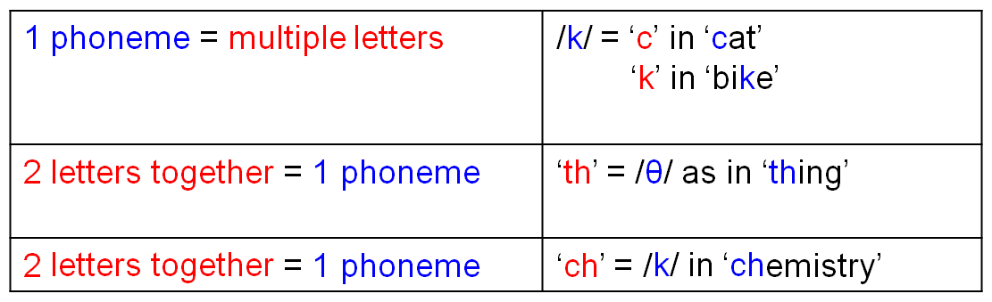

- Phones and allophones: phones are different versions of sound-type regularly produced in actual speech. They are phonetic units and appear in square brackets. When we have a set of phones, all of which are versions of one phoneme, we add the prefix “allo-” (one of a closely related set) and refer to them as allophones of that phonemes. [t] sound in the word tar is normally pronounced with a stronger puff of air than is present in the [t] sound in the word star . (aspiration)
- Minimal pairs and sets: when two words such as pat and bat are identical in form except for a contrast in one phoneme, occurring in the same position, the two words are described as a minimal pair. site – side, bet – bat, night – right, might – fight. One minimal set based on the vowel phonemes (heat, hit, hat, hot, hut, hate), and another minimal set based on consonant phonemes (big, pig, rig, fig, dig, wig).

- Syllables:
A syllable must contain a vowel or vowel like sound, including diphthongs. The most common type of syllable in language also has a consonant (C) before the vowel (V) and is typically represented as CV. The basic elements of the syllabus are the onset (one or more consonants) followed by the rhyme. The rhyme (sometimes written as “rime”) consists of a vowel which is treated as the nucleus, plus any following consonant(s), described as the coda.
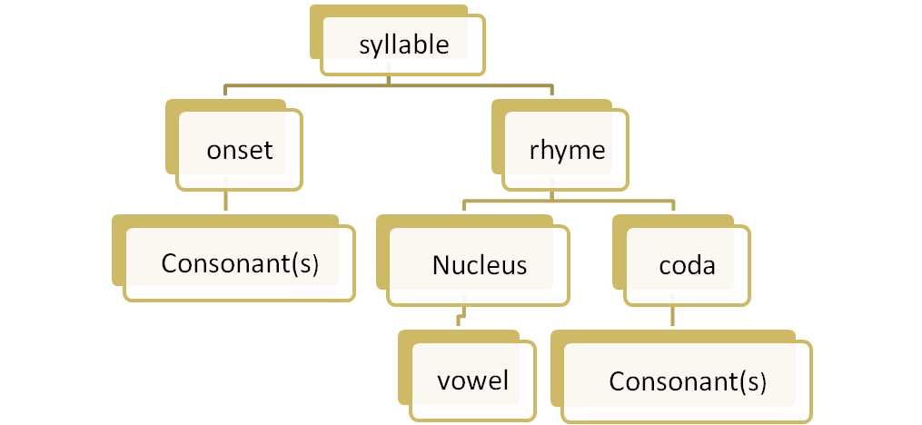

Syllables like me, to or no have an onset and a nucleus, but no coda. They are known as open syllables. When a coda is present, as in the syllables up, cup, at or hat, they are called closed syllables.
The basic structure of the kind of syllable found in English words:
green (CCVC), eggs (VCC), and (VCC), I (V), do (CV), not (CVC),
like (CVC), them (CVC), Sam (CVC), am (VC)

- Consonant clusters:
Both the onset and the coda can consist of more than one consonant, also known as a consonant cluster. The combination /st/ is a consonant cluster (CC) used as onset in the word stop, and as coda in the word post. Examples, black, bread, trick, flat.
- Assimilation:
When two sound segments occur in sequence and some aspect of one segment is taken or “copied” by the other, the process is known as assimilation.
Examples,
have I have to go (in everyday speech)
good girl goog girl
good boy goob boy
- Elision:
The process of not pronouncing a sound segment that night be present in the deliberately careful pronunciation of a word in isolation is described as elision.
Examples: you and me (d sound is not pronounced)
friendship (d sound is not pronounced)
he must be (t sound is not pronounced)

- Do exercises 2, 3 and 6 in page 49.

[4]
Word formation
- Etymology
- Coinage
- Borrowing
- Compounding
- Blending
- Clipping
- Backformation
- Conversion
- Acronyms
- Derivation
- Prefixes and suffixes

- Etymology:
Etymology is the study of the history of words, their origins, and how their form and meaning have changed over time. By an extension, the term "etymology (of a word)" means the origin of a particular word.
- Spanish: has contributed many words, particularly in the southwestern United States. Examples include buckaroo, alligator, rodeo, and states' names such as Colorado and Florida.
- Portuguese: Albino, lingo, verandah, and coconut.
- Italian: diva, prima donna, pasta, pizza, paparazzi, and umbrella.
- Finnish: sauna
- Arabic: adobe, alcohol, algebra, apricot, assassin, caliber, cotton, hazard, jacket, jar, mosque, Muslim, orange, safari, sofa, and zero.
- Japanese: sushi, and tsunami.

- Coinage
Coinage is the word formation process in which a new word is created either deliberately or accidentally without using the other word formation processes and often from seemingly nothing. For example, the following list of words provides some common coinages found in everyday English: aspirin, escalator, band-aid, Frisbee, Google, kerosene, Kleenex, Xerox, zipper.

- Borrowing
Borrowing is the word formation process in which a word from one language is borrowed directly into another language. For example, the following common English words are borrowed from foreign languages:
algebra – Arabic
chowmein – Chinese
murder – French
paprika – Hungarian
pizza – Italian
yo-yo – Tagalog

Borrowed words are also referred to as loanwords.
- Compounding
Compounding is the word formation process in which two or more lexemes combine into a single new word. Compound words may be written as one word or as two words joined with a hyphen. For example:
noun-noun compound: note + book → notebook
adjective-noun compound: blue + berry → blueberry
verb-noun compound: work + room → workroom
verb-preposition compound: break + up → breakup
Compounds may be compositional, meaning that the meaning of the new word is determined by combining the meanings of the parts, or non-compositional, meaning that the meaning of the new word cannot be determined by combining the meanings of the parts. For example, a blueberry is a berry that is blue.
- Blending
Blending is the word formation process in which parts of two or more words combine to create a new word whose meaning is often a combination of the original words. For example:
advertisement + entertainment →advertainment
biographical + picture → biopic
breakfast + lunch → brunch
motor + hotel → motel
smoke + fog → smog
Spanish + English → Spanglish
spoon + fork →spork

Clipping
Clipping is the word formation process in which a word is reduced or shortened without changing the meaning of the word. Clipping differs from back-formation in that the new word retains the meaning of the original word. For example:
examination – exam
influenza – flu
laboratory – lab
mathematics – math
photograph – photo
telephone – phone

- Clipping
The four types of clipping are back clipping, fore-clipping, middle clipping, and complex clipping. Back clipping is removing the end of a word as in gas from gasoline. Fore-clipping is removing the beginning of a word as in gator from alligator. Middle clipping is retaining only the middle of a word as in flu from influenza. Complex clipping is removing multiple parts from multiple words as in sitcom from situation comedy.

- Back-Formation
Back-formation is the word formation process in which an actual or supposed derivational affix detaches from the base form of a word to create a new word. For example, the following list provides examples of some common back-formations in English:
Original – Back-formation
babysitter – babysit
donation – donate
gambler – gamble
moonlighter – moonlight
television – televise

Conversion
Conversion is the word formation process in which a word of one grammatical form becomes a word of another grammatical form without any changes to spelling or pronunciation. For example, the nouns bottle, butter, chair have come to be used, through conversion, as verbs: We bottled the home-juice last night; Have you buttered the toast?; someone has to chair the meeting; They are vacationing in Florida.
Examples:
Adjectives Verbs
dirty to dirty
empty to empty

Noun to Verb Conversion The most productive form of conversion in English is noun to verb conversion. The following list provides examples of verbs converted from nouns:
Noun – Verb
access – to access
bottle – to bottle
can – to can
closet – to closet
email – to email
fool – to fool
Google – to google
name – to name
salt – to salt
ship – to ship

Acronyms
Acronyms are words formed by the word formation process in which an initialism is pronounced as a word. For example, HIV is an initialism for Human Immunodeficiency Virus that is spoken as the three letters H-I-V. However, AIDS is an acronym for Acquired Immunodeficiency Syndrome that is spoken as the word AIDS. Other examples of acronyms in English include:
ASAP – as soon as possible
PIN – personal identification number
radar - radio detection and ranging
TESOL – Teachers of English to Speakers of Other Languages

Acronyms are related to the word formation process of abbreviation.

Derivation
Derivation is the word formation process in which a derivational affix attaches to the base form of a word to create a new word. Affixes, which include prefixes and suffixes, are bound morphemes. Morphemes are the smallest linguistic unit of a language with semantic meaning. Bound morphemes, unlike free morphemes, cannot stand alone but must attach to another morpheme such as a word. For example, the following two lists provide examples of some common prefixes and suffixes with definitions in English:

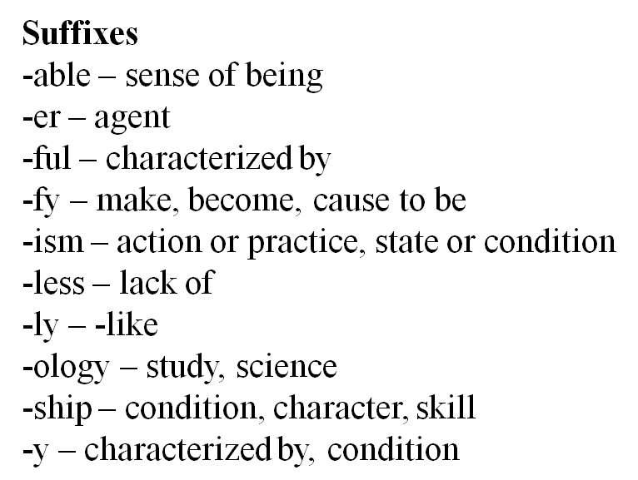
Prefixes
a- – without, not
co- – together
de- – opposite, negative, separation
dis- –opposite, negative
en- – cause to be
ex- – former, previous, from
in- – negative, not
non- – absence, not
re- – again, repeatedly
un- – negative, not, opposite

Do exercises 2, 3 and 6 in page 49.

[5]
Morphology
- Morphology
- Morphemes
- Free and bound morphemes
- Lexical and functional morphemes
- Derivational and inflectional morphemes
- Morphological description
- Morphs and allomorphs

- Morphology is the study of word formation. The basic unit in the study of morphology is the morpheme.
- A morpheme or morph is a minimal unit of meaning or grammatical function. Units of grammatical function include forms used to indicate past tense or plural. For example:
The police reopened the investigation
reopened consists of three morphemes. One minimal unit of meaning is open, another minimal unit of meaning is re- (meaning ‘again’) and a minimal unit of grammatical function is –ed (indicating past tense).
tourists
tour = one minimal unit of meaning.
-ist = another minimal unit of meaning. (person who does something)
-s = a minimal unit of grammatical function (indicating plural).

- Morphemes are two types:
- Free and bound morphemes.
- Free morphemes are morphemes that can stand by themselves as single words.
For example: open and tour
- Bound morphemes are morphemes that cannot normally stand alone and are typically attached to another form.
For example: re-, -ist, -ed, -s (prefixes and suffixes)
Free morphemes can generally be identified as the set of separate English word forms such as basic nouns, adjectives, verbs, etc
When free morphemes are used with bound morphemes attached, the basic word forms are technically known as stems.
For example: undressed and carelessness
(un- bound= prefix) (dress free = stem) (-ed bound= suffix)

- Free morphemes consist of two categories
- Lexical morphemes: ordinary nouns, adjectives, and verbs that we think of as the words that carry the “content” of the messages we convey.
For example: girl, man, house, tiger, sad, long, yellow, open, look, follow, break. (they are described as “open”)
- Functional morphemes: conjunctions, prepositions, articles and pronouns.
For example: and, but, when, because, on, near, above, in, the, that, it, them. (they are described as “closed”)

- Bound morphemes consist of two categories
- Derivational morphemes are used to make new words.
For example: careful + -ful or careless + -less, foolish + -ish, quick + -ly, payment + -ment. re- + reopen, mis-+ misused. (suffixes and prefixes)
- Inflectional morphemes are used to indicate aspects of grammatical function of a word. English has only eight inflectional morphemes.
- Jim’s two sisters are really different. (possessive, plural)
- One likes to have fun and is always laughing. (3rd person singular, present participle)
- The other liked to read and has always taken things seriously. (past tense, past participle)
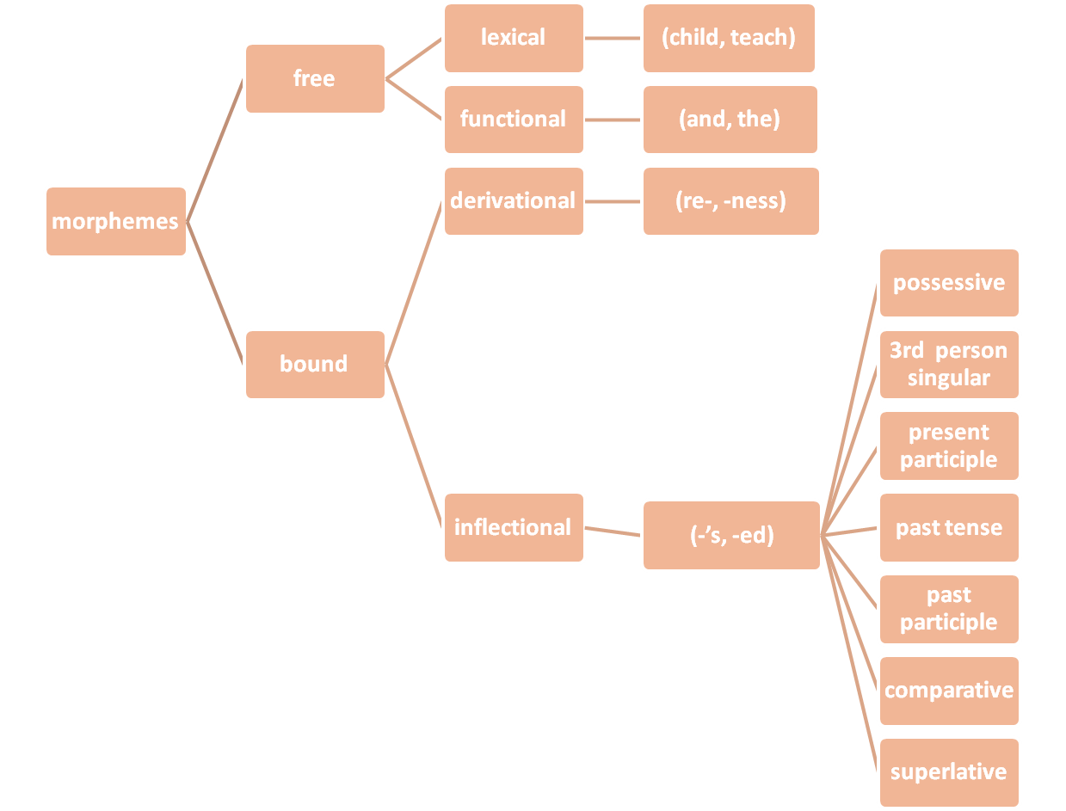
- One is the loudest person in the house and the other is quieter that a mouse. (comparative, superlative)
(inflectional morphemes are all suffixes)

- Morphological description
The child’s wildness shocked the teachers

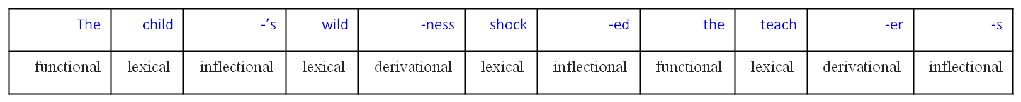

- Morphs and allomorphs
cats consists of two morphs cat + s (a lexical morpheme and an inflectional morpheme)
buses consist of two morphs bus + es (a lexical morpheme and an inflectional morpheme)
(-s and -es) are called allomorphs
sheep + plural
man + plural

- Do exercises 1, 2 a b c, 3 a b c d, 4 in page 74.

[6]

Grammar
- Grammar
- Traditional grammar
- The parts of speech
- Nouns
- Articles
- Adjectives
- Verbs
- Adverbs
- Prepositions
- Pronouns
- Conjunctions
- Agreement

- Grammar
The process of describing the structure of phrases and sentences in such a way that we account for all the grammatical sequences in a language and rule out all the ungrammatical sequences.
- Traditional grammar:
When we label the grammatical categories “article,” “adjective” and “noun” of the words in the phrase the lucky boys we use traditional grammar. The best-known terms from that tradition are those used in describing the parts of speech.

- The parts of speech:
“The lucky boys found a backpack in the park and they opened it carefully”
The lucky boys found a
article adjective noun verb article
backpack in the park
noun preposition article noun
and they opened it
conjunction pronoun verb pronoun
carefully
adverb

- Nouns are often defined as words, which name persons, places or things. For example: boy, river, friend, Mexico, day, school, university, idea, John, movie, vacation, eye, dream, flag, teacher, class, grammar. John is a noun because it is the name of a person; Mexico is a noun because it is the name of a place.
- Articles are words (a, an, the) used with nouns to form noun phrases classifying those “things” (you can have a banana or an apple) or indentifying them as already known (I’ll take the apple).
- Adjectives are words used, typically with nouns, to provide more information about the things referred to (happy people, large objects, a strange experience).

- Verbs are words used to refer to various kinds of actions (go, talk) and states (be, have) involving people and things in events (Sarah is ill and has a sore throat so she can’t talk or go anywhere).
- Adverbs are words used, typically with verbs, to provide more information about actions, states and events (slowly, yesterday) . Some adverbs (really, very) are also used with adjectives to modify information about things (Really large objects move slowly. I had a very strange experience yesterday).
- Prepositions are words (at, in, on, near, with, without) used with nouns in phrases providing information about time (at five o’clock, in the morning) , place (on the table, near the window) and other connections (with a knife, without a thought) involving actions and things.

- Pronouns are words (she, herself, they, it, you) used in place of noun phrases, typically referring to people and things already known (she talks to herself. They said it belonged to you).
- Conjunctions are words (and, but, because, when) used to make connections and indicate relationship between events (Dana’s husband was so sweet and he helped her a lot because she couldn't do much when she was pregnant)

- Agreement is the grammatical connection between two parts of a sentence (number, person, tense, voice and gender ) as in the connection between a subject Cathy and the form of a verb loves chocolate. (agreement in number (singular and plural) and person)
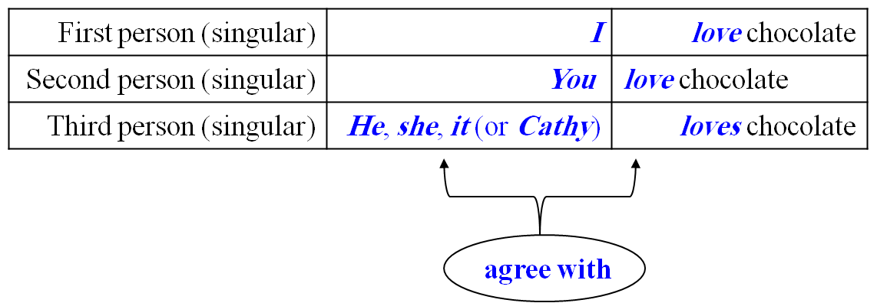

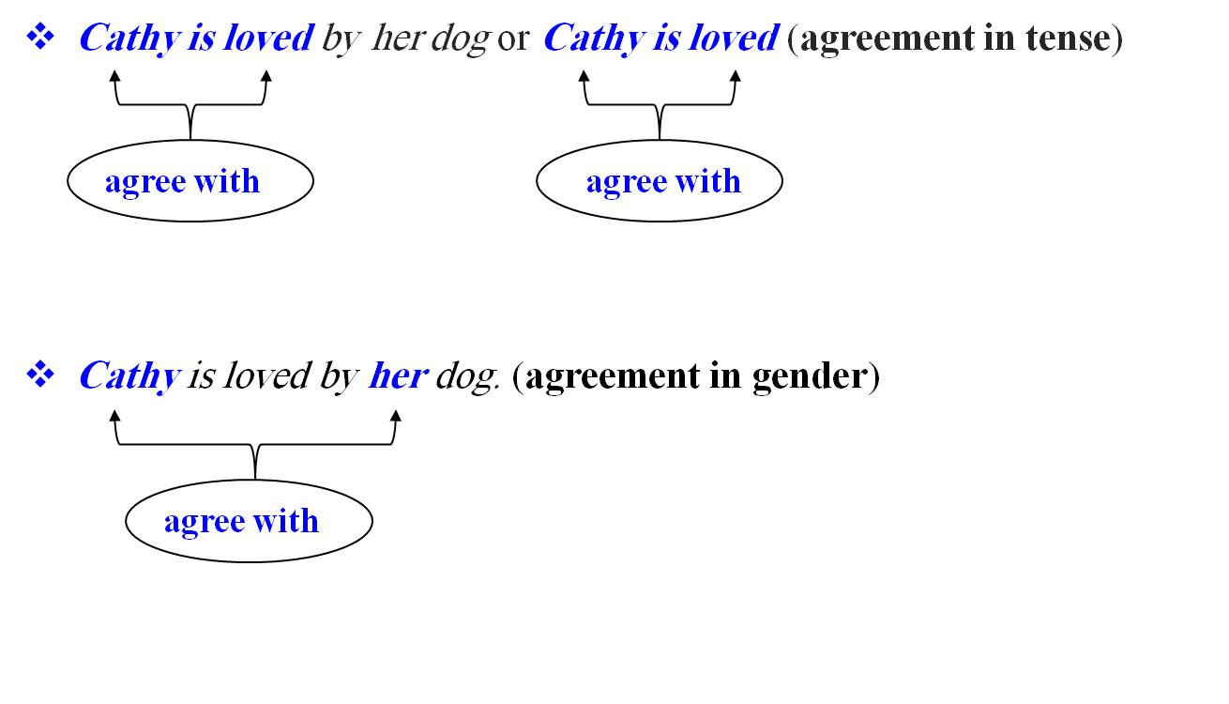

- Traditional analysis:
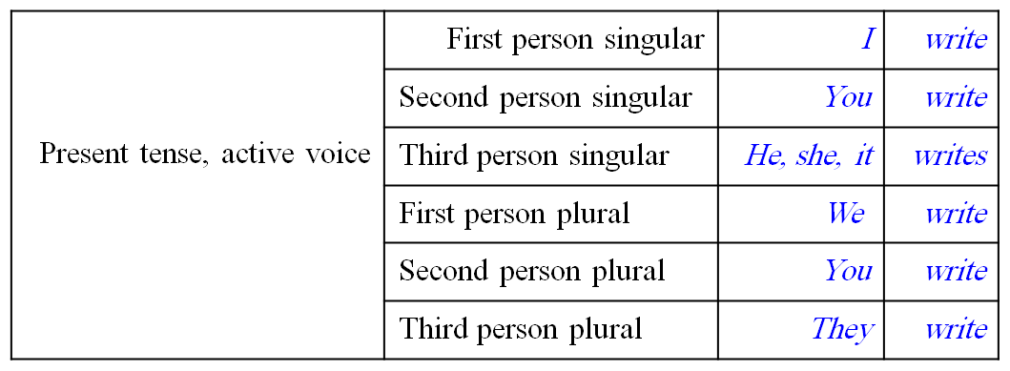

- The prescriptive approach:
An approach taken by a number of grammarians, mainly in eighteen-century England, who set out rules for the “proper” use of English.

Who did you go with? With whom did you go?
Marry runs faster than me. Marry runs faster than I.
Me and my family. My family and I.

Study questions
Do exercises 1 and 3 (i and ii) in page 92

