Homework -1
- (a) Two protons in a molecule are 3.80 × 10⁻¹⁰ m apart. Find the electrical force exerted by one proton on the other. (b) State how the magnitude of this force compares with the magnitude of the gravitational force exerted by one proton on the other. (c) What If? What must be a particle’s charge-to-mass ratio if the magnitude of the gravitational force between two of these particles is equal to the magnitude of electrical force between them?
- 4. A charged particle A exerts a force of 2.62 μN to the right on charged particle B when the particles are 13.7 mmapart. Particle B moves straight away from A to make the distance between them 17.7 mm. What vector force does it then exert on A?
- Three charged particles are located at the corners of an equilateral triangle as shown in the Figure . Calculate the total electric force on the 7.00μC charge.
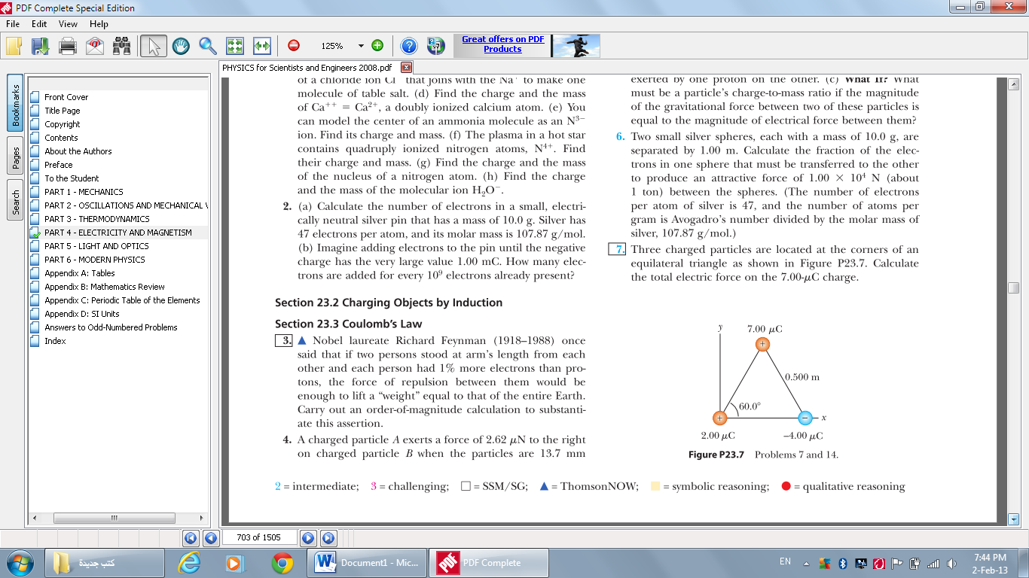

- Two small beads having positive charges 3q and q are fixed at the opposite ends of a horizontal insulating rod,extending from the origin to the point x = d. As shown in The Figure , a third small charged bead is free to slideon the rod. At what position is the third bead in equilibrium?Explain whether it can be in stable equilibrium.
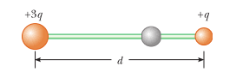

- 9. Two identical conducting small spheres are placed with their centers 0.300 m apart. One is given a charge of 12.0 nC and the other a charge of -18.0 nC. (a) Find the electric force exerted by one sphere on the other. (b) What If? The spheres are connected by a conducting wire. Find the electric force each exerts on the other after they have come to equilibrium.
- The separation distance between electron and proton in a hydrogen atom is 5.3×10⁻¹¹m. Calculate the electric force magnitude between them ?
- Three charged particles are located at the x-axis as shown in the figure. The positive charge q₁=15μc, and located at x=2m the second positive charge q₂=6μc located at the original point and the effective net force on q₃ equal zero . find the location of q₃on x-axis ?
