Homework -2
- In Figure, determine the point (other than infinity)at which the electric field is zero.
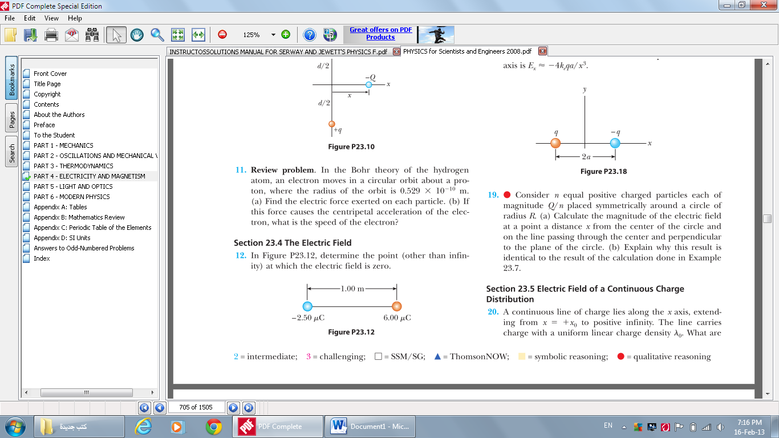

- Three charged particles are at the corners of an equilateral triangle as shown in Figure (a) Calculate the electric field at the position of the 2.00μC charge due to the 7.00μC and -4.00μC charges. (b) Use your answer to part (a) to determine the force on the 2.00μC charge.

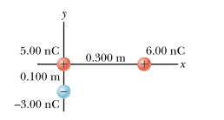
- Three charges are arranged as shown in Figure Find the magnitude and direction of the electric field on the charge at the origin from 6nC and -3nC.

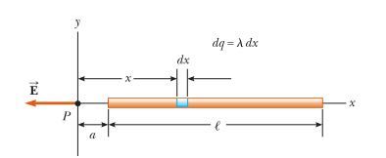
- A rod of length l has a uniform positive charge per unit length l and a total charge Q. Calculate the electric field at a point P that islocated along the long axis of the rod and a distance a from one end.

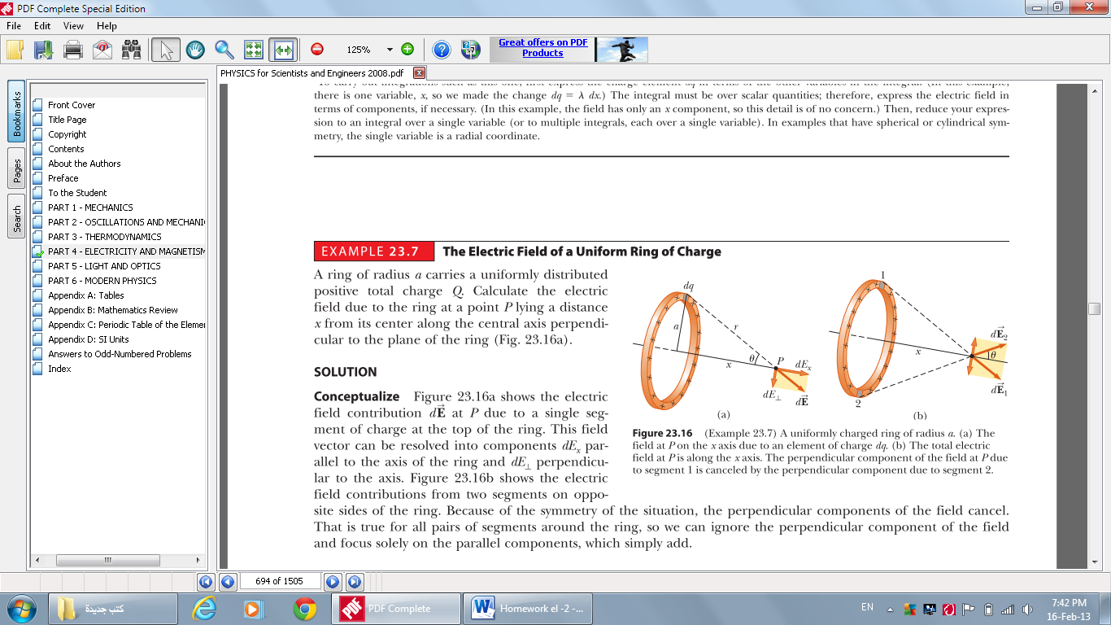
- A ring of radius a carries a uniformly distributed positive total charge Q. Calculate the electricfield due to the ring at a point P lying a distance x from its center along the central axis perpendicular to the plane of the ring.

