بعض الأسئلة من الأخوات الطيبات Angel human وكومــي
راجية من الله التوفيـق لكم

محآضرةة 11
احتمال يجيب مثل هالامثآل
A. Said: "I can't cook worth a cam".
B. Intended: "I can't cook worth a damn".
^^^
يقول هنآ المثآل يدل على ايش او مثال على ايش :
1-Plural attraction
2-Preservation error
3-Anticipation error
4-Segment exchange error
وهكذآ .. يعني ركزو على الامثله وهي تبع ايش : )

بكمل بقيةة الامثله : )
تسهيل عليكم
a. The time for fun and games are over.
b. The illiteracy level of our children are appalling
1-Plural attraction
2-Preservation error
3-Anticipation error
4-Segment exchange error

A. Said: "taddle tennis".
B. Intended: "paddle tennis".
1-Plural attraction
2-Preservation error
3-Anticipation error
4-Segment exchange error

A. Said: "hass or grash".
B. Intended: "hash or grass".
1-Plural attraction
2-Preservation error
3-Anticipation error
4-Segment exchange error

/////////////////////////////////////////////////////////////////
هذه أسئلة الواجب الثالث جات كلها
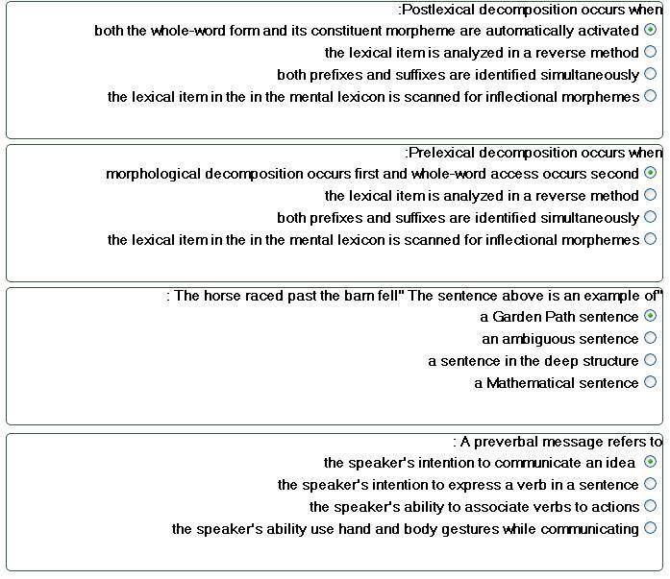
و هاذي الواجب الثاني ااااااااااخ غلطت في الأخير
Event-related potentials (ERPs) is an experiment that:
A. measures electrical activity in the brain
B. measures the potential to learn a language
C. measures the speed of someone's speech
D. measures the time of a learning event
Bottom-up processing is:
A. a phonetic analysis used to relate sounds to items in the mental lexicon
B. a morphological analysis used to relate sounds to items in the mental lexicon
C. a syntactic analysis used to relate sounds to items in the mental lexicon
D. a semantic analysis used to relate sounds to items in the mental lexicon
The psycholinguistic study of morphological processing:
A. seeks to understand how morphological principles play a role in the representation of words in the mind
B. seeks to create a computer programs that work as word processors
C. seeks to analyze words and phrases in the sentences with speech errors
D. seeks to understand how computer word processors can be used to enhance language acquisition
و هذا الواجب الأول ..
Psycholinguistics studies:
A. how language is represented and processed in the mind
B. how language affects your psychological well being
C. how different languages can be learned
D. how words are organized in a dictionary
A (intended) You have wasted the whole term.
B (said) You have tasted the whole worm.
Sentence B is an example of:
A. a slip of a tongue
B. a syntactic error
C. a parsing problem
D. a priming effect
Lexical Decision is
A. a method used to understand how words are represented in the mind
B. a method used to organize words in a dictionary
C. a method used to analyze words using a computer
D. a method used to measure how many word are in the brain
(( الله يعطيه العافية ان الدكتور راح يجيب اسئلة AL'HARBI' سبق و قالها الأخ الواجب ماشاء الله عليك يا اخوي صارت ))
Cohort Model is :
consist of all the lexical items that share an initial sequence of phonemes
language is species specific is :
language is likely to be part of the genetic makeup of members of the species
universal Grammar is :
language of the world are are similar because all humans have the same language capacities
Neurolinguistic is :
the study of the representation of the language in the brain
aphasia is :
a language impairment linked to brain injury
non fluent aphasia known as :
Broca's Aphasia
fluent aphasia known as :
Wernicke's aphasia
language lateralized is :
language function is located in one of the two hemispheres
Contralateral is :
the left hemisphere controls the right side of the body and the right hemisphere controls the left side of the body
Dichotic listening experiment is :
given two different inputs to each ear at the same time
Barrowing is :
is incorporated into the lexicon of another language
unilingual mode is :
only one language
bilingual mode is :
Has two language
Grammatical encoding is :
the creation of sentence structure during sentence planning
Tip of the tongue Phoneme :
the speaker knows the word but cannot retrieve it
interlocutor is :<< قهرر خطأت هنا بس اللهم لك الحمد
Participate in conversation
Orthorgraphy is :
writing system
أتذكر أنه سأل عن الـ Acquisition
جاب رسمتيــــن حطهم في المحاضرة الرابعة عشر
وحده لأجزاء المخ و الثانية لأجزاء الفم

