Lucture7
بناء الجملة Syntax
 Syntax بناء الجملة
- Deep and surface structure باطن وظاهر التركيب
- Structural ambiguity إلتباس التركيب
- Recursion التكرار
 Tree diagrams الشجرة البيانية
 Symbols used in syntactic analysis رموز تستخدم في التحليل النحو
 Lexical rules قواعد الألفاظ
 Movement rules قواعد تحريك الكلمات

Syntax بناء الجملة
 Syntax is the study of the principles(المبادئ) and processes by which sentences
are constructed(المبنية/ المركبة )in particular (معينة) languages.
• Surface structure: ظاهر التركيب (superficial level) مستوى ظاهر
1. Charlie broke the window (in traditional grammar it is called an active
sentence focusing on what Charlie did)
2. The window was broken by Charlie. (in traditional grammar it is called a
passive sentence focusing on the window and what happened to it)
1 & 2 have different syntactic forms. But very closely related
• Deep structure: باطن التركيب (underlying level)
An abstract level of structural organization in which all the elements
determining structural interpretation are represented.
1. It was Charlie who broke the window.
2. Was the window broken by Charlie?
King Faisal University [ ]

3Syntax
• Structural ambiguity: إلتباس التركيب
I shot an elephant in my pajamas. صورت الفيل في بجامتي (two underlying structures with the same
surface structure)
1. I shot an elephant (while I was) in my pajamas
2. I shot an elephant (which was) in my pajamas
• Recursion : التكرار (repeating any number of times)
The gun was on the table. (create a prepositional phrase again and again)
(on the table) (near the window) (in the bedroom)
The gun was on the table near the window in the bedroom.
Cathy knew that Mary helped George.
John believed that Cathy knew that Mary helped George. (no end)

Syntax
Tree diagrams الرسم البياني

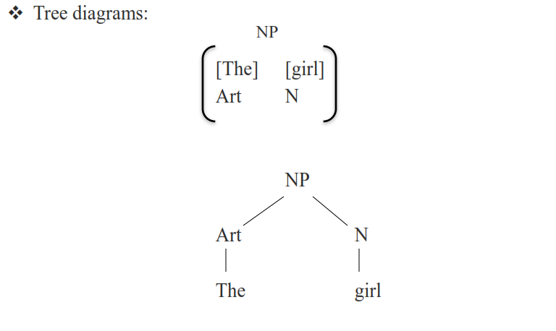

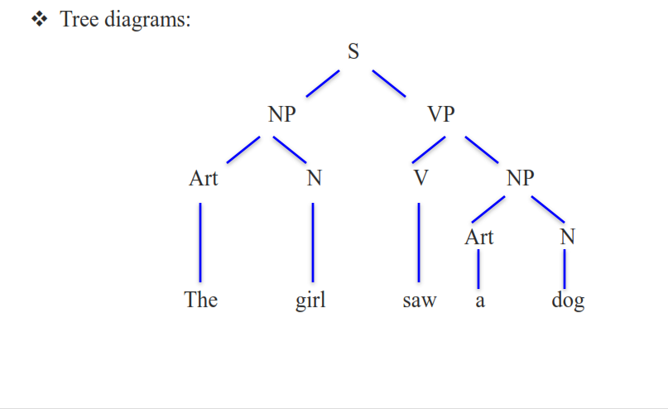
Syntax
 Symbols used in syntactic analysis:
رموز تستخدم في التحليل النحو

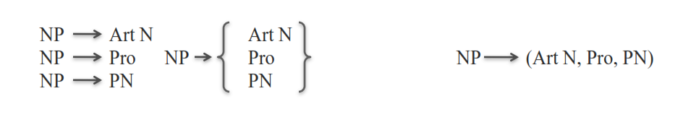

S sentence NP noun phrase عبارة اسمية PN proper noun الاسم الصحيح/ مثل أحمد
N noun VP verb phrase عبارة فعلية Adv adveb فعل
V verb Adj adjective صفة Prep preposition حرف جر
Art article Pro pronoun ضمير PP prepositional phrase عبرة جر

Syntax
 Lexical rules:قواعد الألفاظ
PN {Mary, George}
N {girl, boy, dog}
Art {a, the}
Pro {it, you}
V {followed, helped, saw}

A dog followed the boy

King Faisal University [ ]
Syntax
 Movement rules: قواعد تحريك الكلمات

You will help Mary

Will you help Mary
 Do exercises 4 and 6 in page 107 9

