Lucture8
Semanticsدلالات الألفاظ
  Semantics:
 Meaningالتعريف
 Semantic features سمات الدلالات
 Semantic roles وظائف الدلالات
• Agent and theme العامل و التخصص
 Lexical relations العلاقات المعجمية

King Faisal University [ ]
2
 Lexical relations
• Synonymy ترادف الكلمات
• Antonymy تضاد الكلمات
• Hyponymy الانتماء الدلالي
• Prototypesالنماذج
• Homophones and homonyms التجانس اللفظي
• Polysemy تعدد المعاني
• Word play التلاعب بالكلمات
• Metonymy تبديل الكلمة/المزاج المرسل

Semantics is the study of the meaning of words, phrases and sentences
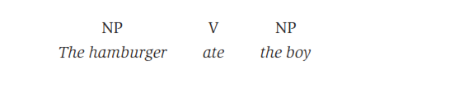
This sentence is syntactically(نحوياً) good, but semantically(دلاليا) odd(غريب). Since the sentence The boy
ate the hamburger is perfectly acceptable.

Agent and theme
In our example sentence, one role is taken by the noun phrase The boy as “the entity(كائن)
that performs(يقوم بـ ) the action,” technically known as the agent. Another role is taken by the
ball as “the entity that is involved(مشارك في) in or affected(متأثربـ) by the action,” which is called the theme (or sometimes the “patient” (معتل) ). The theme can also be an entity (The ball) that is simply being described(كائن موصوف) (i.e. not performing an action), as in The ball was red. Agents and themes are the most common semantic roles. Although agents are
typically human (The boy), they can also be non-human entities that cause actions,
as in noun phrases denoting(دليل) a natural force (The wind), a machine (A car), or a
creature(مخلوق) (The dog), all of which affect the ball as theme.

The boy kicked the ball.
The wind blew the ball away.
A car ran over the ball.
The dog caught the ball.

The theme is typically non-human, but can be human (the boy), as in The dog chased the boy.

Lexical relations
Not only can words be treated as “containers” of meaning, or as fulﬁlling “roles” in
events, they can also have “relationships” with each other. In everyday talk, we often explain the meanings of words in terms of their relationships . The word conceal, for example, we might simply say, “It’s the same as hide,” This approach is used in the semantic description of language and treated as the analysis of lexical relations. The lexical relations we have just exemplified are synonymy (conceal/hide), antonymy (shallow/deep) and hyponymy (daffodil/flower).

Semantics
explain the meanings of words in terms of their relationships. If we’re asked the
meaning of the word conceal, for example, we might simply say, “It’s the same as
hide,” or give the meaning of shallow as “the opposite of deep,” or the meaning of
daffodil as “a kind of ﬂower.” In doing so, we are characterizing the meaning of each
word, not in terms of its component features, but in terms of its relationship to other
words. This approach is used in the semantic description of language and treated as the
analysis of lexical relations. The lexical relations we have just exempliﬁed are synonymy
(conceal/hide), antonymy (shallow/deep) and hyponymy (daffodil/ﬂower).

Synonymy
Two or more words with very closely related meanings are called synonyms.
Other common examples of synonyms are the pairs: almost/nearly,
big/large, broad/wide, buy/purchase, cab/taxi, car/automobile, couch/sofa, freedom/
liberty.

Antonymy
Two forms with opposite meanings are called antonyms. Some common examples are
the pairs: alive/dead, big/small, fast/slow, happy/sad, hot/cold, long/short, male/
female, married/single, old/new, rich/poor, true/false.

Hyponymy
When the meaning of one form is included in the meaning of another, the relationship
is described as hyponymy. Examples are the pairs: animal/dog, dog/poodle, vegetable/
carrot, ﬂower/rose, tree/banyan.

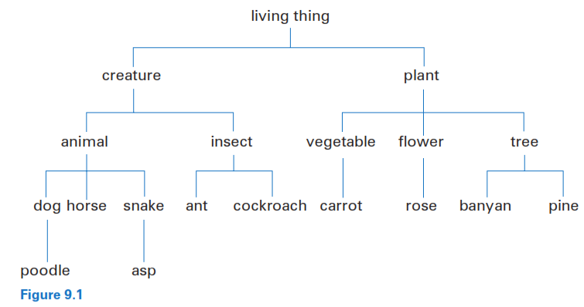

Prototypes

The idea of “the characteristic instance” of a category is known as the prototype.
Given the category label furniture, we are quick to recognize chair as a better
example than bench or stool. Given clothing, people recognize shirts quicker than
shoes, and given vegetable, they accept carrot before potato or tomato.

Homophones and homonyms
When two or more different (written) forms have the same pronunciation, they are
described as homophones. Common examples are bare/bear, meat/meet, ﬂour/
ﬂower, pail/pale, right/write, sew/so and to/too/two.

Polysemy
When we encounter twoor more words with the sameform and related meanings, we have
what is technically known as polysemy.
Examples are the word head, used to refer to the object on top of your body, froth on top of a glass of beer, person atthe top of a company or department, and many other things. Other examples of polysemyare foot (of person, of bed, of mountain) or run (person does, water does, colors do).

Word play
Mary had a little lamb, we think of a small animal, but in the comic version Mary had a little lamb, some rice and vegetables, we think of a small amount of meat. The polysemy of lamb allows the two interpretations.

Metonymy
The relatedness of meaning found in polysemy is essentially based on similarity. The
head of a company is similar to the head of a person on top of and controlling the body.
There is another type of relationship between words, based simply on a close connection
in everyday experience. That close connection can be based on a container–contents
relation (bottle/water, can/juice), a whole–part relation (car/wheels, house/roof)ora
representative–symbol relationship (king/crown, the President/the White House). Using
one of these words to refer to the other is an example of metonymy.

Study questions
  Do exercises 4, 5 and 6 in page 123

