Children’s Literature
Instructor : Dr Abdulgawad Elnady

1st Lecture
Warm-up: definitions
- Before we talk about the nature and characteristics of children’s literature, let us try to define the two terms.
- This will help us to understand a lot about the nature of the genre and to be specific about this interesting and comparatively new field of study.
Questions
What is meant by the word genre?
- Food
- Type
- Literary type
Essential terms
Biologically, a child (plural: children) is generally a human between the stages of birth and puberty. Some vernacular definitions of a child include the fetus, as being an unborn child. The legal definition of "child" generally refers to a minor, otherwise known as a person younger than the age of majority.
"Child" may also describe a relationship with a parent (such as sons and daughters of any age) or, metaphorically, authority figure, or signify group membership in a clan, tribe, or religion; it can also signify being strongly affected by a specific time, place, or circumstance, as in "a child of nature" or "a child of the Sixties“.
Questions
- a child means any human being between birth and puberty: this means that the child is
- any person
- A human being
- A mature person

Essential terms:
Literature (from Latin litterae) is the art of written work. The word literature literally means "things made from letters“ and letters" means literature while a “man of letters” means a writer or author of works of art.
Questions
In the field of literature, the word letters means:
- Sounds
- Linguistics
- Works of art
- A man of letters is
- the teacher of phonetics
- The one who sells letters
- An author or a writer of creative works
The word literature is originally:
- Arabic
- English
- Italian
- Latin

Literature
- The collective body of literary productions, embracing the entire results of knowledge and fancy preserved in writing; also, the whole body of literary productions or writings upon a given subject, or in reference to a particular science or branch of knowledge, or of a given country or period; as, the literature of Biblical criticism; the literature of chemistry.
- The class of writings distinguished for beauty of style or expression, as poetry, essays, or history, in distinction from scientific treatises and works which contain positive knowledge; belles-lettres.
- The occupation, profession, or business of doing literary work.

Questions
1.The word literature has one meaning only
- True
- Untrue
- We have no idea

Essential terms
Literature may consist of texts based on factual information (journalistic or non-fiction), as well as on original imagination. Literature can be classified according to historical periods, genres, and political influences.

- Children’s Literature: Definitions
Is there a single definition for children’s literature?
The body of written works and accompanying illustrations produced in order to entertain and instruct young people.
The genre encompasses a wide range of works, including acknowledged classics of world literature, picture books and easy-to-read stories written exclusively for children, and fairy tales, lullabies, fables, folk songs, and other primarily orally transmitted materials.
Questions
The body of written works and accompanying illustrations produced in order to entertain and instruct young people is called:
    - Drama
    - The novel
    - Children’s literature

Children’s Literature: Definitions
Children's literature: both fiction and non-fiction books, written especially for children 0-12 years old.
Young adult literature: both fiction and non-fiction books, written for people 13-18 years old.

“Children’s literature is good quality trade books for children from birth to adolescence, covering topics of relevance and interests to children of those ages, through prose and poetry, fiction and nonfiction.”

Children’s literature covers the period of time from
- Birth to death
- Birth till the age of ten
- 5 to 18
- Birth to the age of 18

- Despite the recent trend of categorizing children's literature by age, an increasing number of adults have begun reading children's books, blurring the boundaries between children's and adult texts.
- Although children's literature is intended primarily for children, it is more accurate to view such texts as having dual audiences of children and adults.

Questions
Children’s literature is:
- read only by children
- Read by children and adults
- Read only at schools
- Read only before going to sleep

Questions
Is children’s literature to be read and appreciated by children only?
Of course not. All classes of people can read, study, and appreciate this genre of literature.

Final word: Definition of Children’s Literature:
- There is no single, widely accepted definition of children's literature. It can be broadly defined as anything that children read, but a more useful definition may be fiction, poetry, and drama intended for and used by children and young people, a list to which many crtics add non-fiction.
- Nancy Anderson of the College of Education at the University of South Florida defines children's literature as all books written for children, "excluding works such as comic books, joke books, cartoon books, and nonfiction works that are not intended to be read from front to back, such as dictionaries, encyclopedias, and other reference material".

2nd Lecture
History
Children’s literature first clearly emerged as a distinct and independent form of literature in the second half of the 18th century, before which it had been at best only in an embryonic stage.
From when to when?
Children's literature has its roots in the stories and songs that adults told their children before publishing existed, as part of the wider oral tradition. Because of this it can be difficult to track the development of early stories. Even since widespread printing, many classic tales were originally created for adults and have been adapted for a younger audience.

Although originally children's literature was often a re-writing of other forms, since the 1400s there has been much literature aimed specifically at children, often with a moral or religious message. To some extent the nature of children's fiction, and the divide between older children's and adult fiction became blurred as time went by and tales appealing to both adult and child had substantial commercial success.

In the beginning the same tales that adults tell and enjoy are adapted for children. Then stories are created specifically for children, to educate, instruct and entertain them. In the final stage literature for children is established as separate from that of adults, having its own genres, divisions, expectations and canon. The development of children's literature is influenced by the social, educational, political and economic resources of the country or ethnic group.

According to Aspects and Issues in the History of Children's Literature from the International Research Society for Children's Literature, the development of literature for children anywhere in the world follows the same basic path. All children's literature, whatever its current stage of development, begins with spoken stories, songs and poems.

History of Children’s literature
Up until the 19th century books written for children were entirely religious, instructional, or for the improvement of their morals and manners.
What do you know about how children were viewed prior to the inception of child development as a discipline? The views about children then influenced nature of lit.

History (continued)
In 1865 Alice in Wanderland” was written, the first book that was written for mere enjoyment. & that marked the beginning of children’s literature

Differences between children’s books now and then
More experimentations with genres- from teaching values to fantasy, fiction, etc
Blurring age boundaries- picture books for everyone.
Changing topics, eg., technology, terrorism
Technology & commercialization, books on audio and videotapes.: eg. Harry Potter.
Increasing diversity melting pot versus salad bowl. International literature.
Building on the past, looking into the future.

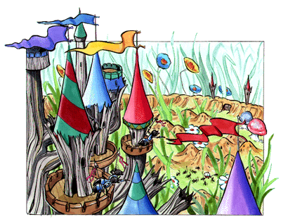
History
Children’s literature is a relatively new kind of literature.
- Before 1850, books taught lessons on manners
and morals.
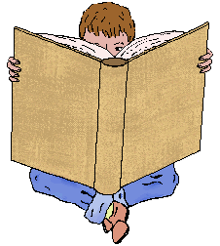

- Books also contained lessons on the ideas of history and science that existed at the time.

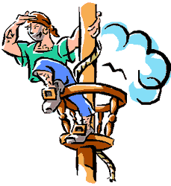
Children’s Books

- Children found the books dull, so they read stories intended for adults.
  - Robinson Crusoe by Daniel Defoe
  - Gulliver’s Travels by Jonathan Swift
  - Rip Van Winkle by Washington Irving

Early Beginnings
- In 600 A.D., the Old English period, monks and other learned
men wrote “lesson books” for children.

Questions
Children’s literature dates back to
- The year 600 A.D.
- 1600
- 1700
- 1800

Why did children prefer reading Gulliver’s Travels and Robinson Crusoe to reading books by scholars and preachers?
- The latter books were dull
- The former books were available
- Both novels were a must at schools

The 1700s
John Newbery was a writer, publisher, and bookseller of St.Paul’s Church, London.
He published a series of books for children. Recognized they had special interests and tried to meet them.
He printed chapbooks, cheap little paper editions, which were sold on the streets by chapmen (peddlers); they contained ballads and folk tales. The ordinary person could afford to buy these books.
He also published translations from the French:
Tales of Mother Goose by Charles Perrault. It was considered beneath the dignity of authors to write books for children, so they were published without any name attached.

Questions
in the 1800s, why were books for children published without any name attached?
  - Writers were ashamed of them
  - That was the habit with all books
  - No one knows

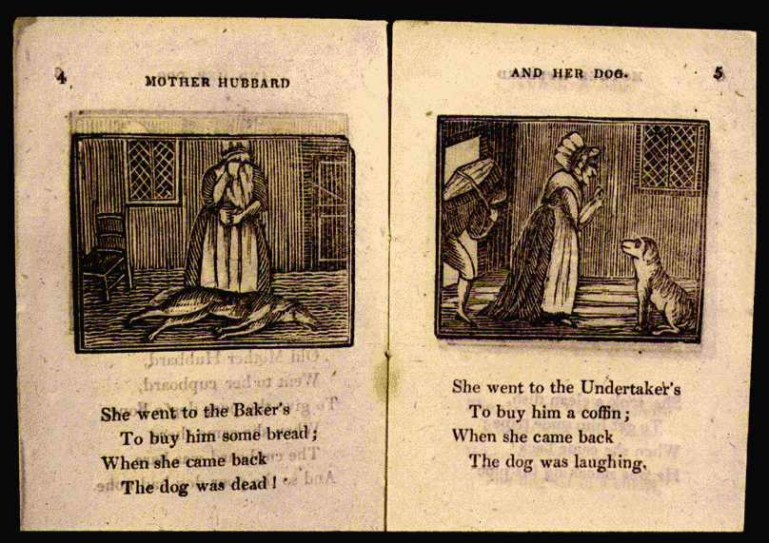
The 1800s
- In the beginning of the 1800s, children’s
literature became more creative.
- Real literary authors could write for children
and not damage their reputations.

The Early 1800s
- Charles and Mary Lamb, brother and sister, wrote to give children pleasure.
- They worked together (in 1807) to write a children’s version of Shakespeare’s plays.
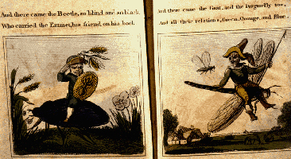

Questions
What did Charles and Mary Lamb write for children in the 19th century?
- a novel
- A poem
- a children’s version of Shakespeare’s plays
Charles and Mary Lamb were
Husband and wife
Brother and sister?

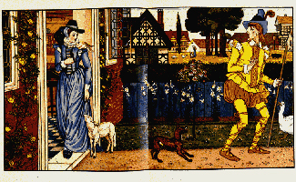
And Then . . .
- A period of change began in the next 50 years.

- Authors had a profound influence on children’s literature.

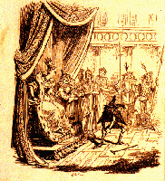
And Then . . .
- Jacob Ludwig and Wilhelm Carl
Grimm traveled around Germany, talking to
people and collecting folk stories.
- Their collection was translated into
English in 1824.

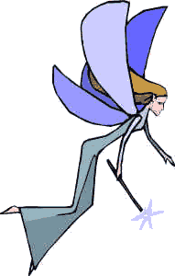
And Then . . .

- Hans Christian Anderson, in 1841, wrote “modern” fairy
tales, so called because Anderson actually created them
and copied old ways of telling stories.
- Some of his stories are “The Little Mermaid,” “The Ugly Duckling,”
and “The Emperor’s New Clothes.”

In the 20th century
- "From the 1960s through the 90s “socially relevant” children's books have appeared, treating subjects like death, drugs, sex, urban crisis, discrimination, the environment, and women's liberation. S. E. Hinton's The Outsiders (1980) and Robert Cormier's I Am the Cheese (1977) are two novels that offer vivid portrayals of the sometimes unpleasant aspects of maturing.
- These books also reveal the trend toward a growing literature for teenagers. Other novelists that write convincingly of growing up in contemporary society include Ellen Raskin, Judy Blume, and Cynthia Voigt. Some critics consider these books as didactic as the children's books of the 17th and early 19th cent.

3rd Lecture
Characteristics of Children’s literature
Just a quick reminder: Children’s literature is Both fictional and non-fictional books, written especially for children 0-18 years old. It is a genre that began very early in history and that was initiated officially, so to speak, in the year 1865 with the publication of Alice in the Wonderland by Lewis Carroll as the first novel to have been written for the pure pleasure and enjoyment of children.
Question
What is the first novel to have been written for the pure pleasure and enjoyment of children?
- Alice in the Wonderland
- Robinson Crusoe
- Gulliver’s Travels
- Animal Farm

Characteristics of Children’s literature
Alice in the Wonderland by Lewis Carroll tells of a girl named Alice who falls down a rabbit hole into a fantasy world (Wonderland) populated by peculiar, mythological creatures. The tale plays with logic, giving the story lasting popularity with adults as well as children.
Adults and children alike can read and enjoy children’s literature.

Question
Children’s literature can be read and enjoyed by:
- children only
- Adults only
- Both adults and children

Characteristics of Children’s literature
Let us try something new today. I will not directly tell you of those characteristics you find in the title. I will show you a picture and a movie and then we can come up, ourselves, with some very nice feature. Ready?
Move to the next slide please.

First, the Picture


What is a work of art for children expected to be like?

Then the Movie

What is a work of art for children expected to be like?

Characteristics of Children’s literature
Initial ideas from the picture and the movie:
- Children’s literature has to….be easy & simple.
- Children’s literature has to….contain a message.
- Children’s literature has to….have a moral lesson.
- Children’s literature has to….attractive, surprising , and exciting
- Children’s literature has to provide adventures
- Children’s literature has to provide suspense
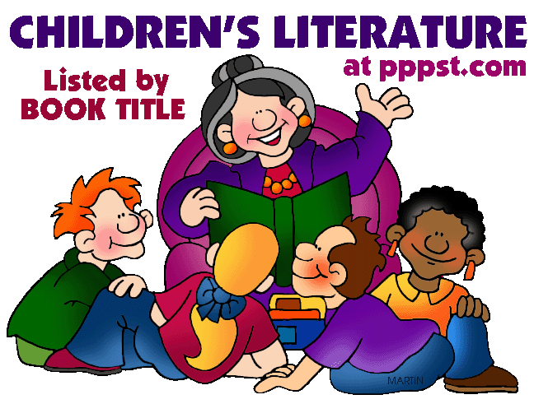

Funny. Uses stories. Interesting.

Telling stories
The art of telling a story is very important in writing for children. It helps the writer to capture the interest and imagination of the child. Without possessing this art everything might turn dull and children will easily lose concentration. As the writer tells the story he or she has to be exciting, funny, interesting, and challenging. How so?

The art of Telling stories
- Using an unfamiliar way of starting or ending a sentence.
- Using negation
- Using questions
- Allowing for some time of silence so the kids would think or even have a break
- Changing different tones, not just maintaining one monotonous voice from start to finish
- Marinating a cozy smile all the way through

To understand all this I want you to imagine yourself as a father or mother telling your child a bedtime story.
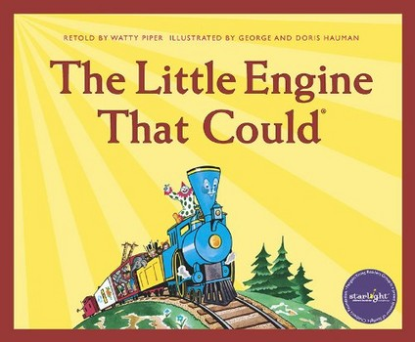

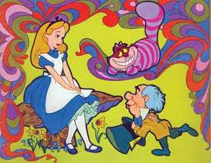

fantasy

Fantasy
Children’s literature depends greatly on fantasy, but we have to remember that some logic is also needed, otherwise we are not doing justice to the children. We will talk about this later.

Question
Literature for children
- must use fantasy only.
- Must mix fantasy and realism
- Must never use logic or realism
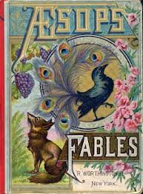

The fable is: A story in which all characters are animals

Fables
Fables are fine with children, but it has been noticed that allegory as in Animal Farm works miracles with the children, much more than fables. Why? Because it mixes fantasy with logic.

Question
Which is more preferable for children, fables or allegories?
- Fables
- Allegories
- None of the above

4th Lecture
Further characteristics of
children’s literature

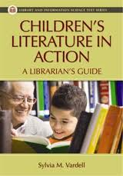

There must be some kind of action

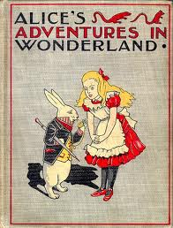

A novel written in 1865. the first real
novel for children

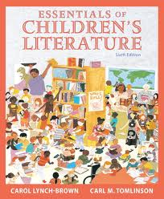

Has to be about the world of children

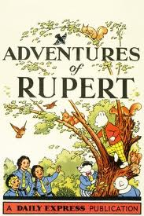
Harry potter
Harry Potter is a series of seven fantasy novels written by the British author J. K. Rowling. The books chronicle the adventures of a wizard, Harry Potter, and his friends Ronald Weasley and Hermione Granger, all of whom are students at Hogwarts School of Witchcraft and Wizardry. The main story concerns Harry's quest to overcome the Dark wizard Lord Voldemort, whose aims are to become immortal, conquer the wizarding world, subjugate non-magical people, and destroy all those who stand in his way, especially Harry Potter.

Since the release of the first novel Harry Potter and the Philosopher's Stone on 30 June 1997, the books have gained immense popularity, critical acclaim and commercial success worldwide. The series has also had some share of criticism, including concern for the increasingly dark tone. As of June 2011, the book series has sold about 450 million copies, making it the best-selling book series in history, and has been translated into 67 languages. The last four books consecutively set records as the fastest-selling books in history.
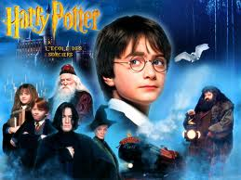

A child character at the forefront and somoe adults are there as a backdrop, in the background

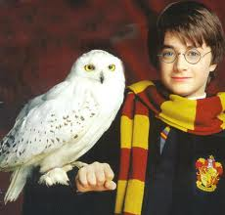
Uses animals and birds as characters
as in a fable

Questions
Whose point of view should be dominant in a book for children?
- That of children
- The point of view of grown ups
- The author’s point of view.
Characteristics of Children’s Literature


Characteristics of Children’s Literature
Simple and straightforward.
You cannot use complex language or difficult issues in talking to kids.
This does not mean that vocabulary needs to be overly simplistic or that style should be choppy or flat (as too many books for children are).
Children’s Literature:
- must always be simplistic
- Should be easy and acceptable
- Must be difficult to understand
Focuses on action.
Subtle psychological events are often implied through narration and comment on actions.
Thoughts and ideas will make children absent minded or they would lose interest easily. So it is better to keep them focussed on action.
Children’s Literature Focuses on action:
- it should never deal with ideas
- It has to have action all the time
- It does provide action which helps to understand ideas.
Is about childhood.
Naturally. It cannot talk about adults. Or wars or marriage or higher studies or the UN. Only the concerns of childhood.
Expresses a child’s point of view.
Same as above
Child ideas and topics mean the point of view to be expressed.
Can it present the point of view of elders?
Can children be just followers of the views of adults?
Can they have their own p o view?

Is optimistic.
“Hope is a vital dimension of a children’s book”. (Sarah Smedman)
Pessimism does not fit the world of children. It just puts them off and creates a wall between them and the novel. Of course we are talking here about children readers and characters.

Tends toward fantasy.
Fantasy often implies a symbolic defiance of our knowledge of reality.
Lots of imagination with some logic of course. But fantasy should be the ruling principle.

Is a form of pastoral idyll.
The pastoral idyll celebrates the joys and innocence of rural life, close to nature and in the company of friends.
Greenery, shrubs, trees, flowers, water, rivers, roses, nature in general. All these are so dear to the hearts of kids.
Pasture

Views an un-idyllic world from the viewpoint of innocence.
More complex and interesting books reflect ambivalence about desire to have the comforts of home and the exciting dangers of adventure, desire to be innocent and experienced, desire to grow up but not grow up, etc.
being not able to grasp the evil there is in the whole world, thinking that all is well while in fact it is not. Cf optimistic.

5th Lecture
Characteristics of Children’s Literature
9. Is didactic. Preaching
Traditionally, children’s literature has been seen as attempting to educate children.
A universal theme is teaching children that despite its boredom, home is a better place to be than the dangerous world outside.
Truthfulness. Cooperation. Filial obedience. Brotherhood. Innocence. Good X evil.
Question
Children’s literature is didactic:
- It teaches children readers a moral lesson
- It only provides fun no more
- It teaches children politics
10. Tends to be repetitious.
Repeating tasks is a basic method of education.
Repetition is a common trait of oral literature.
Repetitions with variations of words, phrases, situations, and narrative patterns are common in children’s literature.
Some examples from the novel.
Question
Repetitions in children's literature means:
- Repeating some words only
- Repeating words, phrases, and situations
- Repeating adjectives only
- Repeating adverbs only
11. Tends to balance the idyllic and the didactic.
Some books are almost completely didactic (teaching them how to become like mature adults and deal with the adult world) or idyllic (reflecting a desire to retain the innocence of childhood), but most books combine the two approaches, and deal with opposing ideas, such as home vs. away, communal concern vs. self-concern, good vs. evil.
Teaching X delighting
Question
Children’s Literature Tends to balance the idyllic and the didactic:
- it mixes teaching and delighting
- It prefers teaching to delighting
- It prefers delighting to teaching
Idyllic
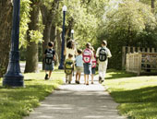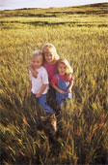
Idvllic
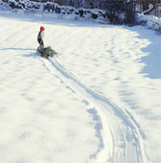

Didactic


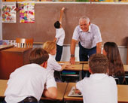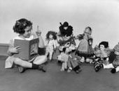

About the Author
Like Roberta, Peter and Phyllis in The Railway Children, Edith Nesbit (1858–1924) was born into a middle-class family whose fortunes eventually declined. Unlike the children in the novel, however, Nesbit didn’t see her problems suddenly swept away. Her financial troubles continued throughout her lifetime – even until her death.

The Relationship Between the Novel and the Writer’s Own Life
Nesbit’s childhood was a difficult one. Her father died when she was only four years old, and her mother moved the family around Europe looking for a warm, dry climate suitable for Nesbit’s sister, Mary, who suffered from consumption, a disease that was incurable at the time. It wasn’t until 1871 – after Mary’s death – that the family settled in south-east England in Kent.

One of Kent’s main attractions was the railway line that ran past a field at the back of the family’s house. Living in this house, Nesbit
began writing poetry – some of which was eventually published – and started dreaming of becoming a great poet.

Later, Nesbit moved to London, where she met and married Hubert Bland in 1880. Her husband’s business collapsed, and it wasn’t long before Nesbit had to provide the main source of income for their growing family.

She achieved this mainly by writing poetry, stories, novels – anything that matched the literary taste of the time. Slowly, the family’s fortunes improved. Bland became a successful journalist, and Nesbit focused her energies on writing children’s stories, which brought her fame and success.

When her husband died in 1914, Nesbit was heartbroken, and her financial situation once again became unstable.
Her difficulties were eased a little in 1915, when she
was awarded a small pension from the government for her services to literature. She also sold produce from the garden of her house to bring in a little extra money.

In 1917, Nesbit married a cheerful marine engineer named Thomas Terry Tucker. After struggling on her own for three years, Nesbit found her marriage to Tucker to be an enormous relief. Her final novel, The Lark, which was published in 1922, represented a return to form for Nesbit. Unfortunately, however, she didn’t have a chance to keep the form going, as she died two years later from the ill effects of lung cancer.

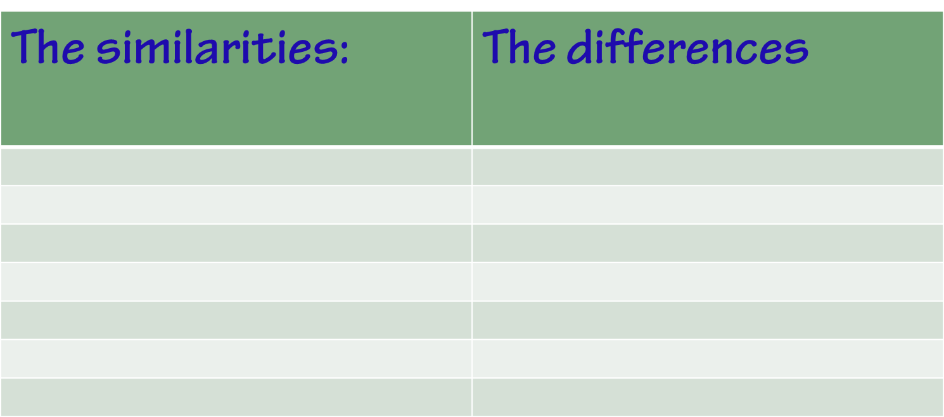
Mother in the novel is almost an exact copy of:
- The writer
- The writer’s sister
- One famous woman in the 19th century
- Any woman in any age

The dedication
TO MY DEAR SON PAUL BLAND BEHIND WHOSE KNOWLEDGE OF RAILWAYS MY IGNORANCE CONFIDENTLY SHELTERS

6th Lecture
The Railway Children: Story
The story concerns a family who move to "Three Chimneys", a house near the railway, after the father, who works at the Foreign office, is imprisoned as a result of being falsely accused of selling state secrets to the Russians.

Father is falsely accused of selling state secrets to the Russians. This crime is called:
    - High treason
    - Forgery
    - Greed
How many chapters does The Railway Children consist of?
14
15
16
17
Why has Father been imprisoned?
- He has been accused of selling state secrets to the Russians
- He killed his boss
- He stole money from the government

The three children, Roberta (Bobbie), Peter and Phyllis (Phil), find amusement in watching the trains on the nearby railway line and waving to the passengers. They become friendly with Albert Perks, the station porter, and with the Old Gentleman who regularly takes the 9:15 down train. He is eventually able to help prove their father's innocence, and the family is reunited.
CHAPTER 1: THE BEGINNING OF THINGS
One night at their home in London, father, mother, Roberta(also known as Bobbie), Peter and Phyllis are talking about Peter’s broken model engine when there is a knock on the front door. Two gentlemen come to see father and talk for a long time. Father speaks briefly with mother and mysteriously leaves home.
The next morning, mother leaves for London and returns in the evening, looking tired. She requests the children to be good while she is away and not to ask any question about father. Several horrid weeks pass by and one morning, mother tells the children that they are moving to a little white house near railway line in the country. They take the train and arrive at their new home in the dark.

THE BEGINNING OF THINGS
THEY were not railway children to begin with. I don't suppose they had ever thought about railways except as means of getting to Maskelyne and Cooke's, the Pantomime, Zoölogical Gardens, and Madame Tussaud's. They were just ordinary suburban children, and they lived with their Father and Mother in an ordinary red-brick-fronted villa, with coloured glass in the front door, a tiled passage that was called a hall, a bath-room with hot and cold water, electric bells, French windows, and a good deal of white paint, and "every modern convenience," as the house-agents say.

THE BEGINNING OF THINGS
THEY were not railway children to begin with. The narrative voice starts the book with an unfamiliar sentence, totally unexpected. This is one way of arousing the interest of children. The novel is called the Railway Children and yet it begins with a negation of this fact.
The novel is called the Railway Children and yet it begins with a negation of this fact:
- To arouse the interest of children
- Because the writer is fond of negation
- To show that children hate trains
- To attract attention to trains

THE BEGINNING OF THINGS
I don't suppose they had ever thought about railways. In this introductory sentence again we have a glimpse of the narrative voice. At the start of the novel it is a minor voice that does not interfere much in the events or the story. But we will discover that later on it will be very close to children.

THE BEGINNING OF THINGS
There were three of them. Roberta was the eldest. Of course, Mothers never have favourites, but if their Mother had had a favourite, it might have been Roberta. Next came Peter, who wished to be an Engineer when he grew up; and the youngest was Phyllis, who meant extremely well.

THE BEGINNING OF THINGS
like the first sentence, the way the writer introduces herself is also unfamiliar and interesting, just giving us one fact about each child. That is also done in an interesting way.

THE BEGINNING OF THINGS
Mother did not spend all her time in paying dull calls to dull ladies, and sitting dully at home waiting for dull ladies to pay calls to her. She was almost always there, ready to play with the children, and read to them, and help them to do their home-lessons. Besides this she used to write stories for them while they were at school, and read them aloud after tea, and she always made up funny pieces of poetry for their birthdays and for other great occasions, such as the christening of the new kittens, or the refurnishing of the doll's house, or the time when they were getting over the mumps.

THE BEGINNING OF THINGS
Mother did not spend all her time in paying dull calls to dull ladies, and sitting dully at home waiting for dull ladies to pay calls to her. She was almost always there…
- The writer supports feminism in an indirect way
- She is also very realistic.

Does the writer support feminism in the novel?
- Yes she does, in an indirect way
- She is very realistic.
- She does that in a direct way
- No she does not

the narrative voice is an important aspect of the novel:
- It creates an atmosphere of story telling
- It is just there for fun
- It has nothing to do with the story

Questions
THE BEGINNING OF THINGS
Mother was almost always there:
- She never slept
- She was always with her kids
- She spent most of her time with her kids

THE BEGINNING OF THINGS
They also had a father who was just perfect--never cross, never unjust, and always ready for a game--at least, if any time he was not ready, he always had an excellent reason for it, and explained the reason to the children so interestingly and funnily that they felt sure he couldn't help himself.
Father is only perfect- from the point of view of children. Realism again.

Questions
For the children, Father was just perfect :
- He used to get high marks at school
- He wanted his chldren to be perfect
- He knew what his kids needed so they considered him perfect

THE BEGINNING OF THINGS
You will think that they ought to have been very happy. And so they were, but they did not know how happy till the pretty life in the Red Villa was over and done with, and they had to live a very different life indeed.
The dreadful change came quite suddenly.
Peter had a birthday--his tenth.

Questions
Peter had a birthday--his tenth. This sentence:
- Explains the real change that has taken place in the life of the children
- Is a very fine technique used by the writer to explain the change gradually to children
- Has no meaning

The Beginning of Things
Mother began to be afraid that he might be sickening for measles, when suddenly he sat up in bed and said:--
"I hate gruel--I hate barley water--I hate bread and milk. I want to get up and have something real to eat."
"What would you like?" Mother asked.
"A pigeon-pie," said Peter, eagerly, "a large pigeon-pie. A very large one."
So Mother asked the Cook to make a large pigeon-pie. The pie was made. And when the pie was made, it was cooked. And when it was cooked, Peter ate some of it. After that his cold was better. Mother made a piece of poetry to amuse him while the pie was being made. It began by saying what an unfortunate but worthy boy Peter was, and then it went on

CHAPTER 1: THE BEGINNING OF THINGS
We learn from this brief summary that:
- the period of happiness the children spent at home came to an end with the arrest of the father. It was also very short-lived.
- The children did not notice the change in their life due to the responsible behaviour of the mother.
- Mother was different from all other mothers at that time.

We learn from this brief summary that:
- Father and Mother have been perfect, according to children’s definition of perfection: Father is always there for children, playing with them and fixing their engines, and mother also spends almost all her time with them.
- They are not ALWAYS there. No they are described as being almost always there. Very realistic. The novel can be said to enjoy a lot of verisimilitude.

7th Lecture
Chapter One
There is a very close connection between the poem at the start and the course of the whole novel.
Chapter One
He had an engine that he loved
With all his heart and soul,
And if he had a wish on earth
It was to keep it whole.
One day--my friends, prepare your minds;
I'm coming to the worst--
Quite suddenly a screw went mad,
And then the boiler burst!
With gloomy face he picked it up
And took it to his Mother,

For those who perished on the line
He did not seem to care,
His engine being more to him
Than all the people there.
And now you see the reason why
Our Peter has been ill:
He soothes his soul with pigeon-pie
His gnawing grief to kill.

He wraps himself in blankets warm
And sleeps in bed till late,
Determined thus to overcome
His miserable fate.
And if his eyes are rather red,
His cold must just excuse it:
Offer him pie; you may be sure
He never will refuse it.
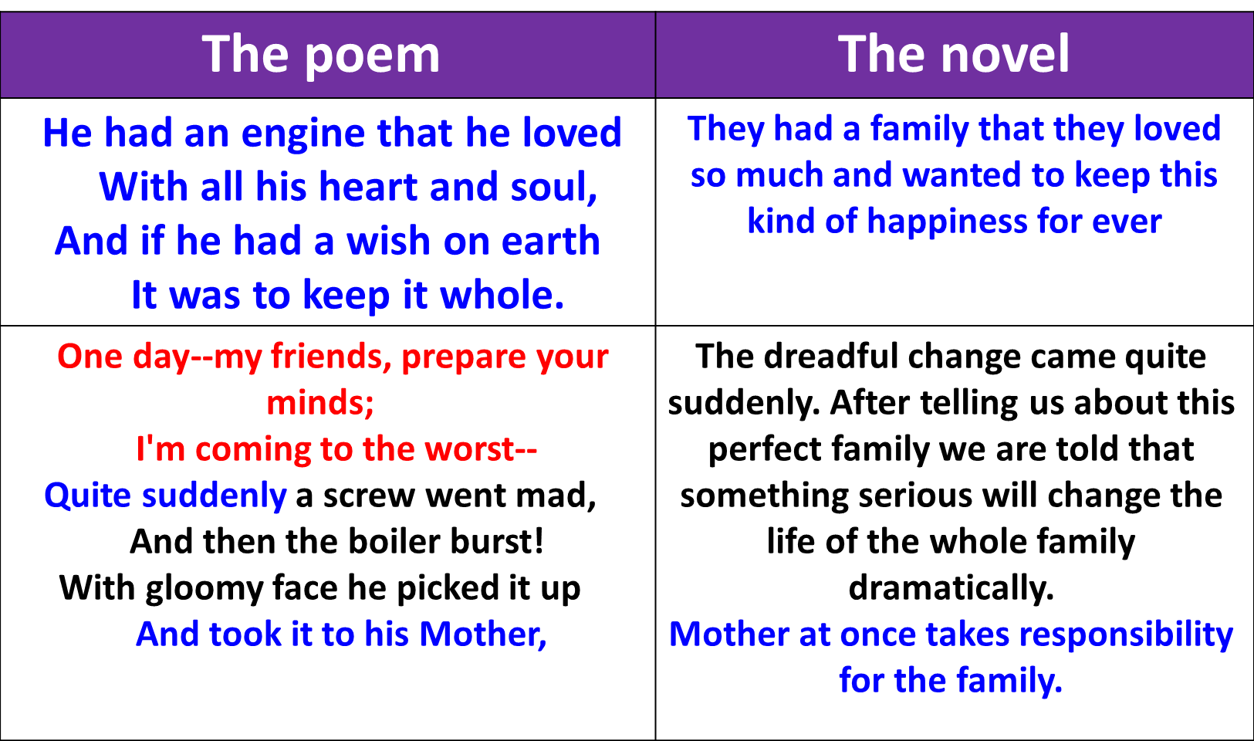
The novel and the poem

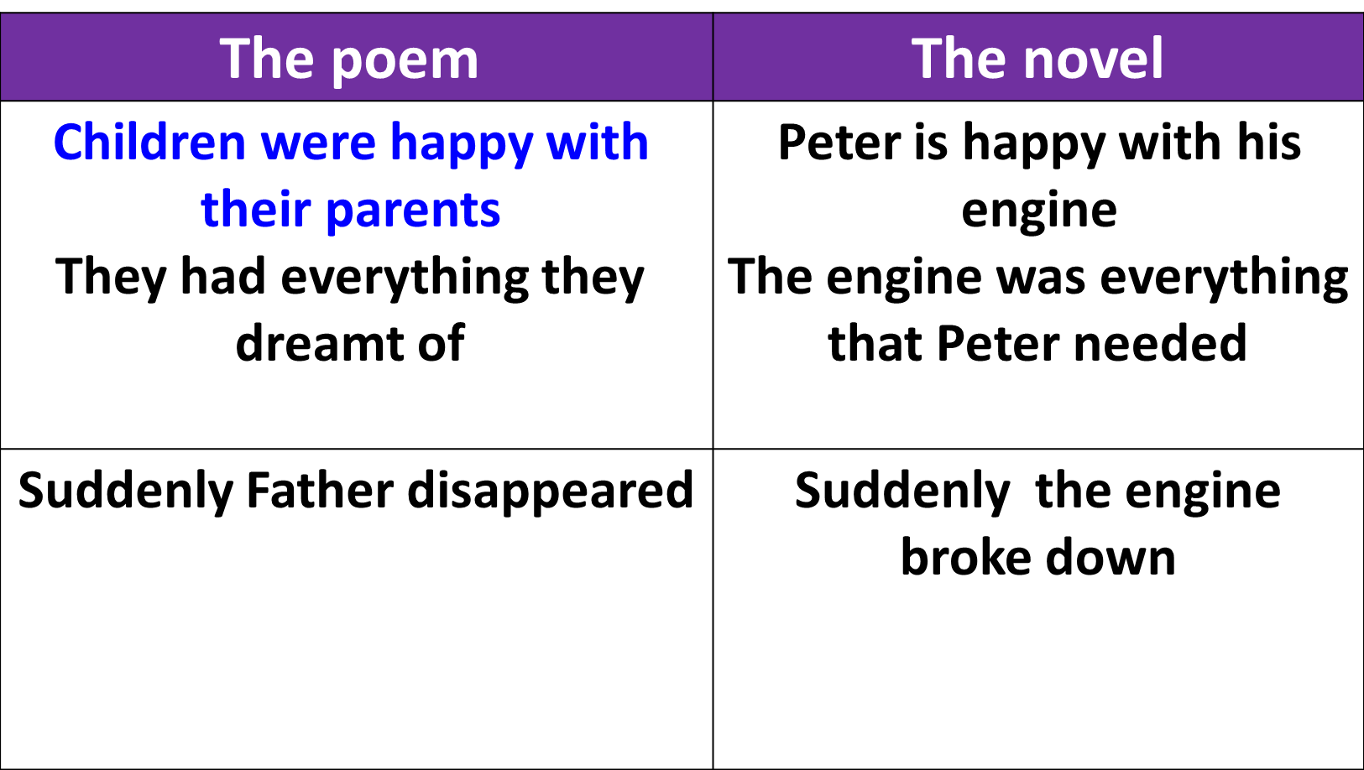
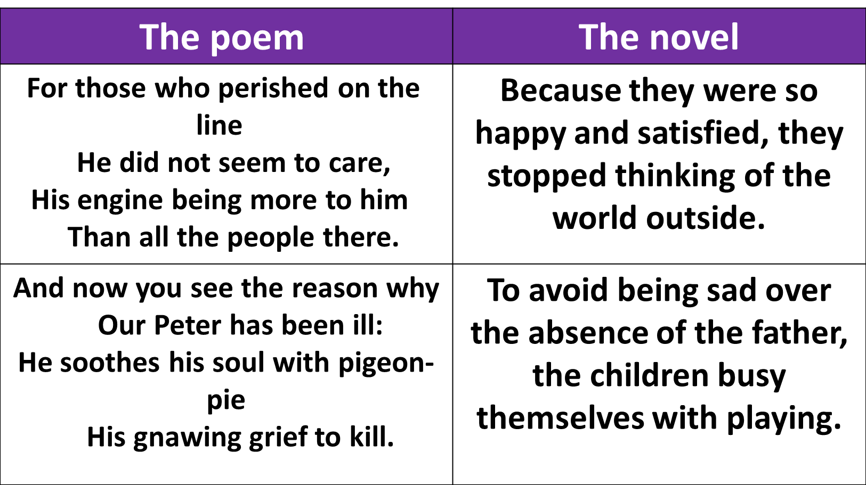
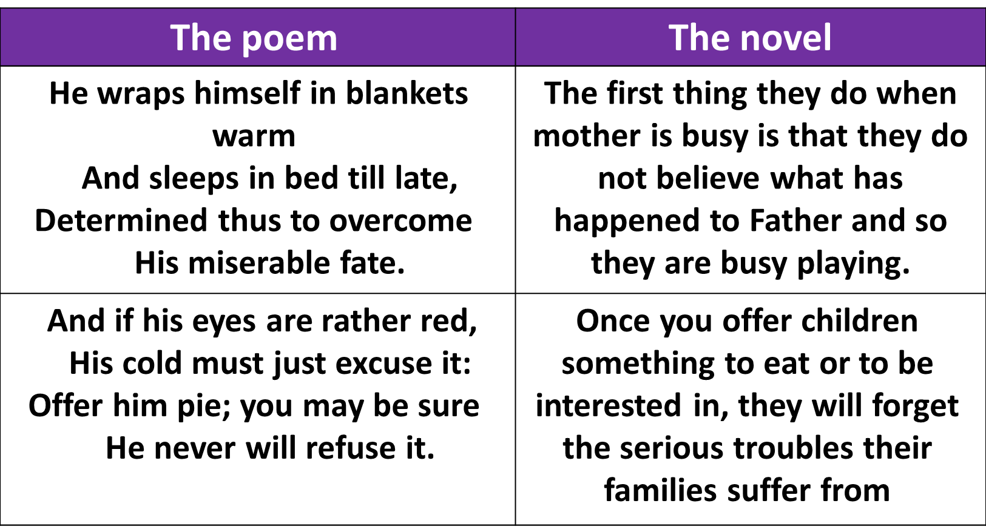

Chapter One
Peter with heroic unselfishness did not say anything about his Engine till after Father had had his dinner and his after-dinner cigar. The unselfishness was Mother's idea--but it was Peter who carried it out. And it needed a good deal of patience, too.
- The role of the mother in teaching politeness to children
- Children’s literature is didactic.
"Can girls help to mend engines?" Peter asked doubtfully.
"Of course they can. Girls are just as clever as boys, and don't you forget it! How would you like to be an engine-driver, Phil?"
"My face would be always dirty, wouldn't it?" said Phyllis, in unenthusiastic tones, "and I expect I should break something."
"I should just love it," said Roberta,--"do you think I could when I'm grown up, Daddy? Or even a stoker?"
"You mean a fireman," said Daddy, pulling and twisting at the Engine.
The novel indirectly talks about the call for the emancipation of women, what is regarded as the Feminist movement.
"Can girls help to mend engines?" Peter asked doubtfully.
"Of course they can. Girls are just as clever as boys, and don't you forget it! How would you like to be an engine-driver, Phil?“
- Peter represents all men who see women as unable to perform many things.
- Father is so wise. He is aware that boys and girls, men and women are equal in many respects. So he does not support his son against his daughters.
- All this is done indirectly.

The novel indirectly talks about the call for the emancipation of women, what is regarded as the Feminist movement.
- Directly
- Indirectly
- Casually
Peter’s way of dealing with his sisters suggests
- that he is like all boys who do not trust in the power of girls
- He does not have trust in himself
- His sisters do not like him
"Please'm," she (Ruth) said, "the Master wants you to just step into the study. He looks like the dead, mum; I think he's had bad news. You'd best prepare yourself for the worst, 'm--p'raps it's a death in the family or a bank busted or--"
"That'll do, Ruth," said Mother, gently; "you can go.“
Comment on the way each woman expresses herself.

"I say, Ruth, what's up?" he asked.
"Don't ask me no questions and I won't tell you no lies," the red-headed Ruth replied. "You'll know soon enough."
- The child is curious
- He forgets that it is wrong to ask servants about the affairs of the family
- Ruth is rude and cannot select her words decently.
"To London," Ruth said, and left them to their breakfast.
"There's something awful the matter," said Peter, breaking his egg. "Ruth told me last night we should know soon enough."
"Did you ask her?" said Roberta, with scorn.
"Yes, I did!" said Peter, angrily. "If you could go to bed without caring whether Mother was worried or not, I couldn't. So there!"
"I don't think we ought to ask the servants things Mother doesn't tell us," said Roberta.
"That's right, Miss Goody-goody," said Peter, "preach away."

- Peter takes the role of the father after Father is arrested. The writer draws a very interesting picture of how boys love to show themselves as in control of girls when their parents are busy.
- This is quite realistic. The novel has a lot of verisimilitude.
- Girls are less adventurous, more decent, as shown in Roberta’s reply.
- But they know among themselves that it was quite wrong to ask Ruth about their Father.

It was nearly seven before she came in, looking so ill and tired that the children felt they could not ask her any questions. She sank into an armchair. Phyllis took the long pins out of her hat, while Roberta took off her gloves, and Peter unfastened her walking-shoes and fetched her soft velvety slippers for her.
- Mother starts searching for work in order to support the family
- She does not tell her kids the real reason behind the absence of the Father.
- The kids are so polite. Their happy life in the villa gave them a lot of decency and politeness as when they take care of their tired mother.
"You can help me very much," said Mother,
"by being good and happy and not quarrelling when I'm away,"--Roberta and Peter exchanged guilty glances,--"for I shall have to be away a good deal."
"We won't quarrel. Indeed we won't," said everybody. And meant it, too.
"Then," Mother went on, "I want you not to ask me any questions about this trouble; and not to ask anybody else any questions."
Peter cringed and shuffled his boots on the carpet.
"You'll promise this, too, won't you?" said Mother.
"I did ask Ruth," said Peter, suddenly. "I'm very sorry, but I did."
"And what did she say?"
"She said I should know soon enough."
"It isn't necessary for you to know anything about it," said Mother; "it's about business, and you never do understand business, do you?"
Chapter one - Questions
The novel has ………………………verisimilitude.
- A lot of
- No
- Some
- No trace of
The way the novel is narrated is ……………..methods of narration in the 19th century novel
- Similar to
- Different from
- Superior to
- Has nothing to do with

"Then don't you worry either, Mother," said Phyllis, "and we'll all be as good as gold."
Mother sighed and kissed them.
"We'll begin being good the first thing to-morrow morning," said Peter, as they went upstairs.
"Why not now?" said Roberta.
"There's nothing to be good about now, silly," said Peter.
"We might begin to try to feel good," said Phyllis, "and not call names."

In the novel, there is a lot of repetition that is:
- Redundant
- Boring
- Useless
- Funny and important

8th Lecture
Approaches
So far, we have been trying to understand the novel as an example of children’s literature.
However, we need to think all the time of the following very important approaches which we will come across many times:
- The characteristics of children’s literature
- Feminism
- Railways and how effective they were on the life of people in the 19th century
Today, let us start with the first and second topics.
- Feminism
- It means the interest in women and women’s issues, in the good, interests, hope, ambitions, dilemma, disappointment of women.
- It also deals mainly with how women have been subjected and suppressed by men.
- To understand all this please try to understand the coming quotation.

It is in vain to say human beings ought to be satisfied with tranquillity: they must have action; and they will make it if they cannot find it. Millions are condemned to a stiller doom than mine, and millions are in silent revolt against their lot. Nobody knows how many rebellions besides political rebellions ferment in the masses of life which people earth. Charlotte Bronte, Jane Eyre

Women are supposed to be very calm generally: but women feel just as men feel; they need exercise for their faculties, and a field for their efforts, as much as their brothers do; they suffer from too rigid a restraint, too absolute a stagnation, precisely as men would suffer; and it is narrow-minded in their more privileged fellow-creatures to say that they ought to confine themselves to making puddings and knitting stockings, to playing on the piano and embroidering bags. Charlotte Bronte, Jane Eyre
One word: equality. Equality between men and women was the keyword.
What was the common idea about women in the Victorian Age?
They were forced to confine themselves to making puddings and knitting stockings, to playing on the piano and embroidering bags.

It is thoughtless to condemn them, or laugh at them, if they seek to do more or learn more than custom has pronounced necessary for their sex. Charlotte Bronte, Jane Eyre

- In the 19th century, both men and women were suppressed . They lived in stagnation. They needed freedom.
- Men thought that women do not have any faculties or energies.
- Men regarded the place of women to be home and only home.
- Women are not different from men in wanting change and in desiring the expression of their powers.
- Charlotte Bronte, Jane Eyre
- In The Railway Children, we are told in an indirect way of this eternal struggle between men and women.
- We are also told of how women do their best to achieve themselves and to arrive at self-assertion which is the essence of Feminism.
- Mother is different from all 19th century mothers.
- She may not have to work away from home now, but she gives almost all her time to her family, feeling very responsible for them.
Mother did not spend all her time in paying dull calls to dull ladies, and sitting dully at home waiting for dull ladies to pay calls to her. She was almost always there, ready to play with the children, and read to them, and help them to do their home-lessons. Besides this she used to write stories for them while they were at school, and read them aloud after tea, and she always made up funny pieces of poetry for their birthdays and for other great occasions, such as the christening of the new kittens, or the refurnishing of the doll's house, or the time when they were getting over the mumps.
- Mother has brought up her children in a very decent way. She has given them the major values they live upon when they grow up alone without Father. Examples: when Peter asks Ruth the servant about Father and later on he feels very sorry because kids are not supposed to do so. Also when he and Roberta quarrel in the absence of Mother. They soon realize that this is not nice and become friends again. They tell some family secrets to the station master. They steal coal from the station, and they apologize and understand that all this is wrong.
- Another aspect of Feminism is the continuous struggle between Peter as a boy and his sisters. We have had an example in Chapter one when Peter asks Father if girls can mend engines too.
- The wise Father (also the wise author) says that girls are as fit as boys. He talks to Roberta and Phil about that too.
- Peter says (a germ of endearment) in chapter one too in order to show up as the man of the house. It is funny because we know that the real phrase is ( a term of endearment)
- Another way of showing Mother as the perfect example of the WOMAN idealized by the author is in the contrast we have between her and Ruth and aunt Emma.

Ruth | Aunt Emma | Mother
Redheaded | Disorganized | Pretty and clean
Rough | Does not play with the kids | Almost always there
Rash , reckless | Stays away from kids | Wise
Uses indecent words | Insults children | Very sweet with kids
Not educated | A governor | A writer, a poet, so cultured
Driven away from the house | Travels to Germany, rescued only by Mother | A real example to follow even when she is sick or busy
Ruth and Mother
"Please'm," she said, "the Master wants you to just step into the study. He looks like the dead, mum; I think he's had bad news. You'd best prepare yourself for the worst, 'm--p'raps it's a death in the family or a bank busted or--"
"That'll do, Ruth," said Mother, gently; "you can go."

Ruth brushed the girls' hair and helped them to undress. (Mother almost always did this herself.) When she had turned down the gas and left them she found Peter, still dressed, waiting on the stairs.
"I say, Ruth, what's up?" he asked.
"Don't ask me no questions and I won't tell you no lies," the red-headed Ruth replied. "You'll know soon enough."

One day when Peter had made a booby trap over the bath-room door, and it had acted beautifully as Ruth passed through, that red-haired parlour-maid caught him and boxed his ears.
"You'll come to a bad end," she said furiously, "you nasty little lamb, you! If you don't mend your ways, you'll go where your precious Father's gone, so I tell you straight!"
Roberta repeated this to her Mother, and next day Ruth was sent away.
Aunt Emma and Mother
Mother was nearly always out. Meals were dull and dirty. The between-maid was sent away, and Aunt Emma came on a visit. Aunt Emma was much older than Mother. She was going to Germany to be a governess. She was very busy getting her clothes ready, and they were very ugly, dingy clothes, and she had them always littering about, and the sewing-machine seemed to whir--on and on all day and most of the night. Aunt Emma believed in keeping children in their proper places. And they more than returned the compliment.

Their idea of Aunt Emma's proper place was anywhere where they were not. So they saw very little of her. They preferred the company of the servants, who were more amusing. Cook, if in a good temper, could sing comic songs, and the housemaid, if she happened not to be offended with you, could imitate a hen that has laid an egg, a bottle of champagne being opened, and could mew like two cats fighting. The servants never told the children what the bad news was that the gentlemen had brought to Father. But they kept hinting that they could tell a great deal if they chose--and this was not comfortable.
9th Lecture
Second approach: Railways
- The invention of trains transformed the lives of people so much.
- It changed the rhythm of life from slow to fast
- It made transportation easier
- It made knowledge easier
- It created change and variety and killed boredom

For those who perished on the line
He did not seem to care,
His engine being more to him
Than all the people there.

He confessed to being absorbed in railways, the new lines of railways projected to thread the land and fast mapping it. —
George Meredith, Diana of the Crossways
"How gloriously we go along! I should like to ride on a railway every day." Hippias remarked: "They say it rather injures the digestion." "Nonsense! see how you'll digest to-night and to-morrow." "I hate slow motion after being in the railway," he said. — George Meredith, The Ordeal of Richard Feverel

"I hate slow motion after being in the railway,“
Every man and woman in the 19th century seemed to say

- children never though of trains before.
- Their life was still, perhaps boring.
- They felt happy but it was the sort of happiness that is coupled with boredom.
- They never saw or used trains except as means of going to the attractions as on page one.
- Once they are introduced to them their life changes completely.

A whirling week of packing followed--not just packing clothes, like when you go to the
seaside, but packing chairs and tables, covering their tops with sacking and their legs with straw.
All sorts of things were packed that you don't pack when you go to the seaside. Crockery, blankets, candlesticks, carpets, bedsteads, saucepans, and even fenders and fire-irons.

The girls folded up their clothes with more than usual neatness--which was the only way of being good that they could think of.
"I say," said Phyllis, smoothing out her pinafore, "you used to say it was so dull--nothing happening, like in books. Now something has happened."
"I never wanted things to happen to make Mother unhappy," said Roberta. "Everything's perfectly horrid."

When all the ugly useful things had been packed up and taken away in a van by men in green-baize aprons, the two girls and Mother and Aunt Emma slept in the two spare rooms where the furniture
Page 18

was all pretty. All their beds had gone. A bed was made up for Peter on the drawing-room sofa.
"I say, this is larks," he said, wriggling joyously as Mother tucked him up. "I do like moving! I wish we moved once a month."
Mother laughed.

This was the first train the children saw on that railway which was in time to become so very dear to them. They did not guess then how they would grow to love the railway, and how soon it would become the centre of their new life, nor what wonders and changes it would bring to them. They only shivered and sneezed and hoped the walk to the new house would not be long. Peter's nose was colder than he ever remembered it to have been before. Roberta's hat was crooked, and the elastic seemed tighter than usual. Phyllis's shoelaces had come undone
p. 18

A long gate had to be opened for the cart to pass through, and after that the road seemed to go across fields,--and now it went down hill. Presently a great dark lumpish thing shewed over to the right.
"There's the house," said Mother. "I wonder why she's shut the shutters."
"Who's she?" asked Roberta.
"The woman I engaged to clean the place, and put the furniture straight and get supper."

"It's only the rats," said the cart man. And he went away and shut the door, and the sudden draught of it blew out the candle.
"O dear," said Phyllis, "I wish we hadn't come!" and she knocked a chair over.
"Only the rats!" said Peter, in the dark

PETER'S COAL-MINE
"WHAT fun!" said Mother, in the dark, feeling for the matches on the table. "How frightened the poor mice were--I don't believe they were rats at all."
She struck a match and relighted the candle and every one looked at each other by its winky, blinky light.
"Well," she said, "you've often wanted something to happen, and now it has. This is quite an adventure, isn't it? I told Mrs. Viney to get us some bread and butter, and meat and things, and to have supper ready. I suppose she's laid it in the dining room. So let's go and see."

"What a horrid old woman!" said Mother; "she's just walked off with the money and not got us anything to eat at all."
"Then shan't we have any supper at all?" asked Phyllis, dismayed, stepping back on to a soap-dish that cracked responsively.
"Oh, yes," said Mother, "only it'll mean unpacking one of those big cases that we put in the cellar. Phil, do mind where you're walking to, there's a dear. Peter, hold the light."

"Let me do it," said Peter, thinking he could do it better himself. Every one thinks this when he sees another person stirring a fire, or opening a box, or untying a knot in a bit of string.
"You'll hurt your hands, Mammy," said Roberta; "let me."
"I wish Father was here," said Phyllis; "he'd get it open in two shakes. What are you kicking me for, Bobbie?"
"I wasn't," said Roberta.

"Hooray!" said Mother; "here are some candles--the very first thing! You girls go and light them. You'll find some saucers and things. Just drop a little candle-grease in the saucer and stick the candle upright in it."
"How many shall we light?"
"As many as ever you like," said Mother, gaily. "The great thing is to be cheerful. Nobody can be cheerful in the dark except owls and dormice."
So the girls lighted candles. The head of the first match flew off and stuck to Phyllis's finger; but, as Roberta said, it was only a little burn, and she might have had to be a Roman martyr and be burned whole if she had happened to live in the days when those things were fashionable.
Then when the dining room was lighted by fourteen candles, Roberta fetched coal and wood, and lighted a fire.

"What a good thing Aunt Emma packed up all the odds and ends out of the Store cupboard," said Mother. "Now, Phil, don't put the marmalade spoon in among the sardines."
"No, I won't, Mother," said Phyllis, and put it down among the Marie biscuits.
"Let's drink Aunt Emma's health," said Roberta, suddenly; "what should we have done if she hadn't packed up these things? Here's to Aunt Emma!"

They all felt that they had been a little hard on Aunt Emma. She wasn't a nice cuddly person like Mother, but after all it was she who had thought of packing up the odds and ends of things to eat.
It was Aunt Emma, too, who had aired all the sheets ready; and the men who had moved the furniture had put the bedsteads together, so the beds were soon made.

"Wassermarrer?" asked Phyllis, still almost wholly asleep.
Page 29
"Wake up! wake up!" said Roberta. "We're in the new house--don't you remember? No servants or anything. Let's get up and begin to be useful. We'll just creep down mouse-quietly, and have everything beautiful before Mother gets up. I've woke Peter. He'll be dressed as soon as we are."

So they dressed quietly and quickly. Of course there was no water in their room, so when they got down they washed as much as they
thought was necessary under the spout of the pump in the yard. One pumped and the other washed. It was splashy but interesting.
"It's much more fun than basiny washing," said Roberta. "How sparkly the weeds are between the stones, and the moss on the roof--oh, and the flowers!"

10st Lecture
"Wassermarrer?" asked Phyllis, still almost wholly asleep.
Page 29
"Wake up! wake up!" said Roberta. "We're in the new house--don't you remember? No servants or anything. Let's get up and begin to be useful. We'll just creep down mouse-quietly, and have everything beautiful before Mother gets up. I've woke Peter. He'll be dressed as soon as we are."
So they dressed quietly and quickly. Of course there was no water in their room, so when they got down they washed as much as they thought was necessary under the spout of the pump in the yard. One pumped and the other washed. It was splashy but interesting.
"It's much more fun than basiny washing," said Roberta. "How sparkly the weeds are between the stones, and the moss on the roof--oh, and the flowers!"
"Wassermarrer?"
basiny washing
Germ of endearment
These are ways in which the writer emphasizes the…………..of the novel.
- Verisimilitude
- Breadth
- Length
- Power

CHAPTER 2
The family do not get a decent supper as they think Mrs. Viney has not prepared it for them. Mother prepares what she can and off they go to bed. The next morning, the children wake up feeling excited in their new home. They discover that a nearby field backs onto a railway line but the railway station is too far to see from where they are.
When Mother discovers that Mrs. Viney has not prepared the food for the moving family and that she has not taken care of the new house, she says some strong words about her:
"There's the house," said Mother. "I wonder why she's shut the shutters.“
"Who's she?" asked Roberta.
"The woman I engaged to clean the place, and put the furniture straight and get supper."

"Well," she said, "you've often wanted something to happen, and now it has. This is quite an adventure, isn't it? I told Mrs. Viney to get us some bread and butter, and meat and things, and to have supper ready. I suppose she's laid it in the dining room. So let's go and see.“
p.24
"It isn't pigeon-pie," said Mother; "it's only apple. Well, this is the supper we ought to have had last night. And there was a note from Mrs. Viney. Her son-in-law has broken his arm, and she had to get home early. She's coming this morning at ten.“
p. 35
It was the very next day that Mother had to stay in bed because her head ached so. Her hands were burning hot, and she would not eat anything, and her throat was very sore.
"If I was you, Mum," said Mrs. Viney, "I should take and send for the doctor. There's a lot of catchy complaints a-going about just now. My sister's eldest--she took a chill and it went to her inside, two year ago come Christmas, and she's never been the same gell since." p. 35

Then they all looked at each other. Each of the three expressive countenances expressed the same thought. That thought was double, and consisted, like the bits of information in the Child's Guide to Knowledge, of a question, and an answer.
Q. Where shall we go?
A. To the railway.
So to the railway they went, and as soon as they started for the railway they saw where the garden had hidden itself. It was right behind the stables, and it had a high wall all round.
Idyllic, railways, adventure, realistic
"Oh!" said Roberta, drawing a long breath; "it was like a great dragon tearing by. Did you feel it fan us with its hot wings?"
"I suppose a dragon's lair might look very like that tunnel from the outside," said Phyllis.
But Peter said:--
"I never thought we should ever get as near to a train as this. It's the most ripping sport!"
"Better than toy-engines, isn't it?" said Roberta.
(I am tired of calling Roberta by her name. I don't see why I should. No one else did. Every one else called her Bobbie, and I don't see why I shouldn't.)
p.34
- Children are children. They have forgotten all about Father. They view an unidyllic world from the point of view of innocence.
- The narrative voice replaces Mother in being very close to the children.
(I am tired of calling Roberta by her name. I don't see why I should. No one else did. Every one else called her Bobbie, and I don't see why I shouldn't.)
p.34
Never before had any of them been at a station, except for the purpose of catching trains,--or perhaps waiting for them,--and always with grown-ups in attendance, grown-ups who were not themselves interested in stations, except as places from which they wished to get away.
p.36
Have you ever gone into a farm-house kitchen on a baking day, and seen the great crock of dough set by the fire to rise? If you have, and if you were at that time still young enough to be interested in everything you saw, you will remember that you found yourself quite unable to resist the temptation to poke your finger into the soft round of dough that curved inside the pan like a giant mushroom.

Page 38
And you will remember that your finger made a dent in the dough, and that slowly, but quite surely, the dent disappeared, and the dough looked quite the same as it did before you touched it. Unless, of course, your hand was extra dirty, in which case, naturally, there would be a little black mark.
Well, it was just like that with the sorrow the children had felt at Father's going away, and at Mother's being so unhappy. It made a deep impression, but the impression did not last long.
Page 38
The image of the dough is very interesting and significant. It shows how the writer is very realistic and specific at the same time. In an indirect way she has shown us how the children have grown oblivious of the absence of the Father, just like a dough that is growing will never be affected if you just insert your finger inside it. It will soon come back to its original shape. The life of the children is expanding and nothing will stop that.
Page 38
They soon got used to being without Father, though they did not forget him; and they got used to not going to school, and to seeing very little of Mother, who was now almost all day shut up in her upstairs room writing, writing, writing. She used to come down at tea-tine and read aloud the stories she had written. They were lovely stories.
The rocks and hills and valleys and trees, the canal, and above all, the railway, were so new and so perfectly pleasing that the remembrance of the old life in the villa grew to seem almost like a dream. Mother had told them more than once that they were "quite poor now," but this did not seem to be anything but a way of speaking. Grown-up people, even Mothers, often make remarks that don't seem to mean anything in particular, just for the sake of saying something, seemingly.
Before supper the children decide to go to the railway station. They have a lot to see and a large heap of coal catches Peter’s attention. When Peter steals coal from the station yard, he is caught by the Station Master.
Peter thinks that taking some coals from the middle of the heap is harmless. The Station Master warns them that what they have done is stealing because the coal belongs to the railway station. It is only then they realize what they have done is wrong.

11st Lecture

But in June came three wet days; the rain came down, straight as lances, and it was very very cold. Nobody could go out, and everybody shivered. They all went up to the door of Mother's room and knocked.
"Well, what is it?" asked Mother from inside.
"Mother," said Bobbie, "mayn't I light a fire? I do know how."
And Mother said: "No, my ducky-love. We mustn't have fires in June--coal is so dear. If you're cold, go and have a good romp in the attic. That'll warm you." p.39
"It's more than we can afford, chickeny-love," said Mother, cheerfully. "Now run away, there's darlings--I'm madly busy!"
"Mother's always busy now," said Phyllis, in a whisper to Peter. Peter did not answer. He shrugged his shoulders. He was thinking.
Thought, however, could not long keep itself from the suitable furnishing of a bandit's lair in the attic. Peter was the bandit, of course.

But when Phyllis was going to add jam to her bread and butter, Mother said:--
"Jam or butter, dear--not jam and butter. We can't afford that sort of reckless luxury nowadays."

To Help Mother in their own way, what do the children do?

"I have an idea."
"What's that?" they asked politely.
"I shan't tell you," was Peter's unexpected rejoinder.
"Oh, very well," said Bobbie; and Phil said, "Don't, then."
"Girls," said Peter, "are always so hasty tempered."
"I should like to know what boys are," said

"If I find a coal-mine, you shall help cart the coal," Peter condescended to promise.
"Keep your secret if you like," said Phyllis.
"Keep it if you can," said Bobbie.
"I'll keep it, right enough," said Peter.

The chariot was packed full of coal. And when it was packed it had to be unpacked again because it was so heavy that it couldn't be got up the hill by the three children, not even when Peter harnessed himself to the handle with his braces, and firmly grasping his waistband in one hand pulled while the girls pushed behind.
Three journeys had to be made before the coal from Peter's mine was added to the heap of Mother's coal in the cellar.
Page 44

p. 45
"So I've caught you at last, have I, you young thief?" said the Station Master.
"I'm not a thief," said Peter, as firmly as he could. "I'm a coal-miner."
"Tell that to the Marines," said the Station Master.

Has the writer told us directly that the family is getting poorer and poorer?
One great technique is the image of the candle.

Innocence & Child Talk

"It would be just as true whoever I told it to," said Peter.
"You're right there," said the man, who held him. "Stow your jaw, you young rip, and come along to the station."
"Oh, no," cried in the darkness an agonized voice that was not Peter's.
Page 46
"Not the police station!" said another voice from the darkness.
"Not yet," said the Station Master. "The Railway Station first. Why, it's a regular gang. Any more of you?"

"Only us," said Bobbie and Phyllis, coming out of the shadow of another truck labelled Staveley Colliery, and bearing on it the legend in white chalk, "Wanted in No. 1 Road."
"What do you mean by spying on a fellow like this?" said Peter, angrily.
"Time some one did spy on you, I think," said the Station Master. "Come along to the station."
"Oh, don't!" said Bobbie. "Can't you decide now what you'll do to us? It's our fault just as much as Peter's. We helped to carry the coal away--and we knew where he got it."

"Then why did you?" The Station Master's voice was so much kinder now that Peter replied:--
"You know that wet day? Well, Mother said we were too poor to have a fire. We always
Page 48
had fires when it was cold at our other house, and--"
"Don't!" interrupted Bobbie, in a whisper.

"Well," said the Station Master, rubbing his chin thoughtfully. "I'll tell you what I'll do. I'll look over it this once. But you remember, young gentleman, stealing is stealing, and what's mine isn't yours, whether you call it mining or whether you don't. Run along home."
"Do you mean you aren't going to do anything to us? Well, you are a brick," said Peter, with enthusiasm.
"You're a dear," said Bobbie.
"You're a darling," said Phyllis.
"That's all right," said the Station Master.
And on this they parted.
CHAPTER 3: THE OLD GENTLEMAN

By now the children know the time when the trains pass. Every morning, they will wave to an old gentleman who always waves back at them. They pretended that the old man knows their father and takes their love to him in London. One day, their mother becomes very ill and Bobbie resolves to do something positive to help.
AFTER the adventure of Peter's Coal-Mine, it seemed well to the children to keep away from the station,--but they did not, they could not, keep away from the railway. They had lived all their lives in a street where cabs and omnibuses rumbled by at all hours, and the carts of butchers and bakers and candlestick makers (I never saw a candlestick-maker's cart; did you?) might occur at any moment.

Here in the deep silence of the sleeping country the only things that went by were the trains. They seemed to be all that was left to link the children to the old life that had once been theirs. Straight down the hill in front of Three Chimneys the daily passage of their six feet began to mark a path across the crisp, short turf. They began to know the hours when certain trains passed, and they gave names to them. The 9.15 up was called the Green Dragon. The 10.7 down was the Worm of Wantley.

The children paint the words, “LOOK OUT AT THE STATION” on a large white sheet and wave it at the 9.15 train the next day. When the train is about ready to leave, Phyllis passes a letter to the Old Gentleman. In the evening, a large box of supplies is delivered to the children with all the things they have asked for.

CHAPTER 4: BOBBIE’S RIDE

When their mother finally recovers from her illness, they confess to her what they have done earlier. The family later celebrates Bobbie’s 12th birthday, all dressed in their best. Bobbie receives various presents from the family including Peter who reluctantly has to give her the broken half of his toy train filled with sweets.

Her lovely birthday party however ends on a sad note when she realizes that her mother is very upset later that night. Bobbie secretly wants to repair Peter’s broken train. She goes to the station and accidentally gets into the engine of one of the trains. Feeling scared, she seeks help from two railway workers. The two men not only repair the toy but also make sure she arrives home safely. Weeks later, Bobbie introduces Peter and Phyllis to the friendly engine driver and Jim, the fireman.

CHAPTER 5: SAVING THE TRAIN

The children witness a landslide that covers the railway line. The children prevent an imminent accident by waving the girls’ red petticoats. The train comes to rest just in time, at about twenty metres from where Bobbie stands on the tracks. Weeks later, a ceremony is held at the station to commemorate the children’s bravery. The Old Gentleman presents the children with a gold watch each and meets their mother at home. The children relay that eventful day to their mother.

12st Lecture
Child Talk: Innocence & Verisimilitude, Page 57
"I met the Station Master yesterday," said Peter, in an offhand/ casual way, and he pretended not to hear what Phyllis had said; "he expresspecially invited us to go down any time we liked." Irrelevant details?
"After the coals?" repeated Phyllis. "Stop a minute--my bootlace is undone again."
"It always is undone again," said Peter, "and the Station Master was more of a gentleman than you'll ever be, Phil--throwing coals at a chap's head like that."
All the time, Peter loves to show up as the man of the house.

Phyllis did up her bootlace and went on in silence, but her shoulders shook, and presently a fat tear fell off her nose and splashed on the metal of the railway line. Bobby saw it.

"Why, what's the matter, darling?" she said, stopping short and putting her arm round the heaving shoulders.
"He called me un--un--ungentlemanly," sobbed Phyllis. "I didn't never call him unladylike, not even when he tied my Clorinda to the firewood bundle and burned her at the stake for a martyr."
Peter had indeed perpetrated this outrage a year or two before
"Well, you began, you know," said Bobby, honestly, "about coals and all that. Don't you think you'd better both unsay everything since the wave, and let honour be satisfied?"
"I will if Peter will," said Phyllis, sniffing.
"All right," said Peter; "honour is satisfied. Here, use my hankie, Phil, for goodness' sake, if you've lost yours as usual. I wonder what you do with them."
Very amusing picture of Phil. A motif is something that is repeated in the novel for a certain reason, like the refrain in a poem.

Child Talk: Innocence & Verisimilitude, Page 61
I'm so glad you like the railway. Only, please, you mustn't walk on the line."
"Not if we face the way the train's coming?" asked Peter, after a gloomy pause, in which glances of despair were exchanged.
"No--really not," said Mother.
Then Phyllis said, "Mother, didn't you ever walk on the railway lines when you were little?"
Mother was an honest and honourable Mother, so she had to say, "Yes." (she could have lied to them right?)
"Well, then," said Phyllis.
"But, darlings, you don't know how fond I am of you. What should I do if you got hurt?"
"Are you fonder of us than Granny was of you when you were little?" Phyllis asked. Bobbie made signs to her to stop, but Phyllis never did see signs, no matter how plain they might be.
Mother did not answer for a minute. She got up to put more water in the teapot.
"No one," she said at last, "ever loved any one more than my mother loved me."

Child Talk: Innocence & Verisimilitude, Page 62
Then she was quiet again, and Bobbie kicked Phyllis hard under the table, because Bobbie understood a little bit the thoughts that were making Mother so quiet--the thoughts of the time
when Mother was a little girl and was all the world to her mother. It seems so easy and natural to run to Mother when one is in trouble. Bobbie understood a little how people do not leave off running to their mothers when they are in trouble even when they are grown up, and she thought she knew a little what it must be to be sad, and have no mother to run to any more.

So she kicked Phyllis who said:--
"What are you kicking me like that for, Bob?"
And then Mother laughed a little and sighed and said:--
"Very well, then. Only let me be sure you do know which way the trains come--and don't walk on the line near the tunnel or near corners."
What do you think of the character of Phil?
"Trains keep to the left like carriages," said Peter, "so if we keep to the right, we're bound to see them coming."
"Very well," said Mother, and I dare say you think that she ought not to have said it. But she remembered about when she was a little girl herself, and she did say it,--and neither her own children nor you nor any other children in the world could ever understand exactly what it cost her to do it. Only some few of you, like Bobbie, may understand a very little bit.

Child Talk: Innocence & Verisimilitude, Page 70
"DEAR MR. We do not know your name.
"Mother is ill and the doctor says to give her the things at the end of the letter but she says she can't aford it and to get mutton for us and she will have the broth. We do not know anybody here but you because Father is away and we do not know the address. Father will pay you, or if he has lost all his money, or anything, Peter will pay you when he is a man. We promise it on our honer. I.O.U. for all the things Mother wants
"sined PETER.
"Will you give the parsel to the Station Master, because of us not knowing what train you
come down by? Say it is for Peter that was sorry about the coals and he will know all right. "ROBERTA. "PHYLLIS. "PETER."

How many language mistakes can you find in the previous passage? Why are they kept as they are?
What do you think of the effect of this letter on children/readers?

Child Talk: Innocence & Verisimilitude, Page 72
"Dear Roberta and Phyllis and Peter," it said "here are the things you want. Your mother will want to know where they came from. Tell her they were sent by a friend who heard she was ill. When she is well again you must tell her all about it, of course. And if she says you ought not to have asked for the things, tell her that I say you were quite right, and that I hope she will forgive me for taking the liberty of allowing myself a very great pleasure."

Child Talk: Innocence & Verisimilitude, Page 73
"Now, listen," said Mother; "it's quite true that we're poor, but we have enough to live on. You mustn't go telling every one about our affairs--it's not right. And you must never, never, never ask strangers to give you things. Now always remember that--won't you?"
"And I'll write a letter to your old gentleman, and I shall tell him that I didn't approve--oh, of course I shall thank him, too, for his kindness. It's you I don't approve of, my darlings, not the old gentleman. He was as kind as ever he could be. And you can give the letter to the Station Master to give him,--and we won't say any more about it."

Child Talk: Innocence & Verisimilitude, Page 75
Afterward when the children were alone, Bobbie said:--
"Isn't Mother splendid? You catch any other grown-up saying it was sorry it had been angry."
"Yes," said Peter, "she is splendid; but it's rather awful when she's angry."
"She's like Avenging and Bright in the song," said Phyllis. "I should like to look at her if it wasn't so awful. She looks so beautiful when she's really downright furious."
13st Lecture
Chapter 6: Saviours of the train
The Russian gentleman got better day after another as the family took care of him. The mother wrote letters to some people who might know whereabouts in England a Russian gentleman's wife and family might possibly be.

Only the mother could communicate with him as she knows Russian. Children sympathize with him because he was sent to prison then to Siberia simply because he wrote a book about poor people. This interesting stranger kept the children away from the station for three days. Mother promised to tell the Station Master the story of the Russian Prisoner.
Later on, the children went to Perks, the railway porter, who received them coldly and was upset because he thought that the children kept a secret from him. The children didn't know what secret he meant and tried to solve the problem with Perks. They thought that their mother has told him about the Russian man. At last, he accepted their apologies.
Someday, the children went to collect some cherries. As the children were going down the tunnel, they heard a very odd noise that got louder and louder. Then, rocks, bushes and trees fell down on the railway. The train was only two miles away and there was no time to run to the station and let them know about it. A very frightful accident was expected.
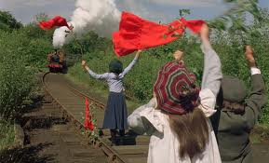
They had an idea to wave to the train as they used to
but they needed red clothes. So they took off their
red flannel petticoats and divided each petticoat into
three pieces. "Now, we've got six flags."

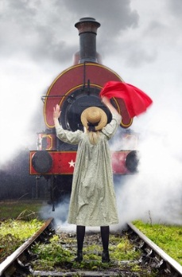
The train came rattling along very, very fast.
Bobbie stood on the railway line waving with
her two flags and when the driver and the fireman
had got off the engine, she fainted waving with the
flags but woke up after sometime.

Chapter 7: For valour
Roberta was quite oddly anxious to make other people happy. Also she had the power of silent sympathy. Bobbie had another quality which just means trying to help people. She kept thinking of some way of helping the Russian gentleman to find his wife and children.
One morning a letter came. It was addressed to Peter and Bobbie and Phyllis. They opened it with enthusiastic curiosity, for they did not often get letters.

The letter said:—
"Dear Sir, and Ladies,—It is proposed to make a small presentation to you, in commemoration of your prompt and courageous action in warning the train on the —- inst., and thus averting what must, humanly speaking, have been a terrible accident. The presentation will take place at the —- Station at three o'clock on the 30th inst., if this time and place will be convenient to you.
"Yours faithfully,
"Jabez Inglewood.
"Secretary, Great Northern and Southern Railway Co."
They felt so proud of themselves. They started getting ready for the day of the presentation guessing what their presents might be. On the day of the presentation, everybody was there including the old gentleman and everything looked as if it was Christmas. The District Superintendent started a long speech praising the children and said all sorts of nice things about the children's bravery and presence of mind.

Then the old gentleman got up and said things, too. It was very like a prize-giving. And then he called the children one by one, by their names, and gave each of them a beautiful gold watch and chain. Each of the children said "Thank you," but Peter said a few words for which people clapped him more than they had done the District Superintendent.

As usual, Bobbie couldn't stop thinking of their Russian friend and thought of asking the old gentleman for a help. They told him about the story of the Russian and how they want more than anything in the world is to find his wife and children for him.

Bobbie wrote down the name of the Russian "Szezcpansky," for the gentleman and he promised to ask about his family. Ten days later, the old gentleman found out about the Russian's wife and children and wanted to be the bearer of the good news but when he saw Bobbie, he let her tell the good news herself. Bobbie wished that she didn't carry the news as the Russian sprang up with a cry of love and longing. Everyone felt happy for Szezcpansky. The Russian packed his few belongings and left to the station. Mother was so thankful to the old gentleman for all what he did for them so far.

Chapter 8: The amateur firemen
Perks and the children are having tea in the porter's room and they are discussing Bobbie's birthday gift. The children ask about Perks's birthday and inquire why he doesn't keep it. He answers that he has other things to keep that are his wife and children.

The children went to the Canal Bridge to fish but the line was not long enough so they stayed and looked at the sunset. While they are staring at the water, a man came over thinking that they were fishing. he twisted Peter's ear slightly. Bobbie apologized and told him that they fished nothing and they didn't know that the Canal is his.
Not knowing where the properties of other people start and end end.
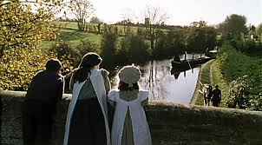
It was past bedtime and the children were going home when they noticed that smoke was coming from the chimney of the cabin of the canal boat. In an instant all three made for the barge. Peter and Bobbie fought over who is going down to the cabin but Peter had already gone down. The cabin glowed red. A paraffin lamp was burning calmly in an orange mist.
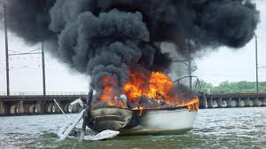
Peter felt his way through the dark smoke, found
something small and soft and warm and alive, picked
it up and backed out. It was the baby whose cry they heard.
Bobbie saved the dog also. Bobbie ran to the 'Rose and
Crown' to tell them.

There is a nice old-fashioned room at the 'Rose and Crown; where Bargees and their wives sit of an evening. The Bargee Bill, whom the children had found so disagreeable, was considered excellent company by his mates. "Oh," said Bobbie, seeing the bargewoman and making for her. "Your barge cabin's on fire. Go quickly." Bill the Bargee rose slowly and heavily. But his wife was a hundred yards up the road before he had quite understood what was the matter. To thank the children, Bill told them to come at seven in the morning to take them on a trip.
Chapter 9: The pride of Perks.
Mother sold another story so there will be buns to have with tea. The children exchanged
glances and asked mother if they can keep the buns till the fifteenth of this month that is
Perks's birthday. Then they planned to make a birthday for Perks. They went through the
village asking people to help in holding a birthday for Perks believing that he is a friendly man
whom a lot of people would like to celebrate his birthday.

The children told Mother about what they did. "There's no harm in it," said Mother, "but it depends HOW you do it. I only hope he won't be offended and think it's CHARITY. Poor people are very proud, you know." "It isn't because he's poor," said Phyllis; "it's because we're fond of him."
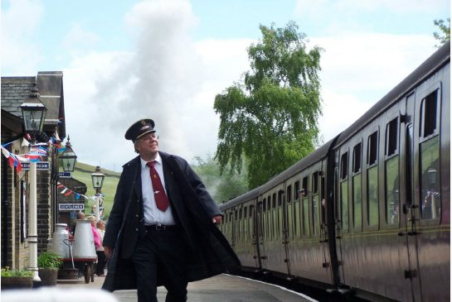
All the things that had been collected for Perks were packed, and at half-past three Peter and Bobbie and Phyllis wheeled down to the little yellow house where Perks lived. Mrs, Perks opened the door for the children. "We knew it was his birthday," said Peter, "and we've got some presents for him outside in the perambulator." She started crying that makes the children think that she didn't like their presents. Together with Mrs. Perks, they arranged the table to have tea with all the things they brought for the birthday.

The children hid as they heard Perks coming home. Perks asked Mrs. Perks from where she got all these things for his birthday. Meantime, Bobbie remembered that she had forgotten to put the labels on any of the things! He won't know what's from who. He'll think it's all US, and that we're trying to be grand or charitable. Perks got very angry thinking that the things they got are charity. The children tried to explain how they did all that because they are fond of him and they thought he would be pleased. They added how they used to exchange gifts with their parents and servants on their birthdays. As he knew that the things are from his neighbors, he asked them to return them.



To convince him, Bobbie read the labels for him as they wrote what people said while giving their gifts. Perks noticed how none of his neighbors mentioned anything about charity and all was given out of their love and respect to him as a dear friend. Finally, they had tea and enjoyed the small birthday party together.

Chapter 10: The terrible secret.
When they first went to live at Three Chimneys, the children had talked a great deal about their Father. But as the time went on they grew to speak less of him. Bobbie had felt almost from the first that for some strange miserable reason these questions hurt Mother and made her sad. And little by little the others came to have this feeling, too, though they could not have put it into words.

One day, Mother asked, "Bobbie, do you think Peter and Phil are FORGETTING Father?" she noticed how they don't talk about Father anymore. Bobbie told her how they do talk about him when they are by themselves. She added that she felt how her questions about her father hurt. Mother told Bobbie that besides being away from Father, they had great sorrow. That evening in the hour before bed-time instead of reading to the children Mother told them stories of the games she and Father used to have when they were children.

Someday, Bobbie and Peter were quarrelling in the garden, and suddenly Mother heard Peter screaming. When she got there, she found his foot hurt. There were three red wounds in Peter's foot and ankle, where the teeth of the rake had bitten him, and his foot was covered with red smears. Mother washed his wounds and took care of him. Bobbie prepared tea and started thinking of gloomy possibilities of what might happen to Peter. Phyllis ran to call the Doctor. The Doctor came and looked at the foot and bandaged it beautifully, and said that Peter must not put it to the ground for at least a week, and he will be fine in a fortnight.


Bobbie went to Perks and asked him for some magazines for Peter as he got bored sitting at home. Suddenly she clutched the parcel tighter and bent her head over it. It seemed like some horrible dream. She never remembered how she got home. But she went on tiptoe to her room and locked the door. What she had read was headed, 'End of the Trial. The name of the man who had been tried was the name of her Father. The verdict was 'Guilty.' And the sentence was 'Five years' Penal Servitude.'

14ST Lecture

Chapter 11
Bobbie knew the secret now. Bobbie tried hard to pretend that there is nothing horrible during the tea meal. Then she went upstairs with Mother and told her how she knew about her father.

"That's all right," said Mother. "It's not true. And they've shut him up in prison, but he's done nothing wrong. He's good and noble and honourable, and he belongs to us. We have to think of that, and be proud of him, and wait."

As Bobbie asked Mother to tell her the whole story, Mother said how those men, who had asked to see Father on that remembered last night when the Engine was being mended, had come to arrest him, charging him with selling State secrets to the Russians—with being, in fact, a spy and a traitor. She heard about the trial, and about the evidence—letters, found in Father's desk at the office, letters that convinced the jury that Father was guilty. "Someone put them there. And the person who put them there was the person who was really guilty."

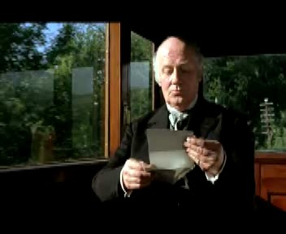
A week later, Bobbie managed to
get away alone.
And once more she wrote
a letter. And once more
it was to the old gentleman.

My dear Friend," she said, "you see what is in this paper. It is not true. Father never did it. Mother says someone put the papers in Father's desk, and she says the man under him that got Father's place afterwards was jealous of Father, and Father suspected him a long time. But nobody listens to a word she says, but you are so good and clever, and you found out about the Russian gentleman's wife directly.

Can't you find out who did the treason because he wasn't Father upon my honour; he is an Englishman and uncapable to do such things, and then they would let Father out of prison. It is dreadful, and Mother is getting so thin. She told us once to pray for all prisoners and captives. I see now. Oh, do help me—there is only just Mother and me know, and we can't do anything. Peter and Phil don't know. I'll pray for you twice every day as long as I live if you'll only try—just try to find out. Think if it was YOUR Daddy, what you would feel. Oh, do, do, DO help me. With love
"I remain Your affectionately little friend
"Roberta.

One morning Mother let them take their lunch and go out for the day to see the paper chase. The hare was a big-boned, loose-limbed boy, with dark hair lying flat on a very damp forehead. The bag of torn paper under his arm was fastened across one shoulder by a strap. The hare ran along the line, and the workmen leaned on their picks to watch him. He ran on steadily and disappeared into the mouth of the tunnel. "That's against the by-laws," said the foreman.
definition of paper chase (Individual Sports & Recreations / Athletics (Track & Field)) a former type of cross-country run in which a runner laid a trail of paper for others to follow ...

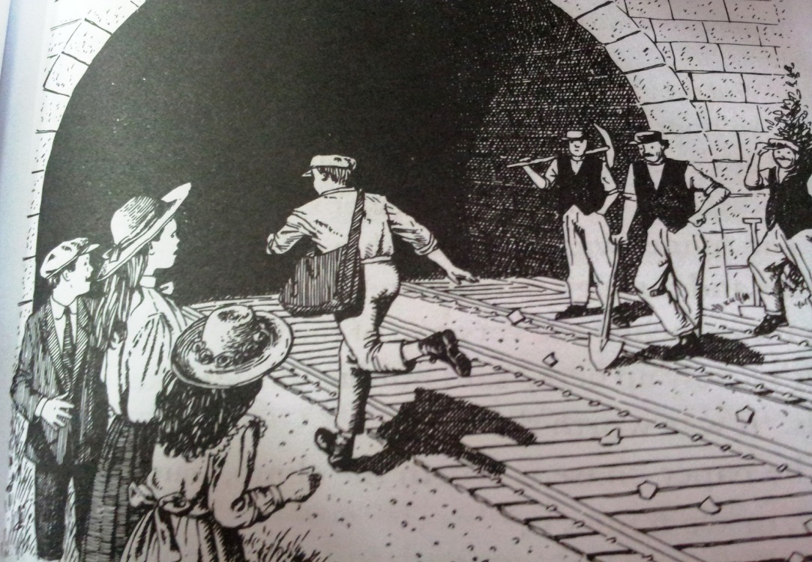
What is a paperchase?
Paper Chase (also known as Hare and Hounds or Chalk Chase) is a racing game played outdoors (best played within a wood or even a shrubbery maze) with any number of players. At the start of the game, one person is designated the 'hare' and everyone else in the group are the 'hounds'. The 'hare' starts off ahead of everyone else leaving behind themselves a trail of paper shreds (or chalk marks in an urban environment) which represents the scent of the hare. Just as scent is carried on the wind, so too are the bits of paper, sometimes making for a difficult game. After some designated time, the hounds must chase after the hare and attempt to catch them before they reach the ending point of the race. It is generally done over a long distance, but shorter courses can be set.

And now, following the track of the hare by the little white blots of scattered paper, came the hounds. There were thirty of them, and they all came down the steep, ladder-like steps by ones and twos and threes and sixes and sevens. Bobbie and Phyllis and Peter counted them as they passed. The foremost ones hesitated a moment at the foot of the ladder, then their eyes caught the gleam of scattered whiteness along the line and they turned towards the tunnel, and, by ones and twos and threes and sixes and sevens, disappeared in the dark mouth of it. The last one, in a red jersey, seemed to be extinguished by the darkness like a candle that is blown out.

Sometimes later, the children came down the hill and the hounds came—by ones and twos and threes and sixes and sevens—and they also were going slowly and seemed very tired. Peter noticed that the one in the red jersey is missing. They waited for him for a long time but he didn't appear. They want into the tunnel to look for him. Peter stopped within a yard of what they had come into the tunnel to look for. Phyllis saw a gleam of red, and shut her eyes tight. There, by the curved, pebbly down line, was the red-jerseyed hound. His back was against the wall, his arms hung limply by his sides, and his eyes were shut. "Oh, look up, speak to me! For my sake, speak!" the children cried.

Chapter 12: What Bobbie brought home.
Wet his ears with milk," said Bobbie. "I know they do it to people that faint—with eau-de-Cologne. But I expect milk's just as good." the red jersey sighed, and opened his eyes, and shut them again and said in a very small voice, "Chuck it." The children made him drink some milk so he got better but he broke his leg as he could not move. Bobbie stayed with the injured boy till Peter and Phil get help.
Sometime later, Peter and Phil came back to the tunnel and Jim had been lifted on to the hurdle and carried to the children's home as he lived away.

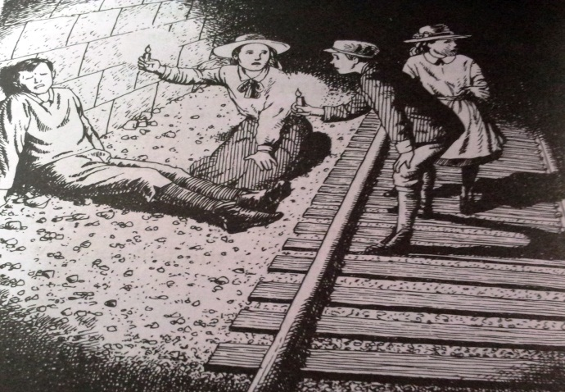
Chapter 13: The hound's grandfather.
The red-jerseyed hound whom the children had brought to Three Chimneys had to be put to bed. And then the Doctor came, and hurt him most horribly. Mother was with him all through it. The doctor said Jim will get better soon and was pleased with what the successful operation he did.

Mother had to write to Jim's grandfather who lived near the Three Chimneys. She cannot afford all what the boy might need and nurse him as she is busy with her writing. Peter wishes to keep the boy in the home till he gets well but he is convinced with what Mother has said. He asks her if she could write a book in which she makes Father come home. Mother tells him how it is better to be in a book written by God as everything will end well without mistakes.

Surprisingly, Jim's grandfather is the old gentleman himself whom the children used to wave to. "I say, though," said Peter, "you're not going to take Jim away, though, are you?" "Not at present," said the old gentleman. "Your Mother has most kindly consented to let him stay here. I thought of sending a nurse, but your Mother is good enough to say that she will nurse him herself." "But what about her writing?" said Peter, before anyone could stop him. "There won't be anything for him to eat if Mother doesn't write." "That's all right," said Mother, hastily. The old gentleman looked very kindly at Mother. "I see," he said, " you trust your children, and confide in them." "Of course," said Mother. "Then I may tell them of our little arrangement," he said. "Your Mother, my dears, has consented to give up writing for a little while and to become a Matron of my Hospital."

At the gate the old gentleman stopped and said:—
"You're a good child, my dear—I got your letter. But it wasn't needed. When I read about your Father's case in the papers at the time, I had my doubts. And ever since I've known who you were, I've been trying to find out things. I haven't done very much yet. But I have hopes, my dear—I have hopes."

Chapter 14: The End.
Life at the Three Chimneys was never quite the same again after the old gentleman came to see his grandson. Although they now knew his name, the children never spoke of him by it—at any rate, when they were by themselves. To them he was always the old gentleman, and I think he had better be the old gentleman to us, too.

It wouldn't make him seem any more real to you, would it, if I were to tell you that his name was Snooks or Jenkins (which it wasn't)?—and, after all, I must be allowed to keep one secret. It's the only one; I have told you everything else, except what I am going to tell you in this chapter, which is the last. At least, of course, I haven't told you EVERYTHING. If I were to do that, the book would never come to an end, and that would be a pity, wouldn't it?

Then as Jim's leg got better it was very pleasant to go up and sit with him and hear tales about his school life and the other boys. The children spent their time studying and making rhymes for their lessons which makes learning them jollier.
"Things DO happen by themselves sometimes, without your making them," said Phyllis, rather as though, usually, everything that happened in the world was her doing "I wish something would happen," said Bobbie, dreamily, "something wonderful." And something wonderful did happen exactly four days after she had said this.

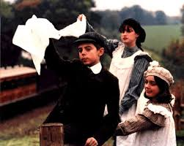
The children missed their goings to the railway. They ran. And once more they waved their handkerchiefs, without at all minding whether the handkerchiefs were clean or not, to the 9.15. "Take our love to Father!" cried Bobbie. And the others, too, shouted:—
"Take our love to Father!"

The old gentleman waved from his first-class carriage window. Quite violently he waved. And there was nothing odd in that, for he always had waved. But what was really remarkable was that from every window handkerchiefs fluttered, newspapers signalled, hands waved wildly. The train swept by with a rustle and roar, the little pebbles jumped and danced under it as it passed, and the children were left looking at each other.

"Well!" said Peter.
"WELL!" said Bobbie.
"WELL!" said Phyllis.
"Whatever on earth does that mean?" asked Peter, but he did not expect any answer. "I don't know," said Bobbie. "Perhaps the old gentleman told the people at his station to look out for us and wave. He knew we should like it!"

Now, curiously enough, this was just what had happened. The old gentleman, who was very well known and respected at his particular station, had got there early that morning, and he had waited at the door where the young man stands holding the interesting machine that clips the tickets, and he had said something to every single passenger who passed through that door.

Only three people got out of the 11.54. The first was a countryman with two baskety boxes full of live chickens who stuck their russet heads out anxiously through the wicker bars; the second was Miss Peckitt, the grocer's wife's cousin, with a tin box and three brown-paper parcels; and the third—

"Oh! My Daddy, my Daddy!" That scream went like a knife into the heart of everyone in the train, and people put their heads out of the windows to see a tall pale man with lips set in a thin close line, and a little girl clinging to him with arms and legs, while his arms went tightly round her.

Now the house door opens. Bobbie's voice calls:—
"Come in, Daddy; come in!"
He goes in and the door is shut. I think we will not open the door or follow him. I think that just now we are not wanted there. I think it will be best for us to go quickly and quietly away. At the end of the field, among the thin gold spikes of grass and the harebells and Gipsy roses and St. John's Wort, we may just take one last look, over our shoulders, at the white house where neither we nor anyone else is wanted now.




