كورن فليكس
محاضرة (1 )
بسم الله الرحمن الرحيم

مهارات القراءة والاستراتيجيات:

أول واحد هو OARWET من المهم، عموما، يساعد في قراءة كتاب اللغة الإنجليزية.

O = نظرة عامة/ ما هذا الكتاب يتحدث عن، وجود فكرة، والكاتب، والعناوين، والصور، الفصول ...
A = اسأل /هل من السهل أو الصعب، ما يتحدث عن ...
R = عندما تقرأ/ قراءة والعثور على الإجابات لأسئلة معلومات ستبقى لفترة طويلة ..
W = الكتابة/ إذا كان لديك كتاب النص طويل جدا محاولة كتابة بعض المعلومات الهامة في ورقة تلخص = من الفكرة الرئيسية.
E = تقييم /من خلال التدريبات في الكتاب، في محاولة لطرح الأسئلة الخاصة بك النفس عن الفكرة الرئيسية للقصة. تقييم = الدراسة.
T = اختبار/ والحصول على "A".
__________________________
يقول الدكــــــتور ~
قراءة القطعة في صفحة 5 من غير توقف للترجمة لأننا في المستوى الرابع لو ترجمنا كل كلمة فلن ننهي الفصل
ــــــــــــــــــــــــــــــــــــــــــــــــــ ــــــــــــ

كلمات من القطعة

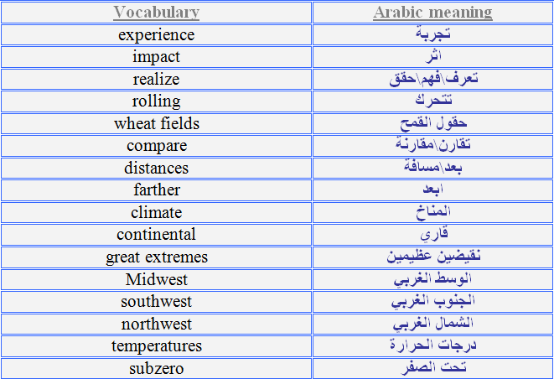

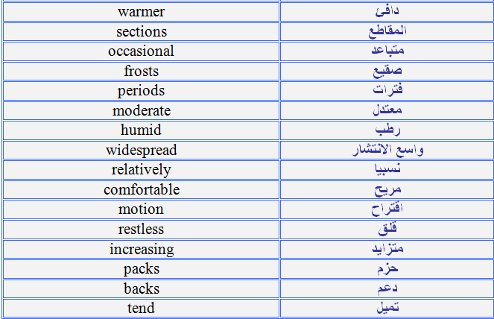

محاضرة (2)
في المحاضرة الثانية يتكلم عن السفكس والبريفكس
استخدام الـprefix and suffixes < تذكرونها طبعا
unhappy = un + happy < تغير معنى الكلمه من سعيد لغير سعيد
prefix + stem
hopeless = hope + less> تغير معني الكلمه
stem + suffixes
احيانا نضيف الـ prefix and suffixe لنفس الكلمه
unhappiness= un+ happy + ness
compound nouns < المفردات المركبه نجمع الاسماء بطريقتين
do-it-yourself-jop< 1/ نجمعهم بس نفصل بينهم بشرطات
overnight< 2/ نجمعهم بدون فصل ولا شرطات
ـــــــــــــــــــــــــــــــــــــــ
Suffixes
حرف او مجموعة من الاحرف تأتي في آخر الكلمه
بناخذ 6 منهم في هل محاضره :
Able -comfortable
al- logical
ant- consultant
er – rader
ity- tranquility
less – helpless

المفردات المركبة و هي على نوعين
يفصل بينها فاصل 1/

Long - distantيعني عن بعد
to - do listقائمة بالاشياء اللي ودك تسويها
self-help-bookكتاب مساعدة ذاتي
do- gooderعمل الخير للناس

2/ من غير فاصل
overnight:طوال الليل
farewell
seashoreشاطئ
householdمنزلي
widespread: واسع الانتشار
القطعه عباره عن طرق الناس المختلفه للسلام على بعض في الحضارات المختلفه لم يقرئها بس قال تتكلم عن آيش
بعدين في بعض الاسئله التي قد تعتبر غير لائقه في بعض الحضارات وعاديه جدا في حضارات اخرى اكثر الاسئله التي قد تعتبر غير لائقه في الدول الاوربيه السؤال عن العمر والراتب ص 14

محاضرة (3 )
Non fictional prose

Non – fictional – prose:= English Academic reading not literatural texts.
Not stem suffix( related to)

_ _ _ _ _ _ _

{ الكتاب مهم للقراءة }

_ _ _ _ _ _ _

We'll study two main ideas:
- Inferencing the main idea.
- More suffixes and prefixes.
- Book page( 16-23)
- _ _ _ _ _ _ _
- تمرين 1صـ 16
- Part 2: My Country:
- Before you read :
- Getting the meaning of words from context and structure_

التمرين الاول اطلع معنى الكلمات كتبت لكم الجواب عَ طول
-
- Endless = stretching out in all directions.
- Vastness = large size .
- Observant = looks around.
- Make up = character.
- Melting pot = people coming from different places.
- Humidity = wetness.
- A new comer = has just arrived.
- Uprising = big revolution.
- Lawmen = sheriffs &policemen.
- Outgoing = not shy.
- French – style = in the French way.
-

17صــ
Finding implied main idea of a paragraph
Not clearمعناها

في هل تمرين اختار الفكرة الرئيسيه لكل برجراف

ويقول الدكتور

I promise I'll not bring such items

أنه ماراح يجيب هالطريقة بالاختبار لأنها جميعها صحيحة ومحيرة

1. What is the main idea of the paragraph " A" ?
Choice (B)
2. What is the main idea of the paragraph " B" ?
Choice (C)
3. What is the main idea of the paragraph " C" ?
Choice (C)
4. What is the main idea of the paragraph " D" ?
Choice (B)
5. What is the main idea of the paragraph " E" ?
Choice (C)

3- Checking your Comprehension : Go to the book page 21-22
Mark the following statements T (true) or F (false)

1. Choice- F

2. Choice- T

3. Choice -F

4. Choice -F

5. Choice -T

6. Choice- F

7. Choice- F

8. Choice -T

9. Choice -F

10. Choice- F
4- Analyzing the prefixes Non- and Anti- using the examples in the Strategy Box above as models, write definitions for the following words: Goto the book page 22

- The prefix non- means "not" تعني لا
- The prefix anti- means "against" تعني ضد
-
- 1. nonresidents : not residents غير المقيمين
- 2. anti-American : against Americanضد امريكا
- 3. an antiwar protest : against war protestاحتجاج ضد الحرب
- 4. a nonviolent group : a group don't like violentمجموعه لا تحبالعنف
- 5. non-Germans : not Germansليس الماني
- 6. non-Mexicans : not Mexicansليس مكسيكي
- 7. antisocial : against social ضد الاجتماعية
- 8. nonvoters : against voters on electionضد التصويت
- 9. antimonopoly laws : against monopoly laws ضد قوانين الاحتكار
- 10. nonpayment : don't payلا تدفع
- _ _ _ _ _ _ _ _ _
- حل تمرين صــ23
- 5- Analyzing Four More Suffixes: : Go to the book page 23 لواحق
- هنا تكون الكلمه فعل بس اضيف لها السفكس تصير اسم

- 1. –ation : The suffix -ation means the "process or condition of some action or quality." It makes nouns out of verbs.
- For example : decorating – decoration
- 2. –ful : The suffix -ful means "full of or characterized by a certain quality."
- It makes adjectives out of nouns.
- For example : harm – harmful
- 3. –ment : The suffix -ment means "something that results from the action of a verb." It makes nouns out of verbs.
- For example : govern – government
- 4. –ous : The suffix -ous means "having or being full of some quality."
- It makes adjectives out of nouns.
- For example : glory – glorious

- 6- Making New Words by Adding Suffixes : Go to the book
- page 23كلمات نضيف لهـآ السفكس
- 1. (line 23) environsment
- 2. (line 4) imagineation
- 3. (line 64) powerful
- 4. (line 20) moderateation
- 5. (line 46) settlersment
- 6. (line 64) move ment
- 7. (line 14) mountainsous
- 8. (line 51) mysteryous

كلــمآت من المحاضره مترجمةة لمن يصعب علية فهمها < متعوب عَ هـ/جمله
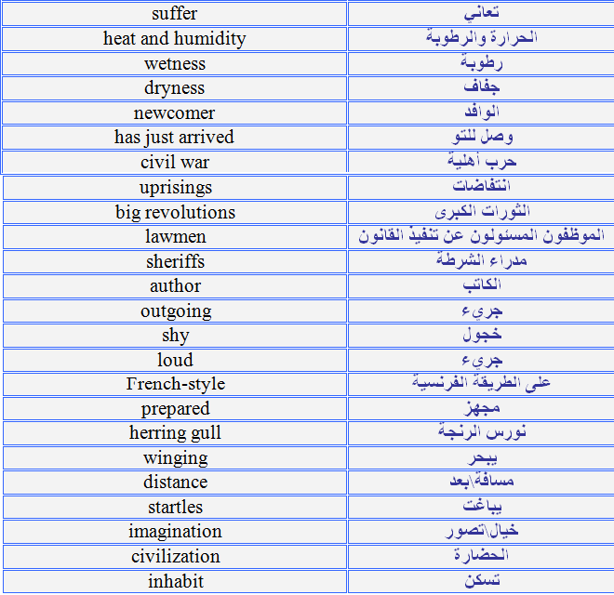
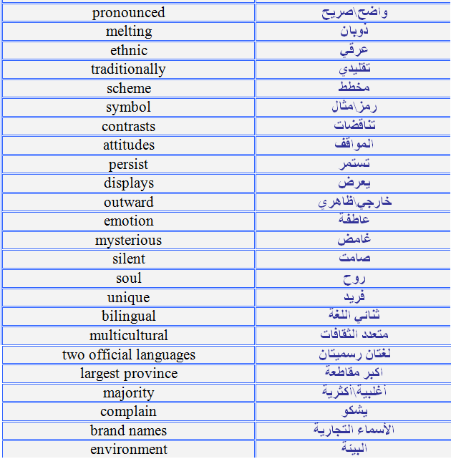
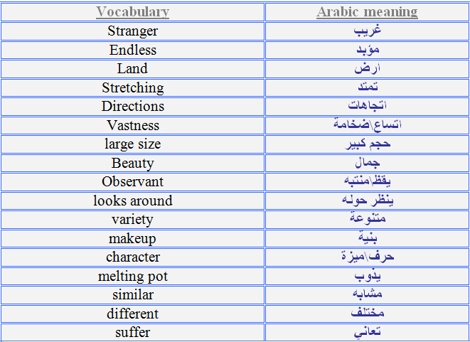

محاضرة (4 )

Today we'll continue with 2nd chapter with more reading strategies :
• Extra reading strategies :
Idioms - التعــــــآبير
Terminologمصطلحــــــــآت -
Idioms ــــ> ther're special sentences that we can't understand them by translating every single word.
Etc: it's raining cats & dogs
It doesn't mean it's raining from the sky cats and dogs !!!
It means it's raining heavily.
ليس معناها تمطر قطط وكلاب بل المقصود فيها تمطر بغزاااارة
ــــــــــــــــــــــــــــــــــــ
It should be memorized by heart so u can understand their meaning
ــــــــــــــــــــــــــــــــــــــ
Let's go to chapter 2 page 30
We have here " two heads are better than one "
When we translate it , it doesn't have a meaning ; but if we understand that it's an English proverb (idiom) we know it means two people working together is better than one working alone.
شخصين يعملون معا افضل من شخص واحد يعمل بمفردة
Exercise page 32:
1- Getting the meaning of idiomatic expressions from context:
- I took a knock or two during my first year in Madrid.
To have a hard time and to have problems.
- With the standards set by the club , you could never say u were in a comfort zone.
To feel safe & relaxed.
- Now I'd been whisked off to a new club in a new country…
To be moved to a new place very quickly.
- Didn't really have a clue what was coming next..
To know what to do..
- I was bracing my self for the challenge..
To prepare for something unknown or difficult.
- There was a little twist in the pit of my stomach.
To feel very nervous & uncomfortable.
- The next day, I didn't need to understand the article to get thedrift of the head lines.
To understand the general idea.
- Almost from kick-off you could tell it was going to be our night.
Every thing was going to go well for us.
- They could to make me feel at home..
To help some one to feel comfortable.
Idioms can be tricky so we have to memorize them
2- Getting the meaning of specialized terms from context:
Took me off >>> removed me from the game.
Kick off >>> the start of the game.
Left wing >>> the left side of the field when facing the other team's net.
Cross it >>> kick the ball across the field.
Cut in >>> to move infront of other players .
Go for goal >>> to try to put the ball in the net.
To miss out >>> to not reach.
The near post >>> the side of the net nearest to the player.
Goal keeper >>> the player in charge of defending the net.
Touch >>>> hit , when the player connects with the ball in any way.
Chested >>> hit the ball with my chest.
Midfield >>> the center of the playing field.
When u know all of the meaning of them u will understand the passage of David Beckham , if not u will find it difficult to understand ,

في المحاضرة الخامسة هناك خطأ في الاختيارات في صـــــ 41 السؤالين 4و5 الإجابة الصحيحة هي :
4 >>>> B

كلمات من المحاضره
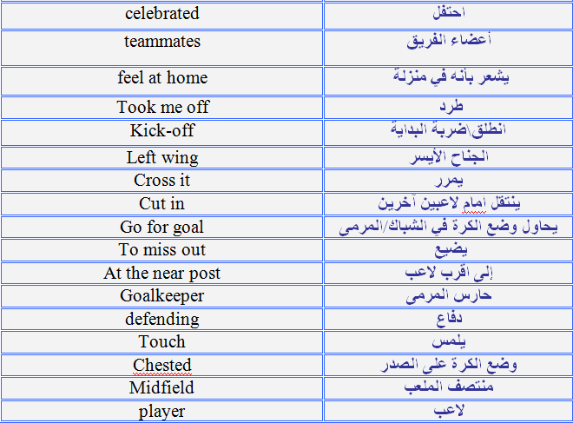
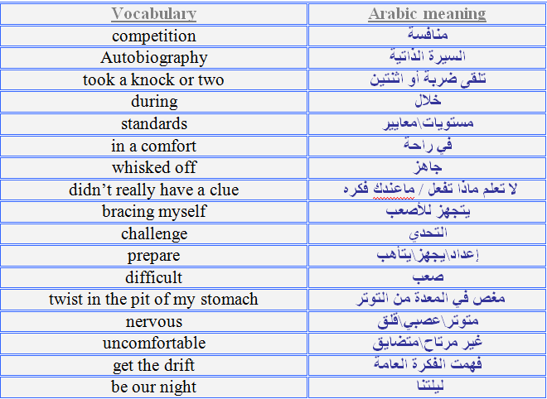

محاضرة (5)
Today we'll continue studying our reading strategy:

*metaphors:

You slept like a baby.

*figuring out the meaning of words from context.

=Metaphors = when u give a word to express a meaning that's not real but u want just to give it that special meaning.

كناية أو مجاز
= You slept like a baby your sleeping is very relaxing and not
feeling about any thing. نائم كالطفل
ــــــــــــــــــــــــــــــــــــــــــــ

حل التمرين صــــ41

Outward Bound

Using thecontext to infer the meanings of words:

1- CEO = the chief executive officer. المديرالعام التنفيذي

2- rallying = organizing & encouraging. يقوي

3- V.P = Vice President. نائب المدير

4- revenues = earnings before expenses and taxes are deducted.العائدات

5- Netprofits = earnings after expenses and taxes aredeductedربح صافي

6- Globalbrands = names & symbols known around the worldماركات

7- Atesting ground = a place to try out latest productsتحت التجربه

8- Factories = manufacturing plants whereproducts are built.مصانع

ــــــــــــــــــــــــــــــــــــــــــــــــــ ــــــــــــــــــــــــــــــــــــــــــــــــــ ــــــــــــــــــ

حل تمرين صـــــ46
Understanding Metaphors:

التشبيه

المشبه

المشبه به

1- Bark
The way kim shouts
theparking of a dog

2-Jumped

The way the moneyincrease

Thejumping of the horse

3- Scored
The way you achievedsuccess
Scoringa goal

4- Cavort

The way kim cavorts to a new stagein his life

Theyoung calfcavortin

5- Sliced
The way you cut the cost or lowerit down
Slicinga cheese

6- Storming
When you feel excited or angryas storm

Thestorming of the wind.

**********************************

Exercise 5 page 47 :

Using compoundAdjectives:

1- Flat screen TVs.

2- High speed access

3- Knee deep in rice paddies.

4- Low cost Chinese companies.

5- Low endproducts.

- Snow covered mountain side6-

(Memorize whatwe learned to become a good reader , a good

speaker & a good writer , they're very important .)

That’s it

محاضرة (6)

ذكر الدكتور ملاحظات هامه أختصرتها بالتالي:

الفصل الدراسي ليس عن حفظ القراءات ولكن تطوير مهارات التعلم وكيف تصبح قارئ جيد ،
أنا لا أجيب على جميع الاسئلة وأتركها لكم لتحلوها لتصبحوا قراء جيدين
مثل قيادة السيارة لن تكتفوا بالجانب النظري ولكن بالعملي أيضا ،
إن لم تلحقوا بإجاباتي افتحوا القاموس وابحثوا عن الكلمات .

كما يجب أن تطوروا المهارات كالتعلم من أنفسكم ثم اطلبوا المساعدة من الغير
وانتبهوا من ملخصات بعض الطلبة لأن بها بعض الأخطاء.

Extra reading strategies :

Skimming = when u skim for something u don't read all things but

general idea & u get the information u want.

مثلا / اذا قرأت قطعة عن السعودية والسؤال ما هي عاصمة السعودية وما تعرف الجواب ما يحتاج

تقرأ القطعة كاملة بس تدور عَ كلمة ( Capital )عاصمة

Scanning = when u scan the passage for
specific number or peace of information .
عندما تبحث عن معلومة أو رقم معين

Reading a chart = when u have a table u know how to read it and explain the information in it

Let's go to the book chapter 3
We have here a picture we'll talk about family and the relation ship between the father, mother , sons and daughters
لدينا هنا صورة سنتحدث عن الأسرة والعلاقة بين الأب والأبناء والأم وبناتها

Relation ships:
Let's go to the first page on chapter 3 page 58 :
1- Skimming for the general idea.
We have a passage of
(who's taking care of the children)
اقرأو القطعةة I expect you to read the passage.

Page 61 :
2- Matching words to their Definitions :
Glass ceiling : invisible barrier to promotion
-(حاجز غير مرئي للترقية)

Flex time : varying arrival and departure times at work.
(وقت مرن)

Job sharing : two people who each work part time
( تقاسم الوظيفة) one job.

Radically: to a great degree, completely .
( جذريا )

In touch: able to contact each other.
يتواصل

Portrayed: shown or represented in a pictorial way.
( صورت )

- Breadwinner: : person who cares for children in their home.
( المعيل )

Extended family : children,parents,grandparents,and other
relatives.
( الأسرة الممتدة )

Immediate family : children and parents.
( الأسرة الحالية )

Trend : tendency or movement in the course of event.
( اخر موضه)

Nanny: person who cares for children in their home.
(مربية)

Self-employed: working for your self
(تعمل لحساب نفسك )

( قال الدكتور حلو هـ تمرين في منتدى الحوآر )
3- Recalling information: حل التمرين صــ62
1- 70 percent
2- a breadwinner
3- immediate
4- large cities
5- more
6- 20%
7- Some

Look at the chart page 63 and answer the questions on page
64:

Read the passage on page 67 ( 70 brides for 7 foreigners)
Scanning for facts :
The answers for the exercise are: حل التمرين صــ66
1- 23
2- Yaroslav
3- 1960
4- The wedding palace
5- 9 months
6- Canada

Identifying antonyms: التعرف على التضاد
Antonyms are words with the opposite meaning from another word; for example ,night and day , or good and bad. Some people
can remember a word better when they learn it with its antonvm.

Page 70 :
4- Recalling antonyms:
1- A person who brings products in to a country is an importer; a person who sends products out of a country is an ____exporter_____.
2- Sometimes we hear a true story; but other times we hear one that is not true . we hear a ____fictitious ___story.
3- An activity that is not permitted by law is an illegal activity; an activity that is permitted by law is a ____legal_____activity.
4- When Stalin was the head of state in Russia , the attitude toward marriage with a foreign was not tolerant. It was ___intolerant___.
5- When lots of water rushes in to a container very fast , it is a torrent bit of water comes in to a container slowly, it is a ____trickle____.
A document that is authentic and official is a valid document . one that is a fake or has expired is an ____invalid___document.

***

Understanding Antonyms & synonyms helps u very greatly
when u meet them while u read.
They will give u some idea about the meaning of that difficult word

That’s it

محاضرة (7)
- Using headings.استخدام العناوين
- Inferencing words meaning from the context.

كلمات الاستدلال يعني من السياق.

Synonyms. مرادفات

2/ Getting meaning from context:
Peasant = simple people
Elite = upper class people
Eclectic = combination of different things
Affluence = wealth
Cuisine = style of cooking
ــــــــــــــــــــــــــــــــــــ

Page 85 طلب نحلة في منتدى الحوار ~
1- Recalling information:

1) A grain, a legume, fruits,
vegetables and a bit of meat, eggs or fish
d/The simple "peasant diet" that is good for you

2) Garlic and salmon
e/ Can help fight heart disease

3) Olive oil
a/A monounsaturated that seems to prevent heart disease

4) Miso soup and cabbage
c/ May help prevent cancer

5) Kiwi fruit
b/Rich in fiber, potassium, and vitamin c
ــــــــــــــــــــــــــــــــــــــــــــــــــ ــ
5- Recognizing synonyms:
- غني Affluent = rich
- مطبخ Cuisine = style of cooking
- انتقائي Eclectic = combining different influences.
- نخبة Elite = upper class
- فلاح Peasant ( adjective)= simple, from a farm.
- ازدهار Prosperity = wealth

That’s it

Lecture 8
We have the passage " here come the tourists"
Tourist سائح
Tourism سياحة
- Skimming for the point of view:
The statement that best express the point of view of the article.

(Tourism has both good and bad effects on the places visited)

-3- getting the meaning of words from context:

1- what kind of tourism do you think ecotourism is? السياحة البيئية
Tourism that uses the environment for adventure.
السياحة البيئة التي تستخدم للمغامرة.

- Meaning of " annoyed" منزعج
To make someone angry.
لجعل شخص غاضب.

- Meaning of locals? السكان المحليين
People from nearby.
الناس من مكان قريب.

- What does up – front mean ? مقدما
Direct. مباشر
- What does indigenous mean ? السكان الأصليين
Native. محلي

- What does distinguish mean? تميز
Make different. جعله مختلف

- What do you think the word frontiers mean ? حد , طرف ,حافة
Places where only adventurous tourists go .
الأماكن التي يذهب إليها السياح المغامرين فقط

- What does subculture mean in the phrase
" a backpacking subculture"?
A group of people with similar customs.
مجموعة من الناس لهم عادات مماثلة

- What does stinginess mean ? بخل
Custom of not spending or giving money.
عادة عدم الانفاق أو إعطاء المال.

- What do you think the verb to bargain means ? صفقة
To try to make the price of something lower.
في محاولة لجعل سعر شيئا أقل

4- distinguishing between fact & opinion صــ95
التفرقة بين الحقيقة والرأي
الحقيقة fact
Opinion والرأي
1-fact 2-fact 3-opinion 4- fact 5- opinion 6-fact 7- opinion 8- opinion 9- fact 10 –fact

5- scanning for vocabulary: طلب الدكتور حلها بأنفسنا

- Things that a country has and can use to its benefis = natural resources.
- An adjective that means delighted = enchanted
- An adjective means not correct for the occasion = inappropriate.
- A synonym for getting or obtaining = acquiring
- To move together in a group = flock
- An adjective means not costing very much = inexpensive.
- An adverb that means almost completely = virtually
- A verb means negotiate and come to an agreement about something = bargain.

Lecture 9
Chapter 5
High tech , low tech page 102
Tech → إختصار لـ technology
→ ( How Hybrid Cars Work) أقرئوا القطعة ..
( كيف تعمل السيارات الهجينة )

2- Scanning for Definitions of Key Terms . Go to the book page 104
1. What makes a vehicle a hybrid? Any vehicle is a hybrid when…
When it combine two sources of power. (lines 15-18)
2. What is a gasoline-electric hybrid car?
A car that runs by gasoline and electric. (lines 43-48)
3- Inferring the Meaning of Expressions from Context and Vocabulary.
Go to the book page 105-106
1. .., being shocked means
Choice (C) Go to the book page 105
2 . .. So gas pump here means
Choice (A) Go to the book page 105
3. .. Better mileage here means
Choice (C) Go to the book page 105
4. .. So the greenhouse effect is ..
Choice (A) Go to the book page 105
5. .., the coolest car on the block means
Choice (B) Go to the book page 106
6. .., charge means
Choice (A) Go to the book page 106
7. .. Here twofold means
Choice (B) Go to the book page 106
8. .., to reduce tailpipe emissions means
Choice (B) Go to the book page 106
9. These goals are tightly interwoven means
Choice (A) Go to the book page 106
4- Inferring the Meaning of Specialized Terms.
Go to the book page 111
1. Locomotives القاطرات (line 27) → D
2. Transmission انتقال (line 56) → N
3. Fuel tank خزان الوقود (line 54) → G
4. Four-cylinder engine (Figure 1) → I
أربع- أسطوانات المحرك
5. Parallel موازية (line 53) → H
6. Components مكونات (line 65) → L
7. Propulsion power دفع القدرة (line 41) → M
8. Braking فرملة (Figure 4) → B
9. Efficient فعال (Figure 3) → J
10. Generator مولد كهربائي (line 59) → E
11. rpm دورة في الدقيقة (Figure 1) → A
12. Global warming (line 90) → C
إرتفاع درجة حرارة الكرة الأرضية
13. Exhaust العادم (line 91) → K
14. Speeds بسرعة (Figure 1) → F

That’s it

Lecture 10
في هل محاضرة تمارين مشابه لاسئله الاختبار النهائي
قال الدكتور بتجي قطعة وحده خارجيه والباقي من المحتوى بس راح تكون سهله
exercises in page 52, 73 , 88, 115 .
Exercises: Pages 52,73,88,115
Focus on Testing : Go to the book page 52-53
1. Choice (B)
2. Choice (D)
3. Choice (B)
4. Choice (D)
5. Choice (C)
6. Choice (B)
7. Choice (A)

Focus on Testing : Go to the book page 73-74
1. Choice (A)
2. Choice (D)
3. Choice (B)
4. Choice (D)
5 . Choice (A)
6. Choice (D)
7 . Choice (B)

Focus on Testing : Go to the book page 88
1. Choice (B)
2. Choice (D)
3. Choice (C)
4. Choice (D)
5. Choice (C)
6. Choice (C)

4- Understanding Compound Words. Go to the book page 115
1. Landmarks
Choice (A)
2. Handmade
Choice (C)
3. Upload and Download
Choice (B)
4. Craftsmen
Choice (B)
5. Widespread
Choice (A)
6. Marketplace
Choice (C)

7. Grassroots
Choice (A)
8. Telecentres
Choice (C)
Lecture 11
→Leapfrogging the Technology Gap
Part2 : Reading Skills and Strategies: "Go to the book page 113-120"
1- Identifying the Pattern of Organization .
Look at the title, illustrations, and instructions of the article on pages 117-118. What problem is being discussed?
What solution is being offered?
- When you start from general to specific you will start with problem then solution and finally examples. But when you start from specific to general you will start with description of examples then the problem finally the solution

4- Understanding Compound Words. Go to the book page 115
1. Landmarks
Choice (A)
2. Handmade
Choice (C)
3. Upload and Download
Choice (B)
4. Craftsmen
Choice (B)
5. Widespread
Choice (A)
6. Marketplace
Choice (C)
7. Grassroots
Choice (A)
8. Telecentres
Choice (C)
6- Analyzing Compound Adjective With Hyphens. Go to the book page 120
1 . Internet – enabled motorcycles
Motorcycles that can access the internet.
2 . service – based economy.
An economy based on service.
3 . Large – scale factory production
A factory that produce a lot of different things.
4 . a knowledge – based economy
An economy that based on information.

5 . best – case scenario.
A scenario that is the best you can imagine as a solution to your problem.
6 . well – educated, tech – savvy, English - speaking
a. Well educated programmers :
a person who educated very well and become a programmer.
b. Tech-savvy programmers:
a person who has technology and talking English very well.
7 . well – educated, tech – savvy, English – speaking programmers are
A person who educated very well and taught technology very well and speaking English.
8 . Internet-linked telecentres
All linked by internet

That’s it
دع ــوآنـكم ../ كـــورن فليكـس
**************
Lecture 12
Chapter6 Money Matters
Part1 : Reading Skills and Strategies: "Go to the book page 128-135"
→Executive Takes Chance on pizza, Transforms Spain

1- Scanning for Specific Information. Go to the book page 130
1. Who is the executive (business manager) mentioned in the title?
Copldo is the executive that mentioned in this title.
2. what does it mean to say he "takes a chance on pizza"?
To try this chance with pizza because it was new.
3. To transform something means to change it, and not just in a small way. How does this man " transform Spain"? Do you think this title uses exaggeration?
That means to start it as it was in Spain. No I don't.
2- Recognizing Word Families. Go to the book page 130-131
1 . global → globalization
2. pizza → pizzeria (line 3) page 132
3. convenient → convenience (line 11) page 132
4. modern → modernizing (line 11) page 132
5. manage → management (line 18) page 132
6. prosperous → prospered (line 21) page 132
7. special → specialties (line 30) page 132
8. afford → affordable (line 34) page 132
9. mental → mentality (line 56) page 133
10. mature → maturing (line 74) page 133

3- Getting the Meaning of Words from Context. Go to the book page 134
Use the context and the clues to explain the following business terms.
1. marketing (line 6)
So, marketing is promoting the buying and selling of products.
2. multinational (line 8)
More than one national.
3. projected sales (line 8)
Presented sales.
4. outlets (line 10)
Traditional market in an open area that buys every things.
5. chain (line 12)
All connected to one owner.
6. boom (line 28)
Spreading out in different places.

7. untapped market (line 44)
Something new no body do it before.
8. franchises (line 67)
License to an open market.
9. growth markets (line 75)
Market that grows it’s profit up.
4- Checking Your Comprehension. Go to the book page 134
1. Choice (B) Go to the book page 134
2. Choice (C) Go to the book page 134
3. Choice (A) Go to the book page 135
4. Choice (C) Go to the book page 135
5. Choice (B) Go to the book page 135
6. Choice (C) Go to the book page 135
ـألسآحر
Lecture 13

Welcome to the last lecture of non-fictional prose the next lecture will be on the exam. Today we're going to continue unit 6 part 2 .
We're going to cover unit 1 – unit 6
I'll talk about the included & not the included in the next lecture.

Go to page 138:
Buying on the Internet
It has many advantages & disadvantages.
Part 2 page 139:
The luncheon inviting someone on lunch
Identifying the setting, characters, and conflict in a narrative:
- Setting: the time and place.
- Characters: the main people who are in the story.
- Plot: the action that starts with a conflict, develops into a complication, and ends with a resolution(solution of the conflict).
Go to page 140:
2- getting the meaning of words from context:
- Flattered by: pleased by the kind words.
- Startled: scared by a sudden surprise.
- Be mortifying to : embarrassing.
- Succulent: juicy
- Absentmindedly: without thinking
- Inadequate tip: generous

Lecture 14

Ethnocentrism
The final exam:
It contains:
- 70 multiple choice items.
- 2 short seen passages.
- 1 fairly short unseen passage.
- Unit 1-6 included(only what has been studied)
- Understanding information passages.
- Getting the meaning for some difficult words from the context.
- Compound suffixes – prefixes – idioms – metaphors.
- All the types of words and VOC we studied in the course.

You should be able to read new passages, apply all the strategies u studied& see whether you're successful or not . I want to check your comprehension of new passages so we get benefit from the course If I give you questions in the exam which are all from the book it will be a memory test not a reading comprehension , I should include at least some questions 6 or 10 just to check your comprehension . differentiate between people who pay time and studied very well and people who just memorize things and come to the exam there should be a difference between these two kinds.
If you study very well you'll find it easy..
Wish you all the best

طبعا هل محاضرات مسجلة من زمان وفي اشياء تغيرت الحين
مثل الاسئله صارت 50 فقرة مو 70
الله يوفقنا يارب وفالكم الـA+
دع ــوآنـكم ../ كـــورن فليكـس

