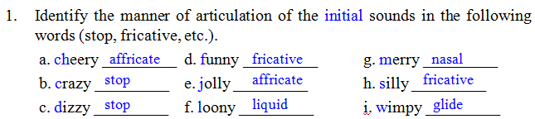
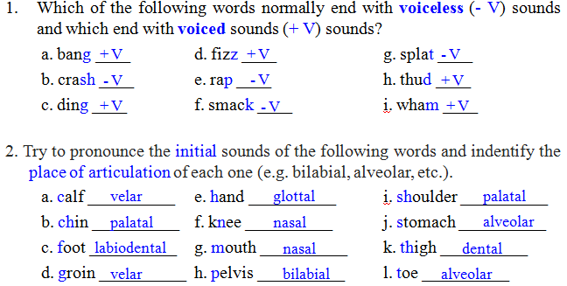
6_Using symbols introduced in this chapter, write a basic phonetic transcription of the most common pronunciation of the following words.
a) catch kætʃ e) noise nɔɪz i) thought θat
b) doubt daʊt f) phone foʊn j) tough tʌf
c) gem d͡ʒm g) shy ʃɑɪ k) would wʊd
d) measure mɛ~ʒr h) these θiz l) wring riɳ

2_ What is an aspirated sound and which of the following words would normally
be pronounced with one: kill, pool, skill, spool, stop, top?
A aspirated sound is a puff of air and would be pronounced with pool, spool, and stop.

3_Which of the following words would be treated as minimal pairs?
ban, fat, pit, bell, tape, heat, meal, more, pat, tap, pen, chain, vote, bet, far, bun, goat, heel, sane, tale, vet
goat vote, fat far, bun ban, chain sane, heel heat, bet bell, pat fat, pit pat, vet bet.

6_Which segments in the pronunciation of the following words are most likely to be affected by elision?
(i) government (ii) postman (iii) pumpkin (iv) sandwich (v) victory
Government- /n/ - gʌvərmɛnt
Postman- /t/ as in “tuh”- poʊstmæn
Pumpkin- /p/ in second part of pumpkin -pʌmkən
Sandwich - /d/ sænwɪtʃ
Victory-/t/ as in “tour” vɪktoʊri
1_ What are the functional morphemes in the following sentence?
When he arrived in the morning, the old man had an umbrella and a large plastic bag full of books.
2_ (a) List the bound morphemes in these words: fearlessly, misleads, previewer, shortened, unhappier
(b) Which of these words has a bound stem: construct, deceive, introduce, repeat? all of them
(c) Which of these words contains an allomorph of the morpheme “past tense”: are, have, must, sitting, waits? none of them (were , had , sat , waited)
3_ What are the inflectional morphemes in these expressions?
(a) Have you eaten yet?
(b) Do you know how long I’ve been waiting?
(c) She’s younger than me and always dresses in the latest style.
(d) We looked through my grandmother’s old photo albums.
4_ What are the allomorphs of the morpheme “plural” in this set of English words:
criteria, dogs, oxen, deer, judges, stimuli?

1 . Identify all the parts of speech used in this sentence (e.g. woman = noun): The woman kept a large snake in a cage, but it escaped recently.
The (= article), woman (= noun), kept (= verb), a (= article), large (= adjective),
snake (= noun), in = preposition), a (= article), cage (= noun), but (= conjunction), it
(= pronoun), escaped (= verb), recently (= adverb)
3. What prescriptive rules for the “proper” use of English are not obeyed in the
following sentences and how would they be “corrected”?
(i) The old theory consistently failed to fully explain all the data.
“You must not split an infinitive.” (to fully explain  to explain fully)
(ii) I can’t remember the name of the person I gave the book to.
“You must not end a sentence with a preposition” (the person I gave the book  to the person to whom I gave the book)
4. Which of the following expressions would be generated by this phrase structure
rule: NP → {Art (Adj) N, Pro, PN}?
(a) a lady (c) her (e) the widow
(b) the little girl (d) Annie (f) she’s an old woman
(a), (b), (c), (d), (e), but not (f) because it’s a sentence, not just a noun phrase.
6 . Using information from the phrase structure rules presented in this chapter, complete the following tree diagrams.

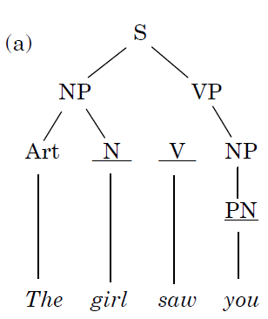
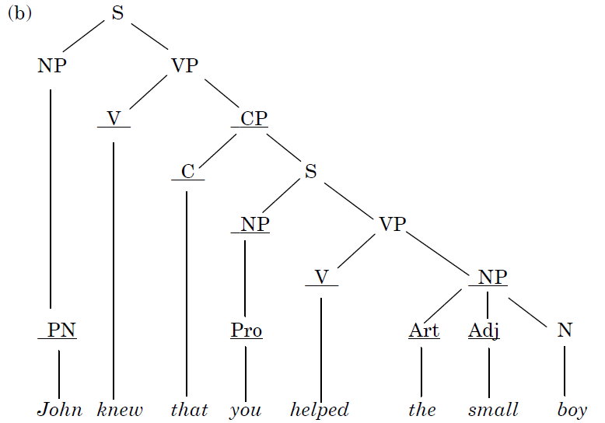
4 .What is the basic lexical relation between each pair of words listed here?
(a) damp/moist (c) furniture/table (e) move/run
(b) deep/shallow (d) married/single (f) peace/piece
(a) synonymy, (b) antonymy, (c) hyponymy, (d) antonymy, (e) hyponymy, (f) homophony (or homophones)

5. Which of the following opposites are gradable, non-gradable, or reversive?
(a) absent/present (c) fail/pass (e) fill it/empty it
(b) appear/disappear (d) fair/unfair (f) high/low
(a) non-gradable, (b) reversive, (c) non-gradable, (d) gradable, (e) reversive, (f) gradable

6. Are these underlined words best described as examples of polysemy or metonymy?
(a) The pen is mightier than the sword.
(b) I had to park on the shoulder of the road.
(c) Yes, I love those. I ate a whole box on Sunday!
(d) The bookstore has some new titles in linguistics.
(e) Computer chips created an important new technology.
(f) I’m going to sue your ass!
(a) metonymy, (b) polysemy, (c) metonymy, (d) metonymy, (e) polysemy (f) metonymy

- Animals and human language
- One of the human properties which organized at two levels or layers simultaneously.
- Displacement
- Arbitrariness
- Productivity
- Duality

2. The sounds of language
- The two sounds /f/ and /v/ are described as
- Bilabial
- Labiodental
- Dental
- Alveolar

3. The sound patterns of language
- Which of the following words are considered as a minimal pair
- night and dark
- site and side
- high and low
- sun and light

4. Word formation:
- Words formed from the initial letters of a set of other words.
- Coinage
- Blending
- Clipping
- Acronyms

5. Morphology
- The underlined word in the sentence “the child’s wildness shocked the teachers” is
- functional
- lexical
- inflectional
- derivational

6. Grammar
- Words used to refer to various kinds of actions.
- nouns
- articles
- adjectives
- verbs

7. Syntax
- ___________ is the study of the principles and processes by which sentences are constructed in particular languages.
- Deep structure
- Surface structure
- Syntax
- Recursion

8. Semantics
- The underlined word in the sentence “the boy kicked the ball” is
- agent
- theme
- instrument
- experiencer

9. Pragmatics
- Expressions such as tomorrow and here are obvious examples of bits of language that we can only understand in terms of the speaker’s intended meaning. They are technically known as
- content
- deixis
- anaphora
- inference

10. Discourse analysis
- _________ describes the way in which a text is tied together by linguistic devices
- Cohesion
- Coherence
- Hedges
- Implicatures

11. First language acquisition
- The earliest use of speech-like sounds has been described as
- two-word stage
- holophrastic
- one-word stage
- cooing

12. Second language learning
- The gradual development of ability in a language by using it naturally in communicative situations with others who know the language is known as
- learning
- input
- acquisition
- method

13. Gestures
- One type of gestures that seem to be a reflection of the meaning of what is said
- deictics
- beats
- iconics
- oralism

