6
Psycholinguistics - Language and the Mind

Psycholinguistics
Psycholinguistics is also defined as the study of “language and the mind”, but unlike the study of “language and the brain” does not attempt to relate its findings to physical reality. Also, psycholinguistics can be described as the study of language and the individual.
The first study on how the mind copes with language is recorded from at least the end of the eighteenth century. But the field was slow to expand. It expanded into a sub-discipline in its own right as a direct result of the work of the linguist
Noam Chomsky. Mainly he argued that a considerable amount of language might be innately programmed: this stimulated research into child language acquisition.
The three major strands of research which can be identified in the literature of psycholinguistics are the perception (comprehension), production and the acquisition of language.

Language acquisition
By the acquisition of language is meant the process whereby children achieve a fluent control of their native language.
The term acquisition is used rather than learning, because learning tends to be employed by psychologists in a more specific sense than is perhaps appropriate.
There are perhaps two fundamental principles on which everyone agrees:
(1) Children have their own system. They are not simply imitating adults, nor just putting words together in random. At every point, they have internal rules which differ from those of adults, and which seem to be more important to them than the “correct” form which they hear around them.
(2) Similarity of development.

Introduction
The study of language acquisition has been strongly influenced by the theory of generative grammar. Chomsky has argued that the speed with which children are able to infer the grammatical rules underlying the speech they hear about them, and then to use these rules for the construction of utterances they have never heard before, suggests that children are born with a knowledge of the (allegedly universal) formal principles which determines the grammatical structure of the language. This is the “rationalist” hypothesis (the hypothesis of “innate ideas”), as opposed to the “empiricist” hypothesis, which, in its strongest form, says that all knowledge comes from experience.
Chomsky introduced to the field two important terms which are competence and performance. This is the sense in which competence in any sphere is identified with capacity or ability, as opposed to actual performance, which may only imperfectly reflect underlying capacity.

The speed of acquisition and the fact that it generally occurs, without overt instruction, for all children, regardless of great differences in range of social and cultural factors, have led to the belief that there is some “innate” predisposition in the human infant to acquire language. We can think of this as the “language - faculty” of the human with which each newborn child is endowed. By itself, however, this faculty is not enough.
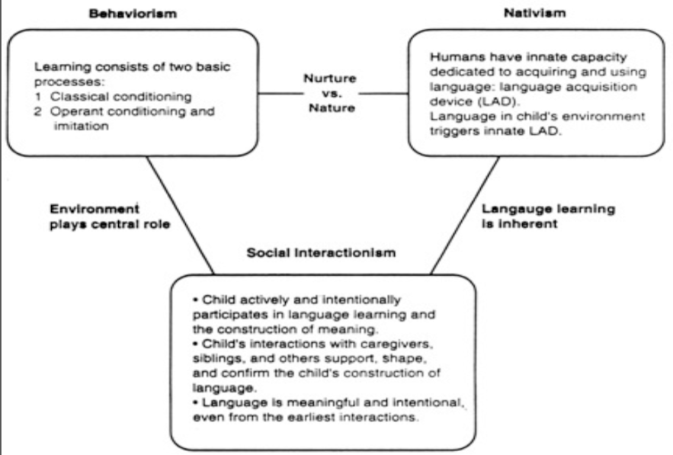

Basic Requirements of Acquisition
1- Other language-users
A child growing up in the first two or three years requires interaction with other language-users in order to bring the language-faculty into operation with a particular language.
(A child who does not hear, or is not allowed to use, language will learn no language.)
2- Cultural transmission
We have also stressed the importance of “cultural transmission” whereby the language a child learns is not genetically inherited, but is acquired in a particular language-using environment.
3- Physically capable
The child must be capable of sending and receiving sound signals in a language. All infants make “cooing” and “babbling” noises during the first few months, but deaf infants stop after six months. By itself, however, hearing language sounds is not enough.

The acquisition schedule
All children, regardless of culture, develop language at roughly the same time, along much the same schedule. It has been suggested that the language acquisition schedule has the same basis as the biologically determined development as the motor skills. There is some general biological program underlying language acquisition. It is certainly dependent on an interplay with many social factors in the child’s environment.

Caretaker speech
Introduction
Adults such as mom, dad, granny and grandpa tend not to address the little gurgler before them as if they are involved in normal adult-to- conversation.
For ex.
Oh, goody, now daddy push choo-choo?
It is a simplified speech style adopted by someone who spends a lot of time interacting with a young child.

Some of the features of this type of speech are:
(1) Frequent questions.
(2) Exaggerated intonation.
(3) “Baby-talk”: these are either simplified words (e.g. tummy, nana) or alternative forms, with repeated sounds, for objects in the child’s environment (e.g. choo-choo, poo-poo, wawa).
(4) The conversational structure seems to assign an interactive role to the young child even before he/she becomes a speaking participant.
(5) Simple sentence structures.
(6) A lot of repetition.

The acquisition process
Several stages in the acquisition process have been identified.
- Pre-language stages. Early stages of child language acquisition are simply called “cooing” and “babbling”.

The period from 3-10 months
The period from about 3 to 10 months is usually characterized by three stages of sound production in the infant’s developing repertoire.
(a) Cooing: The first recognizable sounds, with velar consonants such as [k] and [g] usually present, as well as [i] and [u] .These can be heard by the time the child is 3 months old.
(b) Babbling: By 6 months, the child is able to produce a number of different vowels and consonants such as fricatives and nasals. The sound production at this early stage of babbling may contain syllable-type sounds as mu and da.

In the later babbling stage, around 9 months, there are recognizable intonation patterns to the consonant and vowel combinations being produced. Through the tenth and elevenths months, they are capable of using their vocalizations to express their emotions emphasis. This late babbling stage is characterized by a lot of “sound-play” and attempted imitations.

The one word or holophrastic stage
By 12 and 18 months, children begin to produce a variety of single unit utterances.
It is characterized by speech in which single terms are uttered for everyday objects such as “milk”, “cookie”, “cat” and “cup”.
Terms such as “single- unit” or “single-form” may be accurate, or we could use the term holophrastic.

Single forms are used for naming objects, but sometimes they extend their use (e.g. Karen- bed).

The two-word stage
This stage can begin around 18-20 month. By the time the child is 2 years old, a variety of combinations will be appearing.
For ex. Baby chair, mommy eat, cat bad.
The combination can give different meanings in different contexts (e.g. baby chair). This is overextension. The significant functional consequences are that the adult behaves as communication is taking place. That is, the child not only produces speech, but receives feedback which usually confirms that the utterance “worked”.

Telegraphic stage
Between 2 and 3 years old, the child will be producing a large number of utterances which could be classified as a multiple-word utterance. The number of words is not important at this stage but the variation in word-forms. Of particular interest is the sequence of inflectional morphemes which occurs.
Telegraphic speech is characterized by strings of lexical morphemes in phrases such as
- Andrew want ball.
- This shoe all wet.
- Cat drink milk.
At this stage, the child has clearly developed some sentence-building capacity by this stage and can get the word order correct.
By the age of two and a half, the child’s vocabulary is expanding rapidly and the child is actually initiating more talk.
By three, the vocabulary has grown to hundreds of words and pronunciation has become closer to the form of the adult language.

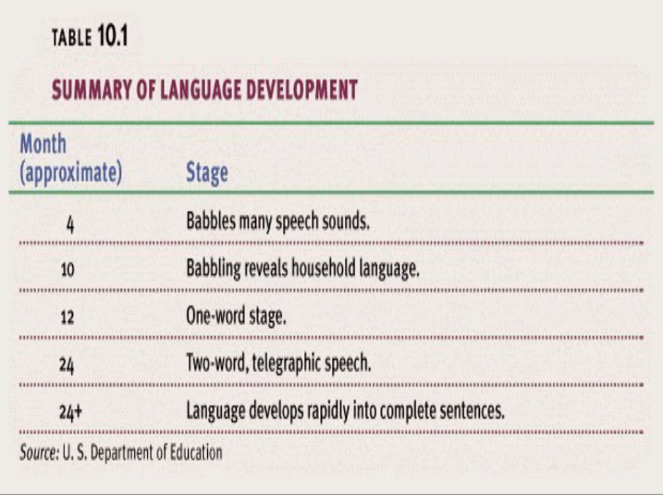

The acquisition process
For the vast majority of children, no one provides any instruction on how to speak the language. A much more realistic view would have children actively constructing, from what is said to them, possible ways of using the language.
The child’s linguistic production, then, is mostly a matter of trying out constructions and testing whether they work or not. It is unlikely that the child is acquiring the language simply through a process of imitating (parrot-fashion) adult speech. Adult “correction” is not a very effective determiner of how the child speaks.

Morphology
By the time the child is 3 years old, he/she is going beyond telegraphic speech forms and incorporating some of the inflectional morphemes which indicate the grammatical function of the nouns and verbs used. The acquisition of these forms is often accompanied by a process of overgeneralization.

