Psycholinguistic Studies:-1
a-how words are organized in a dictionary
b-how language affects your Psycholingical well being
c-how language is represented and processed in the mind
d-how different language can be learned
2- A(Intended) You have wasted the whole term
B(said) You have tasted the whole worm
Sentence B is an example of :
a-a parsing problem
b-a slip of atongue
c- a syntactic error
d- a priming effect

3- Lexical Decision:
a- a method used to organize words in a dictionary
b- a method used to measure how many word are in the brain
c- a method used to analyze word using a computer
d- a method used to understand how words are represented in the mind

4-Event-related potentials (ERPs) is an experiment that:
a- measures the time of a learning event
b- measures the potential to learn a language
c- measures the speed of someone's speech
d- measures electrical activity in the brain

5- Bottom-up processing is:
a-semantic analyze used to relate sounds to items in the mental lexicon
b-a morphological analyze used to relate sounds to items in the mental lexicon
c-a syntactic analyze used to relate sounds to items in the mental lexicon
d- a phonetic analyze used to relate sounds to items in the mental lexicon

6-the Psycholinguistic Study of morphological processing :
a- seeks to analyze words and phrases in the sentence with speech errors
b- seeks to create a computer programs that work as word processing
c- seeks to understand how computer word processors can be used to enhance language acquisition
d- seeks to understand how morphological principles play a role in the representation of words in the mind

7- postlexical decomposition occurs when:
a- both the whole- word form and its constituent morphemes are automatically activated
b- the lexical item is analyzed in a reverse method
c- both prefixes and suffixes are identified simultaneously
d-the lexical item in the mental lexicon is scanned for inflectional morphemes

8-Prelexical decomposition occurs when:
a- morphological decomposition occurs first and whole-word access occurs second
b- the lexical item is analyze in a reverse method
c- both prefixes and suffixes are identified simultaneously
d-the lexical item in the mental lexicon is scanned for inflectional morphemes

9- "the horse raced past the barn fell"
The sentence above is an example of :
a- a Mathematical sentence
b- a Garden path sentence
c- a Sentence in the deep structure
d- an ambiguous sentence

10- A preverbal message refers to :
a- the speaker's ability to associate verbs to actions
b- the speaker's intention to express a verb in a sentence
c- the speaker's intention to communicate an idea
d- the speaker's ability use hand and body gestures while communicating

11- An interlocutor is:
a- a participant in a conversation
b- a speaker with locked up ideas
c- a person with locked lexicon
d-listener that cannot analyze a sentences

12-When a bilingual speaker is speaking in a unilingual mode :
a- she is unifying two language
b- she is speaking alone in quiet place
c-- she is speaking in only one language
d-- she is speaking with no understanding

13- When a bilingual speaker is speaking in a bilingual mode:
a- he is unifying two language into one
b- he is speaking alone in quiet place
c-- he is speaking in two language
d-- he is speaking with no understanding either language

14- Code-switching refers to :
a- the speaker's switch from one language to another
b- the speaker's switch to using code instead of language
c- the speaker's written form of language
d- the speaker's ability to switch computers on and off

15-Word barrowing refers to :
a- the use of a word in second language situation
b-the temporary use of a word in a conversation
c- the incorporation of a word from one language into another
d-the inclusion of all the words of the native language into the second

16-Language transfer refers to:
a- grammatical rules in the first language being used in the second language
b- words in the first language being used in the second language
c-ideas in the mind being transferred to the speech organs
d-the movement of sentences from deep structure to surface structure

17-Lexical retrieval refers to:
a-the process of formulating a word in a speaker's mind
b- the process of retrieving a lexical item from a dictionary
c- the process of understanding a word before the moment of speech
d- the process of retrieving a lexical item from the mental lexicon

18-Tip-of-the-tongue-phenomenon refers to the situation where:
a- the speaker knows the word retrieves it using the tip of the tongue
b- the speaker knows the word and can retrieves it very quickly
c- - the speaker knows the word but cannot retrieve it
d-- the speaker knows the word and signals are sent to the tongue

19-Grammatical encoding refers to :
a- the creation of sentence structure before sentence planning
b-- the creation of sentence structure during sentence planning
c-- the creation of sentence structure after sentence planning
d-writing a sentence by using a code instead of real words

20- A Said: "I left my car in my briefcase "
B Intended: : "I left my briefcase in my car "
Sentence A above is an example of :
a-tip-of-the-tongue-phenomena
b- a word exchange error
c- a word ambiguity situation
d-a garden path sentence

21-Plural attraction refers to the situation where :
a- a speaker only retrieves nouns in the plural form
b- a speaker is attracted to the idea of making nouns plural all the time
c- a plural feature intervenes between a singular subject and its verb
d- a plural feature is added to a noun after a noun attracts it

22-A said: "I can't cook worth a cam"
B Intended :"I can't cook worth a damn"
Sentence A above is an example of:
a-syntactic persistence
b- a segment exchange error
c- an anticipation error
d- a preservation error

23-A. said: "hass or grash "
B. Intended: "hash or grass"
Sentence A above is an example of:
a- a segment exchange error
b- a preservation error
c- an anticipation error
d-syntactic persistence

24- A said: "taddle tennis"
B Intended :"paddle tennis "
Sentence A above is an example of:
a- an anticipation error
b- a preservation error
c- - a segment exchange error
d-syntactic persistence

25- Post-access matching refers to:
a-checking the phonological representation of a word after it has been retrieved
b- checking the morphological representation of a word after it has been retrieved
c- checking the syntactic representation of a word after it has been retrieved
d- checking the syntactic representation of a word after it has been retrieved

26- The Orthography of a language refers to:
a-a language's writing system
b- a language's segment system
c- a language's alphabet
d- a language's speech system

27- TLAZ, ZNER, and MROCK are example of:
a-impossible non-word
b- possible word
c- slips of tongue
d- slips of the ear

28-SKERN,PLAM, and FLOOP are example of:
a-possible non-word
b- possible word
c- slips of tongue
d- slips of the ear

29- possible non-word:
a-take all the time in the word to reject
b-take a short time to reject than impossible non-word
c- take an equal time to reject than impossible non-word
d- take a longer time to reject than impossible non-word

30-A word's cohort consist of:
a-all the similar ideas a speaker thinks about while speaking
b-all the phonetic segments in the given language
c-all the lexical items that share an initial sequence of phonemes
d-all the syllables used in a sentence

31- A word neighborhood:
a-consists of all the lexical items that are phonologically similar
b- consists of all the lexical items that are similar to that word in meaning
c- consists of all the lexical items that are of the same syntactic category
d- consists of all the places the speaker lived in

32- Speech sound are usually measured in:
a-hours
b-seconds
c-minutes
d-millisecond

33-if language is species specific
الخيارات مش واضحه لكن الاجابه الصحيحه هي فقرة d
d-the language is likely to be part of the genetic makeup of members of the species

34-the term Universal Grammar in linguistic mean that :
الخيارات مش واضحه الحل الصحيح هو فقره c
c-languages of the world are similar because all humans have the same language capacities

35-When a child born:
a- the child learn a language naturally because he in born with that capacity
b- the child must listen his/her parents in order to learn a language
c- the child must be extremely intelligent in order to learn a language
d-- the child must be given specific instruction in order to learn a language

36-Childern everywhere :
a-acquire language similarly
b-acquire language differently according to their economic status
c- acquire language differently according to the type of food they eat
d- acquire language differently according to the type of school they attend

37-The critical period for first language acquisition:
a-is around the age of twenty years old
b- is around the age of ten years old
c- is around the age forty years old
d- is around the age tow years old

38-Neurolinguisties is:
a-is the study of the representation of the language in the brain
b- is the study of the intelligent people who speak many language
c- is the study of brain cells that affect language acquisition
d- is the study of the brains of people of different language

39-Aphasia is :
a- is a language impairment linked to brain injury.
b- is type of disease that affects the brain after birth
c- is a language spoken in south America
d-is a language spoken in south East Asia

40-Broca's aphasia is also known as:
a-energetic aphasia
b- fluent aphasia
c-sudden aphasia
d- non-fluent aphasia

41-Wernicke's aphasia is also known as:
a- energetic aphasia
b- non-fluent aphasia
c-sudden aphasia
d- fluent aphasia

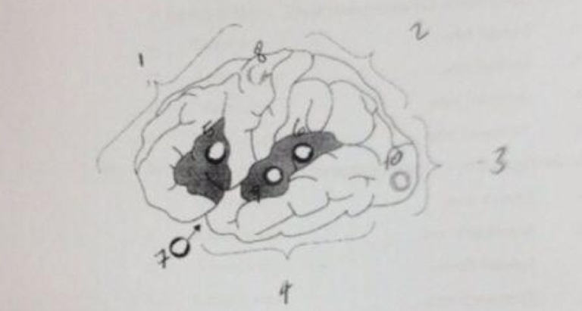

42-in the figure above ,(1) corresponds to the :
a-Parietal lobe
b- Frontal lobe
c- Occipital lobe
d- Temporal lobe

43- in the figure above ,(2) corresponds to the :
a- Frontal lobe
b- Temporal lobe
c- Occipital lobe
d- Parietal lobe

44- in the figure above ,(3) corresponds to the :
a- Frontal lobe
b- Parietal lobe
c- Occipital lobe
d- Temporal lobe

45-in the figure above ,(4) corresponds to the :
a- Frontal lobe
b- Parietal lobe
c- Occipital lobe
d- Temporal lobe

46- in the figure above ,(5) corresponds to the :
a-Broca's area
b-Wernicke's area
c-Sylvian fissure
d- Thomoson's area

47- in the figure above ,(6) corresponds to the :
a-Broca's area
b-Wernicke's area
c-Sylvian fissure
d- Thomoson's area

48- in the figure above ,(7) corresponds to the :
a-Broca's area
b-Wernicke's area
c-Sylvian fissure
d- Thomoson's area

49- in the figure above ,(8) corresponds to the :
a- Motor area
b-Auditory area
c-Visual area
d- Running area

50-- in the figure above ,(9) corresponds to the :
a- Motor area
b-Auditory area
c-Visual area
d- Running area

51-- in the figure above ,(10) corresponds to the :
a- Motor area
b-Auditory area
c-Visual area
d- Running area

52-To say that language is lateralized means that:
a-language function is located in one of the two hemispheres
b-language is combined of capital and small letter
c- language is acquired later in life
d- language is found in many location in the world

53-When we say that control of the body is contralateral it means that:
a- the left side of the brain controls the upper part of the body and the right side of the brain controls the lower part of the body
b- the brain is able to process speaking and listening at that same time
c- the upper part of the body is more functional than the lower part of the body
d- the left hemisphere controls the right side of the body and the right hemisphere controls the left side of the body

54-In a dichotic listening experiment the participant
a-is given a chance to listen to the input twice
b- is given two different inputs to each ear one at the time
c- is given two different inputs to each ear at the same time
d- is given something to listen to while writing something

55-on average ,stimuli presented to the right ear are reported with greater accuracy than the stimuli presented to the left ear . that is known as:
a- the right-ear advantage for language
b- the right-ear ability
c-the quick-ear language ability
d- the left-ear ability

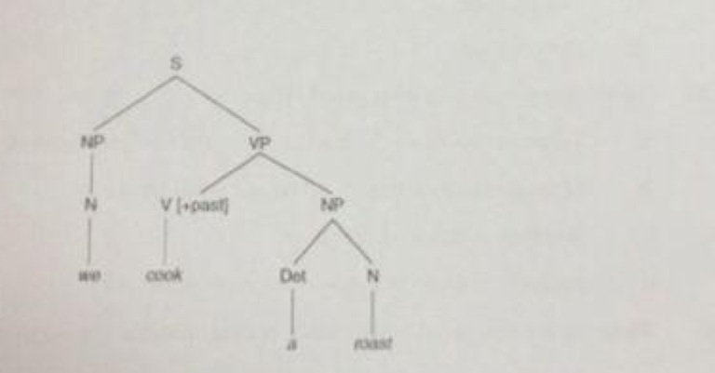

56-In tree diagram above ,S stands for:
a- Subject
b-Sentence
c-Syllable
d-Sense

57- In tree diagram above ,NP stands for:
a-Noun Potential
b-Not Proven
c-Noun Phrase
d-Negative Point

58- In tree diagram above ,N stands for:
a-Noun
b-Not
c-Negative
d-Never

59- In tree diagram above ,VP stands for:
a-Variable Potential
b-Verb Portal
c-Verb Phrase
d-Variability Production

60- - In tree diagram above ,V stands for:
a-Verb
b- Verbal
c- Variable
d-Verbatim

61- In tree diagram above ,{+past} stands for:
a-past tense
b-past participle
c- past progressive
d-past continuous

62- In tree diagram above , Det stands for:
a- Detail
b-Detention
c-Determiner
d-Detachment

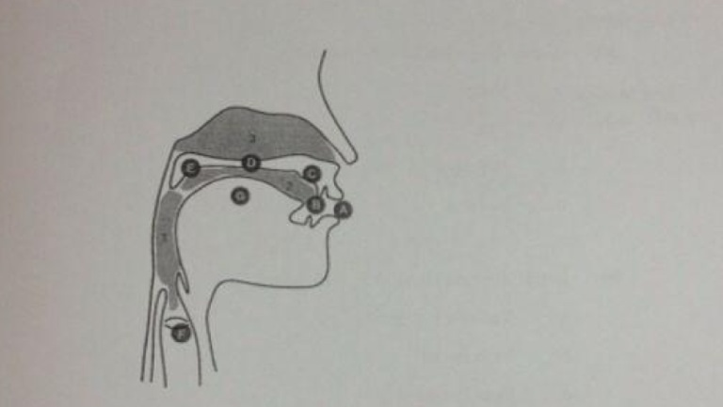

63-In the figure above A corresponds to:
a-the lips
b-the teeth
c-the chin
d-the vocal cords

64- In the figure above B corresponds to:
a- the teeth
b- the lips
c-the chin
d-the vocal cords

65-- In the figure above C corresponds to:
a-the hard palate
b-the alveolar ridge
c-the soft palate
d-the vocal cords

66-- In the figure above D corresponds to:
a-the lips
b- the soft palate
c- the alveolar ridge
d- the hard palate

67- In the figure above E corresponds to:
a-the velum
b- the hard palate
c-the larynx
d- the lips

68- In the figure above F corresponds to:
a-the tongue
b- the velum
c-the glottis
d- the teeth

69- In the figure above G corresponds to:
a- the tongue
b-the nasal cavity
c- the teeth
d- the lips

70-One definition of a morpheme would be:
a-the morpheme is the smallest meaningful unit in a language
b--the morpheme is the smallest sound unit in a language
c- the morpheme is the smallest section in a sentence
d- the morpheme is the smallest understandable unit in a language

