- Language acquisition is the process by which humans acquire the capacity to
Perceive and comprehend language.
- The psycholinguistic study of morphological processing: seeks to understand how morphological principles play a role in the representation of words in the mind
- Transfer non native like production by second language learners can be result of rules from the first language being incorporated into the second language .
- Psycholinguistics studies how language is represented and processed in the mind
- observable behavior is what some people call slips of the tongue or speech errors
- Mental Lexicon is organized a little bit different of the dictionary because :
- It can accommodate new words
- It can be accessed very quickly
- Tip-of-the-tongue phenomena this is the situation where you are unable to access a word (or remember a word)in your mental lexicon and all you needed was the:
meaning of the word - the sound of the word - the first letter or what the word rhymes with
- A technical term The technical term for the items in the lexicon is entries instead of words

- Big problem
((The mental lexicon cannot be observed !))
- Lexical Decision Experiment
- Lexical Decision is a method used to understand how words are represented in the mind
A lexical decision experiment is conducted by asking a native speaker to sit in front of a computer screen where he/she is asked to judge as quickly as possible if the word that appears on the screen is a real word. If the word is real the participant clicks “yes”; if not, the participant clicks “no”. in this task we are looking for

- Response latency is the time it takes for the a participant to respond “yes/no”.

- Response accuracy is whether or not the participant responded accurately

((This test measures the speed and accuracy in which the mental lexicon is accessed.))

((½ a second for frequently word ….. ¾ second for less common words.))

( This is commonly known as the frequency effect)
mental lexicons are probably organized in a way that words we use often are more easy to access.

- Priming Experiment can be considered as an extension of lexical decision task.
in this task before the participant is asked to choose “yes” or “no” the target word is preceded by another stimulus (called the prime). What is measured is the extent the prime influences the participant’s lexical decision on the target stimuli.
- Parsing is the unconscious ability to understood the meaning of the words and analysis its structures .
- Timed-Reading Experiments

- bar-pressing test
In this test the participant is asked to sit in front of a computer screen and read a sentence one word at a time. The participant presses a bar on the keyboard to read the next word till he/she reaches the end of the sentence
- We can learn about the amount of time required to process certain words
- How long participants pauseوقفة at the end of clauseجملة boundariesحدود

- Eye Movement
Tracking eye movement on words during reading revealed that eye fixation time is usually longer for less frequent words and that the points of fixation are usually content words rather than function words.
- Research has shown that the more difficult the sentence is in structure the more regressive
saccades there are in addition to longer fixation times.

- Event-Related Potentials (ERPs)
ERP experiments measure electrical activity in the brain. That is voltage fluctuations resulting from the brain’s electrical activity.
(Those things they put on a person’s head are called “electrods”)

- “bottom-up processing”
a phonetic analysis is used to isolate phonemes and word boundaries and relate these items in the mental lexicon.
- “top-down processing”
the information you know about the words and what to expect from one another (e.g. The dog bit the cat)
- Phonemes
- cohort model a word’s cohort consists of all the lexical items that share an initial sequence of phonemes.
((the phoneme is the fundamental unit of auditory word recognition))
- Language is Species Specific language is likely to be part of the genetic makeup of members of the species
- Universal Grammar languages of the world are similar because all humans have the same language capacities.
- The critical period an age restriction on acquiring a first language.
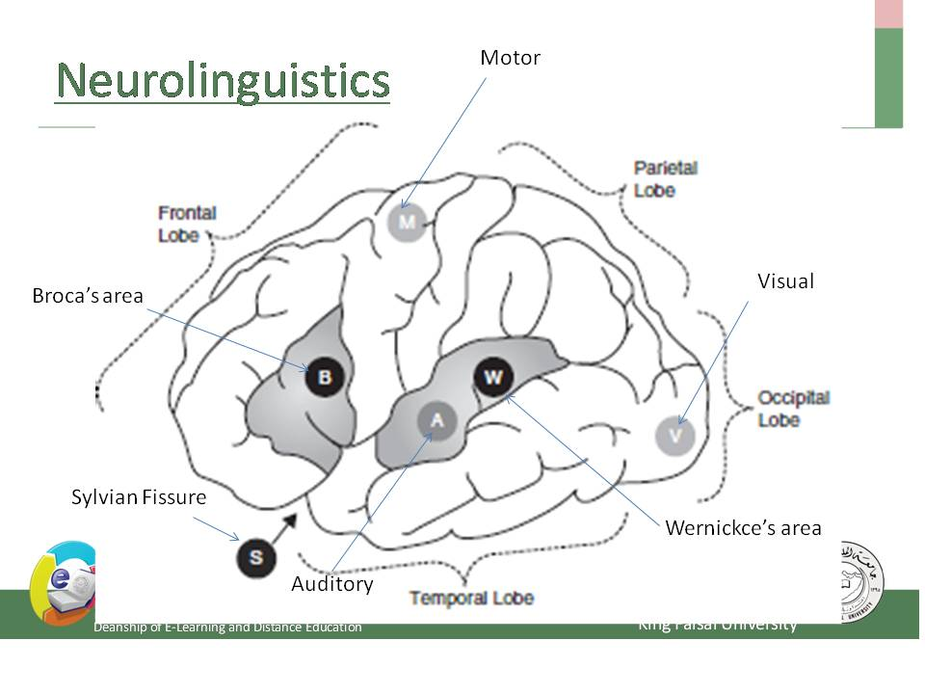
- Neurolinguistics is the study of the representation of the language in the brain
- Aphasia is a language impairment linked to brain injury.
- Broca's aphasia is also known as non-fluent aphasia
- halting , effortful speech because of damage in the frontal lobe of the left hemisphere
- Wernicke's aphasia is also known as fluent aphasia
- fluent meaningless strings because of damage in the temporal lobe of the left hemisphere.
- Lateralized language function is located in one of the two hemispheres.
- contralateral the left hemisphere controls the right side of the body and the right hemisphere controls the left side of the body.
- Wada test one common procedure for determining the hemispheric location of language functions in preoperative patients.(Sodium amytol is injected into one of the two hemispheres of patient’s brain)
- The dichotic listening Experiment
In this experiment the participant is given two different inputs to each ear at the same time.
Usually the participant reports what he/she heard in the right ear.
This is called the right-ear advantage for language
- interlocutor is Participate in conversation
- preverbal message the speaker’s intention to communicate an idea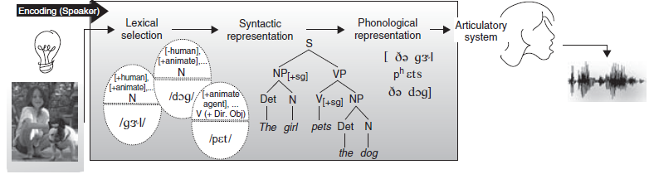
- When a bilingual is speaking in a unilingual mode (only one language), only one of the grammars is consulted to build structural representations, and the active language’s lexical entries are activated.
- When in a bilingual mode (when the bilingual’s two languages are being used in the same conversation), access to both grammars and lexical items from both languages must be possible.
- Code-switching is switching between two codes (two languages, or two distinct dialects of the same language) within the same discourse.
- Intersentential code-switching a switch can also occur within the same sentence.
- Tag-switching the insertion of frequently used discourse markers, like so, you know, I mean, etc
- Barrowing a word from one language is incorporatedإدراج into the lexicon of another language.
*A pidgin is a communication system consisting of elements from more than one language
* pidgins turn into creole languages
* a pidgin has no native speakers
((Remember that speech begins with an idea in the speaker’s brain.))
- Lexical Retrieval
((Remember that the lexicon is a dictionary of all the words a speaker knows))
((A word can be retrieved using two different kinds of information: meaning or sound))
- The word must also be of the appropriate grammatical class (noun, verb, etc.) and must be compatible with the structure that is being constructed.
- the words and the structure are so closely related that the two processes take place practically simultaneously
- This means that a speaker must enter the lexicon via information about meaning, grammatical class, and structure, only later to retrieve the phonological form of the required word.
((The hearer’s task, is the mirror image of the speaker’s.))
- Tip-of-the-tongue phenomenon
the speaker knows the word but cannot retrieve it
((Usually lexical retrieval produces an appropriate set of words required for the speaker’s sentence ))
- Grammatical Encoding the creation of sentence structure during sentence planning
- Word exchange errors the exchange between two words.
- Word exchange errors never occur between content words and function words and are usually limited to words of the same grammatical class
- Creating agreement relations

(another class of errors is subject–verb agreement)
Example:
a. The bridge closes at seven.
b. The bridges close at seven.
- Plural attraction When a plural feature intervenesيتدخل between a singular subject and its verb error can occur.
Example:
a. The time for fun and games are over.
b. The illiteracy level of our children are appalling.
- Preservation error segment perseveres and intrudes in a later word
A. Said: "I can't cook worth a cam".
B.يقصد Intended: "I can't cook worth a damn".
- Anticipation errorتحسباً للخطأ توقع حدس
a speech sound that has not yet been produced intrudes in an earlier word.
A. Said: "taddle tennis".
B. Intended: "paddle tennis".
- Segment exchange error the exchange is between two phonological elements: the final consonants in the two words.
A. Said: "hass or grash".
B. Intended: "hash or grass".
- Phoneme Restoration book Page 180
The Hearer
- post-access matching
After a word has been retrieved, its full phonological representation is checked against what has been heard.
- Orthography is the study of writing systems
- Impossible non-words, like TLAT, ZNER, and MROCK, are rejected very rapidly in a lexical decision task.
- possible non-words, like SKERN, PLIM, and FLOOP, take longer to reject
- A word's neighborhood
A factor that affects retrieval times for words is neighborhood density . A word's neighborhood consists of all the lexical items that are phonologically similar.
Example
the word cot has many words that are phonologically similar to it, so it is said to come from a dense neighborhood; in contrast, the neighborhood for a word like crib is less dense.
- Recognition point of the word book page 195
- The brain’s response to word category errors, that is when the category of a new word does not fit into the current structure being built by parser . The brain responds slightly differently to morphosyntactic violation.
- Positive Evidence is to provide information about the language the child is acquiring
- Lexical ambiguity

- E.G. for A Garden path sentence is ((the horse raced past the barn fell))
The structure in above e.g. includes a reduced relative clause for Example : Danielle emailed me a photograph of the Corvette raced at the Daytona Speedway.
- Other example for garden path:
((the two masked men drew their gun and approached the bank, but the boat was already moving down the river))

The language gene
The search for a genetic basis for language
- Researchers began genetic investigations by conducting pedigree studies.
- pedigree studies These are studies that examine the heritability of a particular trait (or disorder) in several generations of a family.
- FOXP2 specific gene that was implicated in the language disorders of an extended family
- The FOXP2 gene is associated with the development of other parts of human anatomy unrelated to language, including the lung, the gut, and the heart. It is also a gene that is not confined to Homo sapiens; it is also found in other mammals, including mice (Marcus and Fisher 2003).

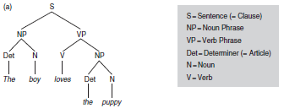
- postlexicon decomposition: Both the whole-word form and its constituent morpheme are automatically activated
- prelexicon decomposition : Morphological decomposition occurs first and whole-word access occurs second
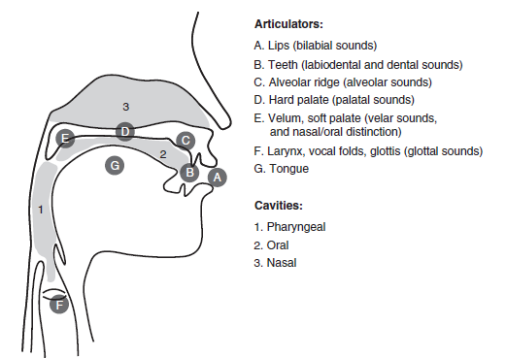

أسئلة الإختبار لعام 1433هـ
- Psycholinguistic Studies:

a-how words are organized in a dictionary
b-how language affects your Psycholingical well being
c-how language is represented and processed in the mind
d-how different language can be learned
2- A(Intended) You have wasted the whole term
B(said) You have tasted the whole worm
Sentence B is an example of :
a-a parsing problem
b-a slip of atongue
c- a syntactic error
d- a priming effect

3- Lexical Decision:
a- a method used to organize words in a dictionary
b- a method used to measure how many word are in the brain
c- a method used to analyze word using a computer
d- a method used to understand how words are represented in the mind

4-Event-related potentials (ERPs) is an experiment that:
a- measures the time of a learning event
b- measures the potential to learn a language
c- measures the speed of someone's speech
d- measures electrical activity in the brain

5- Bottom-up processing is:
a-semantic analyze used to relate sounds to items in the mental lexicon
b-a morphological analyze used to relate sounds to items in the mental lexicon
c-a syntactic analyze used to relate sounds to items in the mental lexicon
d- a phonetic analyze used to relate sounds to items in the mental lexicon

6-the Psycholinguistic Study of morphological processing :
a- seeks to analyze words and phrases in the sentence with speech errors
b- seeks to create a computer programs that work as word processing
c- seeks to understand how computer word processors can be used to enhance language acquisition
d- seeks to understand how morphological principles play a role in the representation of words in the mind

7- postlexical decomposition occurs when:
a- both the whole- word form and its constituent morphemes are automatically activated
b- the lexical item is analyzed in a reverse method
c- both prefixes and suffixes are identified simultaneously
d-the lexical item in the mental lexicon is scanned for inflectional morphemes

8-Prelexical decomposition occurs when:
a- morphological decomposition occurs first and whole-word access occurs second
b- the lexical item is analyze in a reverse method
c- both prefixes and suffixes are identified simultaneously
d-the lexical item in the mental lexicon is scanned for inflectional morphemes

9- "the horse raced past the barn fell"
The sentence above is an example of :
a- a Mathematical sentence
b- a Garden path sentence
c- a Sentence in the deep structure
d- an ambiguous sentence

10- A preverbal message refers to :
a- the speaker's ability to associate verbs to actions
b- the speaker's intention to express a verb in a sentence
c- the speaker's intention to communicate an idea
d- the speaker's ability use hand and body gestures while communicating

11- An interlocutor is:
a- a participant in a conversation
b- a speaker with locked up ideas
c- a person with locked lexicon
d-listener that cannot analyze a sentences

12-When a bilingual speaker is speaking in a unilingual mode :
a- she is unifying two language
b- she is speaking alone in quiet place
c-- she is speaking in only one language
d-- she is speaking with no understanding

13- When a bilingual speaker is speaking in a bilingual mode:
a- he is unifying two language into one
b- he is speaking alone in quiet place
c-- he is speaking in two language
d-- he is speaking with no understanding either language

14- Code-switching refers to :
a- the speaker's switch from one language to another
b- the speaker's switch to using code instead of language
c- the speaker's written form of language
d- the speaker's ability to switch computers on and off

15-Word barrowing refers to :
a- the use of a word in second language situation
b-the temporary use of a word in a conversation
c- the incorporation of a word from one language into another
d-the inclusion of all the words of the native language into the second

16-Language transfer refers to:
a- grammatical rules in the first language being used in the second language
b- words in the first language being used in the second language
c-ideas in the mind being transferred to the speech organs
d-the movement of sentences from deep structure to surface structure

17-Lexical retrieval refers to:
a-the process of formulating a word in a speaker's mind
b- the process of retrieving a lexical item from a dictionary
c- the process of understanding a word before the moment of speech
d- the process of retrieving a lexical item from the mental lexicon

18-Tip-of-the-tongue-phenomenon refers to the situation where:
a- the speaker knows the word retrieves it using the tip of the tongue
b- the speaker knows the word and can retrieves it very quickly
c- - the speaker knows the word but cannot retrieve it
d-- the speaker knows the word and signals are sent to the tongue

19-Grammatical encoding refers to :
a- the creation of sentence structure before sentence planning
b-- the creation of sentence structure during sentence planning
c-- the creation of sentence structure after sentence planning
d-writing a sentence by using a code instead of real words

20- A Said: "I left my car in my briefcase "
B Intended: : "I left my briefcase in my car "
Sentence A above is an example of :
a-tip-of-the-tongue-phenomena
b- a word exchange error
c- a word ambiguity situation
d-a garden path sentence

21-Plural attraction refers to the situation where :
a- a speaker only retrieves nouns in the plural form
b- a speaker is attracted to the idea of making nouns plural all the time
c- a plural feature intervenes between a singular subject and its verb
d- a plural feature is added to a noun after a noun attracts it

22-A said: "I can't cook worth a cam"
B Intended :"I can't cook worth a damn"
Sentence A above is an example of:
a-syntactic persistence
b- a segment exchange error
c- an anticipation error
d- a preservation error

23-A. said: "hass or grash "
B. Intended: "hash or grass"
Sentence A above is an example of:
a- a segment exchange error
b- a preservation error
c- an anticipation error
d-syntactic persistence

24- A said: "taddle tennis"
B Intended :"paddle tennis "
Sentence A above is an example of:
a- an anticipation error
b- a preservation error
c- - a segment exchange error
d-syntactic persistence

25- Post-access matching refers to:
a-checking the phonological representation of a word after it has been retrieved
b- checking the morphological representation of a word after it has been retrieved
c- checking the syntactic representation of a word after it has been retrieved
d- checking the syntactic representation of a word after it has been retrieved

26- The Orthography of a language refers to:
a-a language's writing system
b- a language's segment system
c- a language's alphabet
d- a language's speech system

27- TLAZ, ZNER, and MROCK are example of:
a-impossible non-word
b- possible word
c- slips of tongue
d- slips of the ear

28-SKERN,PLAM, and FLOOP are example of:
a-possible non-word
b- possible word
c- slips of tongue
d- slips of the ear

29- possible non-word:
a-take all the time in the word to reject
b-take a short time to reject than impossible non-word
c- take an equal time to reject than impossible non-word
d- take a longer time to reject than impossible non-word

30-A word's cohort consist of:
a-all the similar ideas a speaker thinks about while speaking
b-all the phonetic segments in the given language
c-all the lexical items that share an initial sequence of phonemes
d-all the syllables used in a sentence

31- A word neighborhood:
a-consists of all the lexical items that are phonologically similar
b- consists of all the lexical items that are similar to that word in meaning
c- consists of all the lexical items that are of the same syntactic category
d- consists of all the places the speaker lived in

32- Speech sound are usually measured in:
a-hours
b-seconds
c-minutes
d-millisecond

33-if language is species specific
الخيارات مش واضحه لكن الاجابه الصحيحه هي فقرة d
d-the language is likely to be part of the genetic makeup of members of the species

34-the term Universal Grammar in linguistic mean that :
الخيارات مش واضحه الحل الصحيح هو فقره c
c-languages of the world are similar because all humans have the same language capacities

35-When a child born:
a- the child learn a language naturally because he in born with that capacity
b- the child must listen his/her parents in order to learn a language
c- the child must be extremely intelligent in order to learn a language
d-- the child must be given specific instruction in order to learn a language

36-Childern everywhere :
a-acquire language similarly
b-acquire language differently according to their economic status
c- acquire language differently according to the type of food they eat
d- acquire language differently according to the type of school they attend

37-The critical period for first language acquisition:
a-is around the age of twenty years old
b- is around the age of ten years old
c- is around the age forty years old
d- is around the age tow years old

38-Neurolinguisties is:
a-is the study of the representation of the language in the brain
b- is the study of the intelligent people who speak many language
c- is the study of brain cells that affect language acquisition
d- is the study of the brains of people of different language

39-Aphasia is :
a- is a language impairment linked to brain injury.
b- is type of disease that affects the brain after birth
c- is a language spoken in south America
d-is a language spoken in south East Asia

40-Broca's aphasia is also known as:
a-energetic aphasia
b- fluent aphasia
c-sudden aphasia
d- non-fluent aphasia

41-Wernicke's aphasia is also known as:
a- energetic aphasia
b- non-fluent aphasia
c-sudden aphasia
d- fluent aphasia

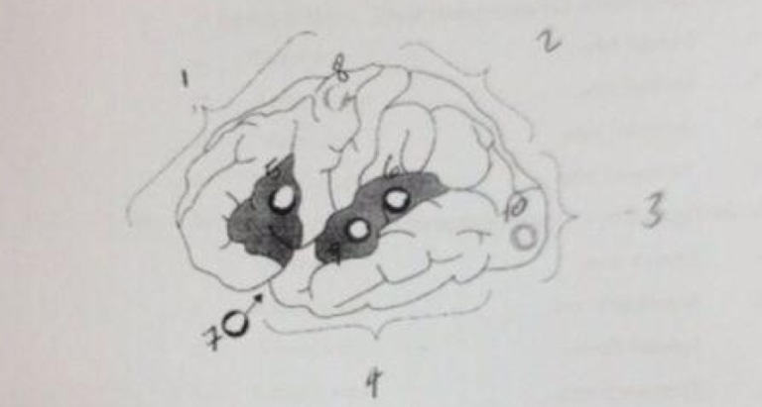

42-in the figure above ,(1) corresponds to the :
a-Parietal lobe
b- Frontal lobe
c- Occipital lobe
d- Temporal lobe

43- in the figure above ,(2) corresponds to the :
a- Frontal lobe
b- Temporal lobe
c- Occipital lobe
d- Parietal lobe

44- in the figure above ,(3) corresponds to the :
a- Frontal lobe
b- Parietal lobe
c- Occipital lobe
d- Temporal lobe

45-in the figure above ,(4) corresponds to the :
a- Frontal lobe
b- Parietal lobe
c- Occipital lobe
d- Temporal lobe

46- in the figure above ,(5) corresponds to the :
a-Broca's area
b-Wernicke's area
c-Sylvian fissure
d- Thomoson's area

47- in the figure above ,(6) corresponds to the :
a-Broca's area
b-Wernicke's area
c-Sylvian fissure
d- Thomoson's area

48- in the figure above ,(7) corresponds to the :
a-Broca's area
b-Wernicke's area
c-Sylvian fissure
d- Thomoson's area

49- in the figure above ,(8) corresponds to the :
a- Motor area
b-Auditory area
c-Visual area
d- Running area

50-- in the figure above ,(9) corresponds to the :
a- Motor area
b-Auditory area
c-Visual area
d- Running area

51-- in the figure above ,(10) corresponds to the :
a- Motor area
b-Auditory area
c-Visual area
d- Running area

52-To say that language is lateralized means that:
a-language function is located in one of the two hemispheres
b-language is combined of capital and small letter
c- language is acquired later in life
d- language is found in many location in the world

53-When we say that control of the body is contralateral it means that:
a- the left side of the brain controls the upper part of the body and the right side of the brain controls the lower part of the body
b- the brain is able to process speaking and listening at that same time
c- the upper part of the body is more functional than the lower part of the body
d- the left hemisphere controls the right side of the body and the right hemisphere controls the left side of the body

54-In a dichotic listening experiment the participant
a-is given a chance to listen to the input twice
b- is given two different inputs to each ear one at the time
c- is given two different inputs to each ear at the same time
d- is given something to listen to while writing something

55-on average ,stimuli presented to the right ear are reported with greater accuracy than the stimuli presented to the left ear . that is known as:
a- the right-ear advantage for language
b- the right-ear ability
c-the quick-ear language ability
d- the left-ear ability

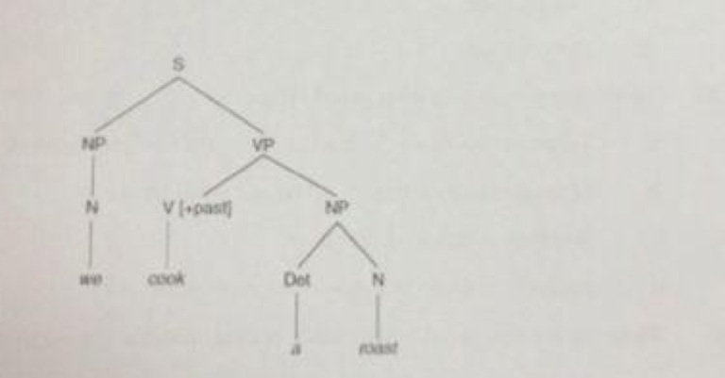

56-In tree diagram above ,S stands for:
a- Subject
b-Sentence
c-Syllable
d-Sense

57- In tree diagram above ,NP stands for:
a-Noun Potential
b-Not Proven
c-Noun Phrase
d-Negative Point

58- In tree diagram above ,N stands for:
a-Noun
b-Not
c-Negative
d-Never

59- In tree diagram above ,VP stands for:
a-Variable Potential
b-Verb Portal
c-Verb Phrase
d-Variability Production

60- - In tree diagram above ,V stands for:
a-Verb
b- Verbal
c- Variable
d-Verbatim

61- In tree diagram above ,{+past} stands for:
a-past tense
b-past participle
c- past progressive
d-past continuous

62- In tree diagram above , Det stands for:
a- Detail
b-Detention
c-Determiner
d-Detachment

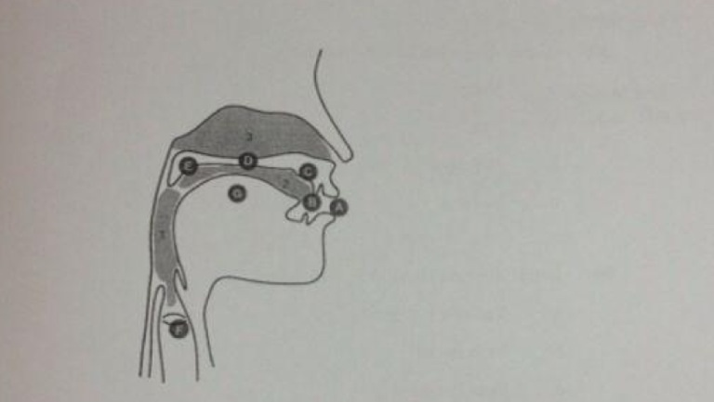

63-In the figure above A corresponds to:
a-the lips
b-the teeth
c-the chin
d-the vocal cords

64- In the figure above B corresponds to:
a- the teeth
b- the lips
c-the chin
d-the vocal cords

65-- In the figure above C corresponds to:
a-the hard palate
b-the alveolar ridge
c-the soft palate
d-the vocal cords

66-- In the figure above D corresponds to:
a-the lips
b- the soft palate
c- the alveolar ridge
d- the hard palate

67- In the figure above E corresponds to:
a-the velum
b- the hard palate
c-the larynx
d- the lips

68- In the figure above F corresponds to:
a-the tongue
b- the velum
c-the glottis
d- the teeth

69- In the figure above G corresponds to:
a- the tongue
b-the nasal cavity
c- the teeth
d- the lips

70-One definition of a morpheme would be:
a-the morpheme is the smallest meaningful unit in a language
b--the morpheme is the smallest sound unit in a language
c- the morpheme is the smallest section in a sentence
d- the morpheme is the smallest understandable unit in a language

