واجبات المقال
واجب المقال الأول

Why I Want to Learn English(1) There are three reasons why I want to learn English. (2) One reason is that English has become an international language.(3) It is now used by most international companies, including the company where I work, for business communication. (4) Another reason why I want to learn English is so that I can travel to English-speaking countries. (5) The United States, England, Australia and many other countries all use English as their primary language. (6) Finally, I want to learn English because I plan to move to the U.S. in the future. (7) I will become a manager for my company soon. (8) For all these reasons, I am very excited about learning English.

1. Identify the topic sentence:

a. 1st sentence

b. 2nd sentence

c. 3rd sentence

d. 4th sentence

2. Identify the conclusion:
a. 5th sentence
b. 6th sentence
c. 7th sentence
d. 8th sentence
3. Identify the first main point:
a. 2nd sentence
b. 3rd sentence
c. 4th sentence
d. 5th sentence

واجب المقال الثاني
Question: what is/are the subtopic(s) of the following of this thesis statement. A healthy lifestyle involves eating a nutritious diet, exercising regularly, and getting enough sleep at night. A healthy lifestyle
Eating a nutritious diet
Exercising regularly
Eating diet, exercising and getting enough sleeping
Which thesis statement is not too general or not an announcement but improved? English Essay is a very difficult and complicated class.
English 101 is an interesting course since I like English.
English Essay is difficult for two reasons.
English Essay is very interesting because I like it
. Which thesis statement is weak not thesis statement? The telecommunication is very advanced in Saudi Arabia. That’s interesting.
The cars are all new in the Jaddah city. Have you rode any?
Food is very special today. Let’s talk about it.
Eating while driving can cause two main fatal accidents
واجب المقال الثالث 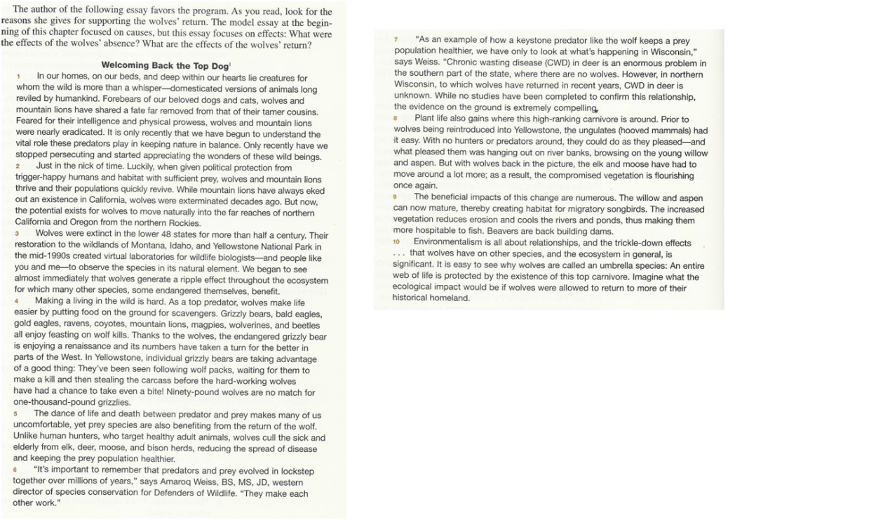

The thesis statement for this essay is the last sentence ofparagraph
1
2
3
There is no thesisstatement
The topic sentence for paragraph 4 is the
Firstsentence
Second sentence
Thirdsentence
There is no topic sentence

Two paragraphs, whenadded together, use the chain pattern. These two paragraphsare:
3and4
4and5
5and6
8and9
Which sentence isparallelized?
1. You can pay me now, or it’s okay if you pay me later
2. You can pay me now or pay me later
3. I like to read and writing

