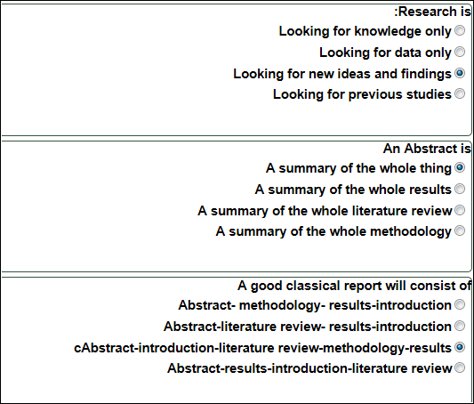

1-The dependent variable is
a-The variable that is affected by the independent variable
b- The variable that is dependent on the hypothesis
c- The variable that is affected by the abstract
d- The variable that is affected by the results
2-The significant difference has to be at the level of
a-P= 50
b- P=.05
c- P=.50
d- P=0.50
3-If you have one variable in your research, then it is
a- Multivariate
b- Univariate
c- Bivariate
d- factorial
4-We use questionnaires in research as a
a- tool to collect data
b- tool to analyse data
c- tool to generate results
d- tool to design research

