Semantics علم المعاني او الدلالات

Semantics is the study of the meaning of words, phrases and sentences.
هو دراسة معنى الكلمات والعبارات والجمل

- Semantic features الخصائص الدلالية او المعنوية

When we say : " The hamburger ate the boy "
عندما نقول " اكل الهمبرجر الولد "
_{NP} | _{V} | _{NP}
_{the boy} | _{ate} | _{The hamburger}

This sentence is syntactically good, but semantically odd. Since the sentence
The boy ate the hamburger is perfectly acceptable.
هذه الجملة صحيحة نحويا لكنها حسب علم المعاني او الدلالات تعتبر خاطئة وغير مقبولة. بينما الجملة المقبولة على نحو تام هي " اكل الولد الهمبرجر "

تنبيه : الترجمة تأخذ مني وقت طويل سأكتفي برؤوس اقلام " اعذروني "

- Semantic roles الادوار الدلالية
- Agent and theme
الفاعل والمفعول به

The boy kicked the ball

In our example sentence, one role is taken by the noun phrase The boy as ‘the
entity that performs the action’, technically known as the agent. Another role
is taken by the ball as ‘the entity that is involved in or affected by the action ', which is called the theme.

Agents and themes are the most common semantic roles. Although agents
are typically human (The boy), they can also be non-human entities that cause
actions, as in noun phrases denoting a natural force (The wind), a machine
(A car), or a creature (The dog), all of which affect the ball as theme
الفاعل غالبا انسان وقد يأتي غير ذلك مثل
The boy kicked the ball.
The wind blew the ball away.
A car ran over the ball.
The dog caught the ball.

The theme is typically non-human, but can be human (the boy), as in the dog
chased the boy.
والمفعول به غالبا غير بشري وقد يأتي بشري مثل ال.. طارد الولد

- Lexical relations العلاقات المعجمية (بين الكلمات)
Not only can words be treated as ‘containers’ of meaning, or as fulfilling ‘roles’
in events, they can also have ‘relationships’ with each other. In everyday talk,
we often explain the meanings of words in terms of their relationships. If we’re
asked the meaning of the word conceal, for example, we might simply say, “It’s
the same as hide”, or give the meaning of shallow as “the opposite of deep”, or the
meaning of daffodil as “a kind of flower”. In doing so, we are characterizing the
meaning of each word, not in terms of its component features, but in terms of its
relationship to other words. This approach is used in the semantic description of
language and treated as the analysis of lexical relations. The lexical relations we
have just exemplified are synonymy (conceal/hide), antonymy (shallow/deep)
and hyponymy (daffodil/flower).
- المترادفات Synonymy
كلمتين او اكثر لهما معاني متقاربة جدا
Two or more words with very closely related meanings are called synonyms.
common examples of synonyms are the pairs :
_{freedom} | _{cab} | _{buy} | _{broad} | _{big} | _{almost} | _{answer}
_{liberty} | _{taxi} | _{purchase} | _{wide} | _{large} | _{nearly} | _{reply}

- المتضادات Antonymy
نموذجين او كلمتين متضادتين في المعنى
Two forms with opposite meanings are called Antonymy.
common examples of Antonymy are the pairs :
_{married} | _{long} | _{hot} | _{happy} | _{fast} | _{big} | _{a live}
_{single} | _{short} | _{cold} | _{sad} | _{slow} | _{small} | _{dead}

- النوع Hyponymy
حيث تكون كلمة نوعا من كلمة أخرى
When the meaning of one form is included in the meaning of another, the relationship is described as hyponymy..
_{flower} | _{vegetable} | _{tree} | _{flower} | _{animal}
_{daffodil} | _{carrot} | _{banyan} | _{rose} | _{dog}
common examples of Hyponymy are the pairs :

Tree diagrams of Hyponymy:
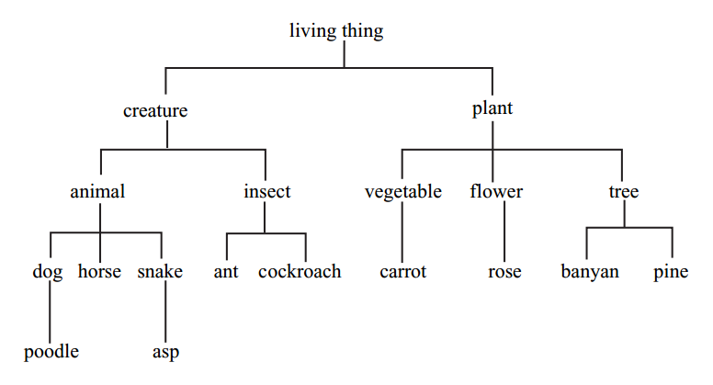

- النموذج Prototypes
النوع الأكثر تميزا في فئة ما. مثلا العصفور هو نموذج لفئة الطيور
The idea of ‘the characteristic instance’ of a category is known as Prototypes.

The concept of a prototype helps explain the meaning of certain words, like bird
not in terms of component features (e.g. ‘has feathers’, ‘has wings’), but in terms
of resemblance to the clearest example. Thus, even native speakers of English
might wonder if ostrich or penguin should be hyponyms of bird(technically
they are), but have no trouble deciding about sparrow or pigeon. These last two are much closer to the prototype.
Given the category label furniture, we are quick to recognize chair as a better
example than bench or stool. Given clothing, people recognize shirts quicker
than shoes, and given vegetable, they accept carrot before potato or tomato…

- المتشابهات اللفظية والشكلية Homophones and homonyms
Homophones المتشابهات اللفظية
كلمتان أو أكثر لهم نفس النطق واختلاف الشكل
When two or more different (written) forms have the same pronunciation, they
are described as homophones.
Common examples :
_{too} | _{right} | _{pail} | _{flour} | _{meat} | _{sew}
_{two} | _{write} | _{pale} | _{flower} | _{meet} | _{so}
_{to}

Homophones المتشابهات الشكلية
كلمتان لهما نفس الشكل لكنهما غير مترابطة في المعنى
We use the term homonyms when one form (written or spoken) has two or
more unrelated meanings, as in these examples:

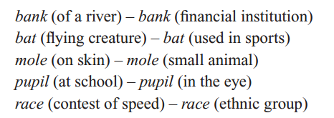

- تعدد المعاني Polysemy
كلمة لها أكثر عدة معاني مترابطة
When we encounter two or more words with the same form and related meanings, we have what is technically known aspolysemy.

Example :.

used to refer to the object on top of your body | _{head}
person at the top of a company or department | _{head}
on top of a glass of beer and many other things | _{head}

- Word play

Mary had a little lamb, we think of a small animal, but in the comic version Mary had a little lamb, some rice and vegetables, we think of a small amount of meat. The polysemy of lamb allows the two interpretations.

- الكناية Metonymy
كلمة تستخدم بدلا من كلمة أخرى بحيث تدل على نفس المعنى
The relatedness of meaning found in polysemy is essentially based on similarity.
The head of a company is similar to the head of a person on top of and controlling
the body. There is another type of relationship between words, based simply on
a close connection in everyday experience. That close connection can be based
on a container–contents relation (bottle/water, can/juice), a whole–part relation
(car/wheels, house/roof) or a representative–symbol relationship (king/crown,
the President/the White House). Using one of these words to refer to the other
is an example of metonymy…

