- Speaking Skills
آلوآجب الاول ,,
What is the best and nicest response when someone gives an apology
a. Nice to meet you
b. I have to go now
c. Talk to you soon
d. That’s OK. That’s all right

What is the best and nicest response when someone introduces another
a. Don’t mention it
b. No problem
c. Keep in touch
d. Glad to meet you

What is the reduction of the phrases - what’s your kind of food
a. What is your kinda food
b. Whatcher kinda food
c. Whater your kinda of food
d. What’s ya kinda food

آلوآجب الثآني ..

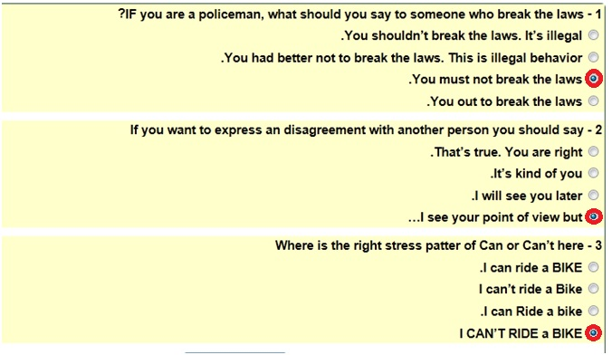

آلوآجب الثآلث ..
؟if you want to ask politely someone for more clarification, you should say
c - Could you repeat that
2- When Americans are not enthusiastic, their voices’ intonation usually…
b - Doesn’t go up
3 - In English, when you want to respond to a negative question or statement with intonation that goes up at the end such as “you don’t have ONE? You should say …
a - No, I don’t
4 - What is the superlative of "unpleasant"?
c - more unpleasant
كل الشكر للي حلوّ آلوآجب
بآلتوفيق دعوآتكم ,,
تجميعي =)
Amo0ora ^_^

