First lecture :Parts of Speech

1) Noun: a part of speech inflected for case, signifying a concrete or abstract entity

2 ) Verb: a part of speech without case inflection, but inflected for tense, person and number, signifying an activity or process performed or undergone

3 ) adjective a word describing the noun

4) Interjection: a part of speech expressing emotion alone

5) Pronoun: a part of speech substitutable for a noun and marked for a person

6) Preposition: a part of speech placed before other words in composition and in syntax

7) Adverb: a part of speech without inflection, in modification of or in addition to a verb, adjective, clause, sentence, or other adverb

8) Conjunction: a part of speech binding together the discourse and filling gaps in its interpretation

9 ) Determiner article a –an- the

Decide which parts of speech are the underlined words

1)You have to believe in yourself if you ever expect to be successful at something.

2) We left for the mountain just before six in the morning.

3) We first went to the store to buy a few things.

4) We had a breakfast at a café near the rail station.

5) My friend wasn't strong enough to lift his heavy rucksack.

6) I helped him carry it.

7) The weather was very cold.

8) My friend said, "Oh! What a cold weather!"

9) We didn't spend the night there.

10) We got back home late at night but we didn't go to sleep immediately. We were very hungry.

2nd lecture sentence patterns in English

Revision questions

What is functional grammar?

What are the 9 parts of speech in English ?

The simple patterns are 5

Subject + Verb
I slept.
They drove.
That bartender slept.

Subject + Verb + Object
They lifted weights.
That singer stole money.
That singer replaced a fuse.

Subject + Verb + Complement
He is a bus driver.
He isn't careless.
I am a farmer.

Subject + Verb + Indirect Object + Direct Object

I bought her a gift.

Those news announcers brought her a small present.

Those scientists paid him this salary.

S + V + O + C

I named the baby Susan.

That dentist painted the room green.

David got the watch fixed.

-----------------------------------------------------------------

Another division which is more complex :
Just about all sentences in the English language fall into ten patterns determined by the presence and functions of nouns, verbs, adjectives, and adverbs.
The patterns are most easily classified according to the type of verb used:
Verb of being patterns (1, 2, 3) use a form of the verb to be as the main verb in the sentence.
is are was
Linking verb patterns (4, 5) use one of the linking verbs as the main verb in the sentence. The linking verb is followed by a noun or adjective functioning as a subjective complement.
smell taste look
Action verb patterns (6, 7, 8, 9, 10) use one of the many action verbs as the main verb in the sentence. The action verb may be either transitive (take a direct object) or intransitive (not take a direct object).
see jump embrace write

Terms used to identify various parts of each sentence pattern include the following:
- NP = noun phrase
This abbreviation refers to a headword noun and its modifiers ("noun phrase") functioning as a subject, direct object, indirect object, subjective complement, or objective complement.

- NP1, NP2, NP3, etc. = designations for different noun phrase functions
Numbers in sequential order are used with each NP to designate its difference from or similarity to other NPs before and after it.
- V-be = verb of being
- LV = linking verb
- V-int = intransitive verb
- V-tr = transitive verb
- ADV/TP = adverbial of time or place
- ADJ = adjective

THE TEN SENTENCE PATTERNS
1. NP1 + V-be + ADV/TP
The verb of being is followed by an adverb indicating where or when.
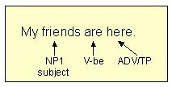 More information on subjects
The adverbial indicating where or when may be a prepositional phrase.
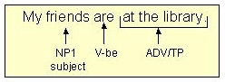
2. NP1 + V-be + ADJ
The verb of being is followed by an adjective that functions as the subjective complement.
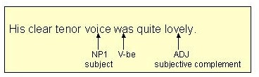 More information on subjective complements
The adjectival functioning as the subjective complement may be a prepositional phrase.
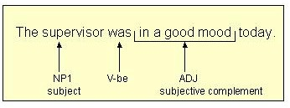

3. NP1 + V-be + NP1
The verb of being is followed by a noun that functions as the subjective complement.
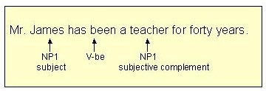
Note: The second NP receives the same numerical designation as the first NP because the second NP, the subjective complement, is the same as the subject (Mr. James = teacher).
4. NP1 + LV + ADJ
The linking verb is followed by an adjective functioning as a subjective complement.
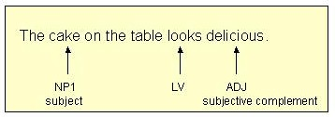
The adjectival functioning as the subjective complement may be a prepositional phrase.
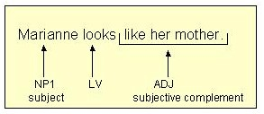
5. NP1 + LV + NP1
The linking verb is followed by a noun functioning as a subjective complement.
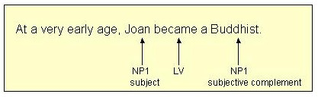
Note: The second NP receives the same numerical designation as the first NP because the second NP, the subjective complement, is the same as the subject (Joan = Buddhist).
6. NP1 + V-int
The action verb takes no direct object.
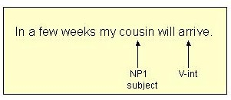
Even if the action verb is followed by a prepositional phrase, the verb is still intransitive as long as it does not take a direct object.
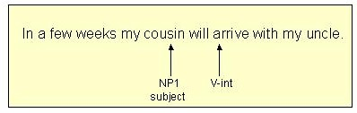
7. NP1 + V-tr + NP2
The action verb is followed by a direct object.
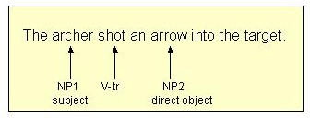 More information on direct objects
Note: The second NP, the direct object, receives a different numerical designation (NP2) because it is not the same as the subject (NP1).
8. NP1 + V-tr + NP2 + NP3
The action verb is followed by an indirect object and then a direct object.
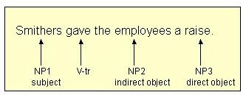 More information on indirect objects
Note: The indirect object and the direct object each receive a new numerical designation because each is different from the other and both are different from the subject.
9. NP1 + V-tr + NP2 + ADJ
The action verb is followed by a direct object. The direct object is followed by an adjective functioning as an objective complement.
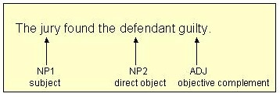 More information on objective complements
Note: The second NP, the direct object, receives a different numerical designation (NP2) because it is not the same as the subject (NP1).
10. NP1 + V-tr + NP2 + NP2
The action verb is followed by a direct object. The direct object is followed by a noun functioning as an objective complement.
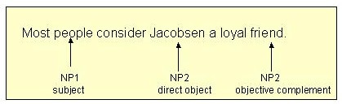

Note: The second NP, the direct object, receives a different numerical designation (NP2) because it is not the same as the subject (NP1). The third NP, the objective complement, receives the same numerical designation as the direct object (NP2) because it is the same as the direct object (Jacobsen = friend)

Exercises on sentence patterns :
Identify the sentence patterns in the following sentences.
(a) S/V-subject-verb
(b) S/V/SC-subject-verb-subject complement
(c) S/V/O-subject-verb-object
(d) S/V/IO/DO-subject-verb-indirect object-direct object.
1)Students from 45 colleges and universities today agreed to form a national organization devoted to fighting student apathy.
2)The students said their immediate objective is to increase student turnout in elections.
3)Students don't vote.
4)That was the message the group told delegates to take home.
5)Most of the delegates to the weekend conference appeared enthusiastic about the prospect of increasing student activism.
Websites recommended :
Englishenglish.com
Usingenglish.com
Englishclub.com

