In The Name Of Allah Most Gracious Most Mercifvl

King Faisal University
Deanship of E-Learning and Distance Education



Content of the Children’s Literature
Instructor : Dr. Abdulgawad Elnady
Level 8


By
Heart story

First Lecture

Warm-up: definitions
- Before we talk about the nature and characteristics of children’s literature, let us try to define the two terms.
- This will help us to understand a lot about the nature of the genre and to be specific about this interesting and comparatively new field of study.

Questions
What is meant by the word genre?
- Food
- Type
- Literary type

Essential terms
Biologically, a child (plural: children) is generally a human between the stages of birth and puberty. Some vernacular definitions of a child include the fetus, as being an unborn child. The legal definition of "child" generally refers to a minor, otherwise known as a person younger than the age of majority.
"Child" may also describe a relationship with a parent (such as sons and daughters of any age) or, metaphorically, authority figure, or signify group membership in a clan, tribe, or religion; it can also signify being strongly affected by a specific time, place, or circumstance, as in "a child of nature" or "a child of the Sixties“.

Questions
- a child means any human being between birth and puberty: this means that the child is
- any person
- A human being
- A mature person

Essential terms
Literature (from Latin litterae) is the art of written work. The word literature literally means "things made from letters“ and letters" means literature while a “man of letters” means a writer or author of works of art.

Questions
In the field of literature, the word letters means:
- Sounds
- Linguistics
- Works of art

- A man of letters is
- the teacher of phonetics
- The one who sells letters
- An author or a writer of creative works

The word literature is originally:
- Arabic
- English
- Italian
- Latin

Literature
- The collective body of literary productions, embracing the entire results of knowledge and fancy preserved in writing; also, the whole body of literary productions or writings upon a given subject, or in reference to a particular science or branch of knowledge, or of a given country or period; as, the literature of Biblical criticism; the literature of chemistry.

- The class of writings distinguished for beauty of style or expression, as poetry, essays, or history, in distinction from scientific treatises and works which contain positive knowledge; belles-lettres.

- The occupation, profession, or business of doing literary work.

Questions

- The word literature has one meaning only
- True
- Untrue
- We have no idea

Essential terms
Literature may consist of texts based on factual information (journalistic or non-fiction), as well as on original imagination. Literature can be classified according to historical periods, genres, and political influences.

Children’s Literature: Definitions
Is there a single definition for children’s literature?
The body of written works and accompanying illustrations produced in order to entertain and instruct young people.

The genre encompasses a wide range of works, including acknowledged classics of world literature, picture books and easy-to-read stories written exclusively for children, and fairy tales, lullabies, fables, folk songs, and other primarily orally transmitted materials.

Questions
The body of written works and accompanying illustrations produced in order to entertain and instruct young people is called:
    - Drama
    - The novel
    - Children’s literature

Children's literature: both fiction and non-fiction books, written especially for children 0-12 years old.
Young adult literature: both fiction and non-fiction books, written for people 13-18 years old.

“Children’s literature is good quality trade books for children from birth to adolescence, covering topics of relevance and interests to children of those ages, through prose and poetry, fiction and nonfiction.”

Children’s literature covers the period of time from
- Birth to death
- Birth till the age of ten
- 5 to 18
- Birth to the age of 18

- Despite the recent trend of categorizing children's literature by age, an increasing number of adults have begun reading children's books, blurring the boundaries between children's and adult texts.
- Although children's literature is intended primarily for children, it is more accurate to view such texts as having dual audiences of children and adults.

Questions
Children’s literature is:
- read only by children
- Read by children and adults
- Read only at schools
- Read only before going to sleep

Is children’s literature to be read and appreciated by children only?
Of course not. All classes of people can read, study, and appreciate this genre of literature.

Final word: Definition of Children’s Literature:
- There is no single, widely accepted definition of children's literature. It can be broadly defined as anything that children read, but a more useful definition may be fiction, poetry, and drama intended for and used by children and young people, a list to which many crtics add non-fiction.

- Nancy Anderson of the College of Education at the University of South Florida defines children's literature as all books written for children, "excluding works such as comic books, joke books, cartoon books, and nonfiction works that are not intended to be read from front to back, such as dictionaries, encyclopedias, and other reference material".

Second Lecture

History
Children’s literature first clearly emerged as a distinct and independent form of literature in the second half of the 18th century, before which it had been at best only in an embryonic stage.
From when to when?

Children's literature has its roots in the stories and songs that adults told their children before publishing existed, as part of the wider oral tradition. Because of this it can be difficult to track the development of early stories. Even since widespread printing, many classic tales were originally created for adults and have been adapted for a younger audience.

Although originally children's literature was often a re-writing of other forms, since the 1400s there has been much literature aimed specifically at children, often with a moral or religious message. To some extent the nature of children's fiction, and the divide between older children's and adult fiction became blurred as time went by and tales appealing to both adult and child had substantial commercial success.

In the beginning the same tales that adults tell and enjoy are adapted for children. Then stories are created specifically for children, to educate, instruct and entertain them. In the final stage literature for children is established as separate from that of adults, having its own genres, divisions, expectations and canon. The development of children's literature is influenced by the social, educational, political and economic resources of the country or ethnic group.

According to Aspects and Issues in the History of Children's Literature from the International Research Society for Children's Literature, the development of literature for children anywhere in the world follows the same basic path. All children's literature, whatever its current stage of development, begins with spoken stories, songs and poems.

History of Children’s literature
Up until the 19th century books written for children were entirely religious, instructional, or for the improvement of their morals and manners.
What do you know about how children were viewed prior to the inception of child development as a discipline? The views about children then influenced nature of lit.

History (continued)
In 1865 Alice in Wanderland” was written, the first book that was written for mere enjoyment. & that marked the beginning of children’s literature

Differences between children’s books now and then
More experimentations with genres- from teaching values to fantasy, fiction, etc
Blurring age boundaries- picture books for everyone.
Changing topics, eg., technology, terrorism
Technology & commercialization, books on audio and videotapes.: eg. Harry Potter.
Increasing diversity melting pot versus salad bowl. International literature.
Building on the past, looking into the future.

Children’s literature is a relatively new kind of literature.
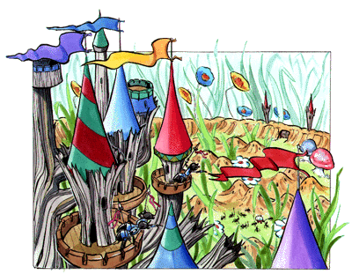
Before 1850, books taught lessons on manners and morals.

Children’s Books

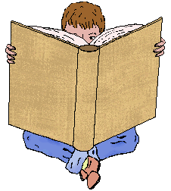
- Books also contained lessons on the ideas of history and science that existed at the time.

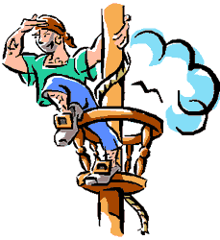

Children found the books dull, so they read stories intended for adults.
Robinson Crusoe by Daniel Defoe
Gulliver’s Travels by Jonathan Swift
Rip Van Winkle by Washington Irving


Early Beginnings
In 600 A.D.,the Old English period, monks and other learned men wrote “lesson books” for children.

Questions
Children’s literature dates back to
- The year 600 A.D.
- 1600
- 1700
- 1800

Why did children prefer reading Gulliver’s Travels and Robinson Crusoe to reading books by scholars and preachers?
- The latter books were dull
- The former books were available
- Both novels were a must at schools

The 1700s
John Newbery was a writer, publisher, and bookseller of St.Paul’s Church, London.
He published a series of books for children. Recognized they had special interests and tried to meet them.
He printed chapbooks, cheap little paper editions, which were sold on the streets by chapmen (peddlers); they contained ballads and folk tales. The ordinary person could afford to buy these books.

He also published translations from the French:
Tales of Mother Goose by Charles Perrault. It was considered beneath the dignity of authors to write books for children, so they were published without any name attached.

Questions
in the 1800s, why were books for children published without any name attached?
  - Writers were ashamed of them
  - That was the habit with all books
  - No one knows

The 1800s
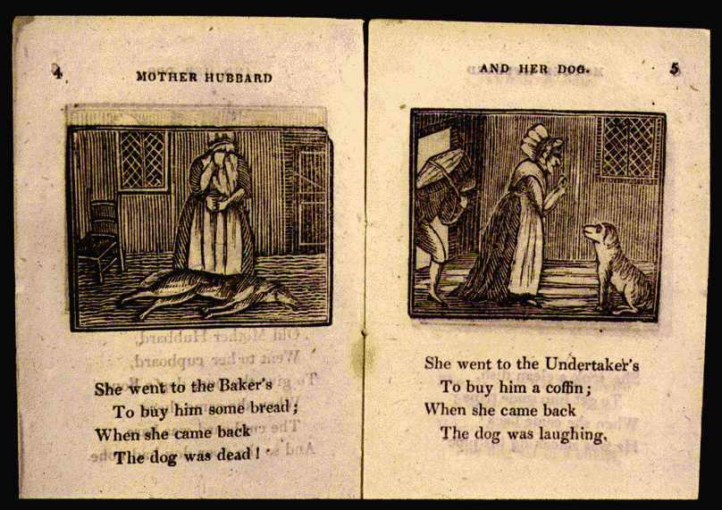
In the beginning of the 1800s, children’s literature became more creative.

Real literary authors could write for children and not damage their reputations.

The Early 1800s
Charles and Mary Lamb, brother and sister, wrote to give children pleasure.

They worked together (in 1807) to write a children’s version of Shakespeare’s plays.

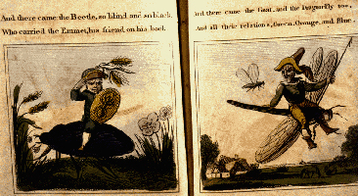

Questions
What did Charles and Mary Lamb write for children in the 19th century?
- a novel
- A poem
- a children’s version of Shakespeare’s plays
Charles and Mary Lamb were
Husband and wife
Brother and sister?

And Then . . .
A period of change began in the next 50 years.
Authors had a profound influence on children’s literature.

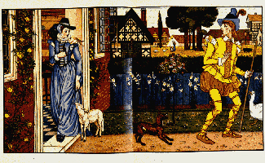

And Then . . .
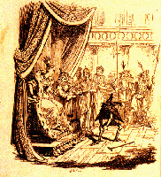
Jacob Ludwig and Wilhelm Carl Grimm traveled around Germany, talking to people and collecting folk stories.
Their collection was translated into English in 1824.

And Then . . .
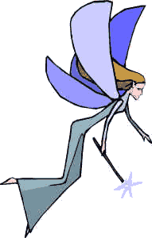 Hans Christian Anderson, in 1841, wrote “modern” fairy tales, so called because Anderson actually created them and copied old ways of telling stories.
Some of his stories are “The Little Mermaid,” “The Ugly Duckling,” and “The Emperor’s New Clothes.”


In the 20th century
"From the 1960s through the 90s “socially relevant” children's books have appeared, treating subjects like death, drugs, sex, urban crisis, discrimination, the environment, and women's liberation. S. E. Hinton's The Outsiders (1980) and Robert Cormier's I Am the Cheese (1977) are two novels that offer vivid portrayals of the sometimes unpleasant aspects of maturing.

These books also reveal the trend toward a growing literature for teenagers. Other novelists that write convincingly of growing up in contemporary society include Ellen Raskin, Judy Blume, and Cynthia Voigt. Some critics consider these books as didactic as the children's books of the 17th and early 19th cent.

Third Lecture

Characteristics of Children’s literature
Just a quick reminder: Children’s literature is Both fictional and non-fictional books, written especially for children 0-18 years old. It is a genre that began very early in history and that was initiated officially, so to speak, in the year 1865 with the publication of Alice in the Wonderland by Lewis Carroll as the first novel to have been written for the pure pleasure and enjoyment of children.

Question
What is the first novel to have been written for the pure pleasure and enjoyment of children?
- Alice in the Wonderland
- Robinson Crusoe
- Gulliver’s Travels
- Animal Farm

Alice in the Wonderland by Lewis Carroll tells of a girl named Alice who falls down a rabbit hole into a fantasy world (Wonderland) populated by peculiar, mythological creatures. The tale plays with logic, giving the story lasting popularity with adults as well as children.
Adults and children alike can read and enjoy children’s literature.

Question
Children’s literature can be read and enjoyed by:
- children only
- Adults only
- Both adults and children

Let us try something new today. I will not directly tell you of those characteristics you find in the title. I will show you a picture and a movie and then we can come up, ourselves, with some very nice feature. Ready?
Move to the next slide please.
First, the Picture

What is a work of art for children expected to be like?

Then the Movie
What is a work of art for children expected to be like?

Initial ideas from the picture and the movie:
- Children’s literature has to….be easy & simple.
- Children’s literature has to….contain a message.
- Children’s literature has to….have a moral lesson.
- Children’s literature has to….attractive, surprising , and exciting
- Children’s literature has to provide adventures
- Children’s literature has to provide suspense
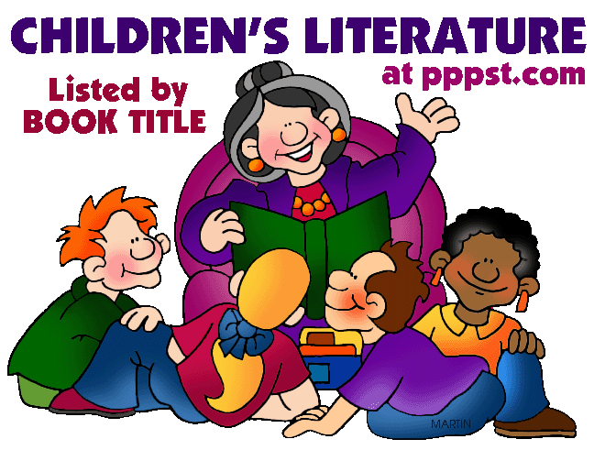
Funny. Uses stories. Interesting.

Telling stories
The art of telling a story is very important in writing for children. It helps the writer to capture the interest and imagination of the child. Without possessing this art everything might turn dull and children will easily lose concentration. As the writer tells the story he or she has to be exciting, funny, interesting, and challenging. How so?

The art of Telling stories
- Using an unfamiliar way of starting or ending a sentence.
- Using negation
- Using questions
- Allowing for some time of silence so the kids would think or even have a break
- Changing different tones, not just maintaining one monotonous voice from start to finish
- Marinating a cozy smile all the way through
To understand all this I want you to imagine yourself as a father or mother telling your child a bedtime story.

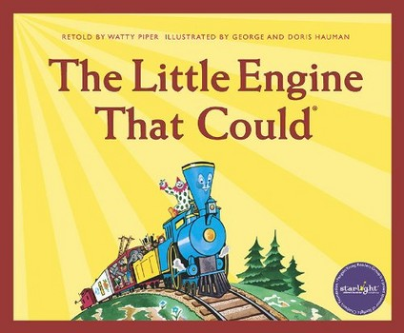

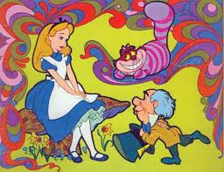
fantasy

Fantasy
Children’s literature depends greatly on fantasy, but we have to remember that some logic is also needed, otherwise we are not doing justice to the children. We will talk about this later.

Question
Literature for children
- must use fantasy only.
- Must mix fantasy and realism
- Must never use logic or realism

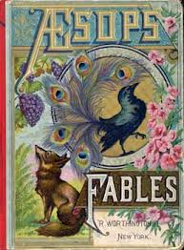
The fable is: A story in which all characters are animals
Fables
Fables are fine with children, but it has been noticed that allegory as in Animal Farm works miracles with the children, much more than fables. Why? Because it mixes fantasy with logic.

Question
Which is more preferable for children, fables or allegories?
- Fables
- Allegories
- None of the above

Fourth Lecture

Further characteristics of children’s literature

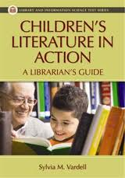
There must be some kind of action
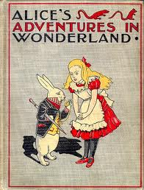
A novel written in 1865. the first real novel for children
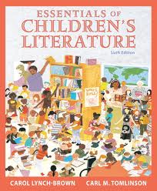
Has to be about the world of children

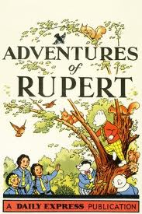
Harry potter
Harry Potter is a series of seven fantasy novels written by the British author J. K. Rowling. The books chronicle the adventures of a wizard, Harry Potter, and his friends Ronald Weasley and Hermione Granger, all of whom are students at Hogwarts School of Witchcraft and Wizardry. The main story concerns Harry's quest to overcome the Dark wizard Lord Voldemort, whose aims are to become immortal, conquer the wizarding world, subjugate non-magical people, and destroy all those who stand in his way, especially Harry Potter.

Since the release of the first novel Harry Potter and the Philosopher's Stone on 30 June 1997, the books have gained immense popularity, critical acclaim and commercial success worldwide. The series has also had some share of criticism, including concern for the increasingly dark tone. As of June 2011, the book series has sold about 450 million copies, making it the best-selling book series in history, and has been translated into 67 languages. The last four books consecutively set records as the fastest-selling books in history.
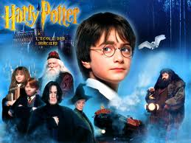
A child character at the forefront and somoe adults are there as a backdrop, in the background
Questions
Whose point of view should be dominant in a book for children?
- That of children
- The point of view of grown ups
- The author’s point of view.

Characteristics of Children’s Literature

Simple and straightforward.
You cannot use complex language or difficult issues in talking to kids.
This does not mean that vocabulary needs to be overly simplistic or that style should be choppy or flat (as too many books for children are).

Children’s Literature:
- must always be simplistic
- Should be easy and acceptable
- Must be difficult to understand

Focuses on action.
Subtle psychological events are often implied through narration and comment on actions.
Thoughts and ideas will make children absent minded or they would lose interest easily. So it is better to keep them focussed on action.

Children’s Literature Focuses on action:
- it should never deal with ideas
- It has to have action all the time
- It does provide action which helps to understand ideas.

Is about childhood.
Naturally. It cannot talk about adults. Or wars or marriage or higher studies or the UN. Only the concerns of childhood.
Characteristics of Children’s Literature
Expresses a child’s point of view.
Same as above
Child ideas and topics mean the point of view to be expressed.
Can it present the point of view of elders?
Can children be just followers of the views of adults?
Can they have their own p o view?

Is optimistic.
“Hope is a vital dimension of a children’s book”. (Sarah Smedman)
Pessimism does not fit the world of children. It just puts them off and creates a wall between them and the novel. Of course we are talking here about children readers and characters.

Tends toward fantasy.
Fantasy often implies a symbolic defiance of our knowledge of reality.
Lots of imagination with some logic of course. But fantasy should be the ruling principle.

Is a form of pastoral idyll.
The pastoral idyll celebrates the joys and innocence of rural life, close to nature and in the company of friends.
Greenery, shrubs, trees, flowers, water, rivers, roses, nature in general. All these are so dear to the hearts of kids.
Pasture

Views an un-idyllic world from the viewpoint of innocence.
More complex and interesting books reflect ambivalence about desire to have the comforts of home and the exciting dangers of adventure, desire to be innocent and experienced, desire to grow up but not grow up, etc.
being not able to grasp the evil there is in the whole world, thinking that all is well while in fact it is not. Cf optimistic.

Fifth Lecture

Characteristics of Children’s Literature
9. Is didactic. Preaching
Traditionally, children’s literature has been seen as attempting to educate children.
A universal theme is teaching children that despite its boredom, home is a better place to be than the dangerous world outside.
Truthfulness. Cooperation. Filial obedience. Brotherhood. Innocence. Good X evil.

Question
Children’s literature is didactic:
- It teaches children readers a moral lesson
- It only provides fun no more
- It teaches children politics

10. Tends to be repetitious.
Repeating tasks is a basic method of education.
Repetition is a common trait of oral literature.
Repetitions with variations of words, phrases, situations, and narrative patterns are common in children’s literature.
Some examples from the novel.

Questions
Repetitions in children's literature means:
- Repeating some words only
- Repeating words, phrases, and situations
- Repeating adjectives only
- Repeating adverbs only

11. Tends to balance the idyllic and the didactic.
Some books are almost completely didactic (teaching them how to become like mature adults and deal with the adult world) or idyllic (reflecting a desire to retain the innocence of childhood), but most books combine the two approaches, and deal with opposing ideas, such as home vs. away, communal concern vs. self-concern, good vs. evil.
Teaching X delighting

Questions
Children’s Literature Tends to balance the idyllic and the didactic:
- it mixes teaching and delighting
- It prefers teaching to delighting
- It prefers delighting to teaching

Idyllic
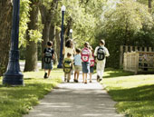

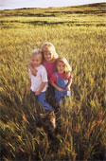

Idyllic




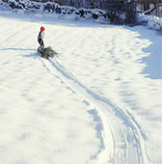

Didactic

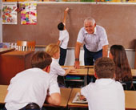

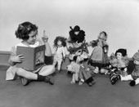

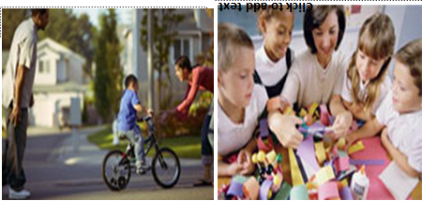

About the Author
Like Roberta, Peter and Phyllis in The Railway Children, Edith Nesbit (1858–1924) was born into a middle-class family whose fortunes eventually declined. Unlike the children in the novel, however, Nesbit didn’t see her problems suddenly swept away. Her financial troubles continued throughout her lifetime – even until her death.

The Relationship Between the Novel and the Writer’s Own Life
Nesbit’s childhood was a difficult one. Her father died when she was only four years old, and her mother moved the family around Europe looking for a warm, dry climate suitable for Nesbit’s sister, Mary, who suffered from consumption, a disease that was incurable at the time. It wasn’t until 1871 – after Mary’s death – that the family settled in south-east England in Kent.

One of Kent’s main attractions was the railway line that ran past a field at the back of the family’s house. Living in this house, Nesbit
began writing poetry – some of which was eventually published – and started dreaming of becoming a great poet.

Later, Nesbit moved to London, where she met and married Hubert Bland in 1880. Her husband’s business collapsed, and it wasn’t long before Nesbit had to provide the main source of income for their growing family.

She achieved this mainly by writing poetry, stories, novels – anything that matched the literary taste of the time. Slowly, the family’s fortunes improved. Bland became a successful journalist, and Nesbit focused her energies on writing children’s stories, which brought her fame and success.

When her husband died in 1914, Nesbit was heartbroken, and her financial situation once again became unstable.
Her difficulties were eased a little in 1915, when she
was awarded a small pension from the government for her services to literature. She also sold produce from the garden of her house to bring in a little extra money.

In 1917, Nesbit married a cheerful marine engineer named Thomas Terry Tucker. After struggling on her own for three years, Nesbit found her marriage to Tucker to be an enormous relief. Her final novel, The Lark, which was published in 1922, represented a return to form for Nesbit. Unfortunately, however, she didn’t have a chance to keep the form going, as she died two years later from the ill effects of lung cancer.

The Relationship Between the Novel and the Writer’s Own Life
The differences | The similarities:

Mother in the novel is almost an exact copy of:
- The writer
- The writer’s sister
- One famous woman in the 19th century
- Any woman in any age

The dedication
TO MY DEAR SON PAUL BLAND BEHIND WHOSE KNOWLEDGE OF RAILWAYS MY IGNORANCE CONFIDENTLY SHELTERS

Sixth Lecture

The Railway Children: Story

The story concerns a family who move to "Three Chimneys", a house near the railway, after the father, who works at the Foreign office, is imprisoned as a result of being falsely accused of selling state secrets to the Russians.

Father is falsely accused of selling state secrets to the Russians. This crime is called:
    - High treason
    - Forgery
    - Greed

How many chapters does The Railway Children consist of?
14
15
16
17

Why has Father been imprisoned?
- He has been accused of selling state secrets to the Russians
- He killed his boss
- He stole money from the government

The three children, Roberta (Bobbie), Peter and Phyllis (Phil), find amusement in watching the trains on the nearby railway line and waving to the passengers. They become friendly with Albert Perks, the station porter, and with the Old Gentleman who regularly takes the 9:15 down train. He is eventually able to help prove their father's innocence, and the family is reunited.

CHAPTER 1: THE BEGINNING OF THINGS
One night at their home in London, father, mother, Roberta(also known as Bobbie), Peter and Phyllis are talking about Peter’s broken model engine when there is a knock on the front door. Two gentlemen come to see father and talk for a long time. Father speaks briefly with mother and mysteriously leaves home.
The next morning, mother leaves for London and returns in the evening, looking tired. She requests the children to be good while she is away and not to ask any question about father. Several horrid weeks pass by and one morning, mother tells the children that they are moving to a little white house near railway line in the country. They take the train and arrive at their new home in the dark.

THE BEGINNING OF THINGS
THEY were not railway children to begin with. I don't suppose they had ever thought about railways except as means of getting to Maskelyne and Cooke's, the Pantomime, Zoölogical Gardens, and Madame Tussaud's. They were just ordinary suburban children, and they lived with their Father and Mother in an ordinary red-brick-fronted villa, with coloured glass in the front door, a tiled passage that was called a hall, a bath-room with hot and cold water, electric bells, French windows, and a good deal of white paint, and "every modern convenience," as the house-agents say.

THEY were not railway children to begin with. The narrative voice starts the book with an unfamiliar sentence, totally unexpected. This is one way of arousing the interest of children. The novel is called the Railway Children and yet it begins with a negation of this fact.
The novel is called the Railway Children and yet it begins with a negation of this fact:
- To arouse the interest of children
- Because the writer is fond of negation
- To show that children hate trains
- To attract attention to trains
I don't suppose they had ever thought about railways. In this introductory sentence again we have a glimpse of the narrative voice. At the start of the novel it is a minor voice that does not interfere much in the events or the story. But we will discover that later on it will be very close to children.
There were three of them. Roberta was the eldest. Of course, Mothers never have favourites, but if their Mother had had a favourite, it might have been Roberta. Next came Peter, who wished to be an Engineer when he grew up; and the youngest was Phyllis, who meant extremely well.

like the first sentence, the way the writer introduces herself is also unfamiliar and interesting, just giving us one fact about each child. That is also done in an interesting way.

Mother did not spend all her time in paying dull calls to dull ladies, and sitting dully at home waiting for dull ladies to pay calls to her. She was almost always there, ready to play with the children, and read to them, and help them to do their home-lessons. Besides this she used to write stories for them while they were at school, and read them aloud after tea, and she always made up funny pieces of poetry for their birthdays and for other great occasions, such as the christening of the new kittens, or the refurnishing of the doll's house, or the time when they were getting over the mumps.

Mother did not spend all her time in paying dull calls to dull ladies, and sitting dully at home waiting for dull ladies to pay calls to her. She was almost always there…
- The writer supports feminism in an indirect way
- She is also very realistic.

Does the writer support feminism in the novel?
- Yes she does, in an indirect way
- She is very realistic.
- She does that in a direct way
- No she does not

The narrative voice is an important aspect of the novel:
- It creates an atmosphere of story telling
- It is just there for fun
- It has nothing to do with the story

Questions
Mother was almost always there:
- She never slept
- She was always with her kids
- She spent most of her time with her kids

They also had a father who was just perfect--never cross, never unjust, and always ready for a game--at least, if any time he was not ready, he always had an excellent reason for it, and explained the reason to the children so interestingly and funnily that they felt sure he couldn't help himself.
Father is only perfect- from the point of view of children. Realism again.

Questions
For the children, Father was just perfect :
- He used to get high marks at school
- He wanted his chldren to be perfect
- He knew what his kids needed so they considered him perfect

You will think that they ought to have been very happy. And so they were, but they did not know how happy till the pretty life in the Red Villa was over and done with, and they had to live a very different life indeed.
The dreadful change came quite suddenly.
Peter had a birthday--his tenth.

Peter had a birthday--his tenth. This sentence:
- Explains the real change that has taken place in the life of the children
- Is a very fine technique used by the writer to explain the change gradually to children
- Has no meaning

Mother began to be afraid that he might be sickening for measles, when suddenly he sat up in bed and said:--
"I hate gruel--I hate barley water--I hate bread and milk. I want to get up and have something real to eat."
"What would you like?" Mother asked.
"A pigeon-pie," said Peter, eagerly, "a large pigeon-pie. A very large one."
So Mother asked the Cook to make a large pigeon-pie. The pie was made. And when the pie was made, it was cooked. And when it was cooked, Peter ate some of it. After that his cold was better. Mother made a piece of poetry to amuse him while the pie was being made. It began by saying what an unfortunate but worthy boy Peter was, and then it went on
We learn from this brief summary that:
- the period of happiness the children spent at home came to an end with the arrest of the father. It was also very short-lived.
- The children did not notice the change in their life due to the responsible behaviour of the mother.
- Mother was different from all other mothers at that time.
- Father and Mother have been perfect, according to children’s definition of perfection: Father is always there for children, playing with them and fixing their engines, and mother also spends almost all her time with them.
- They are not ALWAYS there. No they are described as being almost always there. Very realistic. The novel can be said to enjoy a lot of verisimilitude.

Seventh Lecture

Chapter One
There is a very close connection between the poem at the start and the course of the whole novel.

He had an engine that he loved
With all his heart and soul,
And if he had a wish on earth
It was to keep it whole.
One day--my friends, prepare your minds;
I'm coming to the worst--
Quite suddenly a screw went mad,
And then the boiler burst!
With gloomy face he picked it up
And took it to his Mother,
For those who perished on the line
He did not seem to care,
His engine being more to him
Than all the people there.
And now you see the reason why
Our Peter has been ill:
He soothes his soul with pigeon-pie
His gnawing grief to kill.
He wraps himself in blankets warm
And sleeps in bed till late,
Determined thus to overcome
His miserable fate.
And if his eyes are rather red,
His cold must just excuse it:
Offer him pie; you may be sure
He never will refuse it.

The novel and the poem

The poem | The novel
He had an engine that he loved  With all his heart and soul,  And if he had a wish on earth  It was to keep it whole. | They had a family that they loved so much and wanted to keep this kind of happiness for ever
One day--my friends, prepare your minds;  I'm coming to the worst--  Quite suddenly a screw went mad,  And then the boiler burst!  With gloomy face he picked it up  And took it to his Mother, | The dreadful change came quite suddenly. After telling us about this perfect family we are told that something serious will change the life of the whole family dramatically.  Mother at once takes responsibility for the family.

The poem | The novel
Children were happy with their parents  They had everything they dreamt of | Peter is happy with his engine  The engine was everything that Peter needed
Suddenly Father disappeared | Suddenly the engine broke down

The poem | The novel
For those who perished on the line  He did not seem to care,  His engine being more to him  Than all the people there. | Because they were so happy and satisfied, they stopped thinking of the world outside.
And now you see the reason why  Our Peter has been ill:  He soothes his soul with pigeon-pie  His gnawing grief to kill. | To avoid being sad over the absence of the father, the children busy themselves with playing.

The poem | The novel
He wraps himself in blankets warm  And sleeps in bed till late,  Determined thus to overcome  His miserable fate. | The first thing they do when mother is busy is that they do not believe what has happened to Father and so they are busy playing.
And if his eyes are rather red,  His cold must just excuse it:  Offer him pie; you may be sure  He never will refuse it. | Once you offer children something to eat or to be interested in, they will forget the serious troubles their families suffer from

Chapter one
Peter with heroic unselfishness did not say anything about his Engine till after Father had had his dinner and his after-dinner cigar. The unselfishness was Mother's idea--but it was Peter who carried it out. And it needed a good deal of patience, too.

- The role of the mother in teaching politeness to children
- Children’s literature is didactic.

"Can girls help to mend engines?" Peter asked doubtfully.
"Of course they can. Girls are just as clever as boys, and don't you forget it! How would you like to be an engine-driver, Phil?"
"My face would be always dirty, wouldn't it?" said Phyllis, in unenthusiastic tones, "and I expect I should break something."
"I should just love it," said Roberta,--"do you think I could when I'm grown up, Daddy? Or even a stoker?"
"You mean a fireman," said Daddy, pulling and twisting at the Engine.

The novel indirectly talks about the call for the emancipation of women, what is regarded as the Feminist movement.

"Can girls help to mend engines?" Peter asked doubtfully.
"Of course they can. Girls are just as clever as boys, and don't you forget it! How would you like to be an engine-driver, Phil?“

- Peter represents all men who see women as unable to perform many things.
- Father is so wise. He is aware that boys and girls, men and women are equal in many respects. So he does not support his son against his daughters.
- All this is done indirectly.

The novel indirectly talks about the call for the emancipation of women, what is regarded as the Feminist movement.
- Directly
- Indirectly
- Casually

Peter’s way of dealing with his sisters suggests
- that he is like all boys who do not trust in the power of girls
- He does not have trust in himself
- His sisters do not like him

"Please'm," she (Ruth) said, "the Master wants you to just step into the study. He looks like the dead, mum; I think he's had bad news. You'd best prepare yourself for the worst, 'm--p'raps it's a death in the family or a bank busted or--"
"That'll do, Ruth," said Mother, gently; "you can go.“

Comment on the way each woman expresses herself.

"I say, Ruth, what's up?" he asked.
"Don't ask me no questions and I won't tell you no lies," the red-headed Ruth replied. "You'll know soon enough."
- The child is curious
- He forgets that it is wrong to ask servants about the affairs of the family
- Ruth is rude and cannot select her words decently.

"To London," Ruth said, and left them to their breakfast.
"There's something awful the matter," said Peter, breaking his egg. "Ruth told me last night we should know soon enough."
"Did you ask her?" said Roberta, with scorn.
"Yes, I did!" said Peter, angrily. "If you could go to bed without caring whether Mother was worried or not, I couldn't. So there!"
"I don't think we ought to ask the servants things Mother doesn't tell us," said Roberta.
"That's right, Miss Goody-goody," said Peter, "preach away."

- Peter takes the role of the father after Father is arrested. The writer draws a very interesting picture of how boys love to show themselves as in control of girls when their parents are busy.
- This is quite realistic. The novel has a lot of verisimilitude.
- Girls are less adventurous, more decent, as shown in Roberta’s reply.
- But they know among themselves that it was quite wrong to ask Ruth about their Father.

It was nearly seven before she came in, looking so ill and tired that the children felt they could not ask her any questions. She sank into an armchair. Phyllis took the long pins out of her hat, while Roberta took off her gloves, and Peter unfastened her walking-shoes and fetched her soft velvety slippers for her.
- Mother starts searching for work in order to support the family
- She does not tell her kids the real reason behind the absence of the Father.
- The kids are so polite. Their happy life in the villa gave them a lot of decency and politeness as when they take care of their tired mother.

"You can help me very much," said Mother,
"by being good and happy and not quarrelling when I'm away,"--Roberta and Peter exchanged guilty glances,--"for I shall have to be away a good deal."
"We won't quarrel. Indeed we won't," said everybody. And meant it, too.
"Then," Mother went on, "I want you not to ask me any questions about this trouble; and not to ask anybody else any questions."
Peter cringed and shuffled his boots on the carpet.
"You'll promise this, too, won't you?" said Mother.
"I did ask Ruth," said Peter, suddenly. "I'm very sorry, but I did."
"And what did she say?"
"She said I should know soon enough."
"It isn't necessary for you to know anything about it," said Mother; "it's about business, and you never do understand business, do you?"

Chapter one - Questions
The novel has ………………………verisimilitude.
- A lot of
- No
- Some
- No trace of

The way the novel is narrated is ……………..methods of narration in the 19th century novel
- Similar to
- Different from
- Superior to
- Has nothing to do with

"Then don't you worry either, Mother," said Phyllis, "and we'll all be as good as gold."
Mother sighed and kissed them.
"We'll begin being good the first thing to-morrow morning," said Peter, as they went upstairs.
"Why not now?" said Roberta.

"There's nothing to be good about now, silly," said Peter.
"We might begin to try to feel good," said Phyllis, "and not call names."

In the novel, there is a lot of repetition that is:
- Redundant
- Boring
- Useless
- Funny and important

Eighth Lecture

Approaches
So far, we have been trying to understand the novel as an example of children’s literature.
However, we need to think all the time of the following very important approaches which we will come across many times:

- The characteristics of children’s literature
- Feminism
- Railways and how effective they were on the life of people in the 19th century

Today, let us start with the first and second topics.
- Feminism
- It means the interest in women and women’s issues, in the good, interests, hope, ambitions, dilemma, disappointment of women.
- It also deals mainly with how women have been subjected and suppressed by men.
- To understand all this please try to understand the coming quotation.

It is in vain to say human beings ought to be satisfied with tranquillity: they must have action; and they will make it if they cannot find it. Millions are condemned to a stiller doom than mine, and millions are in silent revolt against their lot. Nobody knows how many rebellions besides political rebellions ferment in the masses of life which people earth. Charlotte Bronte, Jane Eyre

Women are supposed to be very calm generally: but women feel just as men feel; they need exercise for their faculties, and a field for their efforts, as much as their brothers do; they suffer from too rigid a restraint, too absolute a stagnation, precisely as men would suffer; and it is narrow-minded in their more privileged fellow-creatures to say that they ought to confine themselves to making puddings and knitting stockings, to playing on the piano and embroidering bags.
Charlotte Bronte, Jane Eyre

One word: equality. Equality between men and women was the keyword.

What was the common idea about women in the Victorian Age?
They were forced to confine themselves to making puddings and knitting stockings, to playing on the piano and embroidering bags.

It is thoughtless to condemn them, or laugh at them, if they seek to do more or learn more than custom has pronounced necessary for their sex. Charlotte Bronte, Jane Eyre

- In the 19th century, both men and women were suppressed . They lived in stagnation. They needed freedom.
- Men thought that women do not have any faculties or energies.
- Men regarded the place of women to be home and only home.
- Women are not different from men in wanting change and in desiring the expression of their powers.
- Charlotte Bronte, Jane Eyre

- In The Railway Children, we are told in an indirect way of this eternal struggle between men and women.
- We are also told of how women do their best to achieve themselves and to arrive at self-assertion which is the essence of Feminism.
- Mother is different from all 19th century mothers.
- She may not have to work away from home now, but she gives almost all her time to her family, feeling very responsible for them.
Mother did not spend all her time in paying dull calls to dull ladies, and sitting dully at home waiting for dull ladies to pay calls to her. She was almost always there, ready to play with the children, and read to them, and help them to do their home-lessons. Besides this she used to write stories for them while they were at school, and read them aloud after tea, and she always made up funny pieces of poetry for their birthdays and for other great occasions, such as the christening of the new kittens, or the refurnishing of the doll's house, or the time when they were getting over the mumps.

- Mother has brought up her children in a very decent way. She has given them the major values they live upon when they grow up alone without Father. Examples: when Peter asks Ruth the servant about Father and later on he feels very sorry because kids are not supposed to do so. Also when he and Roberta quarrel in the absence of Mother. They soon realize that this is not nice and become friends again. They tell some family secrets to the station master. They steal coal from the station, and they apologize and understand that all this is wrong.

- Another aspect of Feminism is the continuous struggle between Peter as a boy and his sisters. We have had an example in Chapter one when Peter asks Father if girls can mend engines too.
- The wise Father (also the wise author) says that girls are as fit as boys. He talks to Roberta and Phil about that too.
- Peter says (a germ of endearment) in chapter one too in order to show up as the man of the house. It is funny because we know that the real phrase is ( a term of endearment)

- Another way of showing Mother as the perfect example of the WOMAN idealized by the author is in the contrast we have between her and Ruth and aunt Emma.

Ruth | Aunt Emma | Mother
Redheaded | Disorganized | Pretty and clean
Rough | Does not play with the kids | Almost always there
Rash , reckless | Stays away from kids | Wise
Uses indecent words | Insults children | Very sweet with kids
Not educated | A governor | A writer, a poet, so cultured
Driven away from the house | Travels to Germany, rescued only by Mother | A real example to follow even when she is sick or busy

Ruth and Mother
"Please'm," she said, "the Master wants you to just step into the study. He looks like the dead, mum; I think he's had bad news. You'd best prepare yourself for the worst, 'm--p'raps it's a death in the family or a bank busted or--"
"That'll do, Ruth," said Mother, gently; "you can go."

Ruth brushed the girls' hair and helped them to undress. (Mother almost always did this herself.) When she had turned down the gas and left them she found Peter, still dressed, waiting on the stairs.
"I say, Ruth, what's up?" he asked.
"Don't ask me no questions and I won't tell you no lies," the red-headed Ruth replied. "You'll know soon enough."

One day when Peter had made a booby trap over the bath-room door, and it had acted beautifully as Ruth passed through, that red-haired parlour-maid caught him and boxed his ears.
"You'll come to a bad end," she said furiously, "you nasty little lamb, you! If you don't mend your ways, you'll go where your precious Father's gone, so I tell you straight!"
Roberta repeated this to her Mother, and next day Ruth was sent away.

Aunt Emma and Mother
Mother was nearly always out. Meals were dull and dirty. The between-maid was sent away, and Aunt Emma came on a visit. Aunt Emma was much older than Mother. She was going to Germany to be a governess. She was very busy getting her clothes ready, and they were very ugly, dingy clothes, and she had them always littering about, and the sewing-machine seemed to whir--on and on all day and most of the night. Aunt Emma believed in keeping children in their proper places. And they more than returned the compliment.

Their idea of Aunt Emma's proper place was anywhere where they were not. So they saw very little of her. They preferred the company of the servants, who were more amusing. Cook, if in a good temper, could sing comic songs, and the housemaid, if she happened not to be offended with you, could imitate a hen that has laid an egg, a bottle of champagne being opened, and could mew like two cats fighting. The servants never told the children what the bad news was that the gentlemen had brought to Father. But they kept hinting that they could tell a great deal if they chose--and this was not comfortable.

Ninth Lecture

Second approach: Railways
- The invention of trains transformed the lives of people so much.
- It changed the rhythm of life from slow to fast
- It made transportation easier
- It made knowledge easier
- It created change and variety and killed boredom

For those who perished on the line
He did not seem to care,
His engine being more to him
Than all the people there.

He confessed to being absorbed in railways, the new lines of railways projected to thread the land and fast mapping it. —
George Meredith, Diana of the Crossways
"How gloriously we go along! I should like to ride on a railway every day." Hippias remarked: "They say it rather injures the digestion." "Nonsense! see how you'll digest to-night and to-morrow." "I hate slow motion after being in the railway," he said. — George Meredith, The Ordeal of Richard Feverel

"I hate slow motion after being in the railway,“
Every man and woman in the 19th century seemed to say

- children never though of trains before.
- Their life was still, perhaps boring.
- They felt happy but it was the sort of happiness that is coupled with boredom.
- They never saw or used trains except as means of going to the attractions as on page one.
- Once they are introduced to them their life changes completely.

A whirling week of packing followed--not just packing clothes, like when you go to the
seaside, but packing chairs and tables, covering their tops with sacking and their legs with straw.
All sorts of things were packed that you don't pack when you go to the seaside. Crockery, blankets, candlesticks, carpets, bedsteads, saucepans, and even fenders and fire-irons.

The girls folded up their clothes with more than usual neatness--which was the only way of being good that they could think of.
"I say," said Phyllis, smoothing out her pinafore, "you used to say it was so dull--nothing happening, like in books. Now something has happened."
"I never wanted things to happen to make Mother unhappy," said Roberta. "Everything's perfectly horrid."

When all the ugly useful things had been packed up and taken away in a van by men in green-baize aprons, the two girls and Mother and Aunt Emma slept in the two spare rooms where the furniture
Page 18

was all pretty. All their beds had gone. A bed was made up for Peter on the drawing-room sofa.
"I say, this is larks," he said, wriggling joyously as Mother tucked him up. "I do like moving! I wish we moved once a month."
Mother laughed.

This was the first train the children saw on that railway which was in time to become so very dear to them. They did not guess then how they would grow to love the railway, and how soon it would become the centre of their new life, nor what wonders and changes it would bring to them. They only shivered and sneezed and hoped the walk to the new house would not be long. Peter's nose was colder than he ever remembered it to have been before. Roberta's hat was crooked, and the elastic seemed tighter than usual. Phyllis's shoelaces had come undone
p. 18

A long gate had to be opened for the cart to pass through, and after that the road seemed to go across fields,--and now it went down hill. Presently a great dark lumpish thing shewed over to the right.
"There's the house," said Mother. "I wonder why she's shut the shutters."
"Who's she?" asked Roberta.
"The woman I engaged to clean the place, and put the furniture straight and get supper."

"It's only the rats," said the cart man. And he went away and shut the door, and the sudden draught of it blew out the candle.
"O dear," said Phyllis, "I wish we hadn't come!" and she knocked a chair over.
"Only the rats!" said Peter, in the dark

PETER'S COAL-MINE
"WHAT fun!" said Mother, in the dark, feeling for the matches on the table. "How frightened the poor mice were--I don't believe they were rats at all."
She struck a match and relighted the candle and every one looked at each other by its winky, blinky light.
"Well," she said, "you've often wanted something to happen, and now it has. This is quite an adventure, isn't it? I told Mrs. Viney to get us some bread and butter, and meat and things, and to have supper ready. I suppose she's laid it in the dining room. So let's go and see."

"What a horrid old woman!" said Mother; "she's just walked off with the money and not got us anything to eat at all."
"Then shan't we have any supper at all?" asked Phyllis, dismayed, stepping back on to a soap-dish that cracked responsively.
"Oh, yes," said Mother, "only it'll mean unpacking one of those big cases that we put in the cellar. Phil, do mind where you're walking to, there's a dear. Peter, hold the light."

"Let me do it," said Peter, thinking he could do it better himself. Every one thinks this when he sees another person stirring a fire, or opening a box, or untying a knot in a bit of string.
"You'll hurt your hands, Mammy," said Roberta; "let me."
"I wish Father was here," said Phyllis; "he'd get it open in two shakes. What are you kicking me for, Bobbie?"
"I wasn't," said Roberta.

"Hooray!" said Mother; "here are some candles--the very first thing! You girls go and light them. You'll find some saucers and things. Just drop a little candle-grease in the saucer and stick the candle upright in it."
"How many shall we light?"
"As many as ever you like," said Mother, gaily. "The great thing is to be cheerful. Nobody can be cheerful in the dark except owls and dormice."
So the girls lighted candles. The head of the first match flew off and stuck to Phyllis's finger; but, as Roberta said, it was only a little burn, and she might have had to be a Roman martyr and be burned whole if she had happened to live in the days when those things were fashionable.
Then when the dining room was lighted by fourteen candles, Roberta fetched coal and wood, and lighted a fire.

"What a good thing Aunt Emma packed up all the odds and ends out of the Store cupboard," said Mother. "Now, Phil, don't put the marmalade spoon in among the sardines."
"No, I won't, Mother," said Phyllis, and put it down among the Marie biscuits.
"Let's drink Aunt Emma's health," said Roberta, suddenly; "what should we have done if she hadn't packed up these things? Here's to Aunt Emma!"

They all felt that they had been a little hard on Aunt Emma. She wasn't a nice cuddly person like Mother, but after all it was she who had thought of packing up the odds and ends of things to eat.
It was Aunt Emma, too, who had aired all the sheets ready; and the men who had moved the furniture had put the bedsteads together, so the beds were soon made.

"Wassermarrer?" asked Phyllis, still almost wholly asleep.
Page 29
"Wake up! wake up!" said Roberta. "We're in the new house--don't you remember? No servants or anything. Let's get up and begin to be useful. We'll just creep down mouse-quietly, and have everything beautiful before Mother gets up. I've woke Peter. He'll be dressed as soon as we are."

So they dressed quietly and quickly. Of course there was no water in their room, so when they got down they washed as much as they
thought was necessary under the spout of the pump in the yard. One pumped and the other washed. It was splashy but interesting.
"It's much more fun than basiny washing," said Roberta. "How sparkly the weeds are between the stones, and the moss on the roof--oh, and the flowers!"

Tenth Lecture

"Wassermarrer?" asked Phyllis, still almost wholly asleep.
Page 29

"Wake up! wake up!" said Roberta. "We're in the new house--don't you remember? No servants or anything. Let's get up and begin to be useful. We'll just creep down mouse-quietly, and have everything beautiful before Mother gets up. I've woke Peter. He'll be dressed as soon as we are."
So they dressed quietly and quickly. Of course there was no water in their room, so when they got down they washed as much as they thought was necessary under the spout of the pump in the yard. One pumped and the other washed. It was splashy but interesting.
"It's much more fun than basiny washing," said Roberta. "How sparkly the weeds are between the stones, and the moss on the roof--oh, and the flowers!"

"Wassermarrer?"
basiny washing
Germ of endearment
These are ways in which the writer emphasizes the…………..of the novel.
- Verisimilitude
- Breadth
- Length
- Power

CHAPTER 2
The family do not get a decent supper as they think Mrs. Viney has not prepared it for them. Mother prepares what she can and off they go to bed. The next morning, the children wake up feeling excited in their new home. They discover that a nearby field backs onto a railway line but the railway station is too far to see from where they are.

When Mother discovers that Mrs. Viney has not prepared the food for the moving family and that she has not taken care of the new house, she says some strong words about her:
"There's the house," said Mother. "I wonder why she's shut the shutters.“
"Who's she?" asked Roberta.
"The woman I engaged to clean the place, and put the furniture straight and get supper."

"Well," she said, "you've often wanted something to happen, and now it has. This is quite an adventure, isn't it? I told Mrs. Viney to get us some bread and butter, and meat and things, and to have supper ready. I suppose she's laid it in the dining room. So let's go and see.“
p.24

"It isn't pigeon-pie," said Mother; "it's only apple. Well, this is the supper we ought to have had last night. And there was a note from Mrs. Viney. Her son-in-law has broken his arm, and she had to get home early. She's coming this morning at ten.“
p. 35

It was the very next day that Mother had to stay in bed because her head ached so. Her hands were burning hot, and she would not eat anything, and her throat was very sore.
"If I was you, Mum," said Mrs. Viney, "I should take and send for the doctor. There's a lot of catchy complaints a-going about just now. My sister's eldest--she took a chill and it went to her inside, two year ago come Christmas, and she's never been the same gell since." p. 35

Then they all looked at each other. Each of the three expressive countenances expressed the same thought. That thought was double, and consisted, like the bits of information in the Child's Guide to Knowledge, of a question, and an answer.
Q. Where shall we go?
A. To the railway.
So to the railway they went, and as soon as they started for the railway they saw where the garden had hidden itself. It was right behind the stables, and it had a high wall all round.
Idyllic, railways, adventure, realistic

"Oh!" said Roberta, drawing a long breath; "it was like a great dragon tearing by. Did you feel it fan us with its hot wings?"
"I suppose a dragon's lair might look very like that tunnel from the outside," said Phyllis.
But Peter said:--
"I never thought we should ever get as near to a train as this. It's the most ripping sport!"
"Better than toy-engines, isn't it?" said Roberta.
(I am tired of calling Roberta by her name. I don't see why I should. No one else did. Every one else called her Bobbie, and I don't see why I shouldn't.)
p.34

- Children are children. They have forgotten all about Father. They view an unidyllic world from the point of view of innocence.
- The narrative voice replaces Mother in being very close to the children.
(I am tired of calling Roberta by her name. I don't see why I should. No one else did. Every one else called her Bobbie, and I don't see why I shouldn't.)
p.34

Never before had any of them been at a station, except for the purpose of catching trains,--or perhaps waiting for them,--and always with grown-ups in attendance, grown-ups who were not themselves interested in stations, except as places from which they wished to get away.
p.36

Have you ever gone into a farm-house kitchen on a baking day, and seen the great crock of dough set by the fire to rise? If you have, and if you were at that time still young enough to be interested in everything you saw, you will remember that you found yourself quite unable to resist the temptation to poke your finger into the soft round of dough that curved inside the pan like a giant mushroom.
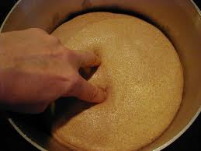

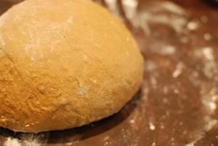

CHAPTER 2Page 38
And you will remember that your finger made a dent in the dough, and that slowly, but quite surely, the dent disappeared, and the dough looked quite the same as it did before you touched it. Unless, of course, your hand was extra dirty, in which case, naturally, there would be a little black mark.
Well, it was just like that with the sorrow the children had felt at Father's going away, and at Mother's being so unhappy. It made a deep impression, but the impression did not last long.

The image of the dough is very interesting and significant. It shows how the writer is very realistic and specific at the same time. In an indirect way she has shown us how the children have grown oblivious of the absence of the Father, just like a dough that is growing will never be affected if you just insert your finger inside it. It will soon come back to its original shape. The life of the children is expanding and nothing will stop that.

They soon got used to being without Father, though they did not forget him; and they got used to not going to school, and to seeing very little of Mother, who was now almost all day shut up in her upstairs room writing, writing, writing. She used to come down at tea-tine and read aloud the stories she had written. They were lovely stories.

The rocks and hills and valleys and trees, the canal, and above all, the railway, were so new and so perfectly pleasing that the remembrance of the old life in the villa grew to seem almost like a dream. Mother had told them more than once that they were "quite poor now," but this did not seem to be anything but a way of speaking. Grown-up people, even Mothers, often make remarks that don't seem to mean anything in particular, just for the sake of saying something, seemingly.

Before supper the children decide to go to the railway station. They have a lot to see and a large heap of coal catches Peter’s attention. When Peter steals coal from the station yard, he is caught by the Station Master.

Peter thinks that taking some coals from the middle of the heap is harmless. The Station Master warns them that what they have done is stealing because the coal belongs to the railway station. It is only then they realize what they have done is wrong.

Eleventh Lecture

But in June came three wet days; the rain came down, straight as lances, and it was very very cold. Nobody could go out, and everybody shivered. They all went up to the door of Mother's room and knocked.
"Well, what is it?" asked Mother from inside.
"Mother," said Bobbie, "mayn't I light a fire? I do know how."
And Mother said: "No, my ducky-love. We mustn't have fires in June--coal is so dear. If you're cold, go and have a good romp in the attic. That'll warm you." p.39
"It's more than we can afford, chickeny-love," said Mother, cheerfully. "Now run away, there's darlings--I'm madly busy!"
"Mother's always busy now," said Phyllis, in a whisper to Peter. Peter did not answer. He shrugged his shoulders. He was thinking.
Thought, however, could not long keep itself from the suitable furnishing of a bandit's lair in the attic. Peter was the bandit, of course.

But when Phyllis was going to add jam to her bread and butter, Mother said:--
"Jam or butter, dear--not jam and butter. We can't afford that sort of reckless luxury nowadays."
To Help Mother in their own way, what do the children do?
"I have an idea."
"What's that?" they asked politely.
"I shan't tell you," was Peter's unexpected rejoinder.
"Oh, very well," said Bobbie; and Phil said, "Don't, then."
"Girls," said Peter, "are always so hasty tempered."

"I should like to know what boys are," said

"If I find a coal-mine, you shall help cart the coal," Peter condescended to promise.
"Keep your secret if you like," said Phyllis.
"Keep it if you can," said Bobbie.
"I'll keep it, right enough," said Peter.

The chariot was packed full of coal. And when it was packed it had to be unpacked again because it was so heavy that it couldn't be got up the hill by the three children, not even when Peter harnessed himself to the handle with his braces, and firmly grasping his waistband in one hand pulled while the girls pushed behind.
Three journeys had to be made before the coal from Peter's mine was added to the heap of Mother's coal in the cellar.
Page 44

p. 45
"So I've caught you at last, have I, you young thief?" said the Station Master.
"I'm not a thief," said Peter, as firmly as he could. "I'm a coal-miner."
"Tell that to the Marines," said the Station Master.

Has the writer told us directly that the family is getting poorer and poorer?
One great technique is the image of the candle.

Innocence & Child Talk
"It would be just as true whoever I told it to," said Peter.
"You're right there," said the man, who held him. "Stow your jaw, you young rip, and come along to the station."
"Oh, no," cried in the darkness an agonized voice that was not Peter's.
Page 46
"Not the police station!" said another voice from the darkness.
"Not yet," said the Station Master. "The Railway Station first. Why, it's a regular gang. Any more of you?"

"Only us," said Bobbie and Phyllis, coming out of the shadow of another truck labelled Staveley Colliery, and bearing on it the legend in white chalk, "Wanted in No. 1 Road."
"What do you mean by spying on a fellow like this?" said Peter, angrily.
"Time some one did spy on you, I think," said the Station Master. "Come along to the station."
"Oh, don't!" said Bobbie. "Can't you decide now what you'll do to us? It's our fault just as much as Peter's. We helped to carry the coal away--and we knew where he got it."

"Then why did you?" The Station Master's voice was so much kinder now that Peter replied:--
"You know that wet day? Well, Mother said we were too poor to have a fire. We always
Page 48
had fires when it was cold at our other house, and--"
"Don't!" interrupted Bobbie, in a whisper.

"Well," said the Station Master, rubbing his chin thoughtfully. "I'll tell you what I'll do. I'll look over it this once. But you remember, young gentleman, stealing is stealing, and what's mine isn't yours, whether you call it mining or whether you don't. Run along home."
"Do you mean you aren't going to do anything to us? Well, you are a brick," said Peter, with enthusiasm.
"You're a dear," said Bobbie.
"You're a darling," said Phyllis.
"That's all right," said the Station Master.
And on this they parted.

CHAPTER 3: THE OLD GENTLEMAN
By now the children know the time when the trains pass. Every morning, they will wave to an old gentleman who always waves back at them. They pretended that the old man knows their father and takes their love to him in London. One day, their mother becomes very ill and Bobbie resolves to do something positive to help.

AFTER the adventure of Peter's Coal-Mine, it seemed well to the children to keep away from the station,--but they did not, they could not, keep away from the railway. They had lived all their lives in a street where cabs and omnibuses rumbled by at all hours, and the carts of butchers and bakers and candlestick makers (I never saw a candlestick-maker's cart; did you?) might occur at any moment.

Here in the deep silence of the sleeping country the only things that went by were the trains. They seemed to be all that was left to link the children to the old life that had once been theirs. Straight down the hill in front of Three Chimneys the daily passage of their six feet began to mark a path across the crisp, short turf. They began to know the hours when certain trains passed, and they gave names to them. The 9.15 up was called the Green Dragon. The 10.7 down was the Worm of Wantley.

The children paint the words, “LOOK OUT AT THE STATION” on a large white sheet and wave it at the 9.15 train the next day. When the train is about ready to leave, Phyllis passes a letter to the Old Gentleman. In the evening, a large box of supplies is delivered to the children with all the things they have asked for.

CHAPTER 4: BOBBIE’S RIDE
When their mother finally recovers from her illness, they confess to her what they have done earlier. The family later celebrates Bobbie’s 12th birthday, all dressed in their best. Bobbie receives various presents from the family including Peter who reluctantly has to give her the broken half of his toy train filled with sweets.

Her lovely birthday party however ends on a sad note when she realizes that her mother is very upset later that night. Bobbie secretly wants to repair Peter’s broken train. She goes to the station and accidentally gets into the engine of one of the trains. Feeling scared, she seeks help from two railway workers. The two men not only repair the toy but also make sure she arrives home safely. Weeks later, Bobbie introduces Peter and Phyllis to the friendly engine driver and Jim, the fireman.

CHAPTER 5: SAVING THE TRAIN
The children witness a landslide that covers the railway line. The children prevent an imminent accident by waving the girls’ red petticoats. The train comes to rest just in time, at about twenty metres from where Bobbie stands on the tracks. Weeks later, a ceremony is held at the station to commemorate the children’s bravery. The Old Gentleman presents the children with a gold watch each and meets their mother at home. The children relay that eventful day to their mother.

