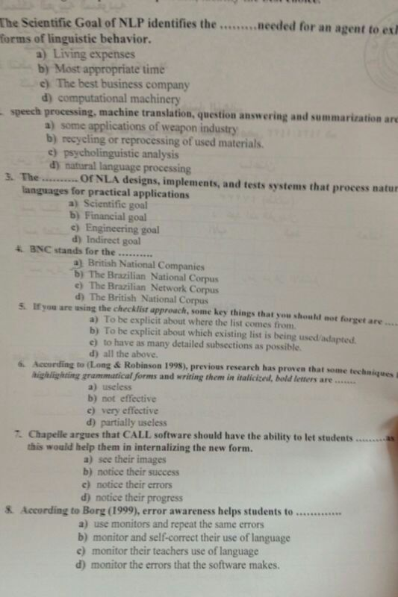

D

D

C

D

D

C

C

B

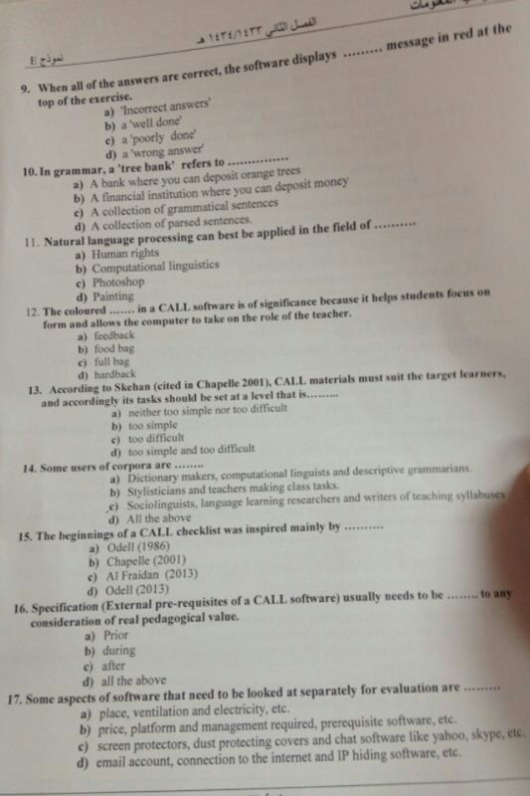

B

D

B

A

A

D

A

A

B

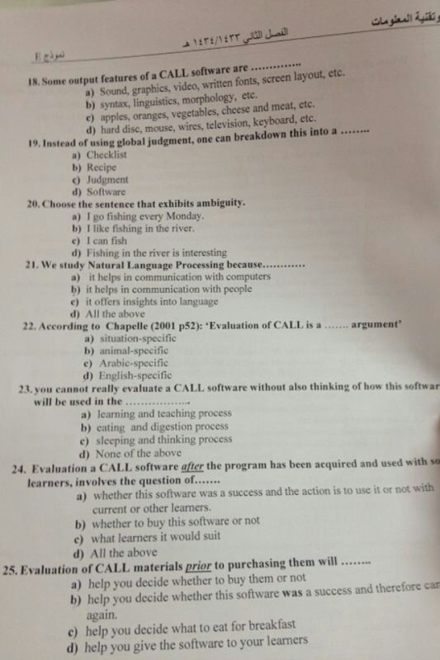

A

C

A

D

A

A

A

A
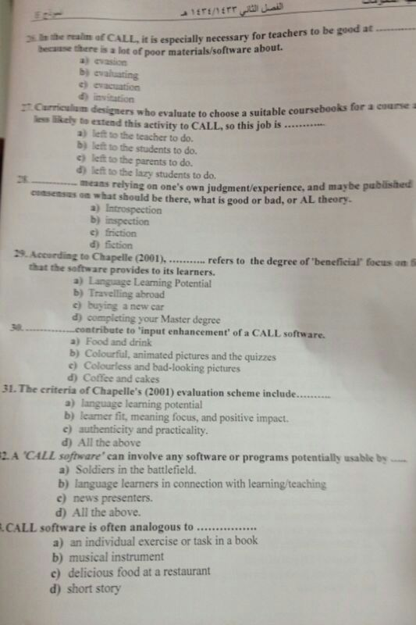
B

A

A

A

B

D

B

A

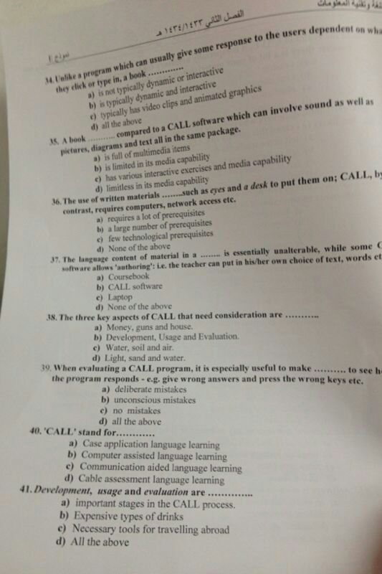
A

B

?? D

A

B

A

B

A

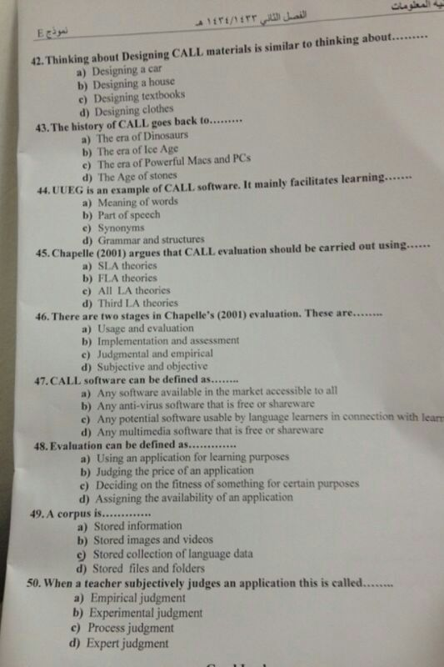
C

C

D

A

C

C

C

C

A

