What is Linguistics?
It is the scientific study of human
When we say that a linguist aims to be scientific, we mean that he attempts to study language in much the same way as a scientist studies physics or chemistry, that is systematically, It means observing language use, forming hypotheses about it, testing these hypotheses and then refining them on the bases.

When we study human language, we are approaching what some might call the “human essence, “the distinctive qualities of mind that are, so far as we know,
A language is a set of signals by which we communicate. Human beings are not the only species to have an elaborate communication system. Even if human languages do not differ in essence from animal communication, they certainly differ in degree. Nothing in the animal kingdom can be compared to human
language is a systematic means of communicating ideas and feelings.

Semantics

Pragmatics

Syntax

Morphology

Phonology

Phonetics

Levels of Linguistics
1. Phonetics and phonemic transcription: introduces the physiology involved in the production of speech sounds as well as phonemic and phonetic transcription systems that are used to represent the
2 . Phonology: Survey the organizational principles that determine the patterns of the speech sounds are subject to.
3. Morphology: is concerned with the properties of words and word-building
4. Syntax: presents a study of the structure of sentences and phrases.
5. Semantics: surveys the properties of
3. Morphology: is concerned with the properties of words and word-building
Pragmatics: explores some of the issues involved in describing human communication and proposes certain communication strategies that people use when they talk to each other.

Introduction to phonetic
Phonetics is concerned with the study of the description of speech sounds .
Objectives of studying Phonetics :
There are different reasons for studying phonetics which means there are many kinds of phoneticians:
1. Some are interested in the different sounds that occur in languages.
2. Some are concerned with pathological speech.
3. Others help people speak a particular form of English.
4. Others are concerned with getting computers to recognize speech.

Speech Production
✦Our interest is in how speech sounds are made.
✦Most of them are the result of movements of the tongue and the lips.
✦Making movements audible involves pushing air out of the lungs while producing a noise in the throat or mouth.
✦These basic noises are changed by the actions of the tongue and lips.
✦Later, we will study how the tongue and lips make about twenty-five different movements to form the sounds of English.
✦ Example:
an x-ray movie of the phrase: on top of his deck
✦ The actions of the tongue are among the fastest and more precise physical movements that people can make.

How do we produce sounds?
Producing any sound requires energy.
✦In all speech sounds, the basic source of power is the respiratory system pushing air out of the lungs.
✦ When we talk, air from the lungs goes up the windpipe (the trachea) and into the larynx, at which point it must pass between two small muscular folds called the vocal folds.
✦ If the vocal folds are apart, the air from the lung will have a relatively free passage into the pharynx and the mouth.
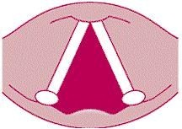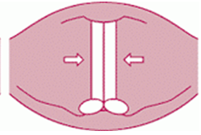
Vocal folds
✦ But if the vocal folds are adjusted so that there is only a narrow passage between them, the airstream from the lungs will set them vibrating.
✦ Sounds produced when the vocal folds are vibrating are called voiced, as opposed to those in which the vocal folds are apart, which are said to be voiceless.
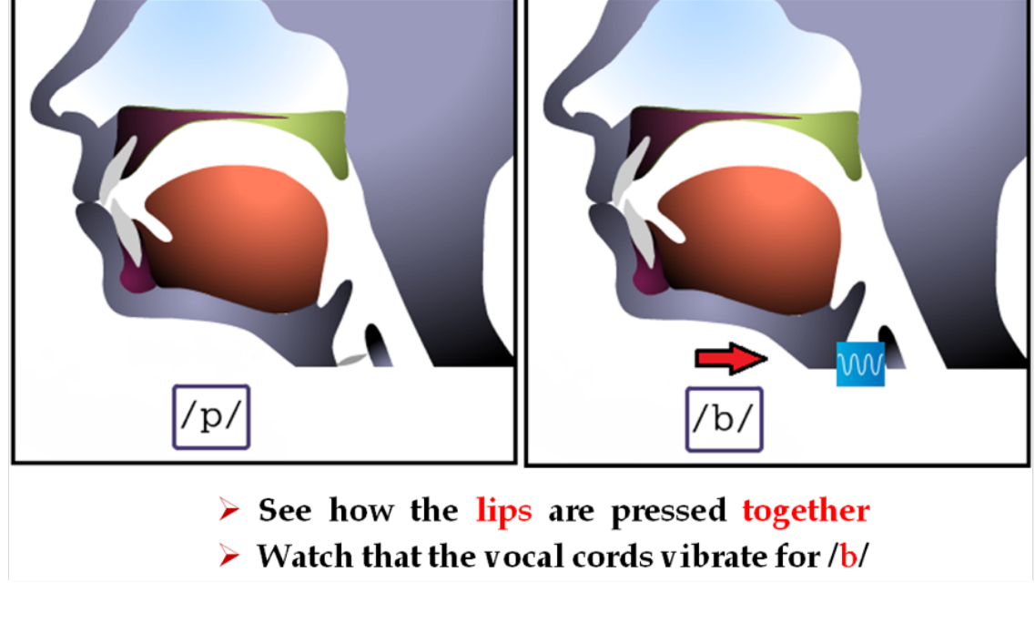
✦ Example:
1. the voiced [z] and voiceless [s] [ssssszzzzzzssssssszzzzzz]
2. the voiced [v] and voiceless [f] [ffffffvvvvvffffffvvvvvvv]

How do we produce sounds?
✦ The difference between voiced and voiceless sounds is important in distinguishing sounds.
✦ Example: fat, vat / thing, thy / Sue, zoo
✦ The air pressure above the larynx is known as the vocal tract.
✦ The parts of the vocal tract that can be used to form sounds, such as the tongue and the lips, are called articulators.
Summary of the speech production
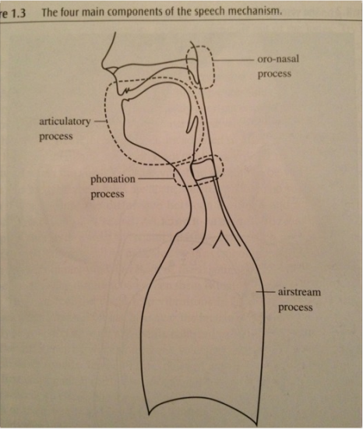
✦ There are four main components:
1. the airstream process
2. the phonation process
3. the oral-nasal process
4. the articulatory process

There are two areas in the study of Phonetic :
1- Acoustic
2-Articulatory
Acoustic Phonetics
- So far, we have been describing speech sounds by stating how they are made, but it is also possible to describe them in terms of what we can hear.
- The way in which we hear a sound depends on its acoustic structure. Linguists and speech pathologist need to understand how certain sounds become confused with one another.
- Speech sounds, like other sounds, can differ from one another in three ways.
- They can be the same or different in
(1) pitch,
(2) loudness, and
(3) quality.
- Thus, two vowel sounds may have exactly the same pitch, and may have the same loudness, yet still may differ in the quality.
- Vibrations in air pressure in the form of sound waves move through the air somewhat like the ripples on a pond. When they reach the ear of a listener, they cause the eardrum to vibrate. A graph of a sound wave is very similar to a graph of of the movements of the eardrum.
