Speech orgens
The Organs of Speech: All sounds we make when we speak are the result of muscles contracting. When the air is pushed from the lungs to the larynx, it goes through the vocal tract.
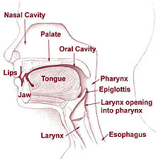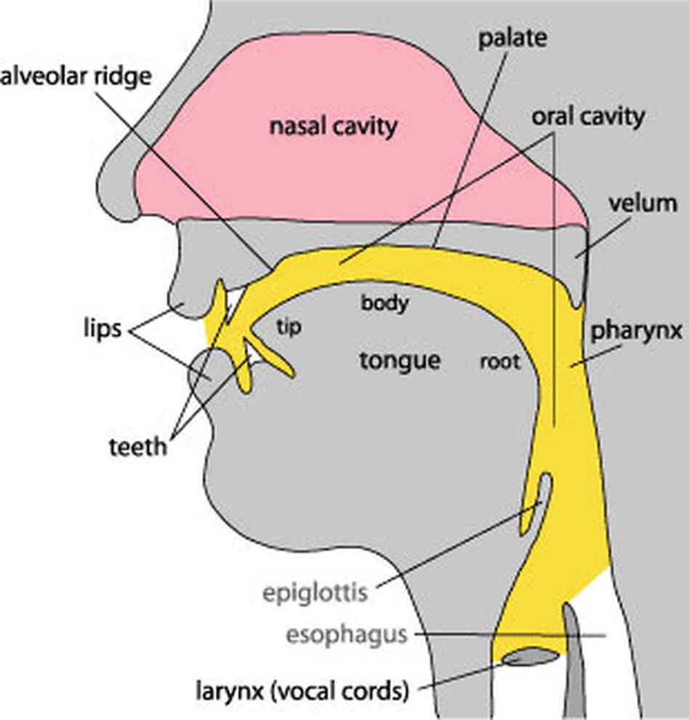
The different parts of the vocal tract are called articulators, and the study of them is called articulatory phonetics.
1.The pharynx:
is a tube which begins above the larynx. At its top end it is divided in to two:
- the back of the mouth,
- and the beginning of the way through the nasal cavity.
2. The velum or soft palate:
is in a position that allows air to pass through the nose and through the mouth .Often in speech, it is raised so that air cannot escape through the nose. The other important thing is that it is one of the articulators that can be touched by the tongue.
3.The hard palate:is often called the “roof of the mouth”. You can feel its smooth surface with your tongue.
4.The alveolar ridge: is between the top front teeth and the hard palate.
5.The tongue: is a very important articulator which can be moved into many different places a n d shapes. It is divided into different parts, though there are no clear dividing lines within the tongue.
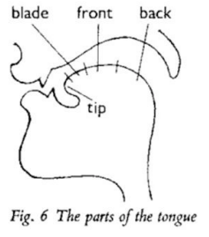
The different parts are:
1.tip
2.blade
3.front
4.back
6.The teeth:(upper & l o w e r ) a r e shown at the front of the mouth behind the lips
The tongue is to contact with the upper side teeth for many speech sounds.
7.The lips: are important in speech. They can be
- pressed together to produce p, b,
- brought into contact with the teeth as in f, v,
- or rounded to produce the lipshape for vowels like o.
The seven articulators described above are the main ones used in speech.

