Manners of Articulation
+ Places of Articulation 2
- The place of articulation of a consonant is the point of contact where an obstruction occurs in the vocal tract between an articulatory movement:
1. an active articulator (typically some part of the tongue),
2. and a passive location (typically some part of the roof of the mouth).

- The Manner of articulation describes how the tongue, lips, jaw, and other speech organs are involved in making a sound. Often the concept is only used for the production of consonants. For any place of articulation, there may be several manners.
Along with the manner of articulation and the phonation, this gives the consonant its distinctive sound.

1. Stop 6
(Complete closure of the articulators involved so that the airstream con not escape through the mouth)
There are two possible types of stopes:
1. Oral Stop (Plosives): If the soft palate is raised so that the nasal tract is blocked off, then the airstream will be completely obstructed. When the articulators come apart, the airstream will be released in a small bust of sound.
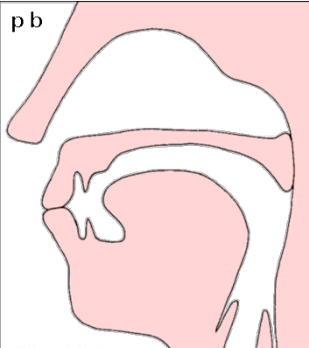
Example:
pie , buy (bilabial closure) : [p] , [b]

Example:
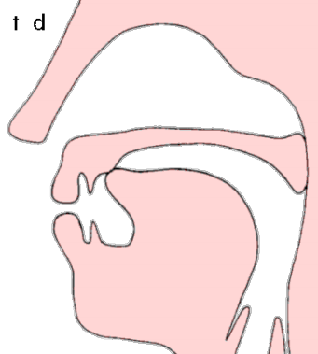
tie , die (alveolar closure) : [t] , [d]

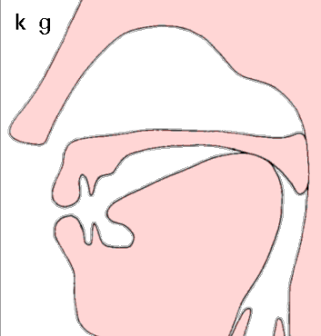
Example:
kye , guy (velar closure) : [k] , [g]

2. Nasal Stop: If the air is stopped in the oral cavity but the soft palate is down so the air can go through the nose, the sound produced is a nasal stop.

