Places of Articulation
The parts of the vocal tract that can be used to form sounds are called articulators.
In order to form consonants, the airstream through the vocal tract must be obstructed in some way.
Consonants can be classified according to the place and manner of this obstruction.
The primary articulators that can cause an obstruction in most languages are the lips, the tongue tip & blade, and the back of the tongue.
•Speech movements using the lips are called labial articulations.
•Those using the tip of the tongue are called coronal articulations.
•Those using the back of the tongue are called dorsal articulations.

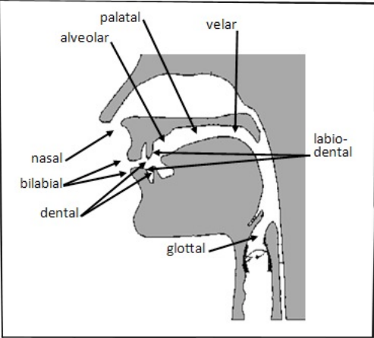

1. Bilabial
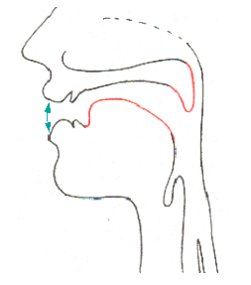
Bilabials are made with two lips.
(using both upper and lower lips)
Examples:
Pie , buy , my
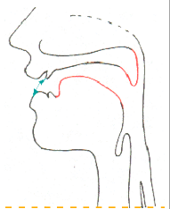
2. Labiodental
Labiodental is made with the lower lip and the upper front teeth.
Examples:
fie , vie

3. Dental
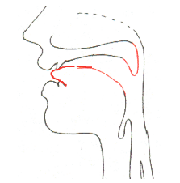
Dentals are made with the tongue tip or blade and upper front teeth.
Examples:
thing , thy

4. Alveolar
Alveolars are made with the tongue tip or blade and the alveolar ridge.
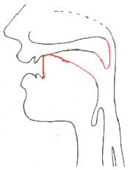
Examples:
tie, die, sigh, zeal, lie

5. Retroflex
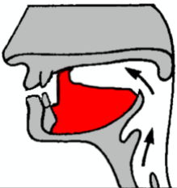
Retroflex is made with the tongue tip and the back of alveolar ridge.
Some English speakers do not use retroflex sounds at all. But some speakers begin words such as rye, row, ray with retroflex sounds.
Speakers who pronounce r at the ends of words may also have retroflex sounds with the tip of the tongue raised in hour and air.

6. Palat0-Alveolar
Palato-Alveolar is made with the tongue blade and the back of the alveolar ridge.
Examples:
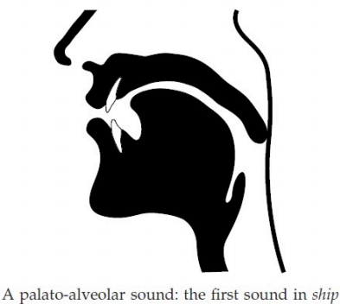
shy, show, she

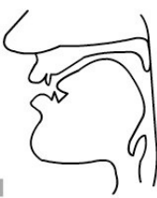
7. Palatal
Palatal is made with the front of the tongue and the hard palate
Examples:
you , yes

8. Velar
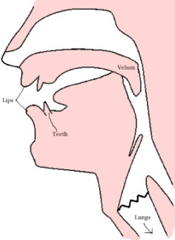
Velar is made with the back of the tongue and the soft palate
Examples:
hack , hag, hang
The back of the tongue is raised so that it touches the velum.

9. Nasal
The air is prevented to go through the mouth but is able to go through the nose because the soft palate or velum is lowered.
Examples:
ran, ram, rang
