-3-
Elements of the Lecture
- Concluding Paragraph
- Essay Outline

Concluding Paragraph
The conclusion is your last chance to make your point clear.
The concluding paragraph consists of:
• A summary of the main points, or a restatement of your thesis in different words;
• Your final comment on the subject, based on the information you have provided.
The concluding paragraph should be introduced with a conclusion transition signal:
in conclusion, in summary, in brief, in short, indeed

Here are some basic principles you should follow to write an effective conclusion:
1. The conclusion should follow logically from the body of the essay.
2. The conclusion must summarize the whole essay, not just one or two major points.
3. The conclusion should not raise any new points but must be related to the thesis
statement or body of the essay.

You can use different devices to make your final comment more interesting. Some of
them are:
• emphasize the result of the ideas in the essay;
• offer a solution to the problems stated in the essay;
• predict a situation that will result or occur from the ideas introduced in the essay;
• make a recommendation concerning material presented in the essay.
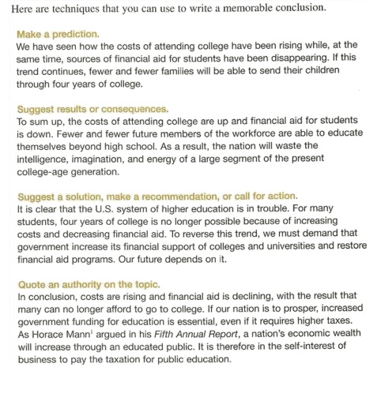

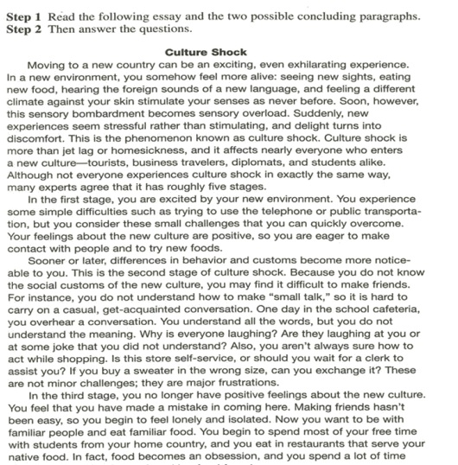



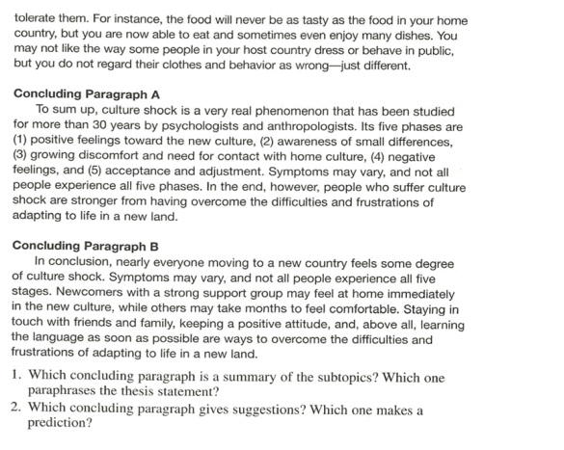

- Paragraph A gives a summary of the subtopics. Paragraph B paraphrases the thesis statement .
- Paragraph B gives suggestions. Paragraph A makes a prediction

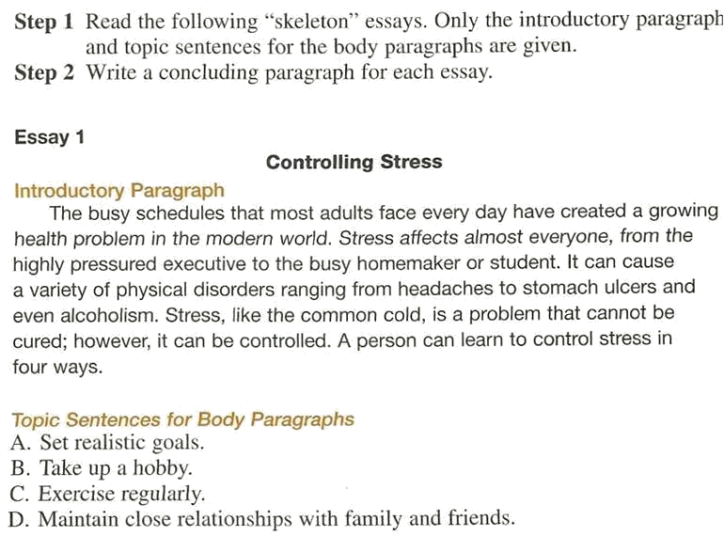

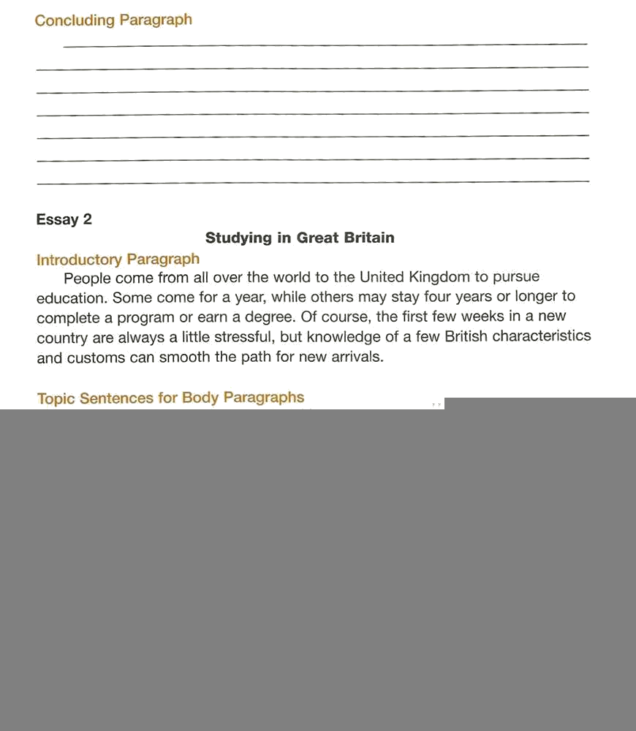
To Summarize, stress is a health issue for those of us who live in modern, industrializes societies. Unless we want to move to a quiet village in the middle of nowhere, we need to follow the advice of health professionals by setting realistic goals, taking up a hobby, getting regular exercise, and above all, staying close to our families and friends.

In conclusion, studying in the United Kingdom can be a wonderful experience. The British people may be more or less friendly than people at home, the weather may be rainier than the weather you are used to, and you may encounter some frosty stares the first time you forget to queue at the bus stop. Also, it may take you a few days to remember which direction traffic is coming from. However, with time and by maintaining a positive attitude, you will soon adapt to the ways of the British and soon feel comfortable in your temporary home.

What’s Essay Outlining ?
Before you begin writing the first  draft of your essay, it is best to make  an outline. An outline is a general  plan of what you are going to write.  You can compare making an outline  to drawing plans to build a house.  Before one begins to build a house, it  is best to draw up plans to make sure  that a house is built in the way you  want. The same is true with writing  an essay and making an outline. | 

Introduction
The Benefits of an Outline

An outline of an essay can be very helpful for two reasons:

- An outline will help make your essay more
organized. A careful plan will help your body
paragraphs stay focused on the ideas in your
thesis statement.

- An outline saves time for writers. Preparing an
outline can take time, but when you are finished,
you will be able to write the rough draft of your
essay more quickly than if you didn’t have an
outline.

Example
Outline

Here is an example of how a blank outline might look:
Essay Outline

- Introduction Thesis: _____________________
- Body Paragraph #1- Topic Sentence: _____________
A. supporting idea
B. supporting idea

III. Body Paragraph #2- Topic Sentence: ____________
A. supporting idea
B. supporting idea

IV. Body Paragraph #3- Topic Sentence: ____________
A. supporting idea
B. supporting idea
V. Conclusion

The Process
Making an Outline

In a formal outline,  Roman numerals can  be used to represent  paragraphs. Capital  letters can be used to  represent supporting  details for the  paragraphs.  Click here to see a  list of Roman numerals. | Essay Outline  Thesis: ____________________ I. Introduction  II. Body Paragraph #1- Topic Sentence: _________  - supporting idea  - supporting idea  III. Body Paragraph #2- Topic Sentence:_________  - supporting idea  B. supporting idea  IV. Body Paragraph #3- Topic Sentence:_________  - supporting idea  - supporting idea

The Process
Thesis Statement
To begin an outline, you need to start with your thesis
statement. The thesis statement will be your guide
throughout the process of writing your essay. From the
thesis statement, you can begin writing the topic sentences
for the body paragraphs in the outline.

The Process
Topic Sentences

The topic sentence for each body paragraph
should support the thesis statement. The topic
sentences need to agree with the main idea or
subpoints in the thesis statement; otherwise,
the essay could be confusing.
The Process
Topic Sentences

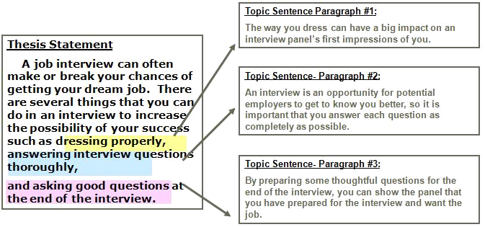
The Process
Supporting Details
Under the topic sentence for each paragraph,
list some of the supporting details, examples,
or ideas you want to include in each paragraph.

The Process
Supporting Details
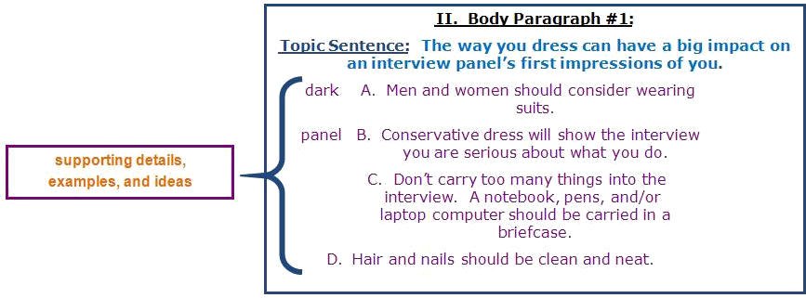

Example Outline

- Introduction- Thesis Statement: A job interview can often make or break your chances of getting your dream job. There are several things that you can do in an interview to increase the possibility of your success such as, dressing properly, answering interview questions thoroughly, and asking good questions at the end of the interview.

- Body Paragraph #1:
Topic Sentence: The way you dress can have a
big impact on an interview panel’s first
impressions of you.

A. Men and women should consider wearing dark suits.
B. Conservative dress will show the interview panel you are serious about what you do.
C. Don’t carry too many things into the interview. A notebook, pens, and/or laptop computer should be carried in a briefcase.
D. Hair and nails should be clean and neat.

- Body Paragraph #2:
Topic Sentence: An interview is an opportunity for potential employers to get to know you
better, so it is important that you answer each
question as completely as possible.

A. Ask interviewers to repeat questions you don’t understand.
B. Take some time to think about the questions before you answer.
C. A notebook to write down key words in interview questions is sometimes helpful.

- Body Paragraph #3:
Topic Sentence: By preparing some thoughtful
questions for the end of the interview, you can
show the panel that you have prepared for the
interview and want the job.

A. Research the job and/or company before you go to the interview.
B. The interview is your opportunity to get to know your potential employer. Ask questions about company goals, mission, expectations of employees, etc.
C. Don’t ask questions about benefits or salary during the interview. You should try to get this information before you apply for the job.

- Conclusion: Don’t underestimate the importance of a good interview.

Roman Numerals
I = 1  II= 2  III= 3  IV= 4  V= 5 | VI= 6  VII= 7  VIII= 8  IX= 9  X= 10 | XI= 11  XII= 12  XIII= 13  XIV= 14  XV= 15

