Lecture 3
Psycholinguistic Research Methods II
Vocabulary Processing
Reminder

Language processing is mind-internal and thus cannot be seen/observed. Therefore, psycholinguists analyze linguistic behavior instead.

Contents
- How are vocabulary items organized in the mind?
- The tip of the tongue phenomenon:
  - What does it mean?
  - What explanations does it offer?

How are entries (i.e. words) organized in the mind?

Lexical items are organized alphabetically in a dictionary, in the brain, however, vocabulary items are organized differently.
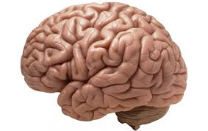VS 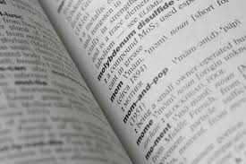
It was on the tip of my tongue!
Have you been in a situation where you could remember the meaning of a word, its sound, its first letter, or other words it rhymes with, but could not remember the word you were looking for?

Tip of the tongue definition:
Remembering some details about a word, but not the word itself.

It was on the tip of my tongue!
Similarly, have you been in a situation where you could remember some details about a word you came across, but you were not sure what does the word mean?
(e.g. eagle: bird + predator)

Why does the tip of the tongue phenomenon often happen to us?
Lexical entries are grouped in the brain as a complex network, according to their sound and meaning.

How does the mind organize entries (i.e. lexical items)?
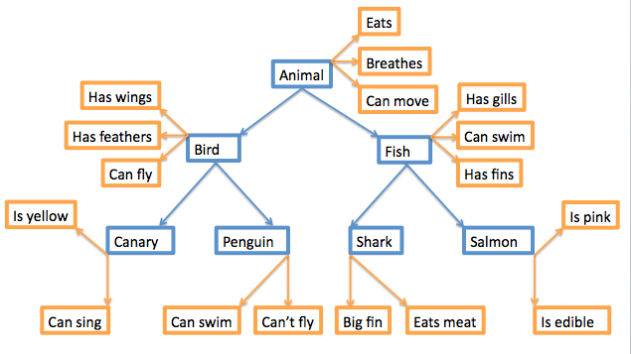

Vocabulary experiments
Lexical decision and priming are two experiments which help us understand:

How are entries (i.e. words) linked together?
How are entries accessed?
What information is contained in an entry?
These two experiments are going to be discussed in detail in the upcoming lecture…

Exercise
Choose the right item:
In psycholinguistics, one thing we can learn from the tip of the tongue phenomenon is that:
- Lexical entries are easy to forget
- Lexical entries are organised alphabetically in our mind
- Entries are grouped in the mind (e.g. according to their meaning and sound)
- Entries are stored independently in the mind

The answer is (c). You may need to view this lecture again if you did not choose the right answer!

