Lecture 4
Psycholinguistic Research Methods III
Vocabulary experiments
Contents
Lexical Decision Experiment
Priming Experiment

Lexical Decision Experiment



Lexical Decision

A lexical decision experiment is conducted by asking a native speaker to sit in front of a computer screen where he/she is asked to judge as quickly as possible whether the word that appears on the screen is a real word or not.

If the word is real the participant clicks “yes”; if not, the participant clicks “no”.

What is the purpose of lexical decision experiments?
What we are looking for in this task is:
Response latency: and that is the time it takes for the a participant to respond “yes or no”.
Response accuracy: and that is whether or not the participant responded accurately.

Details
When designing this task, the participants are usually tested on one set of stimuli against another set of stimuli. For example:
“Nouns” vs. “Verbs”. “concrete words” vs. “abstract words”
This test measures the speed and accuracy in which the mental lexicon is accessed.

Interesting findings
It has been found that it usually takes participants about a half a second to press “yes” for word they know or frequently used words. However, it takes three-quarters of a second to press “yes” for less common words. This is commonly known as the frequency effect.

What we can infer from this is that our mental lexicons are probably organized in a way that words we use often are more easy to access.

Priming
Priming can be considered as an extension of lexical decision task. However, in this task before the participant is asked to choose “yes” or “no” the target word is preceded by another stimulus (called the prime). What is measured is the extent the prime influences the participant’s lexical decision on the target stimuli.
Prime (e.g. bird) → stimulus (e.g. pigeon) → Yes/no

When the target is preceded by a related word the response is usually quicker.

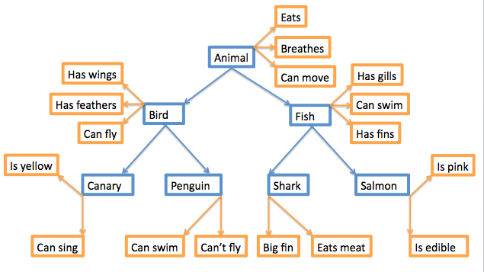
(Picture 2)

References
(picture 1): http://tcho.hanyang.ac.kr/images/HPPL_Perception_booth.gif

(picture 2): http://upload.wikimedia.org/wikipedia/commons/c/cb/Hierarchical_Model_Mental_Lexicon.png

Exercise
Response latency is:

- The time it takes the respondent to complete a lexical decision task
- The Accuracy of the respondent’s answer
- Deciding that the stimulus is an English word
- Deciding that the stimulus is not an English word

The answer is (a)

