Lecture 6
Neurolinguistics

Contents:

- What is Neurolinguistics?
- How can aphasia tell us about the representation of language in the brain?
- Language lateralization

Neurolinguistics:

Neurolinguistics is the study of the representation of language in the brain.

How does the brain look like?
Which hemisphere controls language?
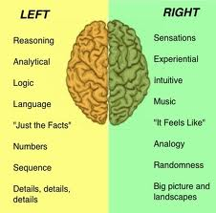

What happens to language if there is a damage in the left hemisphere of the brain?

It can lead to aphasia: language impairment caused by brain injury.

Aphasia:

There are two types of aphasia, depending on the damaged area of the brain:
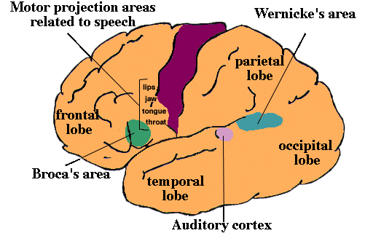

Broca's aphasia is also known as non-fluent aphasia.
Is characterized by halting, effortful speech; it is associated with damage involving Broca’s area in the frontal lobe of the left hemisphere.
Wernicke's aphasia is also known as fluent aphasia.
Is characterized by fluent meaningless strings; it is caused by damage involving Wernicke’s area in the temporal lobe of the left hemisphere.

Language lateralization:
Contra-lateral control:
The left hemisphere of the brain controls the right side of the body, and vice-versa
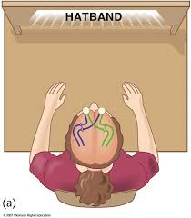

How can this affect language?

Handedness:
For the majority of people, language is in the left hemisphere (this is why the majority of people are right-handers)
Some people, however, language is in the right side (left handers)

