Song+ a song

John suckling

Poetry (9)
Second Year

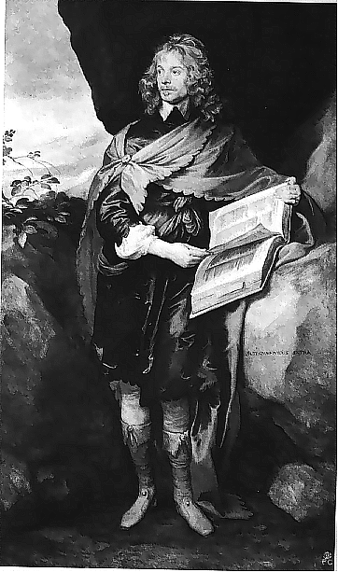

John suckling and Richard Lovelace are two writers wrote lately in the age of the cavalier or the metaphysical poetry period. Firstly, John suckling, he was courtier and well educated man. He is one of these poets who considered pure cavalier poet as he is described as careless writer who never take writing poetry as a serious matter, he did not care in choosing the words, and his language was so direct and simple in contrary to Johnson who was having some seriousness. Concerning his physical appearance, he was a tiny man, the thing which remind us with the Arabic poet" AlGahez" and the English one Alexander pop, as AlGahez used to mock himself, suckling's physical appearance had an influence on his poetry. For suckling, he did not take the matter of writing seriously and used to write very flat writings, this is because of writing in very early period in his life.
من رجال الدوله
شاعر غير معني بما يكتب
لا يأخذ الشعر علي محمل الجديه
لا يعتني باختيار كلماته
ذلك علي عكس جونسون الذي كان يتمتع بقدر من الجديه

كان رجل قصير القامه
مما يذكرنا بالجاحظ وألكسندر بوب
وكما كان الجاحظ يسخر من نفسه فكان لشكل سكلينج أثر علي كتاباته
كتابات سطحيه
حيث أنه كتب في فترة مبكرة من حياته

Song

Why so pale and wan fond lover?
Prithee why so pale?
Will, when looking well can't move her,
Looking ill prevail?
Prithee why so pale?
Why so dull and mute young sinner?
Prithee why so mute?
Will, when speaking well can't win her,
Saying nothing do't?
Prithee why so mute?
Quit, quit for shame, this will not move,
This cannot take her;
If of herself she will not love,
Nothing can make her;
The devil take her.
Sir John Suckling

تقديمية
يخاطب عاشق ولهان
In the introductory stanza, he addresses a fond lover; we can notice that it remind us with Sonnet 31 by Philip Sidney. In a classical way, he addresses the fond lover, as all his features appear to be evidence of being in love. He sees that the lover must not to be pale because it will not attract his beloved, the lover have to get ride of this pale impression on his face.
مما يذكرنا بسونت 31لسيدني
وبطريقه كلاسيكية
ملامح
دليل
لا يجب علي المحب أن يكون شاحب هكذا لان هذا لا يجذب حبيبته
يتخلص من
In the second and third stanza, he addresses the fond lover as "young sinner", so he considers love is sin, he asking him why he is mute, upset by her negative attitude to him. In addition, he says to him that his keeping quite or mute cant be attractive to her, he must express his love and admiration. Lastly, if he trying to do all his best to attract her, she wont be attracted a, so She is only able to be loved and treated by the devil" the devil take her". He considers her have some characteristics of the devil, as she cannot be moved emotionally by all ways, the lady will not be moved by the good or bad.
مذنب
ذنب
صامت ومحبط
بسبب شعورها السلبي تجاهه
لابد وان يعرب عن حبه واعجابه
وأخيرا مهما يفعل هذا العاشق لا يؤثر فيها
الشيطان فقط هو من يستطيع حبها
صفات
All the previous lines reveals suckling as a very young man who lacks patience and the enough experience, he has no experience how the love is and the ways attracting the beloveds. On the other hand, it can be noticed here the metaphysical sense in the poets considering the lover as a sinner, as he addressed the lover in the first stanza as a fond lover and in the second stanza as a sinner.

لا يمكن أن تتحرك عاطفيا بكل الطرق
يفتقد الصبر والخبرة الكافيه
ليس لديه خبره بكيفيه الحب او بطرق جذب الحبيبة
تعتبر القصيدة إلي حد ما رومانسيحيث أنها تتحدث عن المعاناه في الحب
The poem is considered to some extent a romantic approach for the romanticism because of the feeling of suffering and being neglected from the beloved, but there is a matter of complaining because of this act. This is different to Sidney's sonnet where he mentions that he feels satisfied and enjoyed with being tormented because of love .In addition; he was keen on stressing his love to his beloved in the end of every stanza although he was originally writing that poem to mention that he will forget her. The poem in our hands now is in contrary to it, the lover is dismissing his beloved because she always neglects him. Thus, the poem is considered metaphysical poem that stresses the idea that love is sin.
ولكن هناك شكوي من هذا
وهنا تختلف القصيدة عن قصيدة سيدني الذي يعبر عن رضاؤه بهذا العذاب
في هذه القصيدة يتخلص الحبيب من حبه

Richard Lovelace
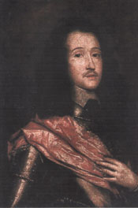

كان رجل وسيم ومهتم بشعره علي عكس ساكلينج

Richard Lovelace was a handsome man and in the contrary to suckling, he was very careful in writing and keen on the poetry. Lovelace had more depth in his poetry more than suckling, in addition to being painter, so he has substance to express his feeling. He was soldier, so he has the experience of war, the thing which made some contradictory in his poetry, and made him express the love as a war.

كان يتمتع شعره بقدر من العمق
وكان رساما فيجد بديل للتعبير عن مشاعره
رجل عسكري
وكان لديه خبره في الحرب مما أعطي شعره تضاد فكان يعبر عن الحب بالحرب

TO LUCASTA, ON GOING TO THE WARS
by: Richard Lovelace (1618-1658)
ELL me not, Sweet, I am unkind,
That from the nunnery
Of thy chaste breast and quiet mind
To war and arms I fly.

True, a new mistress now I chase,
The first foe in the field;
And with a stronger faith embrace
A sword, a horse, a shield.

Yet this inconstancy is such
As thou, too, shalt adore;
I could not love thee, Dear, so much,
Loved I not Honor more.

من البدايه يستطبع القاريء ملاحظه وجهة نظر الشاعر عن الحب والحرب والشرف
In this poem, the reader from the very beginning realizes the poet's very strange approach towards love, honour and war. In the first stanza, the poet says that since I cannot love you I am leaving you now. The poet's beloved is so beautiful to be loved but his beloved cannot appreciate his love to her. The word" sweet" is a word said out of politeness not out of love, and the word "nunnery" means female priest as she is chaste who covers her breast. She is unapproachable because of being chaste, so he will leave her, as she is not ready to be involved in such love relation. Living in this kind of lady is like living in a holy place, she is morally pure. The result, he is flying to the battlefield. The poet wants to be involved in a physical relation with his beloved but she cannot involve with him in such relation because of her moral principles, so he will leave her.
يقدر

راهبه
محتشمة
حيث أنها غير قادرة علي التورط في هذا الشكل من العلاقات
مقدس
In the second stanza, the poet says that he going to chase another mistress and this mistress will be the foe or the enemy in the field. He will deal with this mistress by many ways; by the sword to kill not to kiss, and by the shield not to approach but to protect , so here the image of juxtaposition is so clear. This contrast is so clear in the idea of considering his enemy as his mistress.

وكانت النتيجة ذهابه الي ميدان القتال
مباديء
عشيقه أخري
العدو
والتي سوف يتعامل معها بشتي الطرق
بالاسلحة لا ليقبلها بل ليقتلها ولا ليقترب منها بل ليحمي نفسه
لهذا التضاد والتضارب واضح
In the third stanza, the poet says that if his beloved will love him because of his courage, he will not love her despite his respect towards her morals because he cannot love her with being chaste. The poet prefers to have conflict between him and the foe rather than to see her beauty and cannot touch her. In fact, he is not appreciating her morality
شجاعه
وقد فضل الشاعر الصراع مع عدوه عن الصراع معها
In what sense the last stanza is suitable conclusion to the argument that is constructed in the first stanza?

