Lecture 14

Remembering Sentences and Discourse Processing

Contents

Definition of the term discourse
Working memory and sentence processing
Discourse Processing

Definition of the term discourse:

Sets of sentences that have some sort of connection to each other.

The topic of a given discourse segment – as well as its participants, its context, and its function – will determine the amount of knowledge necessary for successful engagement with it.

Working memory and sentence processing:

There are two types of memory:
Working memory (short-term memory) and Long-term memory.
During discourse, working memory plays a key role in sentence processing. For instance, Just and Carpenter (1992) showed that people with low memory spans have more difficulty with subject–object relative clauses than do people with high memory spans.

(Long-term memory)

Three important things happen to sentences when they get stored in long-term memory:

First, information about structure and even individual lexical items is lost, while meaning is retained.
Second, meanings of many sentences are combined, so individual sentences no longer have independent representations.
Third, inferences are added to representations of meaning

Discourse processing

(Anaphoric reference)
An anaphor is a linguistic device that refers to someone or something that has been mentioned in the previous context. An anaphor can be either a pronoun or a definite noun phrase (a noun phrase introduced by a definite article).

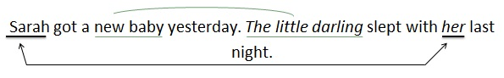

(Making inferences)

Memory for sentences is enhanced by inferences (personal conclusions), which are stored in memory alongside information extracted directly from sentences that were actually experienced. Inferences are used to create connections between sentences in a discourse. Consider this example:

We checked the picnic supplies. Soft drinks were warm.
The listener can infer from these two sentences that soft drinks are part of the picnic supplies.

Exercise

Working memory is:

- Long-term memory
- Short-term memory
- Short-term and long-term memory
- None of the previous is correct

The answer is (B).

