Lecture 1

- What is phonetics?
Phonetics – the study of the way humans make, transmit and receive speech sounds.
- How many branches of phonetics? What are they?
There are tree main branches, They are: Articulatory phonetics- Acoustic phonetics- Auditory phonetics
- ………………. : the study of the way the vocal organs are used to produce speech sounds. (choose the correct answer):
- Articulatory phonetics
- Acoustic phonetics
- Auditory phonetics
- …………………: the study of the way people perceive speech sounds. (choose the correct answer):
- Articulatory phonetics
- Acoustic phonetics
- Auditory phonetics
- ………………… the study of the physical properties of speech sounds. (choose the correct answer):
- Articulatory phonetics
- Acoustic phonetics
- Auditory phonetics
- Phonology is:
- The study of the sound system of languages.
- The study of general properties displayed by these systems.
- The systems of rules underlying the sound patterns in a language
- All of above.

- Sounds start from ( the first step in speech sounds made ):
- ADAM’S APPLE
- Lungs
- vocal tract

- What is calling the process which air is made to move out of the lungs?
It is an egressive pulmonic airstream.

- HOW IS SPEECH POSSIBLE? ( copy and paste from slides ) it’s clear ☺
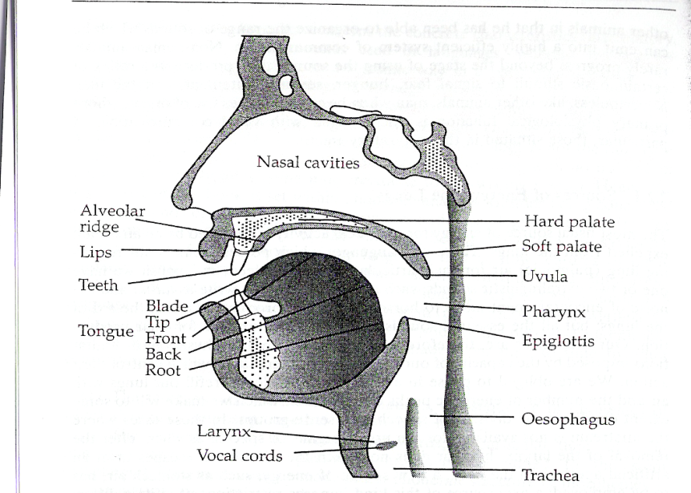
- THE AIRSTREAM EXPELLED FROM THE LUNGS IS THE MOST COMMON SOURCE OF ENERGY FOR OUR VOCAL ACTIVITY.
- IN THE TRACHEA OR WINDPIPE IT PASSES THROUGH THE LARYNX, CONTAINING THE VOCAL FOLDS OR VOCAL CORDS.
- THE FRONT PORTION OF THE TRACHEA OR WINDPIPE IS PROMINENT IN THE NECK BELOW THE CHIN AND IS KNOWN AS “ADAM’S APPLE”.

- Just take a look ☺ it’s good because it transited>>>> happy badoooo
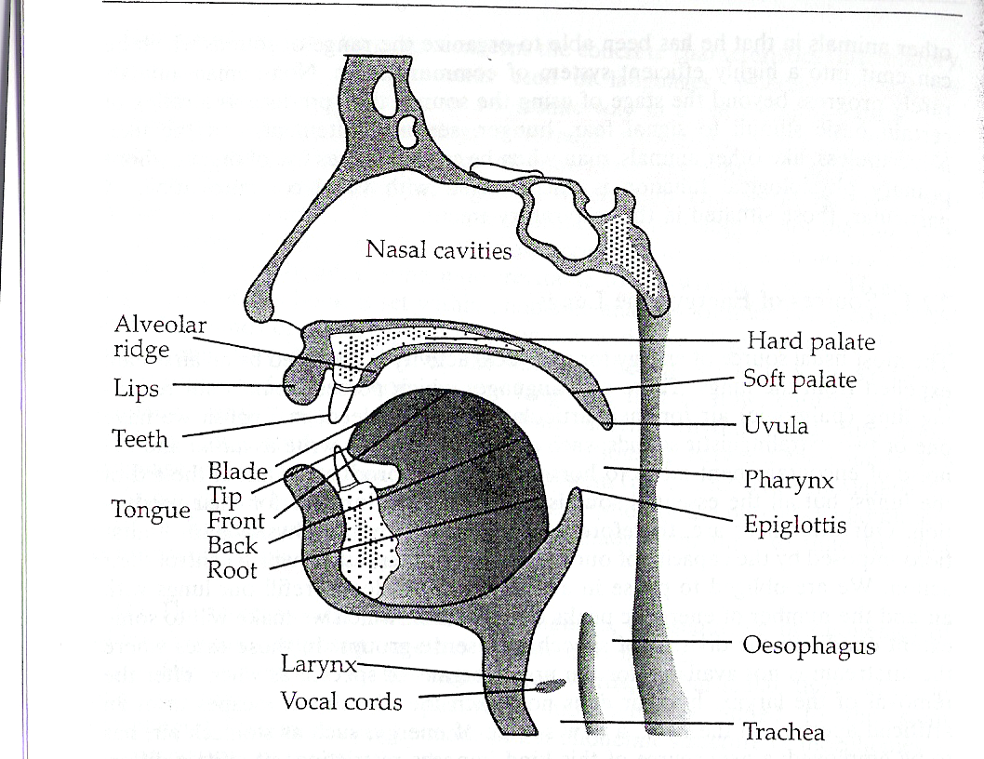
ANOTHER VIEW
البلعوم ←
→الحنجرة
→ الفجوة الأنفية
الجزء ما بعد اللثة واللسان مباشرة
لهاة لحمة الحلق ←
لهاة الحلق ←
→الحبال الصوتية
الرغامي قصبة هوائية
When we speak, the lower jaw move only.
أعلى باطن الفم ←
- What are the seven main articulators?
- The pharynx
- The velum or the soft palate
- The hard palate
- The alveolar ridge
- The tongue
- The teeth
- The lips

- a very important articulator is:
- The teeth
- The pharynx
- The tongue
- pressed together to produce bilabial sounds, such as /p/ and /b/ is:
- The lips
- The velum or the soft palate
- The alveolar ridge

- Vibrates created from larynx, and we can call the larynx:
- Lungs
- Adam’s apple
- Badaweyah<<< out hehehehe

- vibrates when you produced the voiced sound:
- /a/
- /s/
- /z/

- The movement of the ............. (especially the lower one) helps a lot in speaking
- Larynx
- Jaws
- nasal cavity

- dental is:
- the tongue touching the front teeth such as /t/ and /d/
- the tongue touching the back teeth such as /t/ and /d/
- non of above.

- brought into contact with teeth to produce .............. sounds such as /f/ and /v/
- dental
- labiodentals
- all of above.

- Parts of tongue:
- Tip and blade
- Front and back
- Root
- All of above

- often called the ‘roof of the mouth’.
- The alveolar ridge
- The hard palate
- The pharynx
- can be rounded to produce lip-shape for vowels like:
- /k:/
- /h/
- /u:/

- sounds made by the tongue touching this area such as /t/ and /d/ are called alveolar... what’s this area?
- The hard palate
- The alveolar ridge
- The pharynx

بدويه – ملتقى جامعة الملك فيصل – المستوى الخامس
2011 - 2012

