-9-
Elements of the Class

- Types of Clause Independent & Dependent
and then
- Types of Sentences

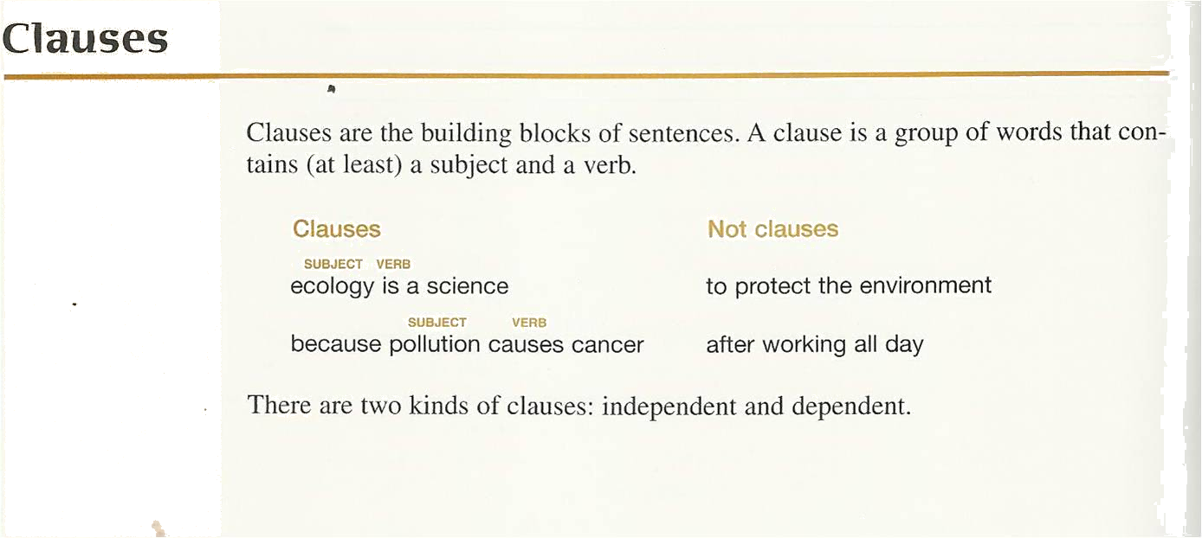

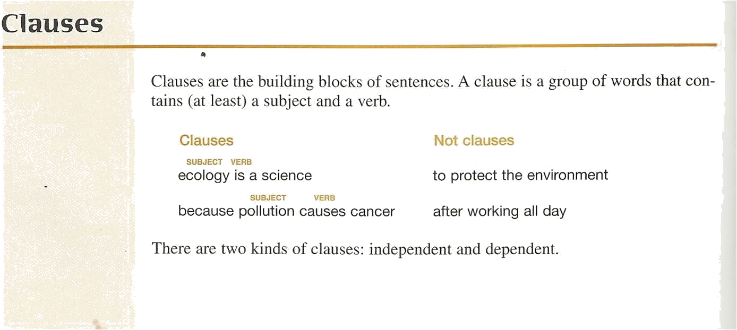

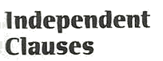

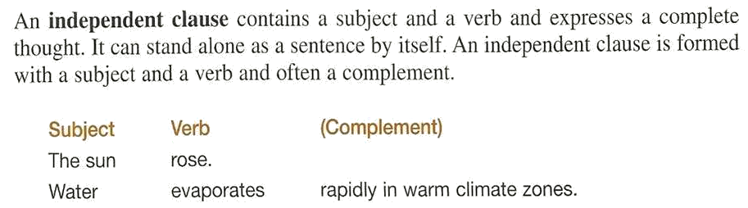

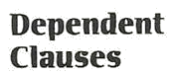

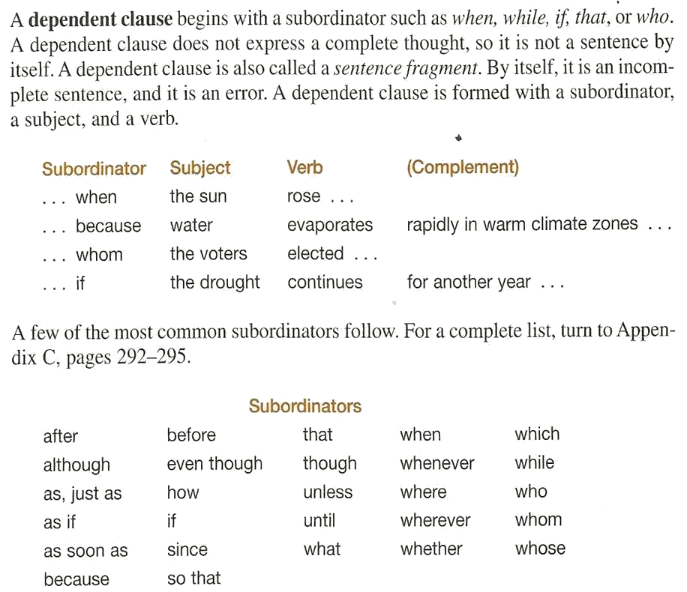

Varying Sentence Structure



Adding Variety to Sentence Structure

To make your writing more interesting, you should try to vary your sentences in terms of length and structure. You can make some of your sentences long and others short. Read the two paragraphs on the next page.

Two Paragraphs

Read the paragraphs below. Choose the paragraph that is more effective.


- I love living in the city. I have a wonderful view of the entire city. I have an apartment. I can see the Golden Gate Bridge. I can see many cargo ships pass under the bridge each day. I like the restaurants in San Francisco. I can find wonderful food from just about every country. I don’t like the traffic in the city.

- I love living in the city of San Francisco. I have a wonderful view of the entire city from my apartment window. In addition, I can see the Golden Gate Bridge under which many cargo ships pass each day. I also like San Francisco because I can find wonderful restaurants with food from just about every country; however, I don’t like the traffic in the city.

How do you vary sentence structure?

You will want to use a variety of sentence structures in your writing. There are three types of sentences we will study in this lesson:

- Simple Sentence
- Compound Sentence
- Complex Sentence

The Simple Sentence

A simple sentence has one independent clause (one subject and a verb):

I live in San Francisco.

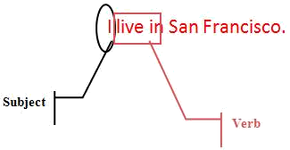
Compound Sentence

A compound sentence contains two independent clauses that are joined together.

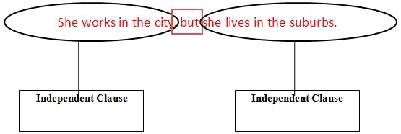

Compound Sentence

You can make a compound sentence by joining two logically related independent clauses by using…
- a semicolon
- a coordinating conjunction
- a transition

Independent Clause + Coordinator + independent Claus

Using a Semicolon

Independent Clause ; Independent Clause

I love living in the city ; there are so many things to do.

Independent Clause

Independent Clause

Using a Coordinating Conjunction

Independent Clause ,coordinating conjunction Independent Clause

He couldn’t watch the show , so he decided to tape it.

Independent Clause

Independent Clause

Coordinating Conjunctions
Logical Relationship | Coordinating Conjunction
Addition | And
Contrast | But, yet
Choice | Or, nor
Cause | For
Result | So

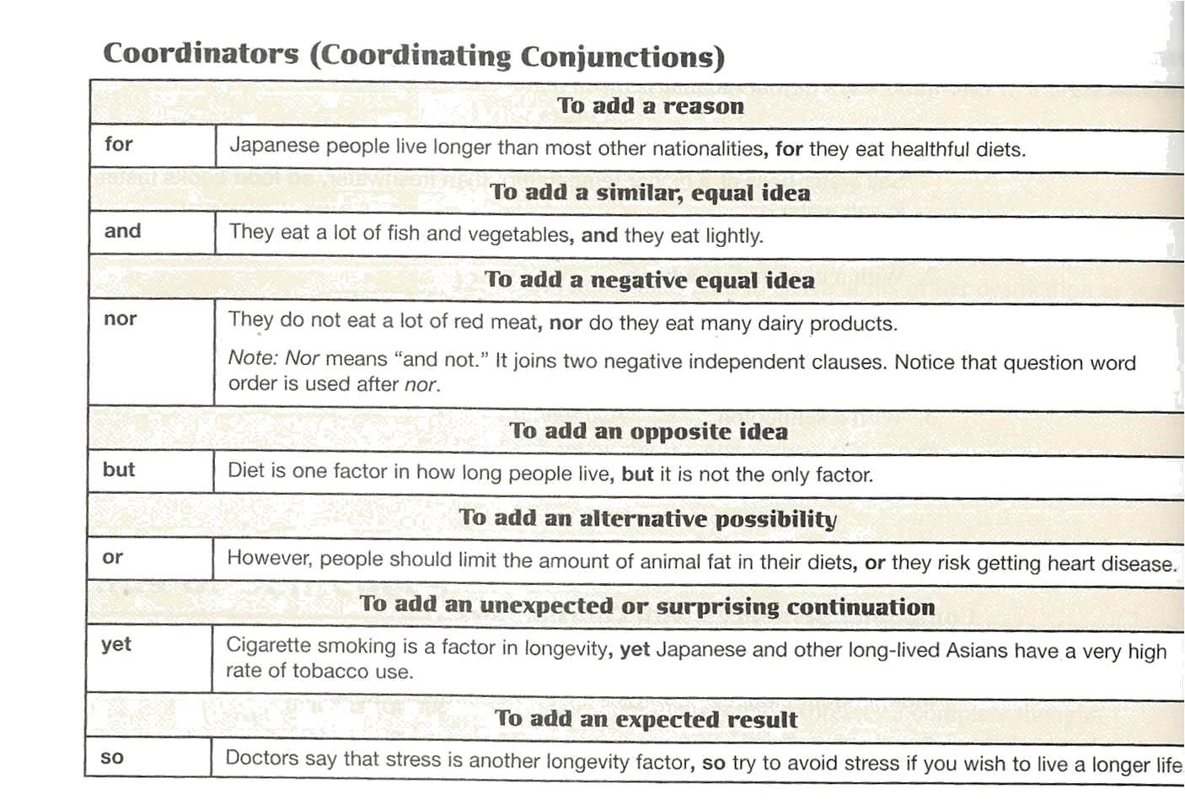

There are 7 coordinators: FANBOYS

Another way to remember these is…

For à F
And à A
Nor à N
But à B
Or à O
Yet à Y
So à S

CAUTION!

Do NOT use a comma every time you use the words and, or, but, nor, for, so, yet. Use a comma only when the coordinating conjunction joins two independent clauses.

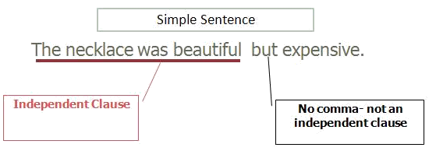

Using a Transition

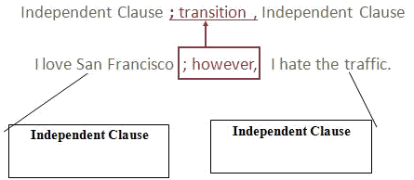

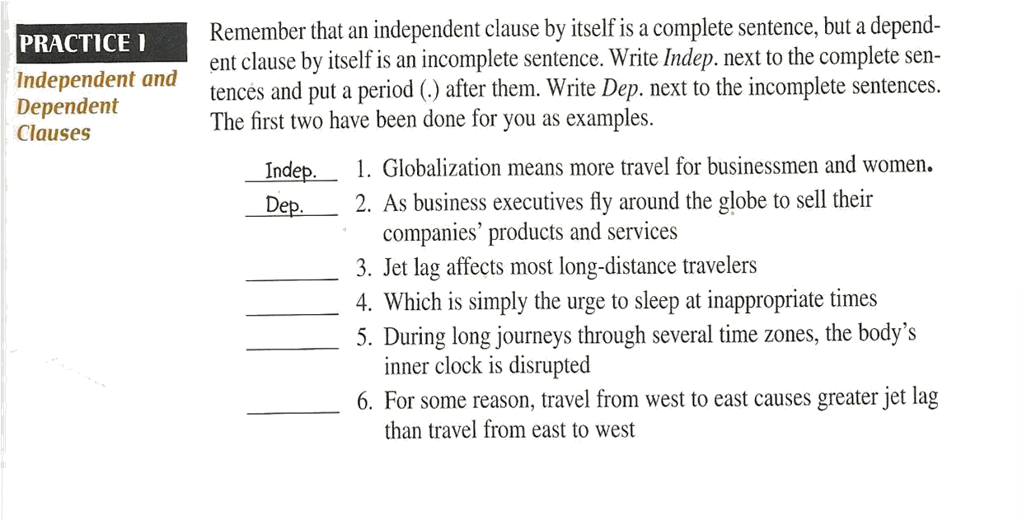
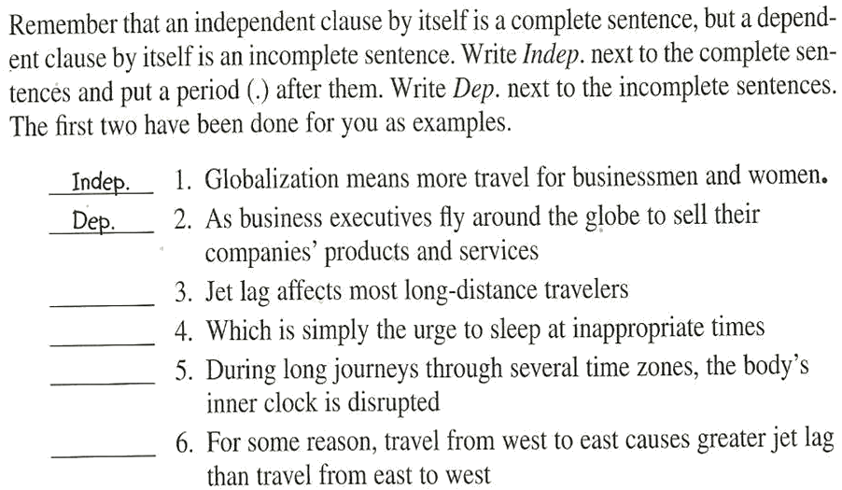

Independent C: 3, 5, 6,
Dependent , 4

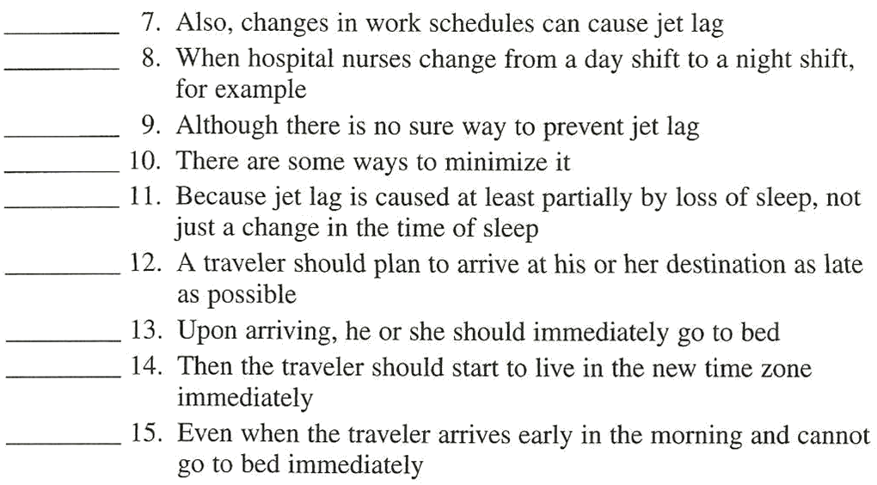

Homework

Practice 4, pages, 167 , 168
Practice 5, page 170

