`
The best position for postoperative patient to maintain a patient airway:
الوضع المناسب للمريض بعد العملية الجراحيه للمحافظة على مسلك الهواء مفتوحا:
Lateral position with neck extended.
الوضع الجانبي مع مد الرقبه.. (جواب الورقه)
Supine position with face lateral
وضع الاستلقاء الظهري بحيث يكون الوجه الى احد الجانبين(جواب الاختبار)

❖ Following a radical mastectomy patient to be positioned:
ماهو الوضع الذي يجب وضع المريضة به بعد عملية استصال ورم من الثدي
In semi-fowler with her affected arm elevated.
وضع الجلوس النصفي مع رفع اليد في الجهه المصبة(جواب الورقه)
On her un operative side
على الجهه الاخرى للعملية(جواب الاختبار)

⬥ Patient with hemopneumothorax had a ICD (inter costal drainage) in the right side what position the patient should be promote drainage:
في حاله اصابه الصدر ووجود تجمع دم وهواء في التجويف الصدري مع وجود انبوب تصريف بين الاضلع في الجهه اليمنى في أي وضع يجب وضع المريض:
الجلوس النصفي Semi stting

 The most suitable to assess the abdomen is:
ماهو الوضع المناسب للمريض عند فحص البطن:
الاستلقاء الظهري Supine position

 Following total hip replacement immediately post operative you would expect order to include:
بعد عملية استبدال مفصل الحوض ماهو أمر الطبيب المتوقع بعد العملية مباشره:
Operative leg maintain in abduction
مد الرجل المصابه بحيث تكون عن المركز
 Eye drops: head tilted backward, placing in the drops conjunctive sac
قطرات العين: اماله الراس الى الخلف ووضع العلاج في اسفل الملتحمة.

 Patient with DVT:
Patient with leg edema:
Elevate the leg above heart level
مريض عنده مرض الخثره الوريدية العميقه :
مريض مصاب بوذمة(تجمع سوائل في الساق:
رفع رجلي المريض فوق مستوى القلب.

 The best position to improve breathing is:
ماهو الوضع المناسب للمريض لتحسين النفس
وضع الجلوس النصفي Semi sitting position
 The most suitable to assess the abdomen is:
ماهو وضع المريض المناسب عند فحص البطن
الاستلقاء الظهري Supine position
 The nurse is planning care for pt with increased intracranial pressure the best position for this pt is:
يقوم الممرض بتخطيط الرعايه التمريضيه لمريض مصاب بارتفاع الضغط داخل الدماغ ماهو الوضع المناسب الذي يجب وضع المريض به
Semi-fowler position
وضع شبه الجلوس(رفع راس السرير 15-30 درجة)

 Patient with hemopnemothorax had a ICD (inter costal drainage) in the right side what position the patient should be to promote drainage:
في حاله اصابه الصدر ووجود تجمع دم وهواء في التجويف الصدري مع وجود انبوب تصريف بين الاضلع في الجهه اليمنى في أي وضع يجض وضع المريض:
على جهه اليمين(الورقة)Right side (unaffected)
وضع الجلوس (الاختبار)Semi sitting

Facilitate maximum air exchange, pt should be placed in the
الحد الاعلى السهل لتبادل الهواء يجب ان يوضع المريض:
Supine position
Sitting position
High-fowlers' position
Semi-fowler's position

 The nurse should position pt receiving from general anesthesia
الممرضة يجب ان تضع المريض على أي وضع عند استلامة من التخدير العام:
Supine position
Side-lying position
High-fowler's position
Trendelenburg position

 9 month old child is to have lumbar puncture. A major role of the nurse the nurse during this procedure is to:
طفل بعمر 9 اشهر عنده البزل القطني ماهو الدور الرئيسي للمرضة بهذا الاجراء؟
Hold the child in the chest to knee side-lying position

Position Patient during Surgery

[Abdominal surgeries Supine
Bladder surgery Slightly trendelenburg
Perineal surgery Lithotomy الشرج
Brain surgery Semi-fowler’s
Spinal cord surgeries Prone mostly
Lumbar puncture Side lying, flexed body فتحة بالصدر
Post-operative Interventions Some Examples of Position Post Op

Mastectomy Semi-fowlers’, affected arm elevated
Thyroidectomy Semi fowlers’, head midline
Hemorrhoidectomy Semi-prone, side-lying
Laryngectomy Fowler’s
Pneumonectomy Lateral, affected side
Lobectomy Lateral, unaffected side
HORIZONTAL RECUMBENT OR SUPINE
POSITION

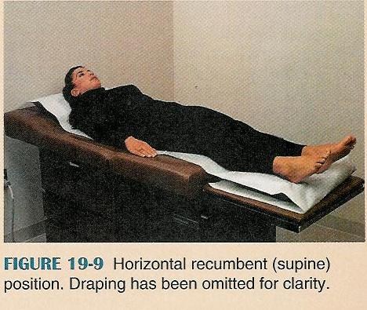

  - Used to exam or treat the front or anterior part of the body
- Pt lies flat on back with legs slightly apart
- One small pillow is allowed under the head
- Arms are flat at the side of the body
- Drape pt with large sheet or drape

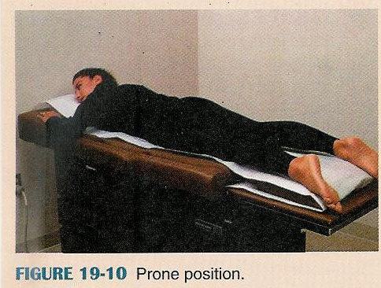

PRONE POSITION
  - Used for exams of back or spine
  - Pt lies on the abdomen with head turned to either side
  - Small pillow is placed under the head
  - Arms may be flexed
at elbows and positioned
on either side of the head
  - Drape pt with large
sheet or drape

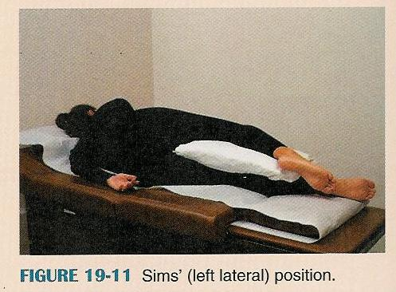

SIMS’ OR LEFT LATERAL POSITION
  - Used for simple rectal or sigmoidoscopic exams, enemas, rectal temps, and rectal treatments
  - Patient lies on left side
  - Head rests on small pillow and is turned to the side
  - L arm is extended behind the back
  - R arm is bent at elbow and placed in comfortable position in front of the body
  - L leg is bent or flexed slightly
  - R leg is bent or flexed sharply and brought up to the abdomen
  - Drape pt with one large sheet or drape or two small sheets that meet at the rectal area

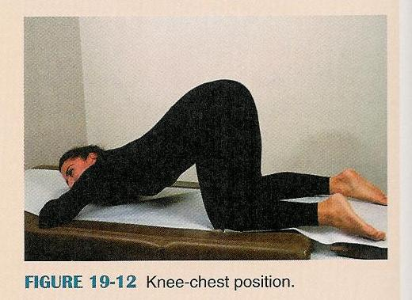

KNEE-CHEST POSITION
  - Used for rectal exams- usually a sigmoidoscopic exam
  - Pt lies on stomach, abdomen, or prone position
  - Pt raises buttocks and abdomen until weight is resting on upper chest and knees
  - Head rest on small pillow and is turned to either side
  - Arms are flexed slightly at the elbows and extended above the head
  - Knees are separated slightly
  - Thighs are at right angles to the table/bed
  - Draping can be done by
    - 1 large sheet can be used to cover the pt
    - 1 large sheet with a hole at the rectal area
    - 2 smaller sheets or drapes that meet at the rectal area

FOWLER’S
  - Used to facilitate breathing, relieve distress, encourage drainage, and examine the head, neck, and chest
  - Pt lies on back with head elevated at different angles
  - A small pillow may be place under the pt’s head
  - Flex knees slightly and place small pillow under knees
  - Drape with a large sheet or drape
  - Don’t tuck sheet! : )

- Low- Fowlers: head elevated at 25° angle
- Mid-fowler’s or semi –Fowler’s- head elevated at 45° angle
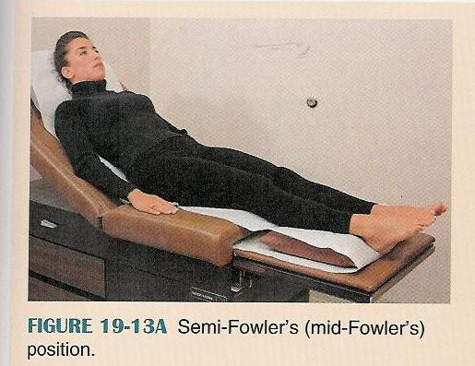

- High Fowler’s- head elevated at 90° angle

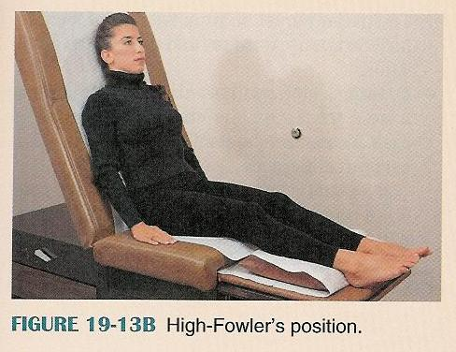

LITHOTOMY POSITION
- Used for vaginal examinations, pap tests, urinary catherization, cystoscopic examinations, and surgery of the pelvic area

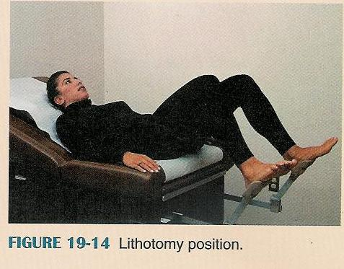

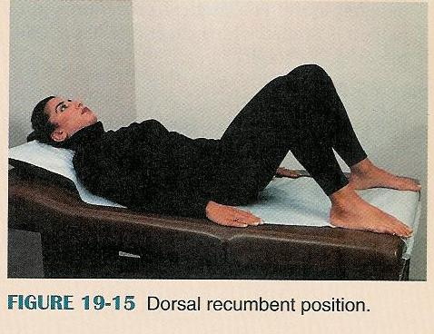
DORSAL RECUMBENT POSITION
- Similar to lithotomy position and used for same purposes

STANDARD TRENDELENBURG POSITION
- Used for circulatory shock because it increases circulation of the blood to the brain and head
- Pt lies flat on back with head on small pillow
- Arms are flat at sides
- Entire bed or table is elevated at the feet
- Pt lies in horizontal recumbent with head lower than the feet

SURGICAL TRENDELENBURG POSITION

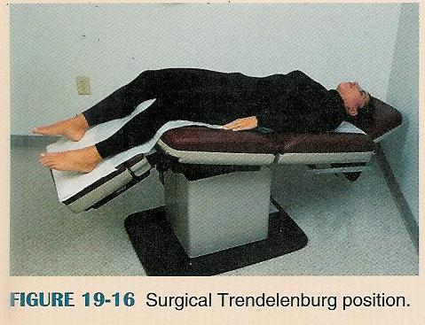

- Used for surgery on pelvic organs and pelvic treatments
- Pt lies flat on back with head on small pillow
- Arms are flat at sides
- Top of table is lowered at an angle to lower the head
- Bottom of table is lowered at an angle to incline legs and feet downward
- Straps are used frequently to hold the pt in position

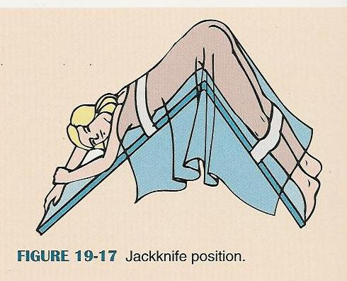

JACKKNIFE POSITION
- Used for rectal surgery or exams, or back surgery and treatments
- Requires a special table that will break in the middle
- Care must be taken so pt will not slide off or be injured in any way
- Pt lies in prone position
- Secure the safety straps on the table around the pt
- Lower the top of the table so the head and upper body are inclined at a downward angle
- Draping is done in a variety of ways
- Special safety precautions

