Dr. Abdullah Al Fraidan
Lecture 1 – lecture 14



Lecture 1
The Present Simple
المضارع البسيط

Simple Present Tense: Uses
استخدامات زمن المضارع البسيط:
Everyday activities: What do you do every day?
النشاطات اليومية: ماذا تفعل يوميا؟
Routines, habits
الروتين,والعادات الحياتية
General truths
الحقائق العامة

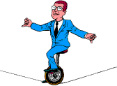

What do these people do?



Bake يخبز

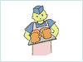

cut / style hair يقص \تسرح شعر

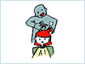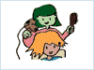

Build يبني
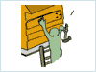
Deliverيوصل

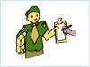

draw / designيرسم\يصمم
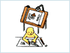
Drive يقود

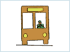

fix / repair plumbing, appliances.يجري صيانة\ يصلح السباكة او المعدات
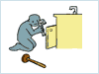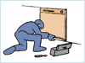

Fly يطير
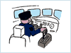
Garden تزرع

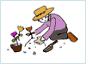
Guard يحرس
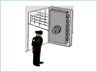

manage / supervise يدير\ يشرف
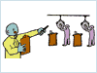

Paintيرسم
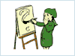

use a computer / programيستخدم الكومبيوتر \ يبرمج
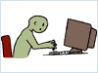

answer telephone, type, file, take messages
ترد على الهاتف.تكتب.تفرز.تتلقى الرسائل.
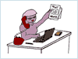
Sellيبيع
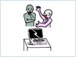
serve, help customersيخدم ويساعد الزبائن

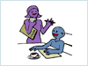
Teach يدرس

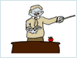

research, do experimentsيجري ابحاث .يقوم بتجارب

wash dishesيغسل الصحون

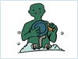
clean, wax ينظف , يلمع

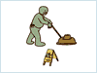
Weldيلحم

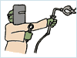
Third Person
He / She / It
Singular subject (my friend, the boss, a co-worker)
الشخص الثالث
هو \ هي \هو(غير العاقل)
Verb + s
Goes, works, talks, does, speaks
s
نضيف ( ) على الفعل عندما نستخدم زمن المضارع البسيط فقط عندما نستخدم الضمائر الثلاثة السابقة
Spelling rules: Third person verbs in simple present tense
Rule 1: verbs ending in –ch, -sh, -ss, and –x + es
اذا أردنا تحويل الفعل الى مضارع بسيط فعلينا اتباع الآتي:
عندما ينتهي الفعل المضارع بأحد هذه النهايات:
ch, -sh, -ss, –x

نضيف عليه
(es)

- teach teaches
research researches

wash washes
push pushes
pass passes

fix fixes
wax waxes

Rule 2: final consonant + y -> - y + ies
y
ies
عندما ينتهي الفعل المضارع بـ( )نحذفها ثم نضيف عليه( )
- Fly fly flies
Dry dry dries
Try try tries
Study study studies

هذه قاعدة سماعية ..تحفظ هكذا..

- Do does
Go goes
Have has

Find and correct the mistakes:
- I’m work for a very good company, and I also student at Mira Costa College.
I work for a very good company, and I also student at Mira Costa College.
- The manager talkes with all employees once a week.
The manager talks with all employees once a week.
- The manager and I has a meeting today.
The manager and I have a meeting today.

Negatives in Simple Present Tense
النفي في الفعل المضارع البسيط
Change these to negative:
غير هذه الجمل من مثبتة إلى منفية:
- I work. I don’t work.
- I like my job. I don’t like my job.
- They have benefits. They don’t have benefits.
- We have a nice boss. We don’t have a nice boss.
- She has a lot of experience. She doesn’t have a lot of experience.
- He drives to his work. He doesn’t drive to his work.
- The new employee comes early. The new employee doesn’t come early.
- My co-worker talks to me. My co-worker doesn’t talk to me.

Negatives in simple present tense
النفي في الفعل المضارع البسيط

- I / you / we / they
Plural subject (the workers, the people)
+ do not (don’t) + verb
- He / she / it
Singular subject
+ does not (doesn’t) + verb (no –s)
تلخيص هذه القاعدة في الرسم البياني الأتي:
do not (don’t) + verb
ونستخدم لها
have
I / you / we / they

تستخدم للفاعل الجمع

تستخدم للفاعل المفرد
does not (doesn’t) + verb
هنا الفعل بدون إضافة
(s)
Has
تصبح
have
He / she / it

Questions in Simple Present Tense
الأسئلة في الفعل المضارع البسيط:
Change these statements to questions:
غير هذه الجمل إلى أسئلة:
- I work. Do you work?
- I like my job. Do you like your job?
- They have benefits. Do they have benefits?
- We have a nice boss. Do you have a nice job?
- She has a lot of experience. Does she have a lot of experience?
- He drives to his work. Does he drive to his work?
- The new employee comes early. Does the new employee come early?
- Your co-worker talks to you. Does your co-worker talk to you?

Questions in Simple Present Tense
- Do + I / you / we / they + verb + ?

- Does he / she / it + verb + ?
تلخيص القاعدة في الرسم البياني الأتي:
I / you / we / they

الفعل من غير
(s)
Do
؟
He / she / it

Does
الفعل من غير (s)

Lecture 2
The Present Simple
المضارع البسيط

And again

+ +

We don’t visit the moon
I You
We They
do not
don’t
+
verb1
Rest of
sentence
SNOB…
Don’t forget the snobs. He She It. They are very tricky. They also take the verb DO it becomes DOES

But the verb looses s 


It snows in the winter.
does not
doesn’t

It snows in the summer

LET’S PRACTISE
لنتمرن:
Write in negative
اكتبها منفية:
- My cat has a swimsuit.
My cat doesn’t have a swimsuit.

- Dan and Dana catch frogs.
Dan and Dana don’t catch frogs
- Robots eat hot dogs
Robots don’t eat hot dogs.

Simple Present Tense- Negative
Change these statements to questions:

- I work.
- I like my job.
- They have benefits.
- We have a nice boss.
- She has a lot of experience.
- He drives to his work.
- The new employee comes early.
- Your co-worker talks to you.

سبق حلها في الحاضرة السابقة..

Yes/ No Questions in Simple Present Tense
سؤال (نعم –لا) بواسطة الفعل المضارع البسيط:
- Do + (I – you – we – they) + verb + rest of sentence ?
- Does (he- she- it) + verb + rest of sentence ?
3. IS (he-she-it)+ rest of sentence?
4. Are (you-we-they)+ rest of sentence?
5. AM (I) + rest of sentence?

تلخيص القاعدة في الرسم البياني الأتي:
+ rest of sentence?
is
He
She
it

+ verb + rest of sentence ?
does

am
+ rest of sentence?
I

You
We
they
do
+ verb + rest of sentence ?

are
+ rest of sentence?

Simple Present Tense- Questions
Change these statements to questions and then answer them
- I work.
DO I work?
2. You like my job.
DO you like my Job?
3. He has cats.
Does he have cats.

Lecture 3
The Present Simple & Progressive
المضارع البسيط و المتقدم

- Using the textbook to answer the exercises
- استخدم الكتاب لحل التمارين.

Lecture 4
The Present Progressive (Continuous)
المضارع المتقدم(المستمر)

The Present Progressive (Continuous)

When you see verb to be you have to think of ing

Noun (pronoun) + Verb to be (is- am –are) + (verb) = verb ing

Majid is playing tennis
Sara is sleeping

كل ما يحصل الآن ..هو مضارع مستمر.
Is ,am , are>>>was, were
عندما نجد ( ) عليك ان تفكر بإضافة ( )
ing

المضارع المستمر المثبت
Present Continuous Afirmative

I | am | Eating  )v+ing)
You | are | Eating  )v+ing)
He  She  It | is | Eating  )v+ing)
We  You  They | are | Eating  )v+ing)

المضارع المستمر الاستفهامي
Present Continuous Interrogative
Am | I | eating ?  Is ,am , are>>>was, were
Are | you | eating ?  Is ,am , are>>>was, were
Is | he  she  it | eating ?  Is ,am , are>>>was, were
Are | We  You  They | eating ?  Is ,am , are>>>was, were
في هذا النوع نجعل ( ) في البداية وبعدها نضع الضمير المناسب ثم الفعل
المضارع المستمر المنفي
Present Continuous Negative
I | am not | eating  not
You | aren´t | eating  not
He  She  It | isn´t | eating  not
We  You  They | aren´t  Is ,am , are>>>was, were | eating  not
هنا نضيف( ) على ( ) فقط
Present Continuous- Signal words
Now- right now
Look!
Listen!
At the moment

المضارع المستمر .كلمات الإشارة التي تدل عليه..مثل..
يعني هذه الكلمات تبين لنا ما إذا كان المضارع مستمر أم بسيط فإذا كانت موجودة فهو مستمر..

I am Reading
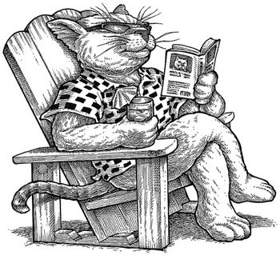

What are they doing?
ماذا يفعلون؟



They are boxingانهم يلاكمون

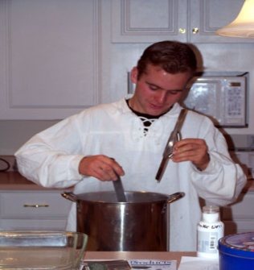
He is cookingانه يطبخ



He is doing judoانه يؤدي الجودو
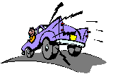
He is drivingانه يقود السيارة


He is falling downانه يسقط

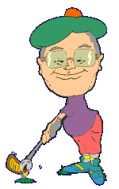
He´s playing golfانه يلعب الجولف
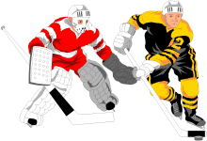
They are playing hockeyانهما يلعبان الهوكي
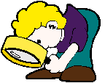
He´s lookingانه ينظر
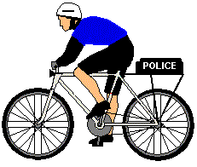
He´s riding a bikeانه يقود الدراجة


It is eating انه يأكل



They are shaking handsانهما يتصافحان بالأيدي



He is skateboarding انه يتزلج

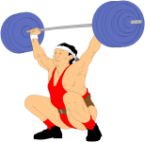

He is weightlifting انه يرفع الاثقال


He´s playing rugbyانه يلعب الركبي

He´s working on the computer انه يعمل على الكومبيوتر
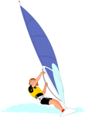

He´s windsurfingانه يركب الامواج


He´s surfing انه يمارس الركمجة
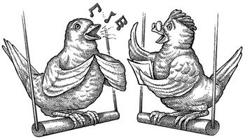

They are singing انهم يغردون

Test-Taking Strategies
تمارين للتقوية:
The boys ____ to the gym everyday
going b) go c) goes

Sary is _____ to the radio right now.
listening b) listens c) listen

Mubarak and Huda usually ______ their parents
a) Visits b) visiting c) visit

Salim ____ a lexus car
drives b) driving c) drive

Reem _____ to a new house.
moving b) is moving c) move

Jamal ______ at 9.30pm
a) sleeping b) sleep c) sleeps

We____ a new house
buy b) are buying c) buys

Maha _____ as a manager.
working b) works c) work

I ______ drinking milkshakes
a) Like b) liking c) likes

Lecture 5
The Simple Future
المستقبل البسيط
The Simple Future

Pre-Test (Affirmative Sentences)
Select the best answer.
__ 1. The stores ____ at noon today.
(A) is going to close (B) are going to close (C) am going to close

__ 2. The secretary ___ the documents tomorrow morning.
(A) is going to fax (B) am going to fax (C) are going to fax

__ 3. Esteban ___ us at the Mall tonight at 8:30.
(A) am going to meet (B) are going to meet (C) is going to meet

__ 4. I ___ a health club next month.
(A) am going to join (B) is going to join (C) are going to join

__ 5. The meeting ___ in 15 minutes.
(A) are going to begin (B) is going to begin (C) am going to begin

Pre-Test (Negative Sentences)
__ 6. Mr. and Mrs. Cardona ____ their home near the beach.
(A) am not going to build (B) isn’t going to build (C) aren’t going to
build
__ 7. Some friends ___ to our welcome party next Friday.
(A) isn’t going to come (B) aren’t going to come (C) am not going
to come
__ 8. I ___ at any fast food restaurant this week.
(A) aren’t going to eat (B) isn’t going to eat (C) am not going
to eat
__ 9. Elizabeth ___ cards to her friends this Christmas. She’s going to visit
them.
(A) isn’t going to send (B) aren’t going to send (C) am not going
to send
__10. Luis fractured his ankle. He ___ basketball this basketball season.
(A) aren’t going to play (B) am not going to play (C) isn’t going to
play

Pre-Test (Yes/No Questions)

__ 11. __ George ___ from California to Mexico next summer ?
(A) Is, going to drive (B) Am, going to drive (C) Are, going to drive

__ 12. __ you ___ casual clothes to the get together activity next Saturday ?
(A) Are, going to wear (B) Is, going to wear (C) Am, going to wear

__ 13. __ the students ___ their e-mails this afternoon ?
(A) Is, going to read (B) Am, going to read (C) Are, going to read

__ 14. __ the train ___ in twenty minutes ?
(A) Am, going to leave (B) Is, going to leave (C) Are, going to leave

__ 15. __ I ___ my reimbursement check next Friday ?
(A) Are, going to receive (B) Is, going to receive (C) Am, going to
receive
Pre-Test (Information Questions)

__ 16. Where __ Anita ___ her job interview tomorrow morning ?
(A) am, going to have (B) is, going to have (C) are, going to have

__ 17. When __ Paul ___ the yard ?
(A) are, going to clean (B) is, going to clean (C) am, going to clean

__ 18. Who _______ Nancy to the airport next Sunday ?
(A) are going to take (B) am going to take (C) is going to take

__ 19. What __ you ___ next weekend ?
(A) are, going to do (B) is, going to do (C) am, going to do

__ 20. Why __ the manatees probably ___ in the future ?
(A) is, going to disappear (B) are, going to disappear (C) am, going to
disappear
Pre-Test Answer Keyمفتاح الحل:
1. B 11. A
2. A 12. A
3. C 13. C
4. A 14. B
5. B 15. C
6. C 16. B
7. B 17. B
8. C 18. C
9. A 19. A
10. C 20. B
Pre-Test Evaluationقيم نفسك:
Total Correct Answers:مجموع اجاباتك

20 Excellent: Go to the Post Test.ممتاز:مستعد للاختبار
19 Very Good: Review the incorrect answer and go to the
Post Test.
جيد جدا: راجع إجاباتك..وستكون مستعدا.
18-12 Good: Review the incorrect answers, study the rules
presented in this module, do the practice exercises
and then go to the Post Test.
جيد:راجع إجاباتك وادرس القواعد ثم طبق التمارين وستكون مستعدا.
11 or You Need More Practice: Study the module, review the
less rules carefully and do the practice exercises. When
you improve your score, you may go to the Post Test.
. تحتاج إلى تدريب أكثر:ادرس القواعد بجد أكثر وحل التمارين بتركيز اكبر وحينما يرتفع معدل درجاتك في هذا الاختبار فأنت مستعد.
Simple Future Tense
زمن المستقبل البسيط:

You use the Simple Future Tense when you talk about future events or plans.
نستخدم زمن المستقبل البسيط حينما تتكلم عن أحداث أو خطط مستقبلية.
You also use the Simple Future Tense when you want to make a prediction or make a promise. ☺
نستطيع أيضا استخدام زمن المستقبل البسيط حينما نريد التنبؤ أو قطع وعود.
There are two (2) ways to make the Simple Future Tense
هناك طريقتان لإنشاء المستقبل البسيط:
Pattern # 1: الطريقة#1:
SUBJECT + BE + GOING TO + VERB (BASE FORM)

Pattern # 2:الطريقة#2:
SUBJECT + WILL + VERB (BASE FORM)

Pattern # 1
هذه قاعدة الطريقة الاولى":
Subject + BE (am, is, are) + going to + Verb (base form)…

Example:
I am going to graduate next May.

Future Time Expressions:تعبيرات مستقبلية:
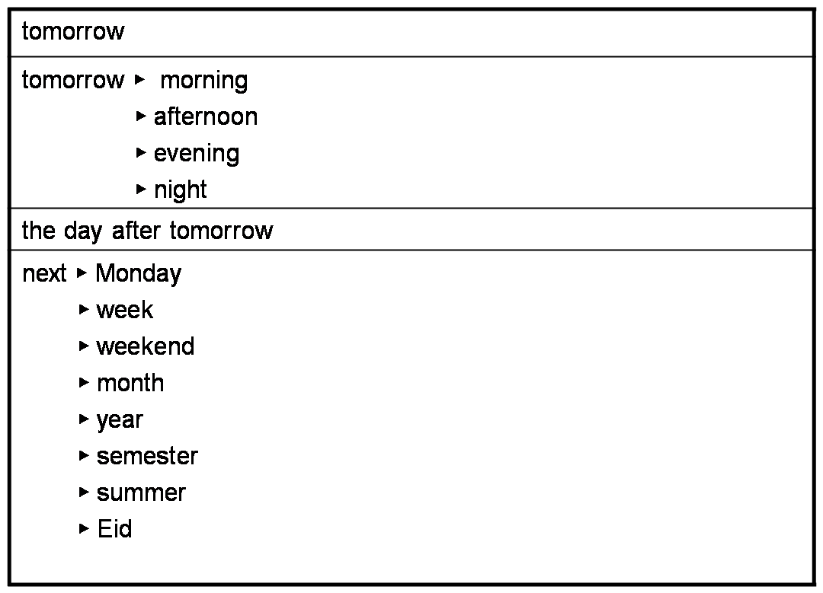

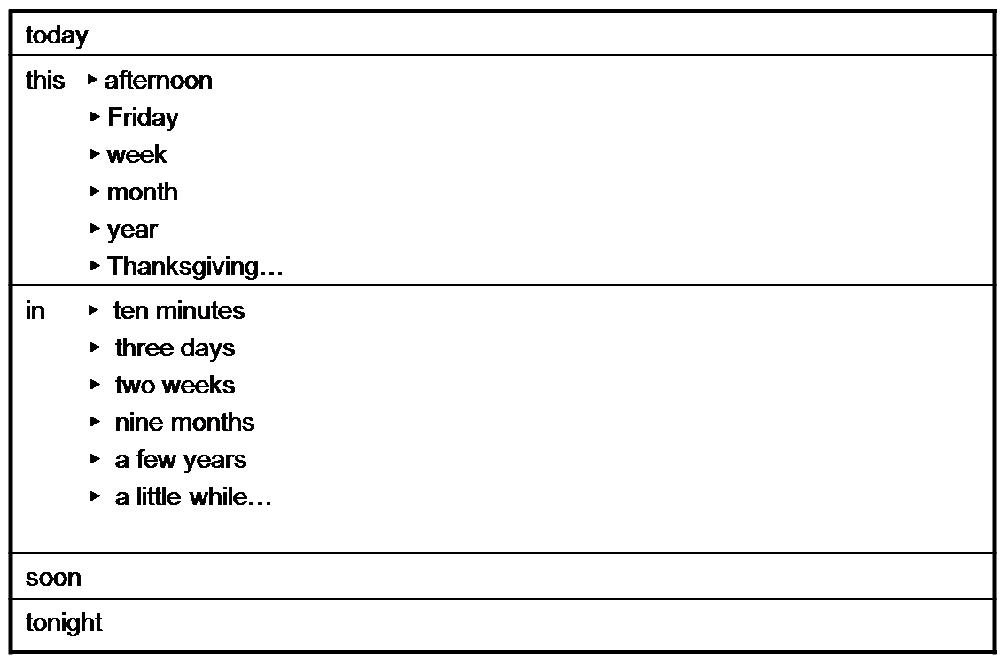

Affirmative Sentences :الجمل المثبتة:
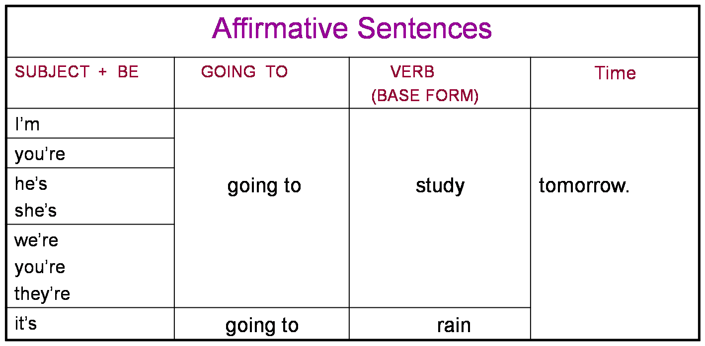
Affirmative Sentences
Examples:

1. I’m going to watch a movie tonight.
2. You’re going to see the doctor tomorrow.
3. Miguel is going to fix his car later today.
4. Sarah and Daniel are going to buy a laptop next month.
5. The dog is going to eat its food soon.
6. We’re going to move to Florida next year.
7. The game is going to begin in 10 minutes.
8. Mrs. Medina is going to sign the house contract next Monday.

Negative Sentences الجمل المنفية:
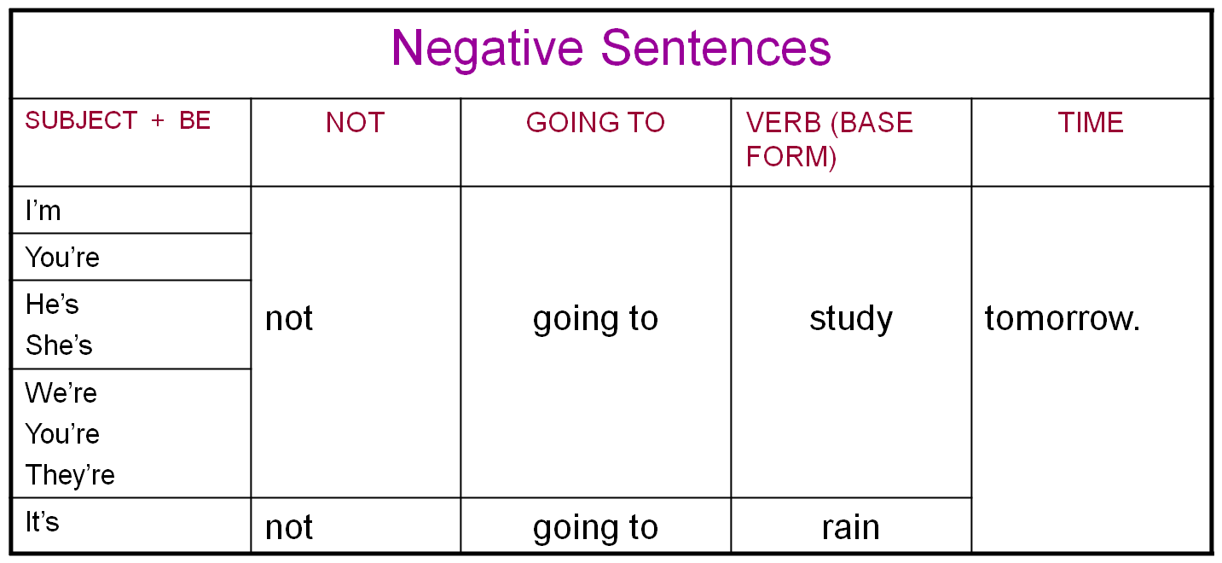
Negative Sentences
Negative Sentences
Examples:

1. I’m not going to watch a movie tonight.
2. You’re not going to see the doctor tomorrow.
3. Miguel is not going to fix his car later today.
4. Sarah and Daniel are not going to buy a laptop next month.
5. The dog is not going to eat its food soon.
6. We’re not going to move to Florida next year.
7. The game is not going to begin in 10 minutes.
8. Mrs. Medina is not going to sign the house contract next Monday.

Use of Contractions استخدامات الاختصارات:
Contractions: A contraction is the combination of two words into
one. In contractions, letters are replaced with an apostrophe (’).
الاختصار: هو تركيب كلمتين لتصبحا كلمة واحدة ولنفعل ذلك لابد من حذف أحرف واستبدالها بفواصل(,)

Examples:
I am not = I’m not
you are not = you’re not / you aren’t
he is not = he’s not / he isn’t
she is not = she’s not / she isn’t
it is not = it’s not / it isn’t
we are not = we’re not / we aren’t
they are not = they’re not / they aren’t
لدينا طريقتين :
1: إما أن نحذف أول حرف من الكلمة الثانية .
o
not
2:أو نحذف حرف ( ) من كلمة ( )

وطبعا في كل الأحوال لابد من استبداله بالفاصلة.
ماعدا المثال الأول فلا يجوز تطبيق الطريقة الثانية ..بل لابد من الأولى فقط.
Examples of Contractions in Negative Sentences
- I am not going to watch a movie tonight.
- You’re not going to see the doctor tomorrow.
- We’re not going to move to Florida next year.
- The game is not going to begin in 10 minutes.

- I’m not going to watch a movie tonight.
- You aren’t going to see the doctor tomorrow.
- We aren’t going to move to Florida next year.
- The game isn’t going to begin in 10 minutes.

Yes/No Questions and Short Answers

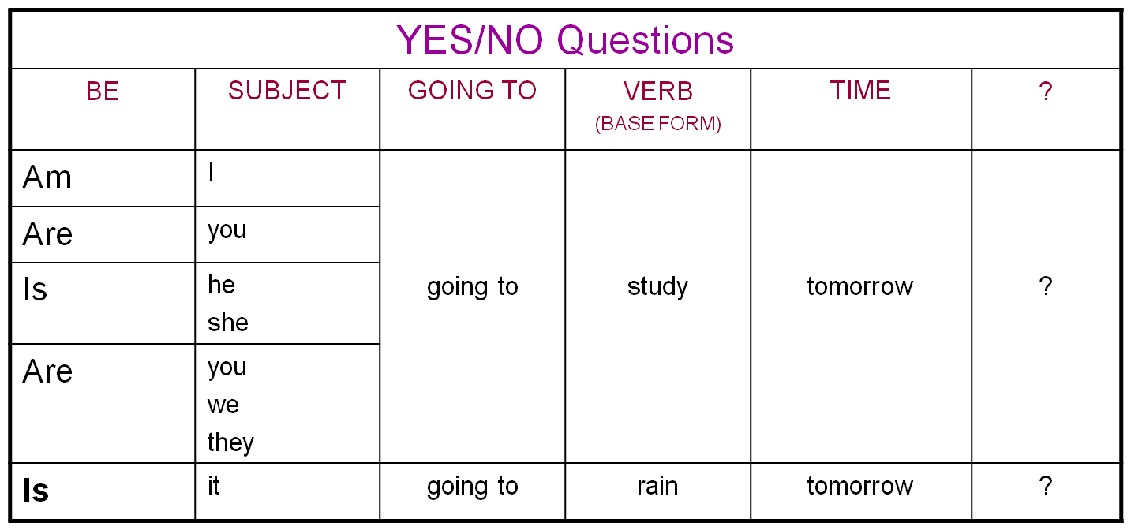
Yes/No Questions and Short Answers

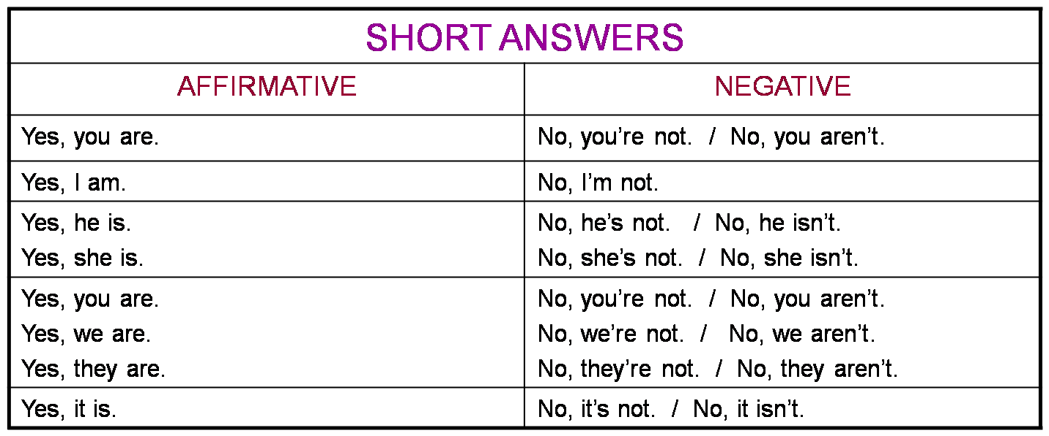

Yes/No Questions and Short Answers

Examples: أمثلة:

1. Are you going to watch a movie tonight?
Yes, I am. / No, I am not. / No, I’m not.

2. Are you going to see the doctor tomorrow?
Yes, I am. / No, I am not. / No, I’m not.

3. Is Mike going to fix his car later today?
Yes, he is. / No, he’s not. / No, he isn’t.

4. Are Sarah and Daniel going to buy a laptop next month?
Yes, they are. / No, they’re not. / No, they aren’t.

5. Is the dog going to eat its food soon?
Yes, it is. / No, it’s not. / No, it isn’t.

6. Are you going to move to Florida next year?
Yes, we are. / No, we’re not. / No, we aren’t.

7. Is the game going to begin in 10 minutes?
Yes, it is. / No, it’s not. / No, it isn’t.

8. Is Mrs. Medina going to sign the house contract next Monday?
Yes, she is. / No, she’s not. / No, she isn’t.

Wh-Questions (Information Questions)أسئلة المعلومات:
الجدول الأول السؤال عن الفاعل
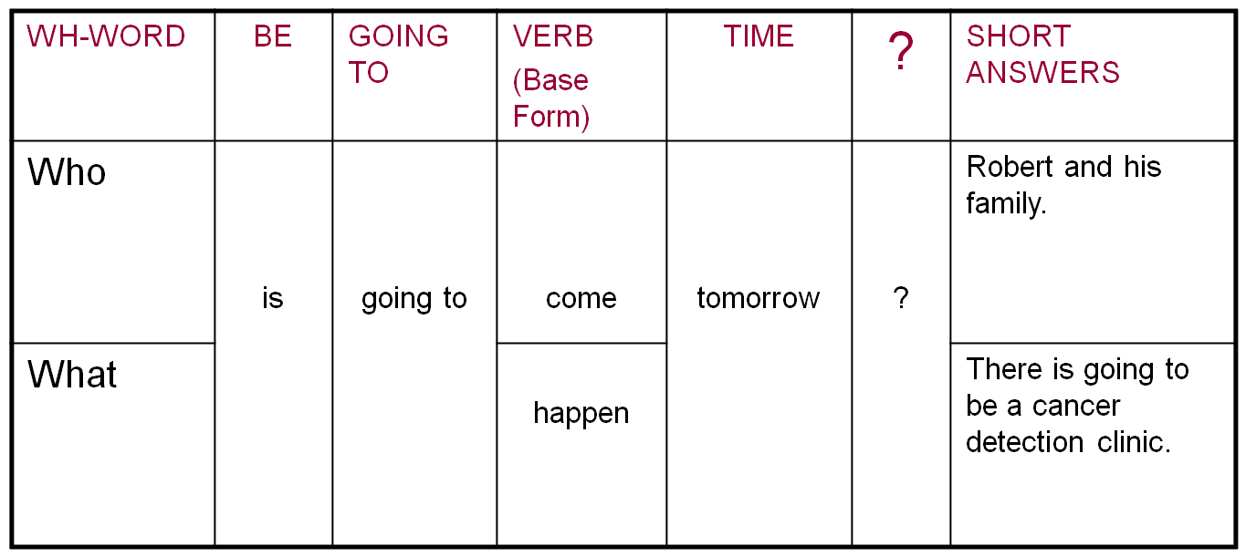
WH-QUESTIONS ABOUT THE SUBJECT

Wh-Questions (Information Questions)أسئلة عن المعلومات:
أسئلة عن أشياء أخرى

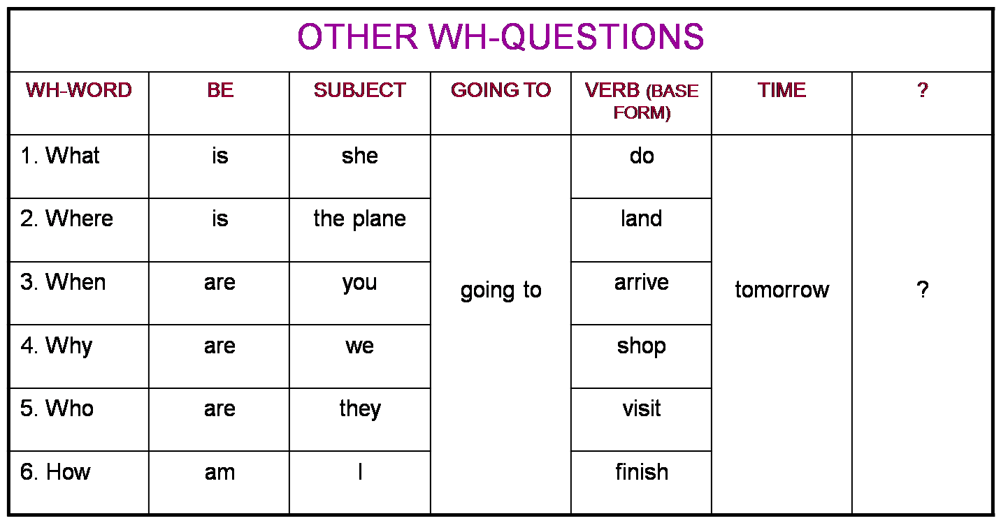

More Examples: أمثلة أخرى:
1. (Q) What are you going to watch tonight?
(A) A terror movie.

2. (Q) When are you going to take a test?
(A) Tomorrow at 9:30 am.

3. (Q) What is Mike going to fix today?
(A) His car.

4. (Q) Where are you going to move to next year?
(A) To Florida.

5.(Q) Who is going to sign the house contract next Monday?
(A) Mrs. Medina.

Practice Exercises (Affirmative Sentences)تمرين(الجمل المثبتة):
Select the best answer.
اختر الإجابة الأفضل:
__ 1. I ____ the laundry this afternoon.
(A) is going to do (B) am going to do (C) are going to do

__ 2. Eliezer ____ to a pool party next Saturday.
(A) is going to go (B) are going to go (C) am going to go

__ 3. We ____ at the new Italian restaurant tomorrow night.
(A) am going to eat (B) is going to eat (C) are going to eat

__ 4. The tutors ____ the students in the English class next week.
(A) is going to help (B) are going to help (C) am going to help

__ 5. Carolyn ____ her baby next month.
(A) is going to have (B) am going to have (C) are going to have

Practice Exercises (Negative Sentences)

__ 6. My mother ____ dinner tonight.
(A) am not going to cook (B) isn’t going to cook (C) aren’t going to cook

__ 7. The temperature ____ in the 90s tomorrow.
(A) isn’t going to be (B) am not going to be (C) aren’t going to be

__ 8. Bob and his family ____ at the lake next weekend.
(A) aren’t going to fish (B) isn’t going to fish (C) am not going to fish

__ 9. I ____ new decorations for the house this Christmas.
(A) aren’t going to buy (B) am not going to buy (C) isn’t going to buy

__10. The meeting ____ at three o’clock. It’s going to end later.
(A) am not going to end (B) isn’t going to end (C) aren’t going to end

Practice Exercises (Yes/No Questions)

__ 11. __ you and your family __ your house before you sell it?
(A) Is, going to remodel (B) Am, going to remodel (C) Are, going to remodel

__ 12. __ Henry __ in the university next semester?
(A) Is, going to register (B) Am, going to register (C) Are, going to register

__ 13. __ your parents __ their wedding anniversary next July?
(A) Am, going to celebrate (B) Are, going to celebrate (C) Is, going to
celebrate
__ 14. __ Julian and Carol __ a business next year?
(A) Is, going to own (B) Am, going to own (C) Are, going to own

__ 15. __ Wal-Mart __ until 10:00 pm next Sunday?
(A) Am, going to open (B) Are, going to open (C) Is, going to open

Practice Exercises (Information Questions)

__ 16. Who ___ your sister ___ to her wedding?
(A) are, going to invite (B) is, going to invite (C) am going to bring

__ 17. When ___ the students ___ their science projects?
(A) are, going to finish (B) am, going to finish (C) is, going to finish

__18. What trick __ the dolphin __ next?
(A) am, going to do (B) is, going to do (C) are, going to do

__ 19. Why ___ Peter ___ his sports car next month?
(A) am, going to sell (B) are, going to sell (C) is, going to sell

__ 20. How ___ the engineers ___ houses in the future?
- are, going to design (B) am, going to design (C) is, going to design

Practice Exercise Answer Key
- B 11. C
- A 12. A
- C 13. B
- B 14. C
- A 15. C
- B 16. B
- A 17. A
- A 18. B
- B 19. C
- B 20. A

Practice Exercise Evaluation
Total Correct Answers:

20 Excellent: Go to the Post Test.
19 Very Good: Review the incorrect answer and go to the
Post Test.
18-12 Good: Review the incorrect answers, consult the module
again and then go to the Post Test.
11 or You Need More Practice: Study the module, review the
less rules carefully and do the practice exercises again.
When you understand the rules and improve your
score, you may go to the Post Test.

Post Test (Affirmative Sentences)
Select the best answer.اختر الاجابة الافضل:
الحل بعد انتهاء التمرين:
__ 1. The stores ____ at noon today.
(A) is going to close (B) are going to close (C) am going to close

__ 2. The secretary ___ the documents tomorrow morning.
(A) is going to fax (B) am going to fax (C) are going to fax

__ 3. Esteban ___ us at the Mall tonight at 8:30.
(A) am going to meet (B) are going to meet (C) is going to meet

__ 4. I ___ a health club next month.
(A) am going to join (B) is going to join (C) are going to join

__ 5. The meeting ___ in 15 minutes.
(A) are going to begin (B) is going to begin (C) am going to begin

Post Test (Negative Sentences)

__ 6. Mr. and Mrs. Cardona ____ their home near the beach.
(A) am not going to build (B) isn’t going to build (C) aren’t going to
build
__ 7. Some friends ___ to our welcome party next Friday.
(A) isn’t going to come (B) aren’t going to come (C) am not going
to come
__ 8. I ___ at any fast food restaurant this week.
(A) aren’t going to eat (B) isn’t going to eat (C) am not going
to eat
__ 9. Elizabeth ___ cards to her friends this Christmas. She’s going to visit
them.
(A) isn’t going to send (B) aren’t going to send (C) am not going
to send
__10. Luis fractured his ankle. He ___ basketball this basketball season.
(A) aren’t going to play (B) am not going to play (C) isn’t going to
play

Post Test (Yes/No Questions)

__ 11. __ George ___ from California to Mexico next summer ?
(A) Is, going to drive (B) Am, going to drive (C) Are, going to drive

__ 12. __ you ___ casual clothes to the get together activity next Saturday ?
(A) Are, going to wear (B) Is, going to wear (C) Am, going to wear

__ 13. __ the students ___ their e-mails this afternoon ?
(A) Is, going to read (B) Am, going to read (C) Are, going to read

__ 14. __ the train ___ in twenty minutes ?
(A) Am, going to leave (B) Is, going to leave (C) Are, going to leave

__ 15. __ I ___ my reimbursement check next Friday ?
(A) Are, going to receive (B) Is, going to receive (C) Am, going to
receive
Post Test (Information Questions)

__ 16. Where __ Anita ___ a job interview tomorrow morning ?
(A) am, going to have (B) is, going to have (C) are, going to have

__ 17. When __ Paul ___ the yard ?
(A) are, going to clean (B) is, going to clean (C) am, going to clean

__ 18. Who _______ Nancy to the airport next Sunday ?
(A) are going to take (B) am going to take (C) is going to take

__ 19. What __ you ___ next weekend ?
(A) are, going to do (B) is, going to do (C) am, going to do

__ 20. Why __ the manatees probably ___ in the future ?
(A) is, going to disappear (B) are, going to disappear (C) am, going to
Disappear
Post Test Answer Key
1. B 11. A
2. A 12. A
3. C 13. C
4. A 14. B
5. B 15. C
6. C 16. B
7. B 17. B
8. C 18. C
9. A 19. A
10. C 20. B

Post Test Evaluation
Total Correct Answers:

20 Excellent: Congratulations! You have successfully
completed this module. You may work with a different
module if necessary.
19 Very Good: Review the incorrect answer. You may work
with a different module if necessary.
18-12 Good: Review the incorrect answers, review the areas of
difficulty and take the Post Test again.
11 or You Need More Practice: I recommend that you review
less the complete module and take the Post Test again.

Lecture 6
The Past
الماضي
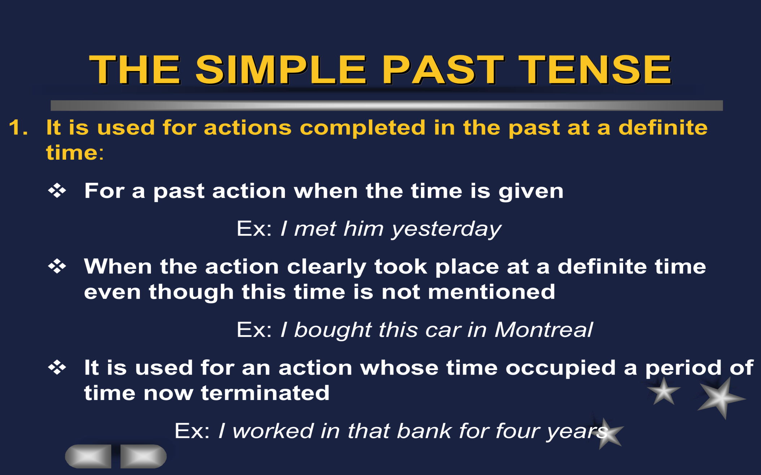
Rule

زمن الماضي البسيط:
يستخدم الماضي البسيط للتعبير عن أحداث انتهت في الماضي في وقت محدد.
- من اجل حدث ماضي وحينما يعطى الوقت.
e.g. I met him yesterday.

- حينما يكون الحدث قد وقع في زمن محدد في الماضي حتى لو لم يذكر الزمن بالتحديد.
e.g. I bought this car in Montreal.

- حينما يكون الحدث قد وقع في الماضي واستمر لفترة من الزمن ثم توقف.

e.g. I worked in that bank for four years.

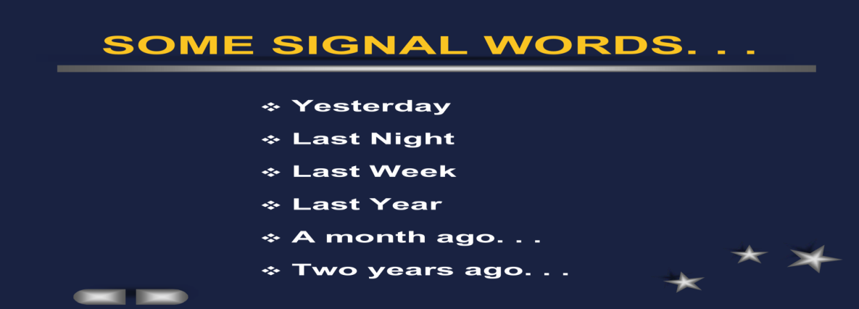

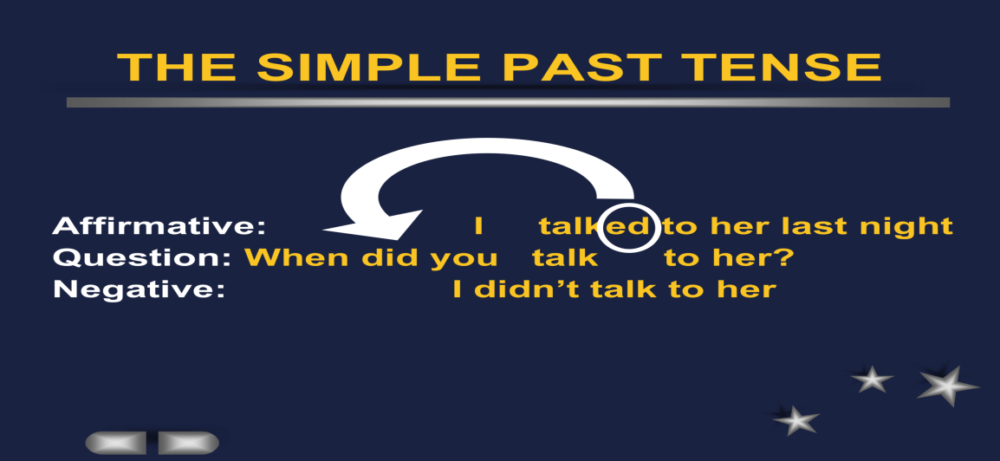
الكلمات في الشريحة السابقة هي إشارة عن الفعل الماضي .أي إذا وجدت فأنه فعل ماض بسيط.

شرح الشريحة السابقة يتلخص فيما يأتي:
I talked to her last night.
تتحول في السؤال لتعود إلى أصلها وهي:

When did you talk to her?
في حالة السؤال
I didn’t talk to her
في حالة النفي

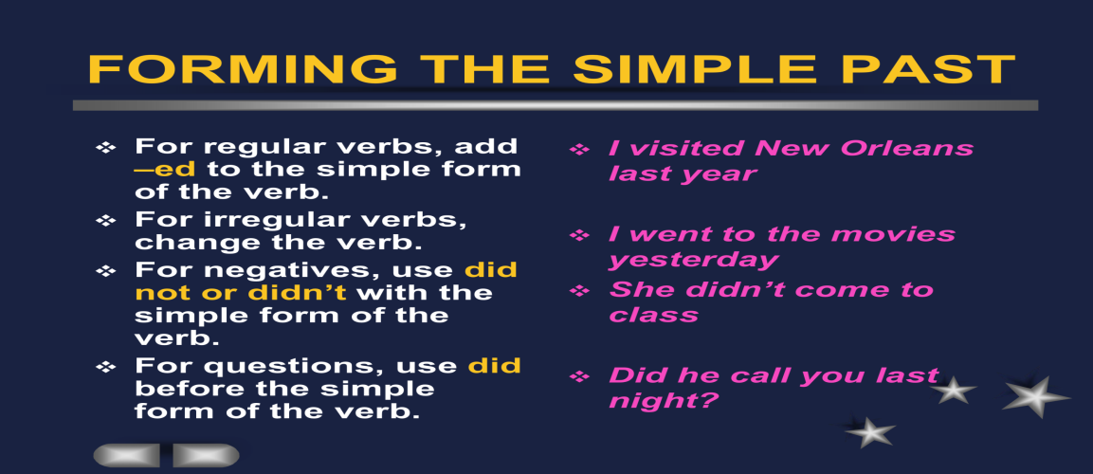

شرح الشريحة السابقة يتلخص في ما يلي.. تشكيل الفعل الماضي:
إذا كان الفعل عادي أو غير شاذ
walk

ed
نضيف إليه
فيصبح
walked

إذا كان الفعل شاذا
come
نحوله إلى
التصريف الثاني للفعل
فيصبح
went
إذا كان الفعل منفيا
come
نعيده إلى
did
نستخدم التصريف الأول للفعل

نستخدم

فيصبح
إذا كان الفعل في صيغة سؤال.
come
Did not come
نعيده إلى
did
نستخدم
نستخدم التصريف الأول للفعل

فيصبح
Did you come?

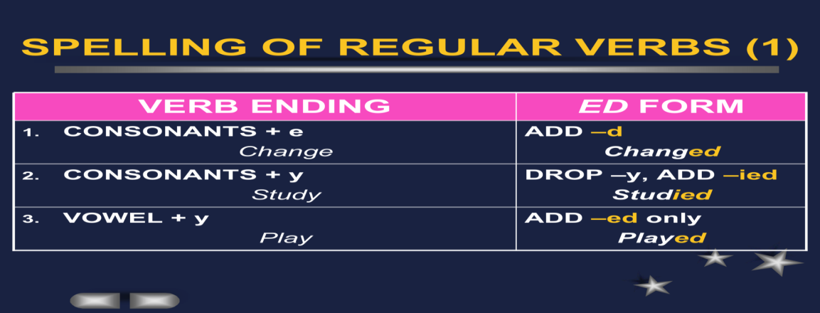
إذا كان الفعل ينتهي بــحرف ساكن + e

إذا كان الفعل ينتهي بـحرف ساكن +y
إذا كان الفعل ينتهي بـحرف صوتي+ y
أضيف فقط
ed
احذف الأخير ثم أضيف
ied
أضيف فقط
d
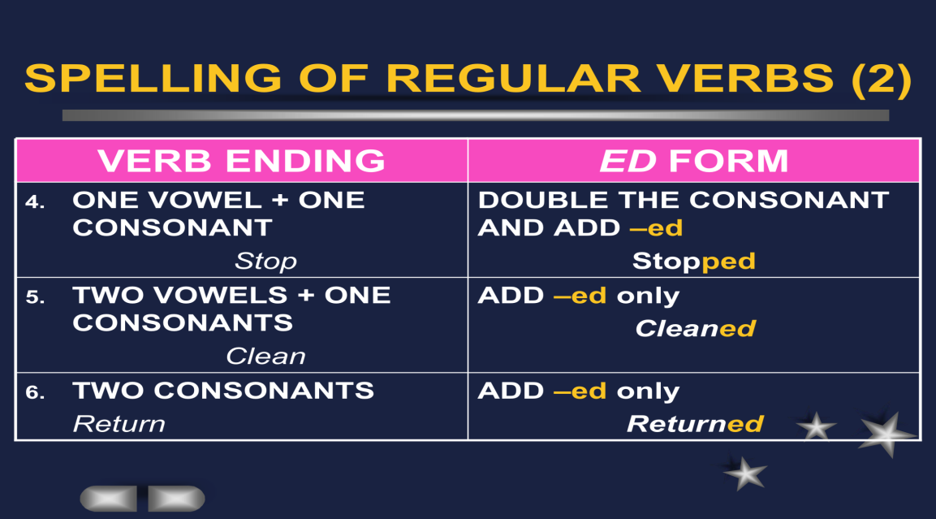
حرف صوتي+ حرف ساكن
نكرر آخر حرف ثم نضيف
حرفين صوتيين+حرف ساكن
حرفين ساكنين
إذا انتهى الفعل الماضي بــــ
ed
نضيف فقط

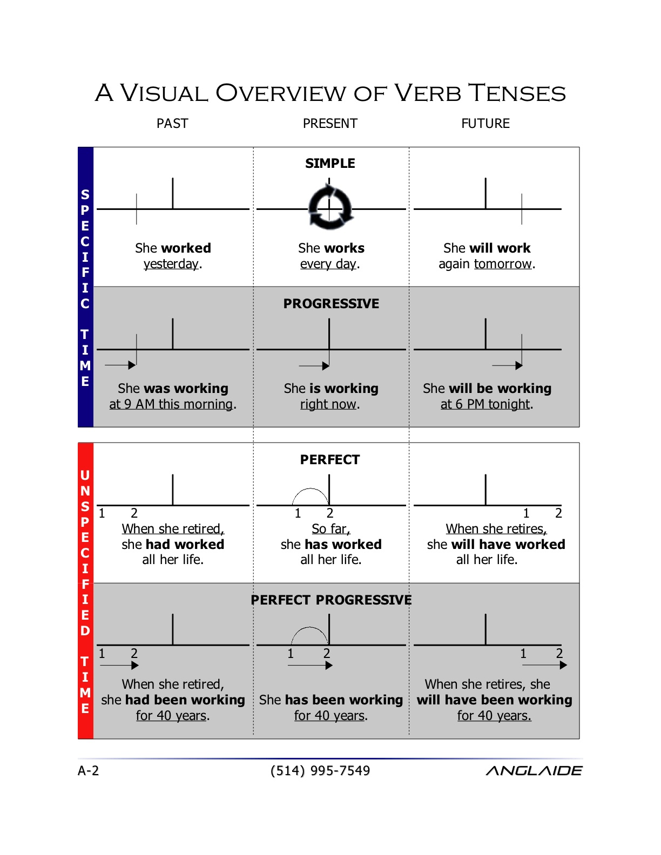
Lecture 7
Practices
تمارين
Unit 1

Referring to the book Unit 1
Pages 13-34
إشارة إلى الوحدة الأولى
من صفحة 13 إلى صفحة 34

Lecture 8
Practices
تمارين
Unit 1

Referring to the book Unit 1 إشارة إلى الوحدة الأولى
من صفحة 34 إلى صفحة 46
Pages 43-46

Lecture 9
Count and Noncount nouns

NONCOUNT NOUNS الاسماء الغير معدودة

- Whole groups or whole masses. المجموعات كاملة أو الكتل
Furniture, coffee and sugar.مثل: الأثاث, القهوة, السكر
- Abstract concepts. المفاهيم المجردة:
Love, wisdom, spirituality.مثل:الحب, الحكمة,الروحانية
- Phenomenon of Natureظواهر الطبيعة:
Sunshine, rain, snow. مثل:شروق الشمس,المطر,الثلج
SOME COMMON NONCOUNT NOUNSبعض الأسماء الغير المعدودة المنتشرة:
Whole groups made up of similar itemsالمجموعات الكاملة المتكونة من اشياء متشابهه


Fluidsالسوائل

Solidsالجمادات


Gasesالغازات
Particlesالجزيئات
Abstractions التجريدات..مثل الوقت.الموسيقى.الاخبار.
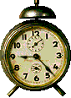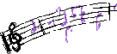
Languagesاللغات

Fields of Studyالمواد العلمية..او الحقول الدراسية
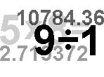

Recreation التسلية والاستجمام
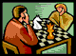
Activitiesالانشطة
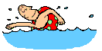

Natural Phenomenaالظواهر الطبيعية
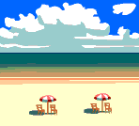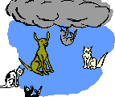
Generic Nounsالاسماء العامة
Articles are used to make generalizations.
A is used for singular nouns
A banana is yellow.
An umbrella
An egg
0 is used for plural nouns and noncount nouns
0 Bananas are yellow.
0 Fruit is good for you
a,an
هنا يتكلم عن ( ) واستخداماتها.وأننا نستخدمها في حالة المفرد فقط أما في الجمع فنستغني عنها.

Indefinite Nounsالاسماء غير واضحة العدد..او مجهولة العدد
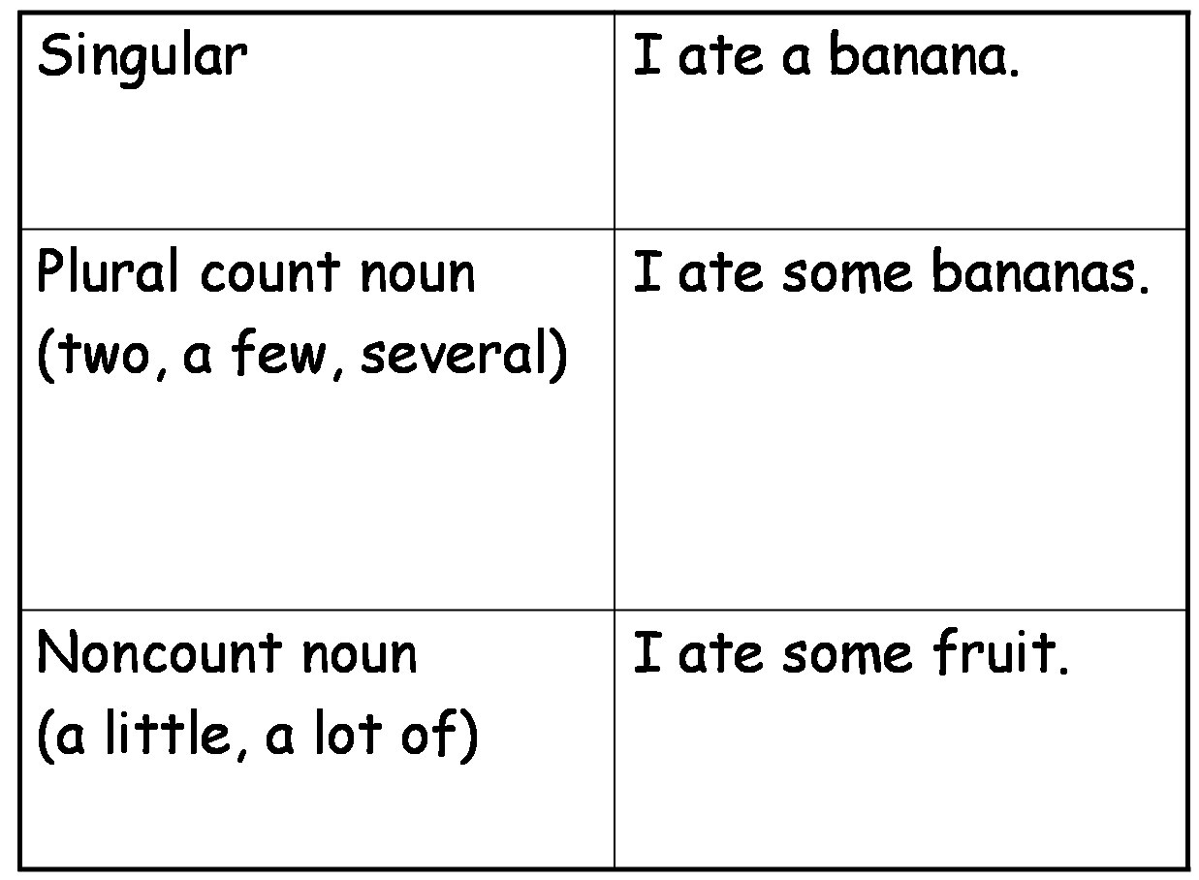
في حالة الأسماء المعدودة غير معروفة العدد نستخدم...
في حالة الأسماء الغير معدودة نستخدم...

Definite Nounsالاسماء المحددة التي تبدأ بــ( )
the
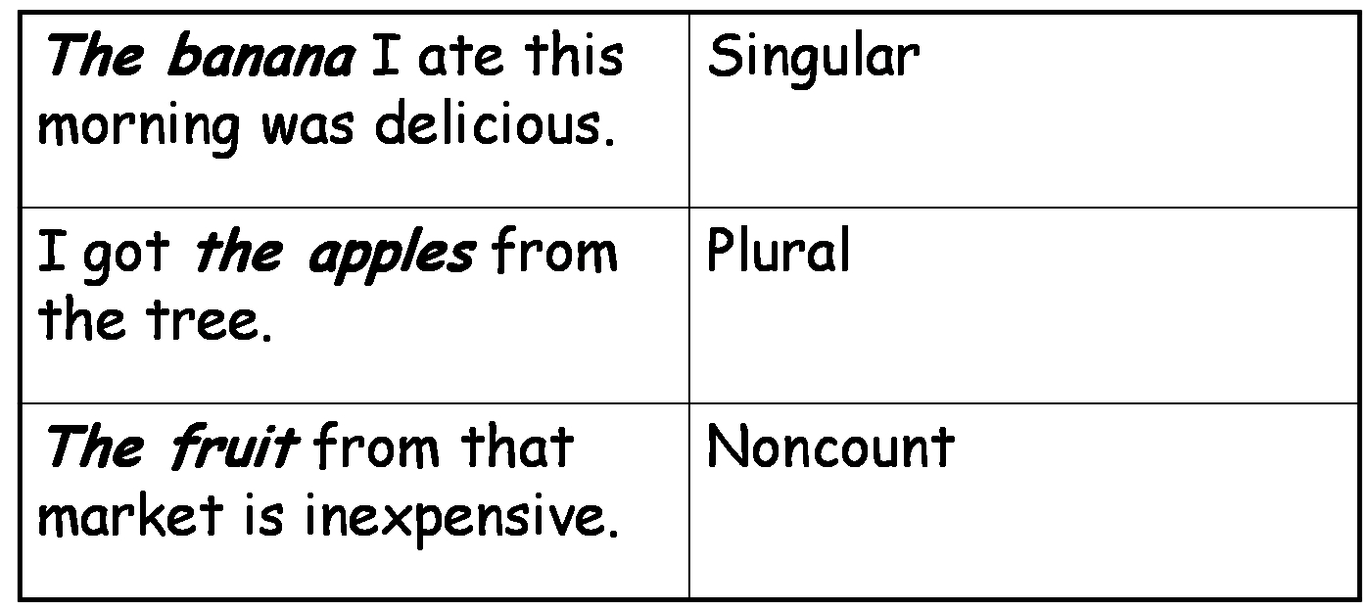
مفرد
جمع
غير معدود
Expressions of Quantity for Count nounsتعبيرات للمعدود:
Oneواحد......
Eachاي......
Everyكل......
Two,three, etc.اثنان,ثلاث...الخ....
A couple ofزوجين من......او اثنين من.....
A fewالقليل.....
Many كثير....
Severalعدة.....
A number ofعدد من.....
Expressions of quantity for noncount nounsتعبيرات لغير المعدود:
A littleالقليل....
Muchكثير.....
A great deal ofقدر كبير من.....
Expressions of quantity for both count and noncount nouns
تعبيرات للمعدود ولغير المعدود:
Noلا....بمعنى لا يوجد تفاح..
Some/anyبعض/أي......
A lot of/lots ofالكثير من.......
Plenty ofالكثير من.......
Most معظم أو الجزء الأكبر...
Allجميع أو كل.....
Negative vs. Positiveالمنفي والمثبت.....
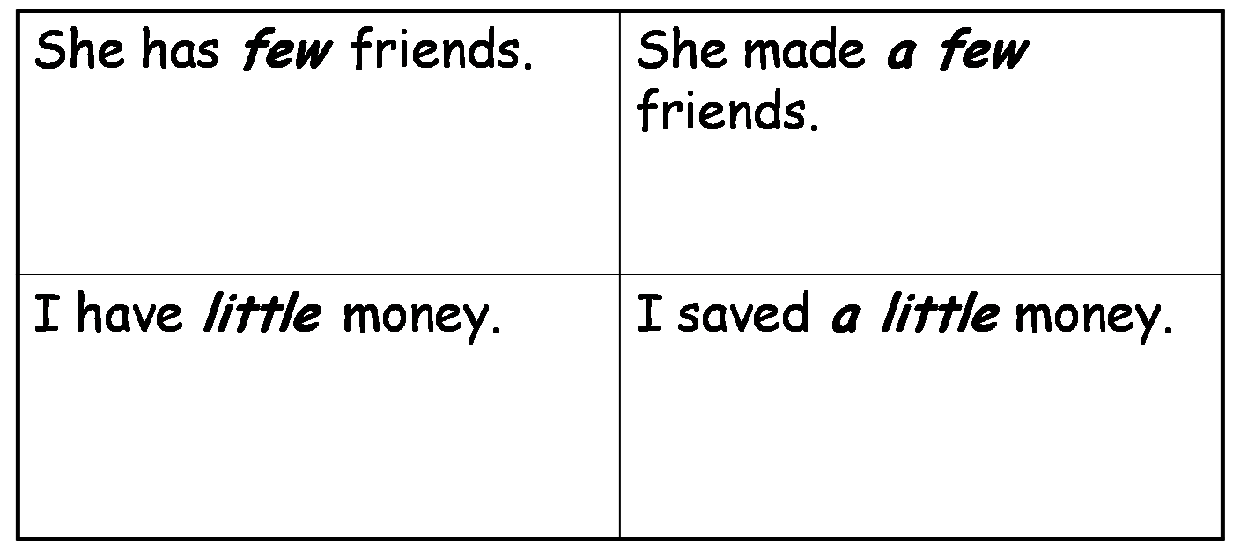
Go to the book pp. 57
Page 96 important
Lecture 10
Modal Auxiliary
What do they mean?ماذا تعني؟؟
Can- Could
will- Would
Shall- Should
Must- Have to – Ought to
May- Might
Modals Giving permissionادوات نستخدمها لطلب الاذن :
Would you please help me?هلا ساعدتني رجاء؟...............
Could you help meهل تستطيع المساعدة؟................
Can you help me?هل تستطيع المساعدة؟..............
Will you help me?هلا ساعدتني؟............
May I ….?هل بإمكاني؟..............
Modals Expressing abilityأدوات نستخدمها للتعبير عن الإمكانية....
I can speak English (present ability)استطيع التحدث بالانجليزية(إمكانية حاضرة)
Last year I could speak English (past ability)
في العام الماضي استطعت التحدث بالانجليزية(إمكانية ماضية)
I am able to …. (present)بمقدوري.....(حاضر)
I was able to …. (past)كان بمقدوري.......(ماضي)
I will be able to ….. (future)سيكون بمقدوري................(مستقبل)
Modals Expressing expectationأدوات للتعبير عن التوقع
The train should arrive nowيجب أن يصل القطار الآن
Ought to seldom used! (negative or questions only!)(يجب أن) نادرا ما تستخدم!
(في النفي والسؤال فقط )
Should – ought to – had better (express advice)
الثلاث الدوات السابقة تستخدم للتعبير عن إسداء نصيحة..مثل:
You are sick. You should see a doctor!
You ‘d better not stay home.
Modals Expressing preferencesأدوات للتعبير عن التفضيلات. يعني ما تفضل فعله ..
I would like ……أفضّل أن ...
I would rather to go to Costa rather than Blockbuster
أفضّل أن أذهب إلى كوستا بدلا من بلاك بستر
Modals Expressing Need or obligationأدوات للتعبير عن الحاجة والالتزام:
Must (You must have a driving license to drive)
يجب (يجب أن يكون لديك رخصة قيادة لكي تقود)
Must not to ( you must not bother your parents)
يجب عليك ألا (يجب عليك ألا تزعج والديك)
Have to (You have to study for the exam.)
يجب أن (يجب أن تدرس للاختبار)
Not have to (You do not have to come with us.)
ليس واجبا أن (ليس واجبا عليك أن تأتي معنا)
Modals Expressing possibility and impossibility
أدوات تعبر عن إمكانية والاستحالة:
May --- may not..ممكن ...غير ممكن
Might …. Might not قد ....قد لا (قد يحدث ..قد لايحدث) Could … could notيستطيع....لا يستطيع......
…..have enough money
It can’t be five! لايمكن أن تكون خمسة! او مستحيل أن تكون خمسة
That couldn’t be my uncle!لايمكن أن يكون هذا غدائي! أو مستحيل أن يكون غدائي
Borrow & Lendالاستعارة..والاقراض
Borrow = you take from some oneالاستعارة= تأخذ من احد ما شيئا
May I borrow your pen?هل أستطيع أن استعير قلمك؟
Borrowing a book from a libraryاستعارة كتاب من المكتبة
Lend= you ask someone to give you something
إقراض= تطلب من أحد أن يقرضك شئ
Can you lend me your car?هلا أقرضتني سيارتك؟
Lending someone money إقراض شخص ما مالا
Modals Expressing preferencesأدوات تستخدم للتعبير عن التفضيلات
Go to the book pp. 135 (important)راجع الكتاب ص 135

Lecture 12
Global Connections
التوصيلات

What do they mean?ماذا تعني؟
They connect two sentencesتربط مابين جملتين
Andو....
Butلكن....
Norولا....
Orأو.....
Soإذن.....
Adverb clauses (condition/ contrast/ reason/ time)
العبارات الظرفية (الحال.النقيض,السبب.الوقت)
If إذا after/beforeقبل/بعد
Unless إلا إذا untilحتى
Although بالرغم when/ sinceعندما/ منذ
Even though بالرغم
So thatبحيث
Because لأن
Transitions التحويلات
For example مثال
In addition/ furthermoreبالإضافة إلى ذلك /علاوة على ذلك
In fact/ as a matter of factفي الواقع /في واقع الأمر
However/ in contrast ولكن في المقابل/على النقيض من ذلك
Therefore/ as a result/ consequently
لذلك / نتيجة / وبناء على ذلك

First/ second/ third etc..أولا/ثانيا/ثالثا..الخ......
Go to the book page 259راجع الكتاب صفحة 259

Lecture 14
The Passive voice
المبني للمجهول
Active sentenceالمبني للمعلوم..
Noha made a cakeأعدت نهى كعكة..
Passive voiceالمبني للمجهول ..
The cake was made by Nohaأُعدَّت الكعكة بواسطة نهى ..
Structure of the passive voiceبناء المبني للمجهول
Present الحاضر
Is/am/are + verb ed + by
لاحظوا بأن المبني للمجهول فعله يجب أن يكون بزمن الماضي. والحاضر هنا في هذه الجزئية..
Pastالماضي
Was/ were + verb ed + by
لاحظوا بأن المبني للمجهول فعله يجب أن يكون بزمن الماضي. والماضي هنا في هذه الجزئية..
Example:مثال:
The cake was made of strawberry
The cake was made for the guests
Passive voice with itالمبني للمجهول مع...
People believe that the Earth is round. (active present)
It is believed that the Earth is round. (passive present)
People thought that English was a difficult language (active past)
It was thought that English was a difficult language. (passive past)
Go to the book page 293
it
لاحظوا باننا حولنا الكلمة الأولى إلى ( ) وجعلنا الفعل في التصريف الماضي.

The Final exam
الاختبار النهائي:
I bought _______________ pepper yesterday.
a) a few b) many
- a little d) how much
_______________ people are there in the hall?
a) How many b) How much
c) How a few d) A few
Please give me _______________ stamps to send these two letters
a) much b) a little
- how many d) a few

I eat _______________ chicken every day.
a) a little b) many
- how much d) a few

_______________ wood do you need to make a chair?
a) How many b) How
c) A little d)How much

................ a business executive’s life stressful?
a. Are b. Is c. Am

The baby ..................at the moment.
a sleep b. are sleeping c. is sleeping d. is sleep

Fred is tired because ....................
a. she has failed her exams b. you haven’t` switched on c. he has worked all night

Yousef .....................a book after lunch every day.
a. read b. is reading c. reads d. are reading

......................go out last night?
a. Do you b. Did you c. Does he d. Does you

……….. that new film yet?
a. Did you see b. Have you seen c. Was you see

She saw the police car while she …………. to work.
a. was driving b. drove c. drive

- حلي للتمارين الأخيرة من اجتهادي وقد يتخللها الخطأ الرجاء مراجعة حل الدكتور للتأكد من الحل الصحيح..بالتوفيق

