المقال | Essay
أ.عمار المعاني

الواجب [ 1 ]
Why I Want to Learn English(1) There are three reasons why I want to learn English. (2) One reason is that English has become an international language.(3) It is now used by most international companies, including the company where I work, for business communication. (4) Another reason why I want to learn English is so that I can travel to English-speaking countries. (5) The United States, England, Australia and many other countries all use English as their primary language. (6) Finally, I want to learn English because I plan to move to the U.S. in the future. (7) I will become a manager for my company soon. (8) For all these reasons, I am very excited about learning English.
- Identify the topic sentence:
- 1st sentence
- 2nd sentence √
- 3rd sentence
- 4th sentence

- Identify the conclusion:
- 5th sentence
- 6th sentence
- 7th sentence
- 8th sentence √

- Identify the first main point:
- 2nd sentence √
- 3rd sentence
- 4th sentence
- 5th sentence

الواجب [ 2 ]

- Question: what is/are the subtopic(s) of the following of this thesis statement. A healthy lifestyle involves eating a nutritious diet, exercising regularly, and getting enough sleep at night.

- A healthy lifestyle
- Eating a nutritious diet
- Exercising regularly
- Eating diet, exercising and getting enough sleeping. √

- Which thesis statement is not too general or not an announcement but improved?
- English Essay is a very difficult and complicated class.
- English 101 is an interesting course since I like English.
- English Essay is difficult for two reasons. √
- English Essay is very interesting because I like it.

- Which thesis statement is weak not thesis statement?
- The telecommunication is very advanced in Saudi Arabia. That’s interesting.
- The cars are all new in the Jaddah city. Have you rode any?
- Food is very special today. Let’s talk about it.
- Eating while driving can cause two main fatal accidents. √

الواجب [ 3 ]
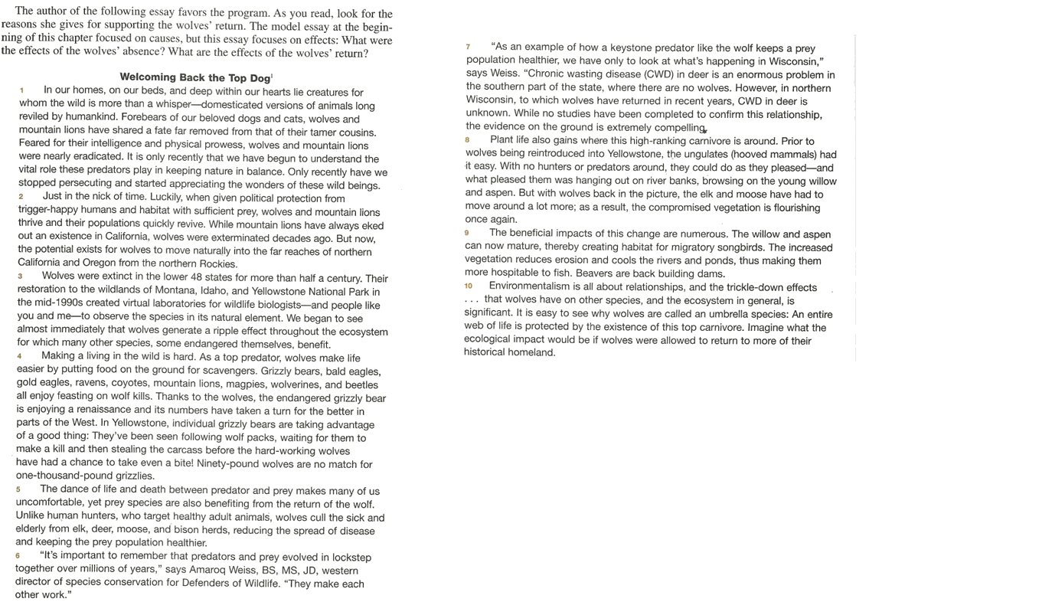

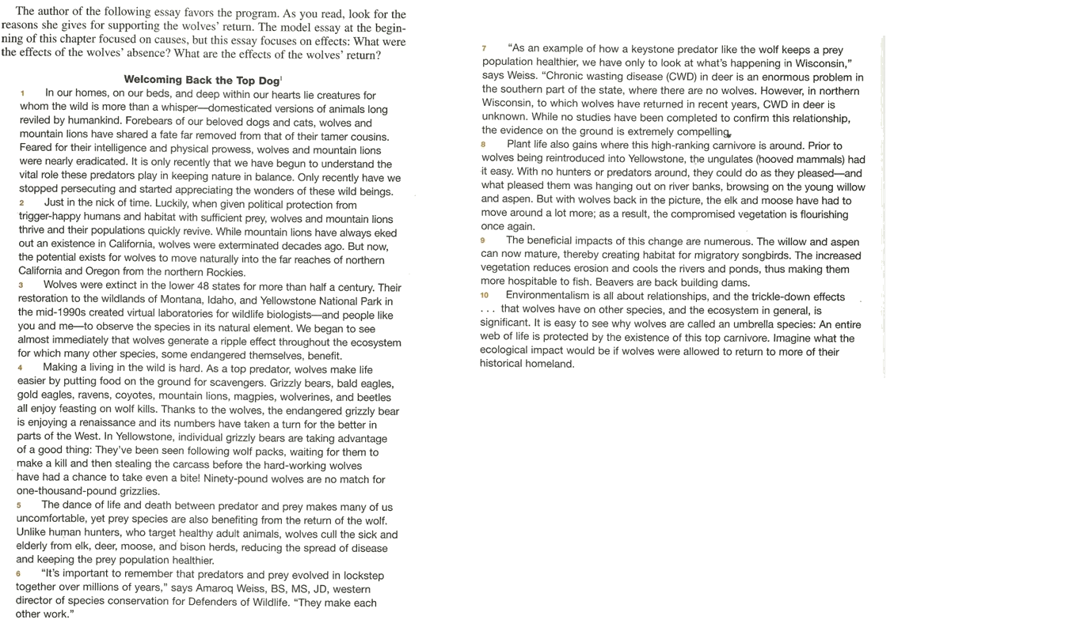

- The thesis statement for this essay is the last sentence of paragraph
- 1
- 2
- 3 √
- There is no thesis statement

- The topic sentence for paragraph 4 is the
- First sentence
- Second sentence √
- Third sentence
- There is no topic sentence
- Two paragraphs, when added together, use the chain pattern. These two paragraphs are:
- 3and4
- 4and5
- 5and6
- 8and9 √

- Which sentence is parallelized?
- You can pay me now, or it’s okay if you pay me later.
- You can pay me now or pay me later √
- I like to read and writing
- He is playing football and to swim

