واجب الأدب الأول

The publishing of children’s books in Saudi Arabia started _________________.
A.
Earlier than many Arab countries
B.
Earlier than many European countries
C.
Later than western countries only
D.
Later than Arab and western countries

السؤال 2

Dr. Aisawi is a _____________________.
A.
medical Child specialist from Saudi Arabia
B.
Saudi academic champion in the promotion and study of children’s literature
C.
writer of picture books from Dammam University
D.
publisher of children’s books from Saudi Arabia

السؤال 3

eco-literacy” is ________________________.
A.
the theme of the Oslo conference
B.
an international theme in Arabic literature books
C.
an International LBF seminar
D.
a local Arab theme

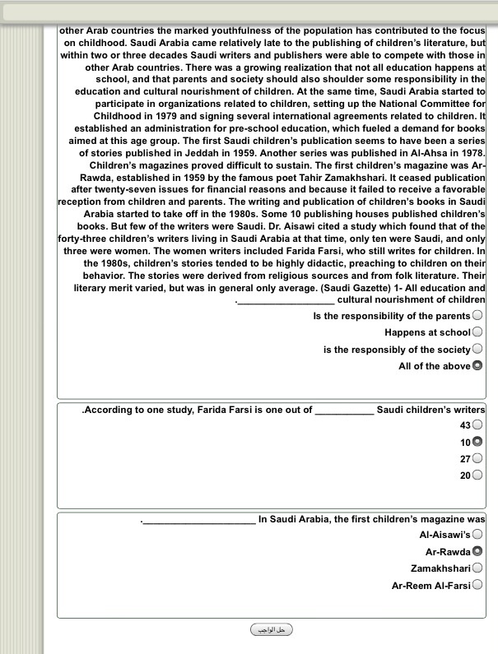
واجب الأدب الثاني

واجب الأدب الثالث

1- What is the rhyme scheme?
aa bb cc dd

2-A good example of alliteration is _____________________.
Crow and caper, caper and crow

3-What is a good theme for this poem?
All babies love to be lifted, twirled and held in loving arms

4-to utter an inarticulate cry of pleasure, as an infant does." is_________
Crow

