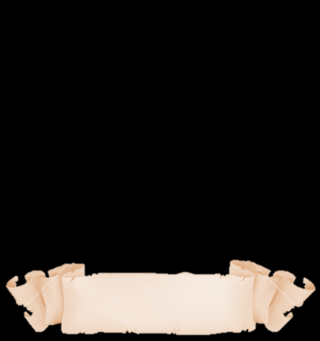
Revision (1)

- I live in Washington near _____ Mount Rainier.
- a
- an
- the
- one
- Spanish is _____ beautiful language.
- a
- an
- the
- none of the above
- Professor Omar is _____ amazing person who you should meet one day.
- a
- an
- the
- what
- The capital of Saudi Arabia is _____ Riyadh .
- an
- a
- the
- leave it blank
- In ancient Egypt _____ cats were considered sacred.
- a
- an
- the
- leave it blank
- Othman is _____ good man who helped us last night.
- a
- an
- the
- one
- Amman and New York _____ very crowded cities.
- is
- are
- am
- is not
- I take _____ apple every day to stay healthy.
- a
- an
- two
- several
- I study in a private school. _____ school is really amazing.
- the
- a
- an
- one
- Are you ready, We have to go? _____
- No, I'm not
- Yes, Im
- No, Iamn't
- Yes, You're
- I _____ feeling very tired.
- am
- is
- are
- has
- The dictionary is _____ the drawer.
- In
- on
- between
- are
- The baby sat _____ the car-seat too early.
- in
- on
- between
- are
- A: ______________________________?
B: Yes, it's.
- Is the sun the biggest body in the solar system?
- Are the sun the biggest body in the solar system?
- Does the sun the biggest body in the solar system?
- the sun is the biggest body in the solar system?
- A: ______________________________?
B: Yes, They are.
- Is tomatoes vegetables?
- The tomatoes are vegetables?
- Are tomatoes vegetables?
- Was tomatoes vegetables?
- Are you ready to learn English.
- Yes, he is.
- No, she is.
- Yes, they are.
- No, I am not.
- _______is he? In my office.
- Where
- How
- Why
- who
- _______is the English class? It's right over here.
- Why
- Where
- When
- what

