الوآجب الاول :
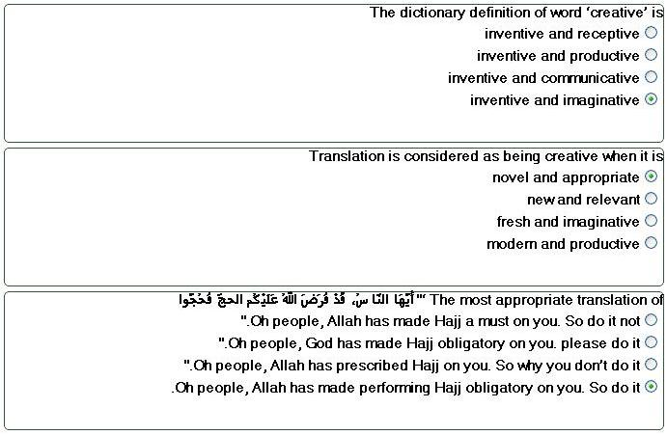
الوآجب الثاني :
One of the most appropriate approaches to translating poetry is
an aesthetic approach
a holistic approach
a communicative approach
a semantic approach
------------
The most appropriate translation of ‘ كان يوماً ملتهباً كطفل نالت منه الحمى
It was a very hot afternoon as the child experienced the heat of a fever
It was a scorching summer afternoon. The heat was feverish
It was as hot as a child suffering from fever.
The day was as hot as a child with a fever
--------
The translation of style in the context of literature is
awfully important
crucially unimportant
really unnecessary
significantly superfluous
الواجب الثالث :
Literary translation
is a form of action in a real-word context
has no links with social context
has no links with subject-setting relationship: ideology, identity and ethics.
is form of lonely voice in the word fiction
---------------
The most appropriate translation of ‘The Chair she sat on, like a burnished throne glowed on the marble’ is
على الرخام لمع المقعد الذي عليه جلست كأنه العرش الوضاء
الكرسي الذي استوت عليه مثل عرش متألق توهج على الرخام
كان الكرسي الذي اقتعدته يحكي عرشاً مصقولاً ويلمع على الرخام
الكرسي الذي جلست عليه بان كالعرش المصقول متوهجاً على الرخام
-----------------
Translatable subject matter but with great loss involves
the translation of literary prose and poetry
the translation of technical and scientific texts
the translation of the Quran
the translation of texts of general nature
-------------------
The most appropriate translation of
" فإن من كان يعبد محمداً فإن محمداً قد مات، ومن كان يعبد الله فإن الله حي لا يموت
If you are used to worshiping Muhammad, Muhammad is dead, and those who worship God, God is alive and does not die.
If you were worshiping Muhammad, Muhammad is dead, and those who were worshiping God, God is still alive and does not die."
Hear me out! If you were used to worship Muhammad, Muhammad is dead, and those who worship God, God is alive and does not die
Hear me out, people, if you used to worship Muhammad, Muhammad is dead, but if you are worshiping Allah, Allah is alive and does not die.

