هنا حل تمارين محتوى مهارات التحدث الحل من اجتهادي

(الحل باللون الاحمر) بالتوفيق.............

The first lecture exercises

Section 1 CD, TR 1
Who is the best teacher, according to the speaker?
______1. a strict teacher who gives a lot of homework and does all the talking.
______2. a friendly teacher who lets the students talk a lot.
- ______ 3. you, the learner

Section 2 CD TR 2
The teacher gives a lot of examples of where to practice English outside of class. What examples does this she give? Listen once and check the answers.
______ supermarket _____ bus stop
______ movie theater _____ library
______ hospital _____ school

Section 3 CD TR 3
The teacher talks about her friend Sara. What four things did Sara do to learn English? Listen once and check the answer.
_____ talked with people everywhere
_____ took a class in English as a second language.
_____ asked frinds for help
_____ listen carefully
_____ wrote idioms in a notebook

Section 4 CD TR 4
The teacher talks about her own experience. With whom did she practice a lot of Greek. Listen once and check the best answer.
______ her Greek teacher
______ taxi drivers
______ friends
______ neighbors

Situation First Sentence in Yes/ No
a conversation with stranger
at the bus stop? | It’s hot today, isn’t it? | Y
At the post office | This line is really slow, isn’t it? | Y
At a wedding | It’s nice to have a chance to celebrate, isn’t it? | Y
In a supermarket | These tomatoes look terrible, don’t they? | Y
On a bus | What country are you from? | Y
Anywhere | Can you lend me some money? | Y
In a museum | This is a wonderful painting, isn’t it? | Y
Put (Y) for sentence that people say are polite. Put (X) for sentences

Making prediction
Situations
_____ by mistake, you just stepped on someone’s foot.
_____ you are introducing a friend to your parents.
____ you’re talking with a friend at school, but you need to leave because you have a class.

What you can say
- _Iam sorry_____________________
- _have you met my frind_____________________
- __I,ll see you (call) you____________________

The second lecture exercises

Getting Ready to listen: Vocabulary Match
For each expression on the left, find the expression on the right with the same meaning. Write its letter on the line.
__b_____ 1. Excuse me. a. paper money
__d_____2. to transfer b. pardon me.
__a_____3. dollar bills c. correct amount of coins
__c_____4. exact change d. to change

CD 1, TR 10
Conversation 1
1. ______ friendly driver?
______ unfriendly driver?

2. what does William need to take to Seventh and Lake Streets?
_____ a. the 13 and the 30
_____ b. the 30 and the 38

3. where does he transfer?
_____ a. at Geary Street
_____ b. at Lake Street

Conversation 2, CD 1, TR 10
- The driver is
_______ friendly
_______ unfriendly
- How much does it cost to take the bus?
______ a. 85 cents
______b. one dollar and 85 cents
3. What does William need?
_______ a. exact change
_______ b. a dollar bill

Listening 3: Reporting Problems CD 1, TR 11
Identifying problems
Situation: After a few months, Susan has some trouble with her new apartment. She calls Mrs. West to complain. Listen to the conversation and check the problems she reports.
_______ 1. The garbage disposal is broken.
Examples | LONG FORM | SHORT FORM
a. You need bus number 3.
b. You need bus number 3.
1. Are you Susan Evans?
2. You can’t use dollar bills.
3. What’s your address?
4. I need to go to the store.
5. Do you go to Parkwood Avenue?
6. Does he want to pay that much?
7. I don’t want to walk?
8. I don’t want to walk?
9. Do you have to go?
I have to buy some furniture?
_______ 2. The roof is leaking.
_______ 3. The neighbors are too noisy.
_______ 4. There is no hot water.
_______ 5. The food in the freezer is melting.
_______ 6. it’s very hot, and the air conditioning does not seem to work

Vocabulary Match
Which definition on the right matches the word on the left? Write its letter on the line.
__b___ 1. opportunities a. admired
_c____ 2. to look down on someone b. possibilities, chances, to do something
_a____ 3. respected c. to think badly of someone

Listening 4: getting main idea CD 1 TR 14
You are going to hear an opinion about the American lifestyle and the mobility of Americans. Pilar Hernandez, an immigrant to California and a former teacher for an American school in her country.
Listen and then tell whether these sentences are true or false:
- _____ 1. Pilar worries because her mother is alone and lonely.
_____ 2. Pilar is not planning to go back to her country.
- ______ 3. In Pilar’s country, it is easy for an average person to become rich and successful.

Third lecture exerciseS

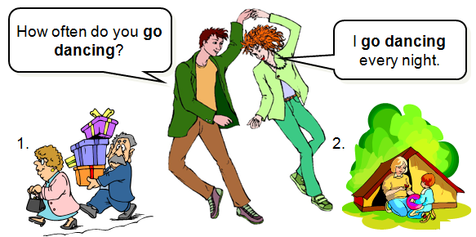

.

Practice 2 : Complete the sentences with gerunds.
Example: a__ _wind surfing__ is very exciting.
- __________ makes me laugh.
- __________ gives me a headache.
- __________ isn’t polite.
- __________ is popular in my country.
- __________ destroys the environment.
- Not __________ can be dangero

1=jacking 2=listening to jazz 3=dancing here الحل هنا
4=playing tennis 5=polluting smoking 6=intereting

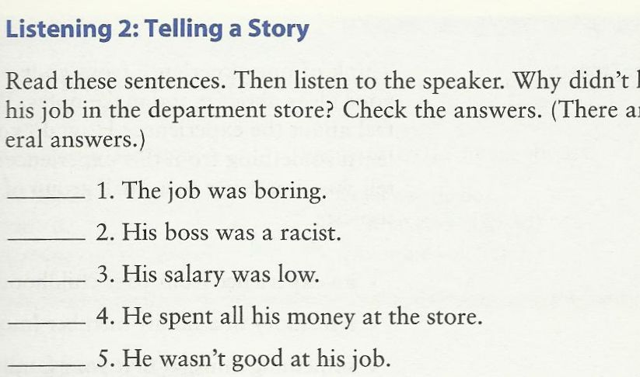
الحل هو رقم 5

‘will’ ‘going to’
- A Why are you turning on the television?
B _____I am going to watch___ the news. (I/watch)
- A Why are you filling that bucket with water?
B __I am going to wash_____ the car. (I/wash)
- A What would you like to eat?
B _I'll have__ a sandwich, please. (I/ have)
- A Hello. Can I speak to Jim, please?
B Just a minute. _I'll get__ him. (I / get)
- A I don’t know how to use this camera.
B It’s easy. _I'll show____ you (I / show)

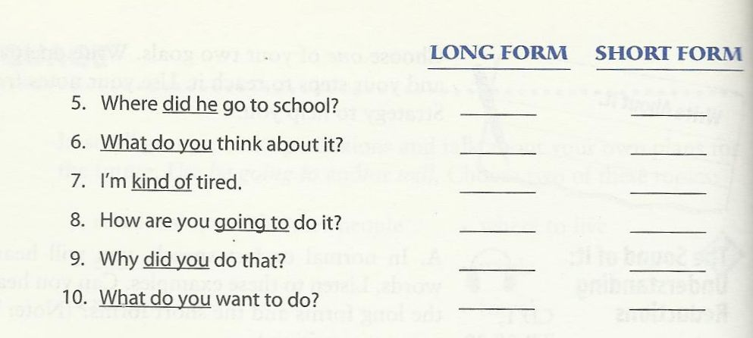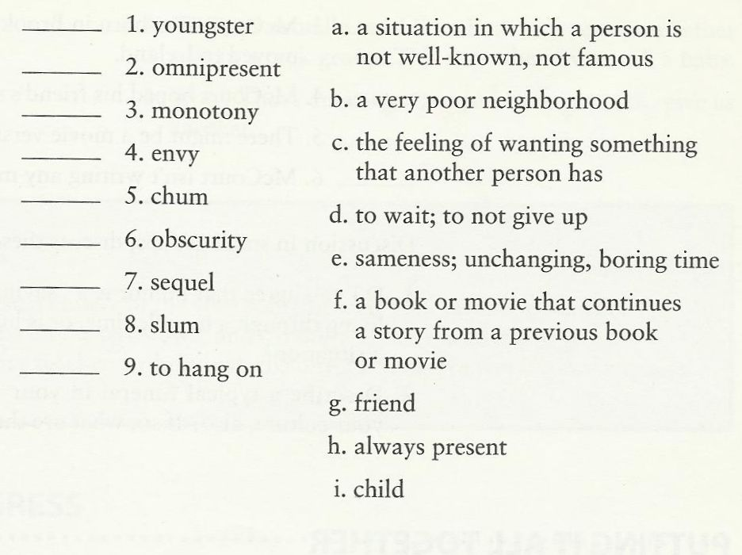

Long form=7-8-9
Short form=1-2-10
حل الكلمات
1=i 2=h 3=e 4=c 5=g 6=a 7=f 8=b 9=d

Fifth lecture exercises

Dialogue:

C. May we see the menu, please?
W. Sure, here it is.
W. Can I take your order?
C. Yes, I'd like a hamburger and a milkshake.
W. How about you?
C. I'd like a ham sandwich.
W. (Would you like) anything to drink?
C. No, thank you. Just water.

الاجابة بتلقونها بالحوار الي فوق

Practice 4: Role Play
Teacher :Can I take your order?
Student :Yes, I'd like __________.
Teacher :Thank you. How about you?
Student :I'd like __________.
Teacher :Would you like anything t drink?
Student :Yes. I'd like __________.

We should wash our hands with liquid soap.
We should prevent disease.
We shouldn't litter.
We should see a doctor promptly if we feel unwell.

Let’s do some exercises

You shouldn,t__________ eat too many sweets. They are not good for you.
You should__________ sleep early.
We should_______ be friendly to our friends.
Lily’s dress is dirty. She _should_________ clean it.
You _shouldn,t________ play on the road.
Your brother is weak in Maths. You _should_____help him.

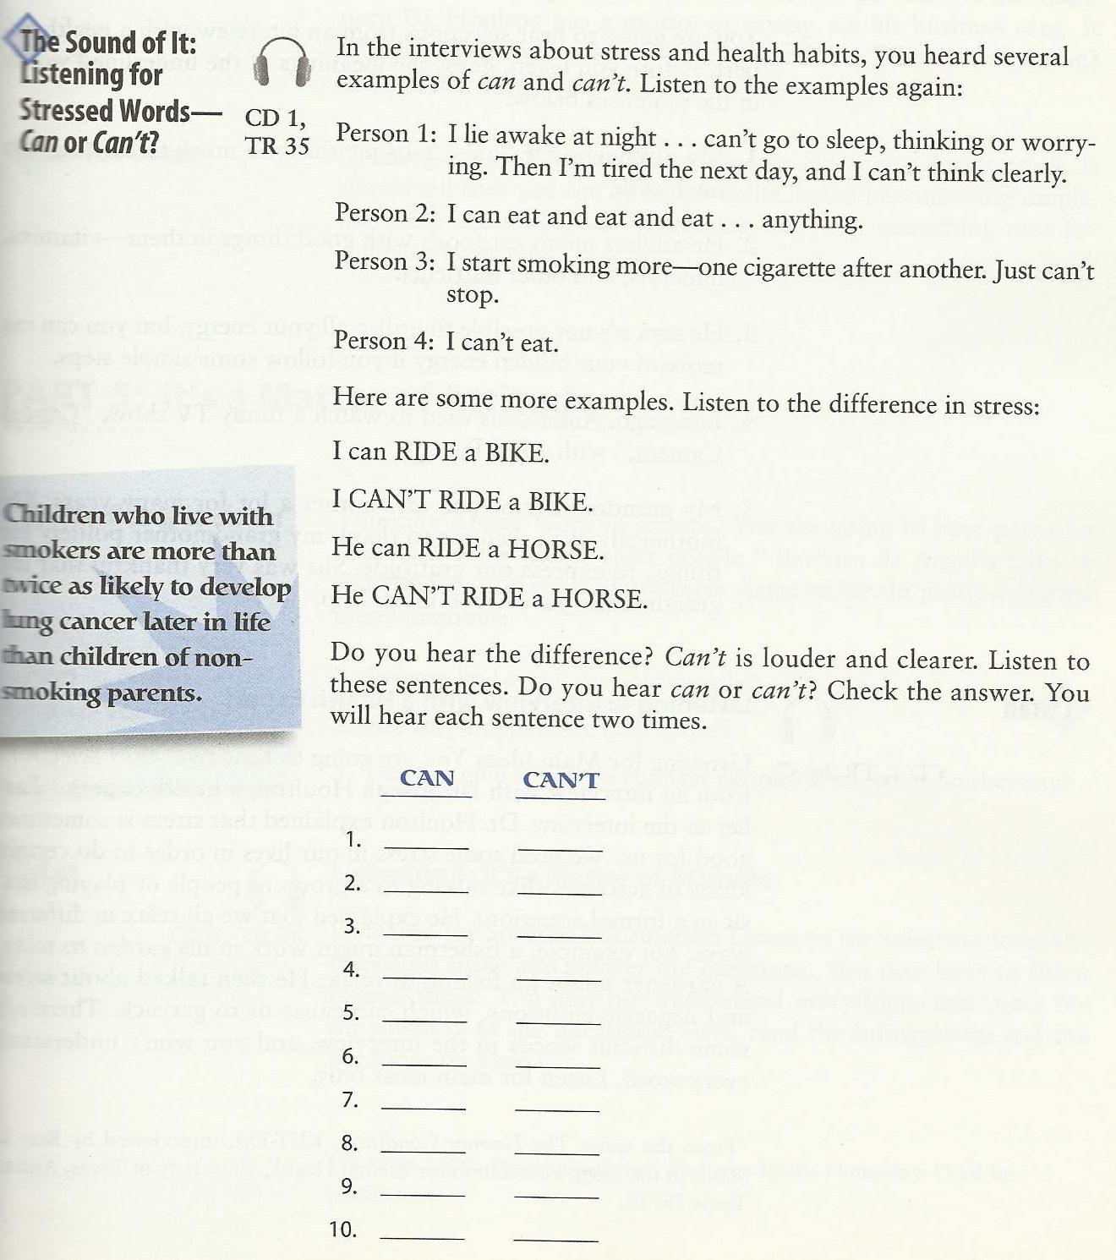

الحل هنا
can=1-3-4-6-8-10
can,t=2-5-7-9

Ninth lecture exercises

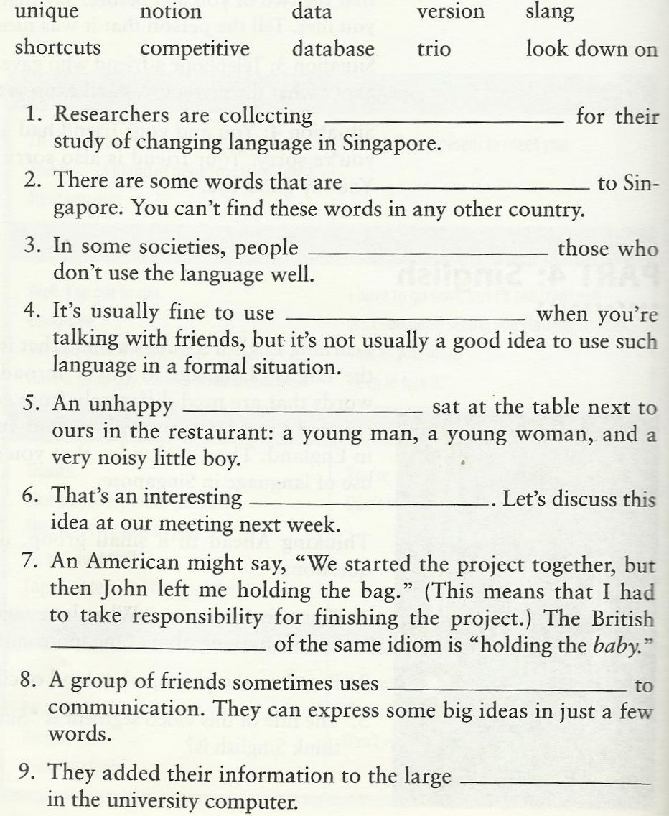
1=data 2=unique 3=look down on 4=slang 5=trio 6=notion
7=version 8=competitive 9=database

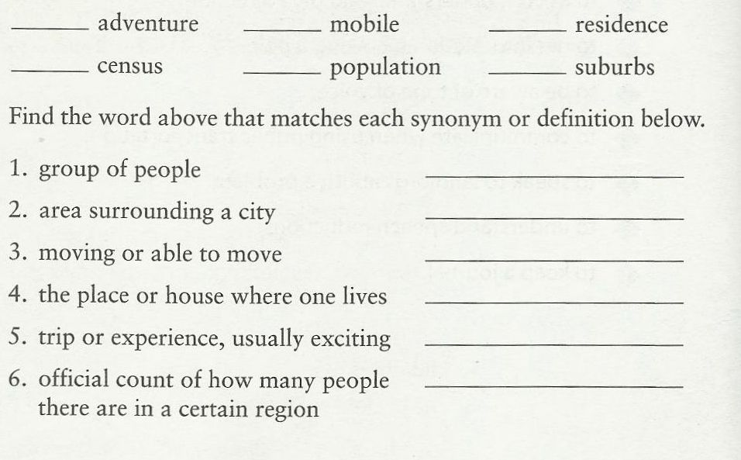
1=population 2=suburbs 3=mobile 4=residence 5=adventure 6=census
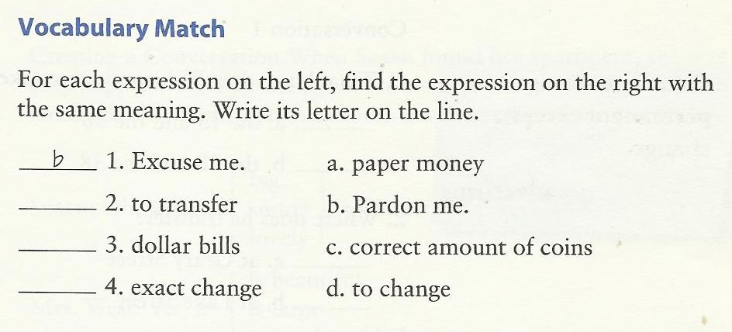

1=b 2=d 3=a 4=c الحل

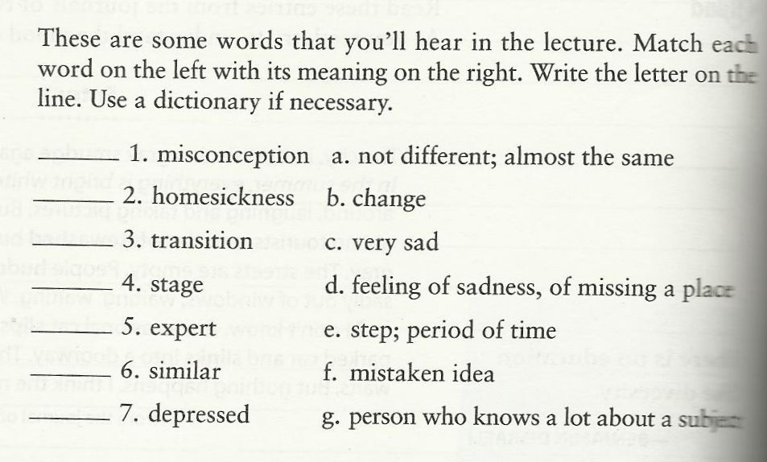
1=f 2=d 3=b 4=e 5=g 6=a 7=c
الحل هنا

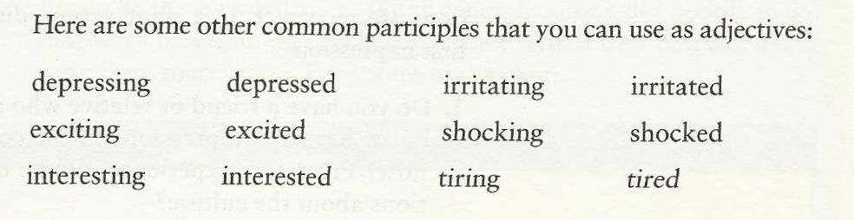

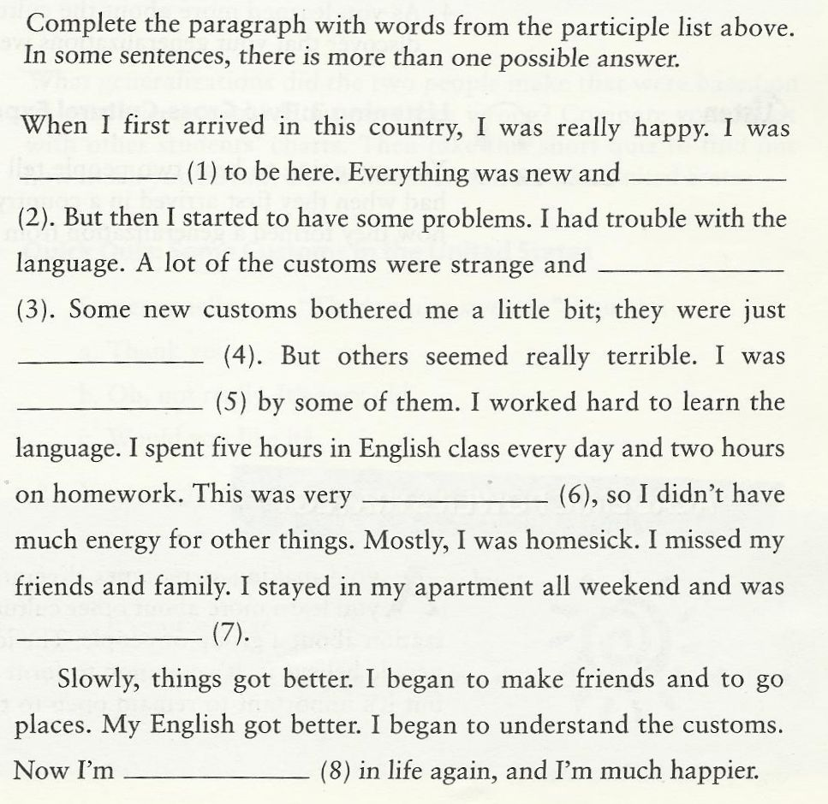

1=excited 2=exciting 3=irritating 4=irritated 5=shocked 6=tiring
7=depressing 8=interested الحل
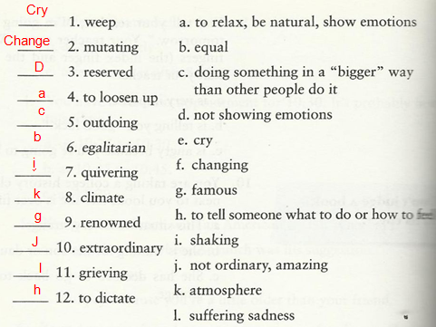

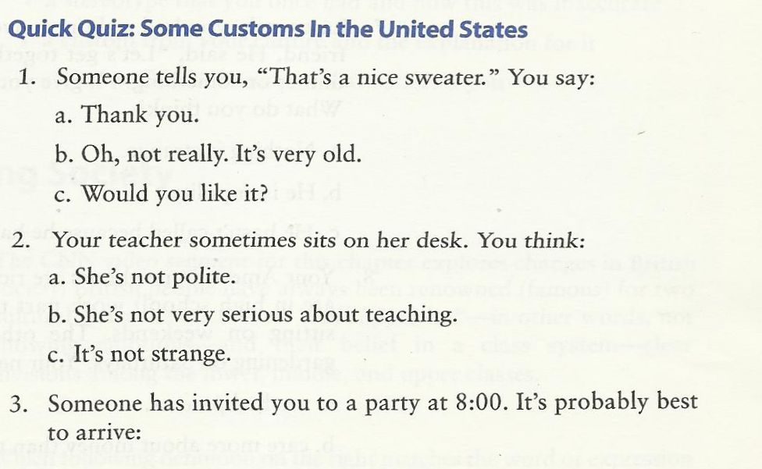
1=a 2=c 3=b
الحل هنا
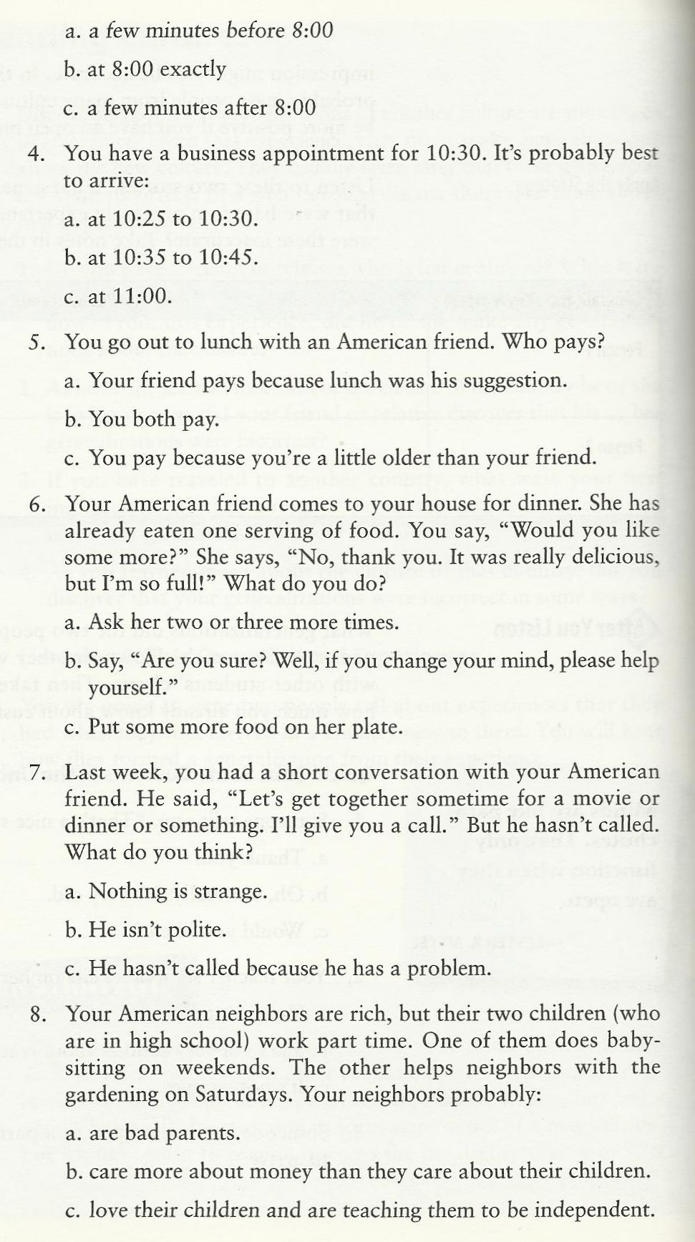
4=a 5=b 6=b 7=c 8=c الحل هنا
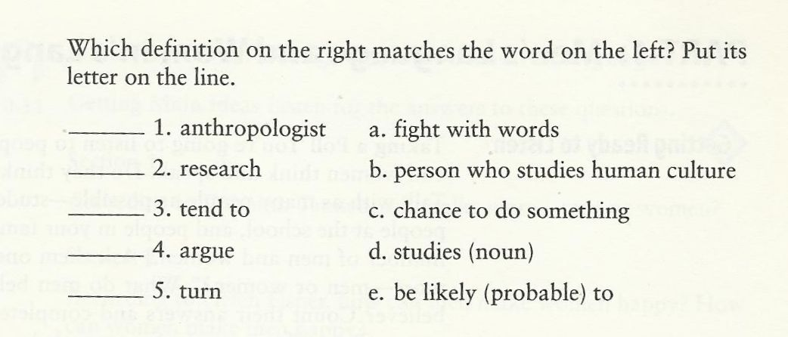

1=b
2=d الحل هنا
3=e
4=a
5=c

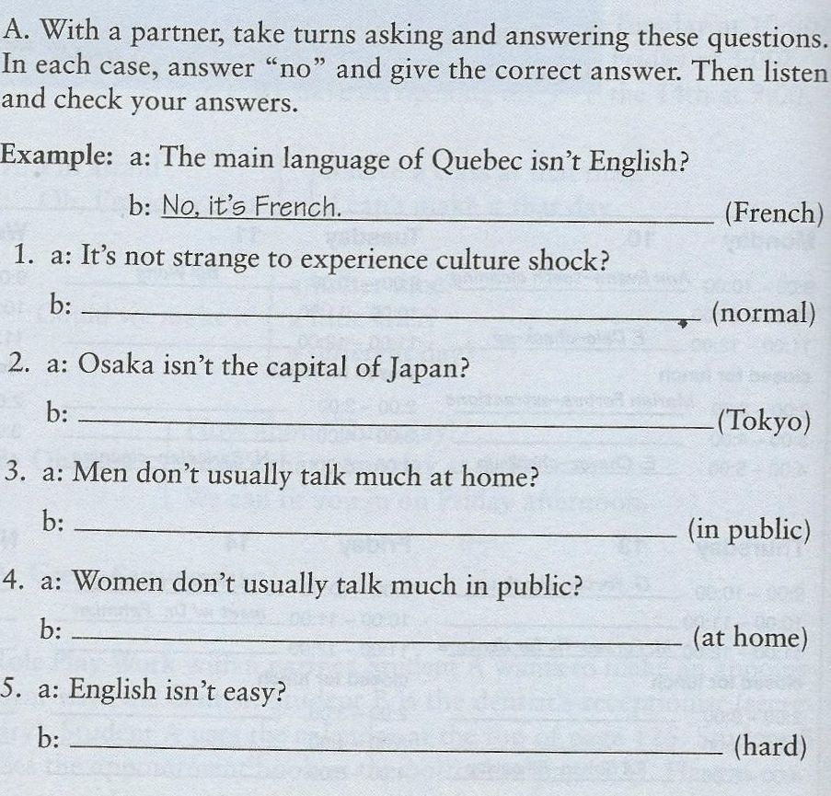

1=No it,s Normal
2=No it,s Tokyo الحل هنا
3=No they talk more in public
4=No they talk more at home
5=No it,s hard

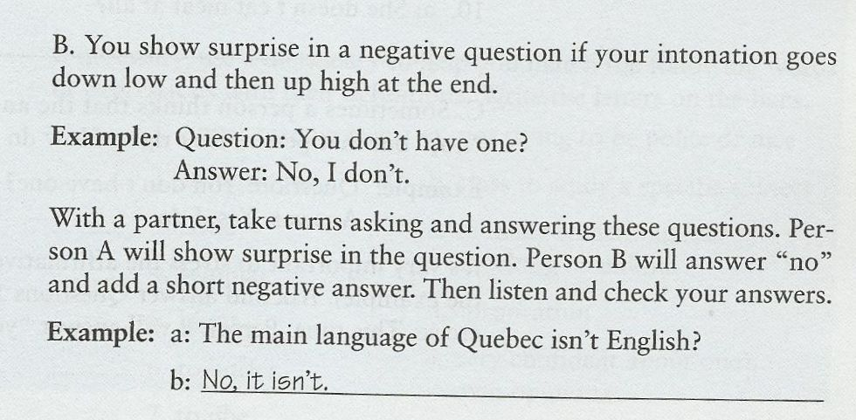
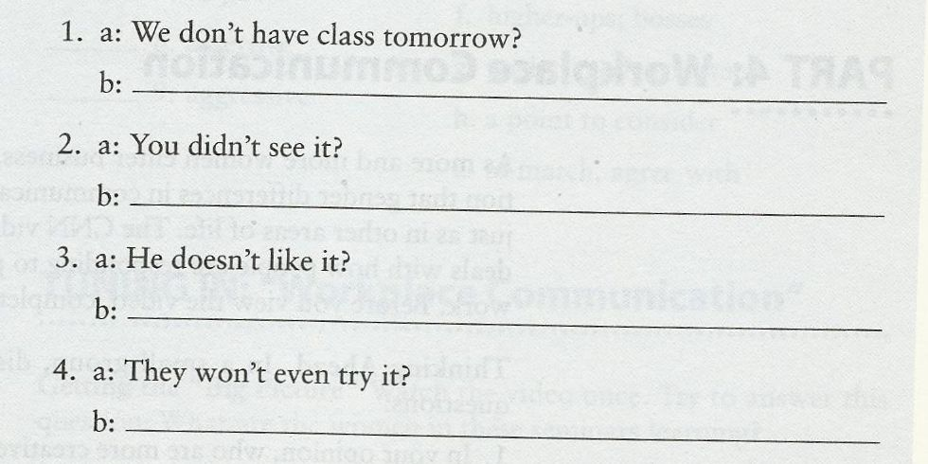

1_No we don,t
2-No I didn,t الحل هنا
3_No he doesn,t
4-No they won,t

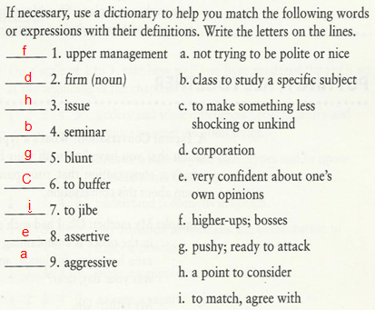

Eleventh lecture exercises`

Do you know common prefixes?

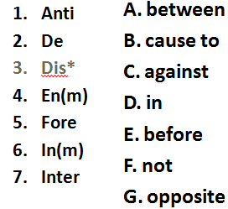

1=c
2=g الحل هنا
3=f
4=b
5=e
6=d
7=a

- Do you know common prefixes?
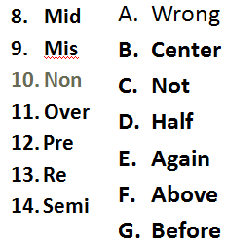

8=b
9=a الحل هنا
10=c
11=f
12=g
13=e
14=d

Do you know common prefixes?
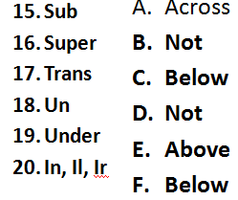

15=c
16=e الحل هنا
17=a
18=b
19=f
20=d

Do you know common suffixes?
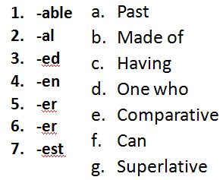

1=f الحل هنا
2=c
3=a
4=b
5=d
6=e
7=g

Do you know common suffixes?
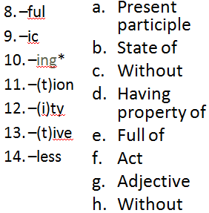

8=e
9=d الحل هنا
10=a
11=f
12=b
13=g
14=h.

Do you know common suffixes?
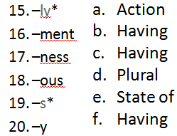

15=b الحل هنا
16=a
17=e
18=c
19=d
20=f

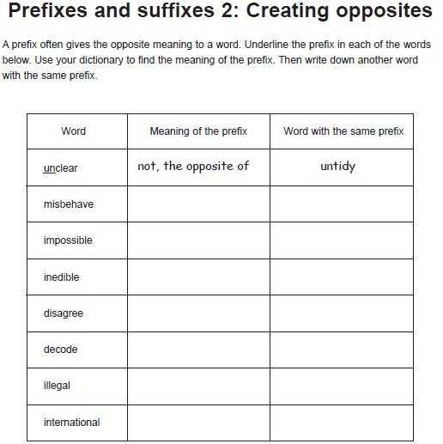

wrongly | mistack
in | implant
in | intake
Not,opposite of | disadvantage
opposite | destroy
not | illiterate
not | injustice
الحل بالجدول
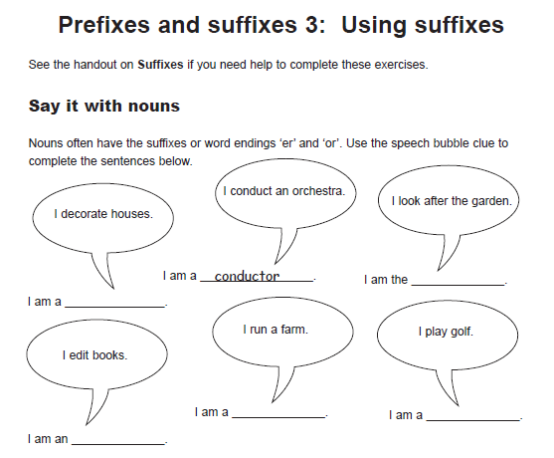
الحل هنا
Decorateor –looker –editor –runner -player
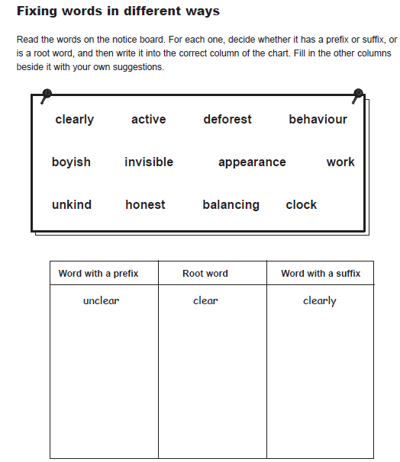
الحل هنا
Prefix=unkind-deforest-behaviour-invisible-
Root word=kind-act-forest-haviour-visible-work-boyish
Suffix=active-clearly
.

Twelve lecture exercises

Let’s Start Exercising
1. The weather in winter is _____________ than it is in summer.
A. colder B. cold
C. coldest D. the coldest
2. I have ___________ money than you do.
A. much B. more
C. most D. least
3. Abdullah is ______________ of all boys.
A. the fastest B. the most fastest
C. fast D. faster

Do More Exercises
- What is the comparative of "sad"?
  - sader
  - sadder
  - sadier
  - saddier
- What is the comparative of "destructive"?
  - destructiver
  - more destructive
  - destructivier
  - more destructiver
- What is the superlative of "soft"?
  - softest
  - softiest
  - softtest
  - most soft
- What is the comparative of "hot"?
  - hoter
  - hotter
  - hotest
  - hottest
- What is the comparative of "heat"?
  - heater
  - heatter
  - heatier
  - hetter
  - none of these
- What is the superlative of "ugly"?
  - uglier
  - uggliest
  - uglyest
  - Ugliest

- What is the superlative of "unpleasant"?
  - unpleasant
  - most unpleasant
  - more unpleasant
  - unpleasantest

10. To fall from a motorcycle is _____ to fall from a bicycle.
- more painful b) more painful than c) painfuller than d) the painfullest

11. If you suffer asthma, don’t go to Mexico City. It is one of the _____ cities in the world
- pollutest b) more polluted c) polluter than d) most polluted

12. The _____ place from Chile is Australia. It’s on the other side of the world.
- farther b) farthest c) farther than d) farthest than

13. I don’t think your bike is _____ mine.
- fastest than b) faster c) fastest d) faster than

14. Michael was _____ basketball player in the world
- taller b) tallest c) the taller d) the tallest

15. Speaking Japanese is _____writing it.
a) the easiest b) easy c) easier than d) easyer than

Write the following sentences using the correct form of the adjective (comparative or superlative)
- Clare is _____________older than_____________________________________ Mike. (old)
- Jane is _most healthy_______ of the four. She eats very well and does a lot of sports, (healthy)
- The coach thinks that Peter is the _fastest_________________ player of the team, (fast)
- The Sahara desert is one of the __hottest_________________deserts in the world. (hot)
- The climate in the North of Chile is ____drier___________________ in the South, (dry)
- Asia is ______________bigger than___________________________________ Europe. (big)
- A Rolls-Royce is one of _____most expensive__________________ cars in the world. (expensive)
- ____the more violent________________________ hurricanes are developed over México, (violent)
- Diamonds are _the most precious_____________________________ jewels in the world. (precious)
- History classes are __more interesting_______________________ chemistry classes. (interesting)

