Immunization should be started when a child
is :
a.one week
b.one mont
c. two months
d. sex mont
The first priority when dealing with patient in a cute stage of MI is :
a. oxygen administration
b. morphine administration
c. rest
d. nitroglycerin sublingual
.The artery which supply the myocardial muscle with oxygen called:
a.carotid
b.anterior vena cava
c.pulmonary artery
d.coronary arteries
. The most vital immediate observation to a new born baby is :-
A. Cardiac rate
B. Respiration rate
C.Dizziness
D.Color
. Preparing patient for sigmoidscopy you should :
a. give pt enema in the morning
b. keep pt NPO24 hours
c. administer oxygen
d.suction mouth
the most method used for sterilizing hospital equipment to b
free of spores and bacteria is :-

A. applying steam under pressure in an autoclave
B. washing and drying it thoroughly after use
C. Send the container
D. Send them to the container, yellow
Hepatitis A is transmitted by :
a. blood
b. skin
c. feces
d. urine
Pt with respiratory rate 4 b/ min developed to cessation of respiration this case called :
a. cardiac arrest
b. respiratory arrest
c. pulmonary embolism
d. tachypnea
Pt with respiratory rate 4 b/ min developed to cessation of respiration this case called :
a. cardiac arrest
b. respiratory arrest
c. pulmonary embolism
d. tachypnea
Normal pulse pressure is :
a. 20
b. 40/70
c. 60/ 100
d. 160/80
test for tuberculosis ( Tb) :
a. acid fast bacillus
b. CBC
c urine analysis
d. chest x-rays
Position for asthmatic pt ( pt with asthma ) for adult and child ?
A) Semi fowler
b) prone position
c) standing position
d) supine
8.Position used when administering general anaesthesia
A) sitting position or lateral position (lying on the side).
b) prone position
c) standing position
d) supine positions
35)You encourage movement for a pt with pelvic fracture …
a)to prevent lung embolism
b)to prevent paralysis
c) to prevent apnoea
42)While blood transfusion , pt’s temperature elevated , what will you do? ….
ee) Stop transfusion and inform doctor
ff) Continuous transfusion and inform doctor
gg) Check pt’s temperature every 1 hours
hh) Check pt’s pulse
75)The nursing intervention For a baby with diarrhoea you should:
a)check intake and output for the baby .
b) check vital signs
c) lab test
77)Pt’s with varicose vein is high risk(complication) for: ….. a)Hypovolemic shock .
b) anaemia
c) cancer
Nursing care for caesarean lady
a)Ambulation
b) rest
c) heavy meals
118)Cleft lip operation done at………:
a)3 months …….of age
b)2 years ………of age
132)Signs of digoxin toxicity in child .
rrr) sinus bradycardia
sss) sinus tachycardia
uuu) all of them
A 30 years old female with chocking
a)Abdominal thrust نضغط ع بطنها
b) prone position with back blows …
c) finger sweep
146) How to prevent needle puncture :…
a)keep the needle down and discard in the yellow container
b)keep the needle upward .
c) recap the needle then discard in the yellow container
d)broken the needle
146) The first nursing intervention for a burned pt is ……
a) fluid replacement , the IV of choice is lactated ringer .
b) blood transfusion
c) normal saline
d) all of them
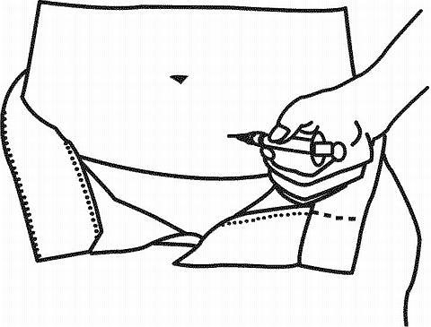
a) SC
b) IM
c) IV
d) ID
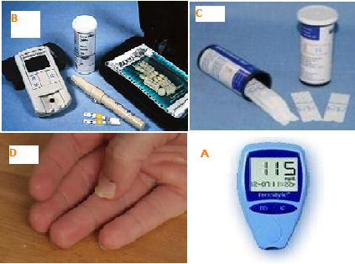
رتب الصوور
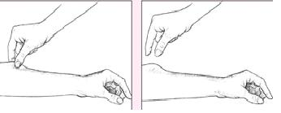
evaluation of Skin turgor

149. What is the normal weight of the new born according to statistics ?
A. 3700 gms
B. 3200 gms.
C. 2500 gms
D. 4500 gms

150. when the head of the baby is already out in a cervix , the nurse should do which of the following first ?
A. ask the mother to push more
B. check if the baby is breathing
C. wait for the baby to come out

151. FHR is heard clearly on fetal :-
A. head
B. back
C. abdomen

152. soon after the delivery of head of the baby the nurse should :-
A. suction mouth and oral cavity
B. wait for the delivery of the baby
C. ask her to push

153. the fetus will get immunity from :-
A. lymph system
B. Placenta
C. Both of them
D. Non of them

154. diet and nutritional status of pregnancy should be encouraged :-
A. first trimester
B. second trimester
C. third trimester

155.when the bag of water ruptures , the nurse should watch for which of the following :-
A. cord prolapse
B. bleeding
C. fetal death
D. fetal distress
E. respiratory distress

156. during labor a mother experienced dystocia , which of the following should the nurse watch out for ?
A. fetal death
B. hemorrhage
C. cord prolapse
D. Hypertention

157. which are the signs of placenta separation ?
A. rising of the fundus
B. sudden gush of blood
C. globular shape of the uterus
D. all of the above

158. during hyperthermia which of the following should be done as measure to lower the temp. of the baby ?
A. immerse baby in normal heat water
B. give cold enema
C. external cooling measures
D. all of the above

159. premature labor occurs during :-
A. between 20-36 weeks
B. between 36-42 weeks
C. before 20 weeks
D. first 12 weeks

160. which of the following hormones prepares the uterus for the arrival of a fertilized ovum for implantation ?
A. progesterone
B. estrogen
C. FHS
D. NON OF THE ABOVE

2-
Which one of the following is important indicator for shock:
Tachycardia
3-
immediately after gastrointestinal endoscopy what should the nurse evaluate beside his vital signs:
Return of gags reflex
4-
which of the following precautions is not essential to care of client with hepatitis A:
Assigning the client to private room
5-
which of the following postoperative complications would the nurse anticipate in a client undergoing a pelvic surgery:
Thrombophlebitise
6-
which of the following symptoms would the n
urse most likely note if the client develops fat embolism:
Numbness in the legs
7-
جاتني صوره جهازه العين
8- صوره ايد ويقول ايش فيها وكان فيها بهاق
9- صوره IM
10- صوره SC
11- صوره ويش نوع الفحص وكان الاجزاء المكشوفه البطن والراس و الايد
12-12 hours after delivery the fundus is at the level of
. one fingerbreadth
below the umbilicus .
13-
Common cause of death in burns :-
. Hypovolemic shock
14-Immunization should be started when child is :-
A. 6 months
B. 2 months
C. 1 months
D. 1 week
15-
. which of the following is an appropriate diet for a patient with congestive heart failure :-
A. low-calorie , high-residue diet with no caffeine
B. low-calorie , low- residue diet with low Na
C. high-calorie , low-fat , low-protein diet
D. high –protein , no fat , no carbohydrate diet
16-
The antidote of heparin is :
a. protamine sulfate
b. vitamin k
c. Morphine
d. Atropine
17-
A pt brought to ER with heart rate is 49 b/min ,respiratory rate is 8 b/min, terms that
represents these vital signs are :
a. bradycardia , bradypnea
b. tachycardia , tachypnea
c. tachycardia , bradypnea
d.bradypnea , tachypnea
18-
The types of hepatitis to which there are vaccines are
hepatitis A and B
.
b) hepatitis c
c) hepatitis d

