Different theories of learning: Toward improved teaching methods of English language at the English language department - the college of Arts and science in Almandaq in ALBAHA University

Student Name: Alalloush
Student Number:

Abstract:
This research will examine different theories of how people learn. In order to improve teaching skills of English language it is vital to study theories of learning and how people learn. The research will analytically investigate two main theories of how people learn and they are; Reinforcement theory and Sensory Stimulation theory. However in order to link those theories to English students experience themselves, questionnaire will be conducted and the best practice will be identified.
Introduction:
Sensory stimulation theory is based on that people best learn when senses are stimulated (Laird, 1985). Laird found that majority of learning occurred through sense, namely seeing (75%), hearing (13%) and smelling, touching and tasting (12%). However Reinforcement theory was developed by Burrhus Frederic who believed that positive reinforcement, whether verbal such as “well done” or more tangible such as certificate or promotion in an organisation will improve people learning. Nevertheless Burrhus Frederic found that negative reinforcement such as punishment will also improve people learning.
Literature review:
1- Sensory stimulation theory
Sensory stimulation theory of learning state that learning take place when people senses are stimulated and those senses are: Seeing, hearing, touching, and smelling. Thus on one hand researchers have found that some individuals may prefer to learn using visual aids and therefore great variety of “vision materials” should be used, as well as facts and variety of colours should be visually presented. While on the other hand some individuals may prefer to learn using listening therefore, audio should be included in the learning process. However greater learning takes place when multi senses are stimulated (Laird, 1985). Nevertheless because majority of learning occurs through sense of seeing and hearing (88%) and for the purpose of the research only sense of hearing and seeing will be examined.

2- Reinforcement theory
Reinforcement theory, also known as motivation theory, was developed by B.F. Skinner. The theory explains human bean behaviour and why they do what they do. Psychologists commonly assumed that human evaluate effect of their behaviour, and do more with pleasant results and do less of those with unpleasant results. According to Edward Lee Thorndike (1931) “responses that produce a satisfying effect in a particular situation become more likely to occur again in that situation, and responses that produce a discomforting effect become less likely to occur again in that situation.”
According to Huitt and Hummel (1997) reinforcement theory consists of four methods, positive reinforcement, negative reinforcement, positive punishment and negative punishment.
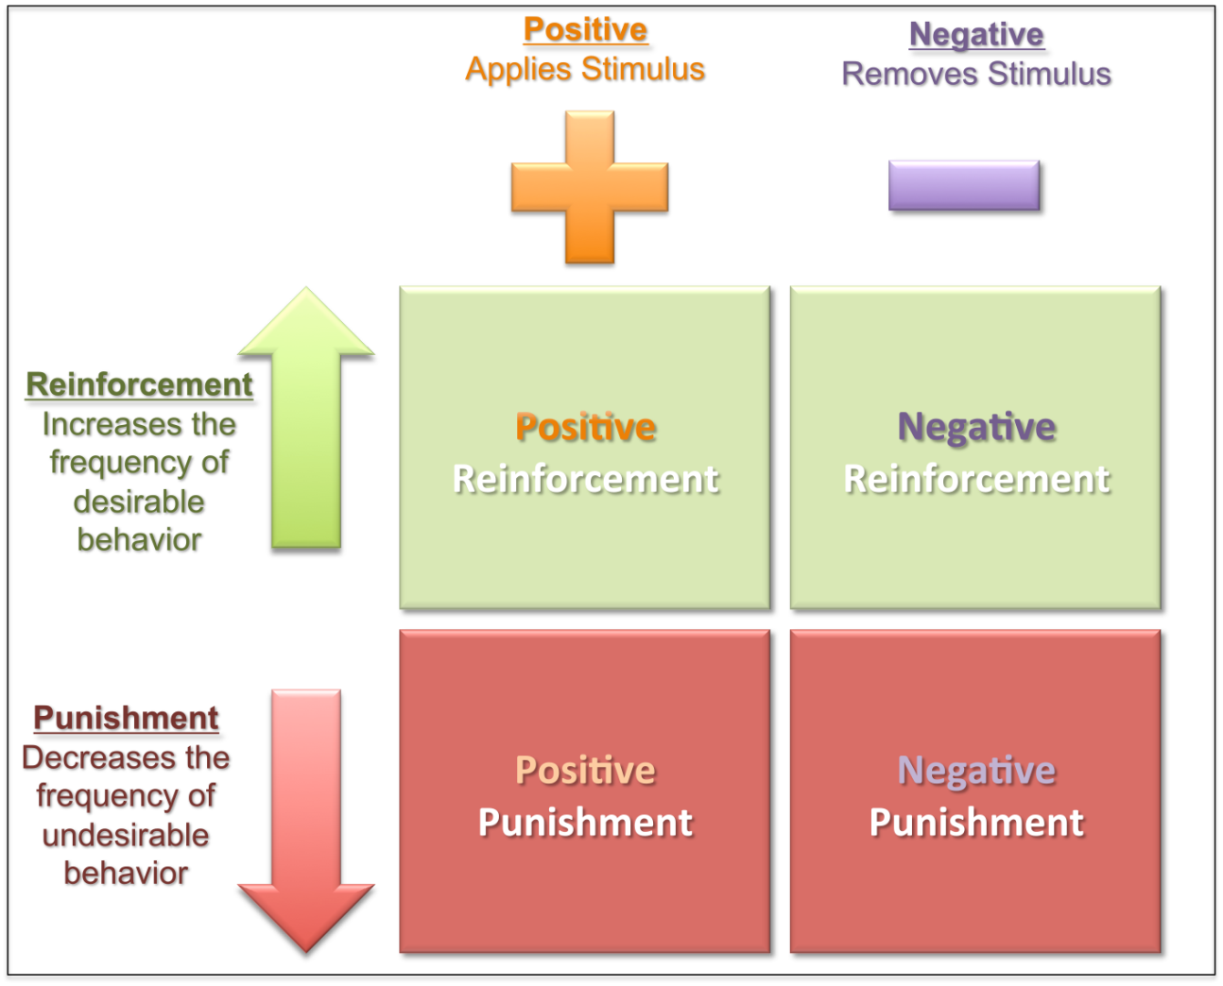
Table created by Huitt & Hummel (1997).

Those four methods will be examined by this study. However in order to achieve desired results of the study, the theory will be tested through student’s preferred learning process (behaviour) at Albaha University.
2.1 Positive Reinforcement:
Positive reinforcement helps to stimulate and encourage beneficial behaviour by using reward system (Taylor, 2008). Thus positive reinforcement will improve students learning. As an example, student who pays attention in class, study hard and does his homework and could be positively reinforced by gaining excellent grades. In addition students could be verbally reinforced using word such as “well done” or "Excellent work" as well as giving them tangible praise such as certificate (Duboc, 2006).
2.2 Negative Reinforcement:
Negative Reinforcement occurs when students are rewarded by removing something unpleasant. Student who knows that he will get low marks at university for having to many absences will attempt to avoid unpleasant stimulus by making sure not to perform these actions (Duboc, 2006).
2.3 Positive Punishment:
"Punishment creates a set of conditions which are designed to eliminate behaviour" (Burns, 1995). Positive Punishment gives individuals what they do dislike when they have performed undesired behaviour (Griggs, 2009). However positive punishment has some shortness as it fails to teach wanted behaviour as well as it could produce undesirable emotional reactions like fear or hostility. It should be noted that reinforcement is not same as positive punishment and they “differ in the increase (negative reinforcement) or decrease (punishment) of the future probability of a response”, (Paul 2003).
2.4 Negative Punishment:
Negative punishment is about removals of what individuals like when they perform undesired behaviour (Griggs, 2009). As an example of negative punishment could be a student who disrupts his fellow colleagues by constantly chatting in a class. His fellow colleagues usually respond to him in a polite manner, which is pleasing stimulus. However his teacher informs him that, if he continues to be disruptive, he may not get a passing mark for a subject (Redmond, 2013).

3. Research questions:
1- What motivate students to learn English language at Albaha University?
2- What methods students uses at Albaha University to learn English language?
3- What are the most effective methods for teaching English language?
4. Methodology:
In order to understand how people learn and what is the most effective method to teach English language primary and secondary data will be gathered. Therefore the researcher will analytically investigate Sensory stimulation theory and Reinforcement theory from academic and trusted books and websites. In addition quantitative research techniques (questionnaire) will be used to gather secondary data and for that reason simple and relevant questionnaire will be developed.
5. Significance:
Teaching is a two way process, thus it is vital to understand how people learn English language in order to be able to improve teaching of English language.
6. Objectives of study:
- To collect data from academic books and websites.
- To analytical study Sensory stimulation theory and Reinforcement theory.
- To conduct a questionnaire with many students studying English language as possible in order to find the way they best learn.
- To compare and analyse primary data collected with the secondary data collected from by questionnaire.
- To understand what motivate student to learn English language at Albaha University
- To define the most effective method to teach English language.
7. Limitation:
Limited time available acted as a barrier for investigating the topic more deeply. However the answers can be considered as a valid and reliable as they are derived from the students themselves past experience.
8. Results:
Students at Albaha University are motivated to study English language by different methods. The study founded that the students are motivated to learn English when they are encouraged by their teachers and families (positive reinforcement), and by tangible praise such as excellent grades. In addition the study has founded that the students prefer to learn English by watching videos materials (movies) and by translating various texts, which include sense of seeing and hearing. Therefore the most effective methods for teaching English language are: Encouraging students to watch interesting video materials as well as translating different texts.
9. Conclusions:
The best approach for learning English language is by watching videos materials and translating. However students are mostly motivated to learn English when they are encouraged by their teachers and families and when students get excellent grades.
10. Recommendations:
In order to improve teaching of English language, the two theorise must be scrutinized by educators and placed into practice.

Bibliography:
Addiction Intervention (2013) Both Positive and Negative Reinforcements Can Create Behavior Changes. Available at: http://www.addiction-intervention.com/current-events/addiction-news/both-positive-and-negative-reinforcements-can-create-behavior-changes [Accessed on 25 Mart 2014]
Banaji, M. (2011). Reinforcement theory. Harvard gazette. Retrieved from http://news.harvard.edu/gazette/story/multimedia/reinforcement-theory/ [Accessed on 25 Mart 2014]
Bowman, R. (2004). Teachers as leaders. The Clearing House, 77(5), 187-189.
Chance, Paul. (2003) Learning and Behavior. 5th edition Toronto: Thomson-Wadsworth.
Duboc, B. (2006). The brain from top to bottom: From the simple to the complex (online). Ottawa, Canada: Canadian Institutes of Health Research. Available from: http://thebrain.mcgill.ca/index.php [Accessed on 25 Mart 2014]
Huitt, W., Hummel, J., & Kaeck, D. (2001).Assessment, measurement, evaluation, and research. Educational Psychology Interactive . Valdosta, GA: Valdos ta State University. Available from: http://www.edpsycinteractive.org/topics/intro/sciknow.html
[Accessed on 19 Mart 2014]

Redmond, F. (2013) Reinforcement Theory [online]. Available at: https://wikispaces.psu.edu/display/PSYCH484/3.+Reinforcement+Theory [Accessed on 25 Mart 2014]
Taylor, J. (2008). My stoke of insight (online video). Available from: http://www.ted.com/index.php/talks/view/id/229 [Accessed on 17 Mart 2014]

Questionnaire:
- What of the following encourage you to study English language?
- If yes, please rate:

Your family encouragement
Not important | Average | Very important
1 | 2 | 3

Your educators encouragement
Not important | Average | Very important
1 | 2 | 3

Gaining certificate
Not important | Average | Very important
1 | 2 | 3

Monetary reward
Not important | Average | Very important
1 | 2 | 3

Words such as “Well done”, “Excellent”
Not important | Average | Very important
1 | 2 | 3

Punishment
Not important | Average | Very important
1 | 2 | 3

Excellent grades
Not important | Average | Very important
1 | 2 | 3

2- From your past experience, which method of the following helps you mostly to study English language?
- If yes, please rate:

Watching video material, please specify …………………………
Not important | Average | Very important
1 | 2 | 3

Listening to music
Not important | Average | Very important
1 | 2 | 3

Translating different materials, please specify ………………….
Not important | Average | Very important
1 | 2 | 3

Reading
Not important | Average | Very important
1 | 2 | 3

Writing
Not important | Average | Very important
1 | 2 | 3

Thank you for your time.

