Oedipus Rex
Oedipus the King, also known by the Latin title Oedipus Rex, is an Athenian tragedy by Sophocles that was first performed c. 429 BC.[ Oedipus Rex chronicles the story of Oedipus, a man who becomes the king of Thebes while in the process unwittingly fulfilling a prophecy that he would murder his father Laius and marry his mother Jocasta. The play is an example of a classic tragedy, noticeably containing an emphasis on how Oedipus's own faults contribute to the tragic hero's downfall, as opposed to having fate be the sole cause. Over the centuries, Oedipus Rex has come to be regarded by many as the Greek tragedy par excellence.

In Oedipus the King, Oedipus is the protagonist. Oedipus' infanticide is planned by his parents, Laius and Jocasta, to avert him fulfilling a prophecy; in truth, the servant entrusted with the infanticide passes the infant on through a series of intermediaries to a childless couple, who adopt him not knowing his history. Oedipus eventually learns of the Delphic Oracle's prophecy of him, that he would kill his father and marry his mother; Oedipus attempts to flee his fate without harming his parents (at this point, he does not know that he is adopted). Oedipus meets a man at a crossroads accompanied by servants; Oedipus and the man fought, and Oedipus killed the man. (This man was his father, Laius, not that anyone apart from the gods knew this at the time). He becomes the ruler of Thebes after solving the riddle of the sphinx and in the process, marries the widowed Queen, his mother Jocasta. Thus the stage is set for horror. When the truth comes out, following from another true but confusing prophecy from Delphi, Jocasta commits suicide, Oedipus blinds himself and leaves Thebes, and the children are left to sort out the consequences themselves (which provides the grounds for the later parts of the cycle of plays)

Wisdom and Knowledge
In Oedipus the King, Oedipus is a seeker of knowledge and truth. He struggles to uncover Laius’s murder and his own identity, despite numerous warnings that he should leave the truth alone. His pursuit of knowledge and truth, however, results in ruin as Oedipus uncovers his destiny, which he was better off not knowing. This suggests that knowledge is futile and limited in its ability to bring happiness to those who seek it.

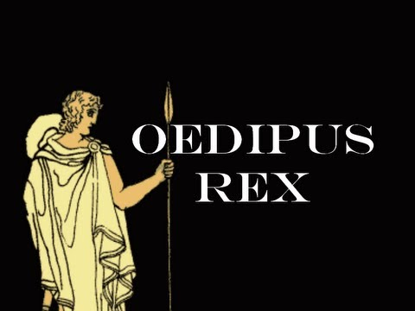

Plot Summary
King Oedipus, aware that a terrible curse has befallen Thebes, sends his brother-in-law, Creon, to seek the advice of Apollo. Creon informs Oedipus that the curse will be lifted if the murderer of Laius, the former king, is found and prosecuted. Laius was murdered many years ago at a crossroads.
Oedipus dedicates himself to the discovery and prosecution of Laius’s murderer. Oedipus subjects a series of unwilling citizens to questioning, including a blind prophet. Teiresias, the blind prophet, informs Oedipus that Oedipus himself killed Laius. This news really bothers Oedipus, but his wife Jocasta tells him not to believe in prophets—they've been wrong before. As an example, she tells Oedipus about how she and King Laius had a son who was prophesied to kill Laius and sleep with her. Well, she and Laius had the child killed, so obviously that prophecy didn't come true, right?
Jocasta's story doesn't comfort Oedipus. As a child, an old man told Oedipus that he was adopted, and that he would eventually kill his biological father and sleep with his biological mother. Not to mention, Oedipus once killed a man at a crossroads, which sounds a lot like the way Laius died.
Jocasta urges Oedipus not to look into the past any further, but he stubbornly ignores her. Oedipus goes on to question a messenger and a shepherd, both of whom have information about how Oedipus was abandoned as an infant and adopted by a new family. In a moment of insight, Jocasta realizes that she is Oedipus’s mother and that Laius was his father. Horrified at what has happened, she kills herself. Shortly thereafter, Oedipus, too, realizes that he was Laius’s murder and that he’s been married to (and having children with) his mother. In horror and despair, he gouges his eyes out and is exiled from Thebes.
نوره عبدالله الرحيّم
الخميس 8

