H.w 1
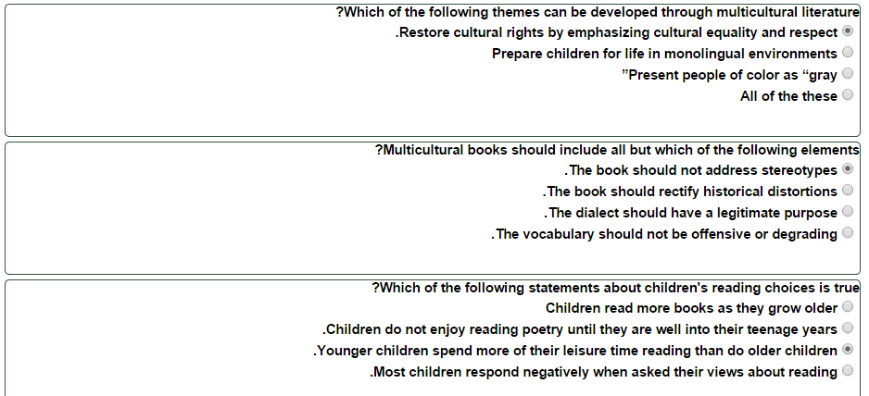

H.W 2

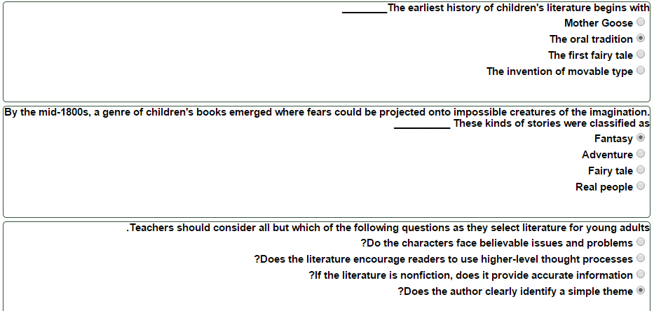

H.w 3

1- Researchers who investigated children's preferences in poetry concluded that_________.
Children enjoy poems about familiar experiences
2- The repetition of vowel sounds by a poet to create interesting and unusual sound patterns is called ___________.
Assonance
3- Which of the following primary elements in poetry encourages children to see, hear, feel, taste, smell, and touch the worlds created by poets?
Imagery
4- Which of the following poets is usually NOT considered a children's poet?
. Langston Hughes

