
Homework 1
refers to the ability of its holders to force obedience of other people to their will.
Power
According to The Sapir-Whorf hypothesis, there is an causative link between ….….
culture and language
Artificial intelligence is the study of how to make computers
more sophisticated
Homework 2
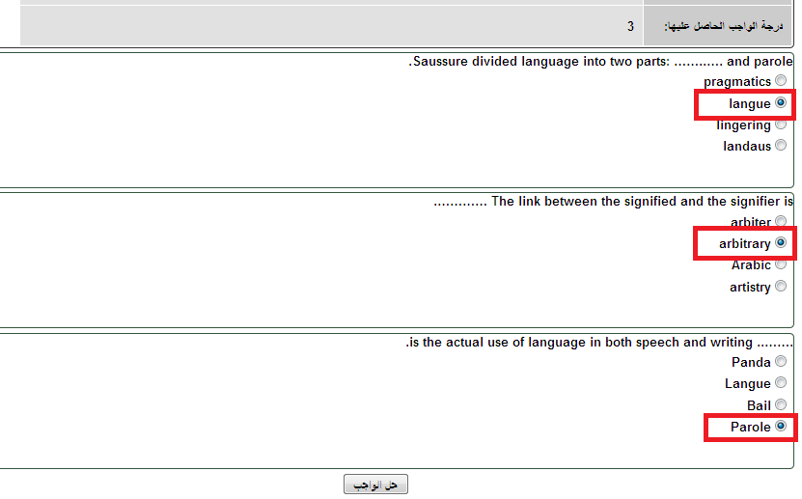
Homework 3
language is usually used in poetry not in science.
Aesthetic
is concerned with power: the power to make decisions, to control resources, to control other people’s behavior and values.
Politics
Physical coercion is associated with
dictatorial regimes
The Media can represent a powerful source in society because it
all the above

