Lecture Four
Grammar – Vocabulary - Reading
Chapter Three

Elements of the Lecture
1- Do / Did / Done
2- Prepositions with Time ( at – on – in )
3-Vocabulary Previewing
4-Reading
A. Word & Pronoun reference
B. Scanning & Skimming

1. Do- Does- Did- Done- doing
They are used as helping verbs in order to form Questions & Negative OR used as
main verbs.
- I, We, They, You or any plural subjects + do ( Present )
- He, She, It or any singular subjects+ does ( present)
did - Plural OR singular subjects+
- After (has, have, had) + done
- After ( is, am, are, was, were) + doing ( active progressive)
________________________________________________________________
e.g:- - We do the homework every week
- She does the homework every week
- The students did the homework last week
- They are doing the homework now/ at the moment
- Salma has done the homework.
1. Exercise================================
1. Sultan __________ his best to get full mark in the last homework.
a. do b. does c. did d. done
2. Fatin has _________ the homework perfectly.
a. done b. did c. do d. does
3. You will _______ me favor if you tell me the answer
a. doing b. do c. doing d. did
4. He always __________ the right thing.
a. do b. doing c. does d. done
5. The students are _________ the exercises now.
a. do b. doing c. done d. did
6. _______________ the homework yesterday?

a. Have you do b. Can you doing c. Do you d. Did you do

2.Prepositions with time ( at- on – in)
At = used before o’clock / night
On =before days / following morning
In = before years and months/ morning/ evening / seasons
======================================================================

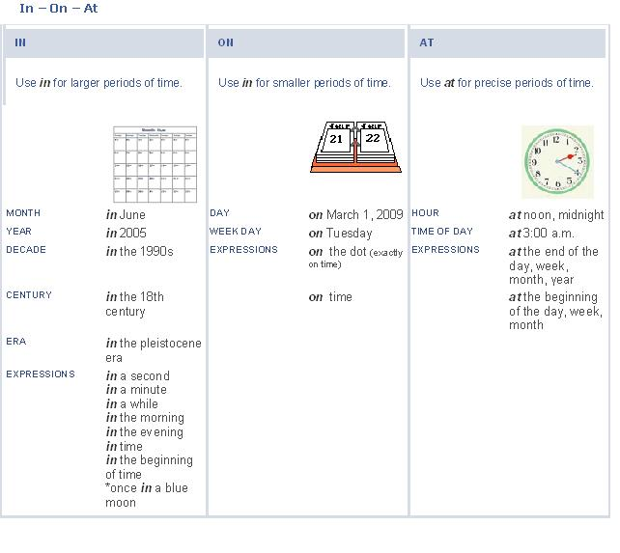

Exercise:
1. He goes to work____________ seven o’clock
a. in b. on c. at d. for
2. She was born_______ October.
a. at b. in c. on d. with
3. The weather is hot______ summer.
a. in b. on c. At d. From
4. Students don’t go to university_______ Friday.
a. in b. At c. Over d. on

3.Vocabulary Previewing

Meaning | Word | No.
A place to park your car | garage | 1
People who buy | customers | 2
Money you earn in business / interest | profit | 3
Buy | purchase | 4
Select | choose | 5
Look for | search | 6
A specialist in food | gourmet | 7
Separated from others/ nobody with you | alone | 8
Classifications | categories | 9
Opposite of difficult | easy | 10
Exercise

1. Where is the car? It’s in the___________
A. library B. bog
C. garage D. kitchen
2. If you didn’t find the book, you can look for it in the other room. the underlined
word look for means:
A. buy B. search
C. read D. eat
3. English language is_________________. It is not difficult.
A. beautiful C. boring
C. safe D. easy

Exercise
4. The word “ classifications’ means ________________ .
A. entertainments B. eatables
C. categories D. customers
5. The word “gourmet means__________________.
A. a policeman B. Food specialist
C. mechanic D. who works at hospital
6. “separated from others” . The underlined phrase means:
A. happy C. sick
C. alone D. busy

4. Reading :
A. Word & Pronoun Reference
Ahmed and his sister are from Riyadh. They study English at university. She is older than him. He speaks English better than her. They always go there by bus. It is a very suitable place for practicing English. They always speak English with each other to improve their language.
1. She refers to : ___________
2. him refers to : ___________
3. They refers to: __________
4. There refers to : __________
5. He refers to:_____________
6. It refers to: ______________
7. Their refers to:____________

B. Scanning & Skimming
8. Where are Ahmed and his sister from? They’re from __________.
A. university B. Riyadh
C. English D. the bus
9. Who is better in English? _______________
A. Ahmed’s sister B. English language
C. Ahmed D. English
10. How do they go to university? _______________________
A. On foot B. In a taxi
C. By plane D. By bus

