King Faisal University
College of Arts
English Language Department

Course: Graduation project

Learning English Language by Distance Learning, Problems and Solution

By:
Sara Mahmoud Lotfi
ID – 211564293
Date of submission: 8 / May /2014
Dr.Bassam Saideen
King Faisal University
2013 / 2014

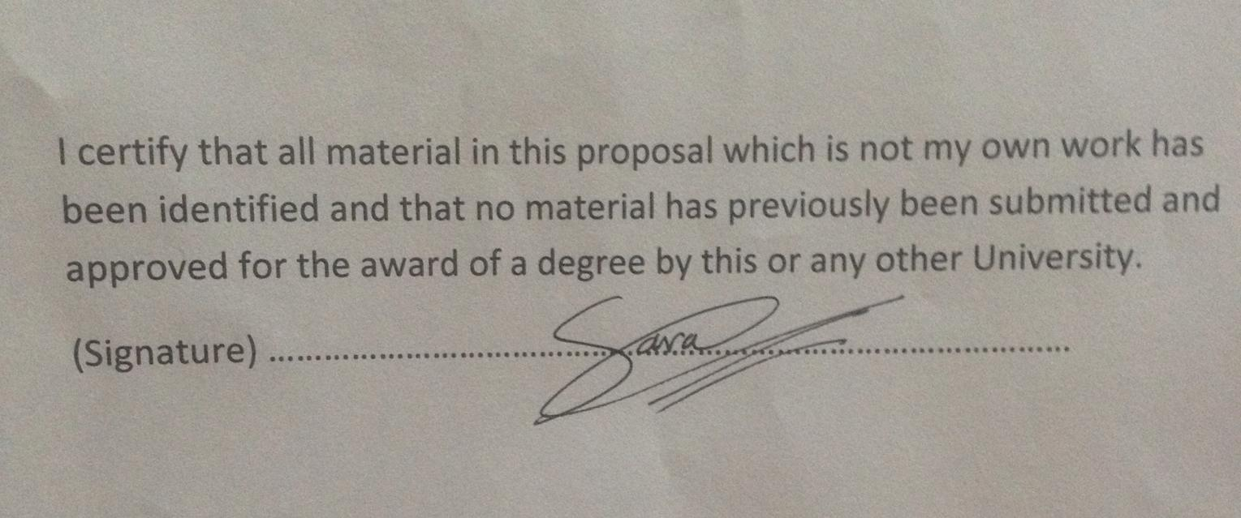

Contents :

Abstract ............................................................................................. 3

Introduction ....................................................................................... 3

Literature review ................................................................................4

Significance of the study…………………………………….….….…4

Limitation of the study…………………………………….……..…..4

Methodology......................................................................................5

Research Questions.............................................................................5
Expected Results ........................................................................................5
Conclusion…………………..........................................…………...…..5
References ............................................................................................6

Appendix A ......................................................................................... 7

Learning English Language By Distance Learning, Problems and Solution

Sara Mahmoud Lotfi
ID – 211564293
Advisor: Dr.Bassam Saideen

- Abstract:

This research deals with problems associated with distance education and solutions. First it identifies these problems. Second, it provides a solution to the problems and some recommendations for the betterment of distance education.
The research study is based on a questionnaire to elicit the perspectives of some of the English language students studying by distance learning. So, this research study will give benefits to the community and those in charge of the English language learners by this learning and thus find a solution to this problem.

Introduction

Distance education technologies are expanding at an overwhelming rapid rate. The idea of taking classes towards an accredited degree at any time, day or night, has captured the interest of millions. As an online education recipient, you can receive classes and specialized instruction from a university thousands of miles from your home. Distance learning has created new learning opportunities for students all over the world. It offers many benefits, such as convenience, flexibility and sometimes lower tuition rates. It offers enormous potential for students who want to take a class, but are physically unable to attend a traditional classroom. However, students must be aware of the problems that can arise from online distance-learning programs. Lake (1999, p.14) notes that ‘technological change has enabled the materials of education to be dispersed economically in new ways with fewer temporal and spatial constraints’

- Literature Review
This part is allocated to review the literature related to distance learning. It becomes a multi-national and multi-billion project. Distance education has the some specific characteristics, which separate it from the traditional system of education and provide it with a unique feature as parallel to formal education such as there is no direct interaction or face-to-face activity between teacher and students, but compensated by contact or counseling sessions.
One of the most comprehensive definitions is by Keegan (1996) in which six basic defining elements of distance education were suggested. He observed that the distance education is characterized by the separation of learner and tutor as opposed to face-to-face teaching, the influence of an educational organization which distinguishes distance education from private study, the use of technical media, e.g. print, audio, or website to unite tutor and learner, the provision of two-way communication so that the student may engage in dialogue with the tutor, the possibility of occasional meetings for purposes of interaction and the self-directed nature of the learner’s involvement.
Many educationists are concerned about distance learning and trying to give and implement various approaches for the field. Knowles (1980) believed that learner behaviour is influenced by a combination of the learner's needs plus the learner's situation and personal characteristics. Rekkedal (1985) studied the role of the teacher for the betterment of the practices and the learner. No single factor appears to cause nonparticipation; however, individual student characteristics and life circumstances appear to have the greatest impact on participation (Kerka, 1986). Garrison (1989) pointed out that with new information technologies, the boundaries between distance education and traditional education will become increasingly blurred.
Significance of the study
This study aims at discussing concept of distance education, problems faced by distant learners and problem associated with distance education system. The study makes an effort to provide suggestive solutions for the betterment of the distance and open learning system.
Limitation of the Study
The results of this study are limited to the sample of the study which consisted of some female students who study English by distance learning in King Faisal University and live in Dammam, Saudi Arabia. Therefore, the results may not generalized for other subjects and other regions.

Methodology
This part contains an account of the procedures used in the study, research design, selection and description of the participants and the instrument used for data collection.
Written Questionnaire:
The advantages of using the questionnaire as data collection tool are that large amounts of information can be collected from a large number of people in a short period. They are easy to analyze. The questionnaire was written in English and it contained nine items. The questions were close-ended. The respondents were asked to put only a tick mark (  ) in the column of their choice. The rating scales range from one up to five where 1=strongly disagree, 2=disagree, 3= neither agree nor disagree, 4=agree and 5=strongly agree.
A questionnaire was used as a research instrument (see Appendix-A) to know the problems faced by students learning English by distance learning. It is one of the common tools used in conducting a survey. It can easily be administered. It can gather sufficient information.
Research Questions:
- What are the problems faced by students learning English by distance learning?
- Are you feel that face-to-face contact with my instructor is necessary to learn?
- Is Learning the same in class and at home on the Internet?
Expected Results:
I expect to the most of students agreed that face-to-face contact with the instructor is necessary to learn and believed that a complete course can be given by the Internet without difficulty. But disagreed could pass a course on the Internet without any teacher assistance. I also expect they believed that an Internet course is possible but for learning English it would be difficult. Also can ask their teacher questions and receive a quick response and I think they disagreed with the item "Learning is the same in class and at home on the Internet."
It is difficult to change the existing system, but we can do certain things to improve it. Students should be divided in groups based on their level. Our suggestion is team (or pair) teaching. It means that a teacher should not work on his own with distance learning students, but have a colleague or an assistant to help him. Practically, this means that one of the teachers will actually teach the course and meet the students during the semester and the other one will keep in touch with students through the on-line platform and meet them during office hours. The course syllabus will be the same for all students; however the assistant will deal more with the students who have difficulties in coping with the level and the requirements imposed by the course curriculum and syllabus.
Conclusion:
The application of distance learning system to English language study is a great challenge. The greatest problem is the lack of face-to-face communication with peers and the teacher. By using state-of-the-art tools for synchronous and asynchronous communication, this problem can be overcome.
We are aware that we are facing much additional work to develop the courses, modify them, make better multimedia presentations, and, in particular, enhance interactivity. We believe that by applying the combination of pedagogical insights and modern technologies it is possible to realize successful English language distance learning.
Despite the need for improvement, the future of distance learning seems bright. Increasing numbers of students enrolling in distance learning classes underscore the need for “comprehensive and thoughtful evolution of distance education if it is to become the educational model of the future” (Harnar, et al., 2000, pg. 37). Despite the cost, coordination, and training that must be put into a program, it has “high potential to deliver and receive educational programs to and from remote sites” (Weber, 1996, pg. 219). Perhaps Keegan (1995) puts it best when he says, “the challenge is to design cost-effective and educationally-effective systems for use in the new millennium of the new technologies that permit for the first time in history (electronic) teaching of students face-to-face at a distance” (pg. 53).

References

Greenberg, G. (1998). Distance education technologies: Best practices for K-12 settings. IEEE Technology and Society Magazine, (Winter) 36-40.

Gulati, S. (2008) Compulsory participation in online discussions: Is this constructivism or normalisation of learning? Innovations in Education and Teaching International, 45 (2), 183-192.

Hughes, M. & Daykin, N. (2002) Towards constructivism: Investigating students’ perceptions and learning as a result of using an online environment. Innovations in Education and Teaching International, 39 (3), 217–223.
Keegan, D. (1995). Distance education technology for the new millennium: compressed video teaching. ZIFF Papiere. Hagen, Germany: Institute for Research into Distance Education. (Eric Document Reproduction Service No. ED 389 931).

Kerka, S. ‘Deterrents to Participation in Adult Education’ 1986 ERIC Digest No. 59, ED275889 86.

Knowles, M. The Modern Practice of Adult Education: From Pedagogy to Andragogy. Chicago: Follett Publishers,1980.

Lake, D. (1999) Reducing isolation for distance students: An on-line initiative. Open Learning, 14 (3), 14-23.
Liu, S. (2008) Student interaction experiences in distance learning courses: A phenomenological study. Online Journal of Distance Learning Administration [online],11(1). Available from: http://www.westga.edu/~distance/ojdla/spring111/Liu111.html [Accessed 15th October 2009].

Harner, M., et al. (2000). Measuring the effect of distance education on the learning experience: Teaching accounting via Picturetel. International Journal of Instructional Media, 27 (1), 37-50.

Rekkedal, T. 1985. ‘Introducing the Personal Tutor/counsellor in the System of Distance Education’. Project report 2: Final report. NKI, Stabekk, Norway.

Teaster, P., & Blieszner, R. (1999). Promises and pitfalls of the interactive television approach to teaching adult development and aging. Educational Gerontology, 25 (8), 741-754.

Weber, J. (1996). The compressed video experience. Paper presented at Summer Conference of the Association of Small Computer Users. North Myrtle Beach, South Carolina. (ERIC Document Reproduction Service No. ED 405 838).

Venter, K. (2003) Coping with isolation: The role of culture in adult distance learners' use of surrogates. Open Learning, 18 (3), 271-287.

Appendix A
Distance Education Questionnaire
Student Name ___________________________
You are invited to participate in this survey regarding your experiences in KFU Distance Learning course. Your thoughts and opinions are important to us and will help us improve the quality of the Distance Learning Program. Your answers will be completely confidential.
Instructions: For each of the statements below, please a tick mark (  ) in the box that best describes yourself or you and your opinion concerning online learning/distance education.

 | Questions | Strongly  Agree | Agree | Neither Agree Nor Disagree | Disagree | Strongly  Disagree
1 | I feel that face-to-face contact with my instructor is necessary to learn.
2 | I believe a complete course can be given by the Internet without difficulty.
3 | I could pass a course on the Internet without any teacher assistance.
4 | I believe an Internet course is possible but for learning English it would be difficult.
5 | I can ask my teacher questions and receive a quick response.
6 | I am able to easily access the Internet as needed for my studies.
7 | Learning is the same in class and at home on the Internet.
8 | I am able to complete assignments on time.
9 | Distance learning is costly.

